**Table of Content**

Donnerstag, 13. Juni 2019

22:31

* + [MFN\_Notes from March](onenote:#MFN_Notes%20from%20March&section-id={5FAD0518-E349-4A07-93E8-5D105BD4AEB4}&page-id={57EF4C0F-29B4-684C-99AF-0A72647312F5}&end&base-path=https://goetheuniversitaet.sharepoint.com/sites/Project4/SiteAssets/Project%204%20Notebook/Magnetic%20Flux%20Noise.one) (First test measurements)
  + [MFN First Measurement Plan (+10deg)](onenote:#MFN%20First%20Measurement%20Plan%20(+10deg)&section-id={5FAD0518-E349-4A07-93E8-5D105BD4AEB4}&page-id={60691B11-C78C-4080-866D-8BA2FE78FA96}&end&base-path=https://goetheuniversitaet.sharepoint.com/sites/Project4/SiteAssets/Project%204%20Notebook/Magnetic%20Flux%20Noise.one)
  + [MFN Measurements (0deg) perp](onenote:#MFN%20Measurements%20(0deg)%20perp&section-id={5FAD0518-E349-4A07-93E8-5D105BD4AEB4}&page-id={41BE641C-5011-43CD-BF42-C68516FAD7CB}&end&base-path=https://goetheuniversitaet.sharepoint.com/sites/Project4/SiteAssets/Project%204%20Notebook/Magnetic%20Flux%20Noise.one)
  + [measurements at 90deg (static field)](onenote:#measurements%20at%2090deg%20(static%20field)&section-id={5FAD0518-E349-4A07-93E8-5D105BD4AEB4}&page-id={319207B4-D488-4405-82E8-C67B1992E815}&end&base-path=https://goetheuniversitaet.sharepoint.com/sites/Project4/SiteAssets/Project%204%20Notebook/Magnetic%20Flux%20Noise.one)
    - [Analyzing Field Dependence (static)](onenote:#Analyzing%20Field%20Dependence%20(static)&section-id={5FAD0518-E349-4A07-93E8-5D105BD4AEB4}&page-id={4C2D7A80-7CBF-4C0D-A7D1-96E621AC6230}&end&base-path=https://goetheuniversitaet.sharepoint.com/sites/Project4/SiteAssets/Project%204%20Notebook/Magnetic%20Flux%20Noise.one)
  + [Measurements while sweeping field](onenote:#Measurements%20while%20sweeping%20field&section-id={5FAD0518-E349-4A07-93E8-5D105BD4AEB4}&page-id={03B9AE70-0C9E-4DF3-8E0A-B28A5EA8879D}&end&base-path=https://goetheuniversitaet.sharepoint.com/sites/Project4/SiteAssets/Project%204%20Notebook/Magnetic%20Flux%20Noise.one)
    - [Analyzing Field Sweeps](onenote:#Analyzing%20Field%20Sweeps&section-id={5FAD0518-E349-4A07-93E8-5D105BD4AEB4}&page-id={6B2A0B47-6A11-48A2-B6E7-BE04798D8013}&end&base-path=https://goetheuniversitaet.sharepoint.com/sites/Project4/SiteAssets/Project%204%20Notebook/Magnetic%20Flux%20Noise.one)
  + [Measurement Plan #2](onenote:#Measurement%20Plan%202&section-id={5FAD0518-E349-4A07-93E8-5D105BD4AEB4}&page-id={785856AA-BCC3-49D5-A9EA-61B0C750F8CA}&end&base-path=https://goetheuniversitaet.sharepoint.com/sites/Project4/SiteAssets/Project%204%20Notebook/Magnetic%20Flux%20Noise.one)
    - [Evaluating Field Sweeps](onenote:#Evaluating%20Field%20Sweeps&section-id={5FAD0518-E349-4A07-93E8-5D105BD4AEB4}&page-id={DC6093B7-AF27-49C2-AC11-B10C7E451B0A}&end&base-path=https://goetheuniversitaet.sharepoint.com/sites/Project4/SiteAssets/Project%204%20Notebook/Magnetic%20Flux%20Noise.one)
    - [Evaluating Static Fields](onenote:#Evaluating%20Static%20Fields&section-id={5FAD0518-E349-4A07-93E8-5D105BD4AEB4}&page-id={F028959A-9800-41BA-B278-F06A0F3818E5}&end&base-path=https://goetheuniversitaet.sharepoint.com/sites/Project4/SiteAssets/Project%204%20Notebook/Magnetic%20Flux%20Noise.one)

**m: MFN\_**

Samstag, 1. Juni 2019

13:05

|  |  |
| --- | --- |
| Angle of sensor θ | *+90* |
| Temp | 30 K |
|  |  |
|  | |  |  |  |  | | --- | --- | --- | --- | |  | ***1 - 13*** |  |  | | ***Gate (0V)*** | ***9 - 4*** |  | ***14 - 7*** | |
|  | |  |  | | --- | --- | |  | *0.5 T Persistend Mode* | |
|  |  |
| Resistance Box | |  |  |  |  |  |  | | --- | --- | --- | --- | --- | --- | |  | *1 MΩ* |  | 6.6 kΩ |  | 450 Ω | |  | *1 MΩ* |  | *2* |  | *6* | |
|  | |  |  |  |  |  |  | | --- | --- | --- | --- | --- | --- | | Sens | 5 mV |  | 4 V |  |  | | *τ* | *3 ms* | *Input A* | *AC* | *Ground* | *Normal Reserve* | |
| Pre Amplifier (SR560) | |  |  |  |  | | --- | --- | --- | --- | | *Gain Mode* | *Low* | *Gain:* | *2e2* | | *Coupling* | *AC* | *Output (50Ω)* | *LI Input A* | | *Filters:* | *Off* |  |  | |
| Signal Analyzer (SR785) | |  |  |  |  | | --- | --- | --- | --- | | *Ch 1 (A)* |  | *Freq - Span:* | *3 Hz* | | *Ch 2 (A)* |  | *Averages:* | *30* | |
| Period of measurement (min) | *min* |
| He (l) level consumption |  |
| Data files |  |
| Plot |  |
|  |  |

**MFN\_Notes from March**

Tuesday, 4. June 2019

11:43

See [Testing Noise Measurements](onenote:Angles_Hloops.one#---------&section-id={E1591C84-FAE5-294E-9FDA-10DB5AB09FE5}&page-id={D47B7E30-51AB-4CD6-9B45-1B18B191AE1B}&end&base-path=https://goetheuniversitaet.sharepoint.com/sites/Project4/SiteAssets/Project%204%20Notebook) in Angles\_Hloop

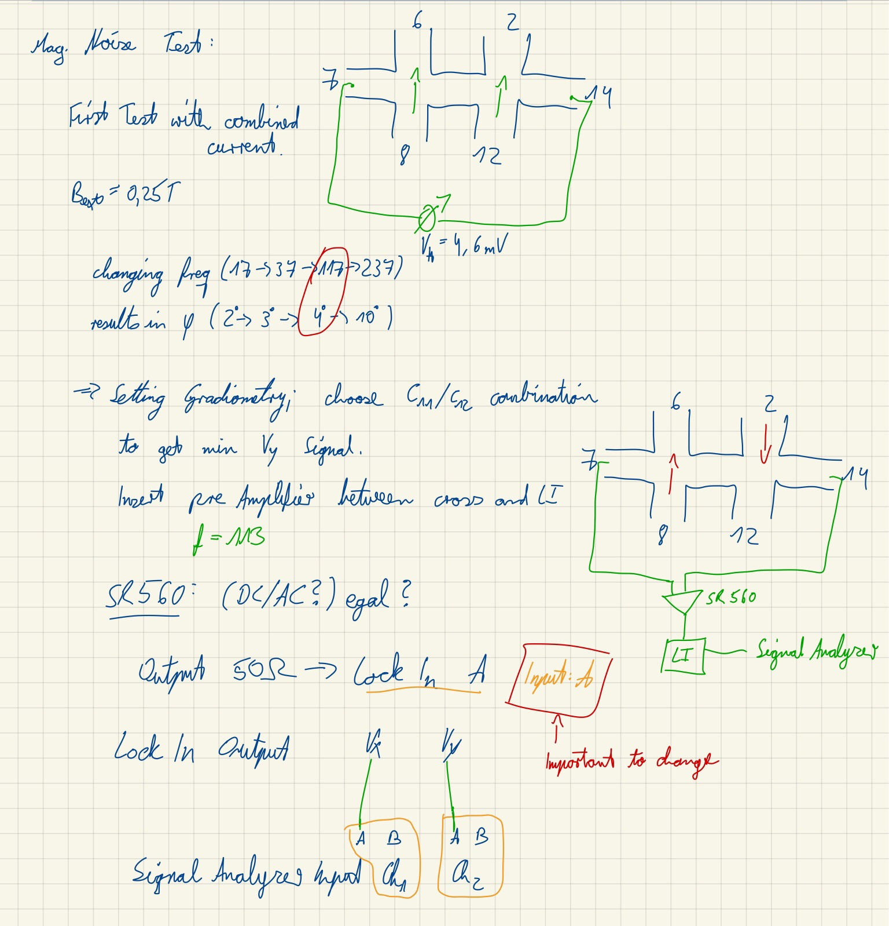

**MFN First Measurement Plan (+10deg)**

Samstag, 1. Juni 2019

13:05

|  |  |
| --- | --- |
| Structure | SR785 |

|  |  |  |  |  |  |  |  |  |  |  |  |  |  |
| --- | --- | --- | --- | --- | --- | --- | --- | --- | --- | --- | --- | --- | --- |
| Plusses (1 - 13) | |  |  |  | | --- | --- | --- | | I1 = 1 - 13  I2 = 8 - 6 | [m260](onenote:#m260%20Plusses_MFN_T=30K_0.5T&section-id={5FAD0518-E349-4A07-93E8-5D105BD4AEB4}&page-id={53990E02-09B7-409A-AE03-A6E287FDEB94}&end&base-path=https://goetheuniversitaet.sharepoint.com/sites/Project4/SiteAssets/Project%204%20Notebook/Magnetic%20Flux%20Noise.one) (100 Hz ; 50 Avg)  [m261](onenote:#m261%20Plusses_MFN_T=30K_0.5T&section-id={5FAD0518-E349-4A07-93E8-5D105BD4AEB4}&page-id={798A9CA3-CA03-4419-B658-D77CB0E8BCEC}&end&base-path=https://goetheuniversitaet.sharepoint.com/sites/Project4/SiteAssets/Project%204%20Notebook/Magnetic%20Flux%20Noise.one) (100/50/25 Hz) |  | | I1 = 1 - 13  I2 = 10 - 5 | |  |  |  | | --- | --- | --- | | I = 2,5 μA | 2 μA | 1 μA | | [m262](onenote:#m262%20Plusses_MFN_T=30K_0.5T%20I%20=%202&section-id={5FAD0518-E349-4A07-93E8-5D105BD4AEB4}&page-id={6010AC6B-12D2-4940-90DF-BF5D33DACE90}&end&base-path=https://goetheuniversitaet.sharepoint.com/sites/Project4/SiteAssets/Project%204%20Notebook/Magnetic%20Flux%20Noise.one) | [m263](onenote:#m263%20Plusses_MFN_T=30K_0.5T%20I%20=%202μA&section-id={5FAD0518-E349-4A07-93E8-5D105BD4AEB4}&page-id={C3DB0049-034C-431E-9514-D7DC9A97A2B2}&end&base-path=https://goetheuniversitaet.sharepoint.com/sites/Project4/SiteAssets/Project%204%20Notebook/Magnetic%20Flux%20Noise.one) | [m264](onenote:#m264%20Plusses_MFN_T=30K_0.5T%20I%20=%201μA&section-id={5FAD0518-E349-4A07-93E8-5D105BD4AEB4}&page-id={467240DE-3778-4D20-9B55-F09E1B78FB83}&end&base-path=https://goetheuniversitaet.sharepoint.com/sites/Project4/SiteAssets/Project%204%20Notebook/Magnetic%20Flux%20Noise.one) |   [Comparing Scaling with I^2](onenote:#Comparing%20Scaling%20with%20I%5e2&section-id={5FAD0518-E349-4A07-93E8-5D105BD4AEB4}&page-id={C14958D5-FEC0-4E10-9DC3-7B8002EA9B47}&end&base-path=https://goetheuniversitaet.sharepoint.com/sites/Project4/SiteAssets/Project%204%20Notebook/Magnetic%20Flux%20Noise.one) |  | |
| Empty Cross | |  |  |  | | --- | --- | --- | | Single Cross (I2 = 10-5) | [m265](onenote:#m265%20MFN_Empty_2_T=30K_0.5T I&section-id={5FAD0518-E349-4A07-93E8-5D105BD4AEB4}&page-id={E9C9857C-F302-4E75-9950-4617EA455234}&end&base-path=https://goetheuniversitaet.sharepoint.com/sites/Project4/SiteAssets/Project%204%20Notebook/Magnetic%20Flux%20Noise.one) (Only Background noise) |  | | Gradiometry  I1 = 6 - 8  I2 = 10 - 5 | |  |  |  |  |  | | --- | --- | --- | --- | --- | | I = 2,5 μA | 2 μA | 1 μA | 0,5 μA | 0 A (BG) | | [m266](onenote:#m266%20MFN_Empty_Gradio_T=30K_0.5T%20I%20&section-id={5FAD0518-E349-4A07-93E8-5D105BD4AEB4}&page-id={298ADCCD-87B2-4006-9A1F-D39A0DEF82A0}&end&base-path=https://goetheuniversitaet.sharepoint.com/sites/Project4/SiteAssets/Project%204%20Notebook/Magnetic%20Flux%20Noise.one) | [m267](onenote:#m267%20MFN_Empty_Gradio_T=30K_0.5T%20I%20&section-id={5FAD0518-E349-4A07-93E8-5D105BD4AEB4}&page-id={01985ED2-22D8-461F-AA85-EEE7F791DC92}&end&base-path=https://goetheuniversitaet.sharepoint.com/sites/Project4/SiteAssets/Project%204%20Notebook/Magnetic%20Flux%20Noise.one) | [m268](onenote:#m268%20MFN_Empty_Gradio_T=30K_0.5T%20I%20&section-id={5FAD0518-E349-4A07-93E8-5D105BD4AEB4}&page-id={C2FC5AA9-13D1-4799-B0A3-CC69265FAEF6}&end&base-path=https://goetheuniversitaet.sharepoint.com/sites/Project4/SiteAssets/Project%204%20Notebook/Magnetic%20Flux%20Noise.one) | [m269](onenote:#m269%20MFN_Empty_Gradio_T=30K_0.5T%20I%20&section-id={5FAD0518-E349-4A07-93E8-5D105BD4AEB4}&page-id={2325BBA9-9A6C-46CE-88B4-F84E6012830F}&end&base-path=https://goetheuniversitaet.sharepoint.com/sites/Project4/SiteAssets/Project%204%20Notebook/Magnetic%20Flux%20Noise.one) | [m272](onenote:#m272%20MFN_Empty_Gradio_Background%20I=0V&section-id={5FAD0518-E349-4A07-93E8-5D105BD4AEB4}&page-id={6168A02D-6C1F-4BBA-BD49-506818D56E5B}&end&base-path=https://goetheuniversitaet.sharepoint.com/sites/Project4/SiteAssets/Project%204%20Notebook/Magnetic%20Flux%20Noise.one) |     Longer Test Measurements (τ=1ms):   |  |  | | --- | --- | | Avg: 200 | 1000 (different Freq-Span) | | [m270](onenote:#m270%20MFN_Empty_Gradio%20tc=1ms%20%20avg=200&section-id={5FAD0518-E349-4A07-93E8-5D105BD4AEB4}&page-id={BED0E42A-9EF0-49AB-8BF8-1CDA22F240FC}&end&base-path=https://goetheuniversitaet.sharepoint.com/sites/Project4/SiteAssets/Project%204%20Notebook/Magnetic%20Flux%20Noise.one) | [m271](onenote:#m271%20MFN_Empty_Gradio%20avg=1000%20over%20night%20(15h&section-id={5FAD0518-E349-4A07-93E8-5D105BD4AEB4}&page-id={C8002DB1-C1CB-4274-A304-08EC3079F738}&end&base-path=https://goetheuniversitaet.sharepoint.com/sites/Project4/SiteAssets/Project%204%20Notebook/Magnetic%20Flux%20Noise.one) | |  | |

**1/f noise function in origin**

Mittwoch, 5. Juni 2019

18:32

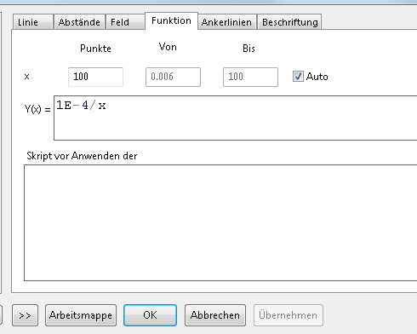



Angle: +10deg / SA: SR785



Samstag, 1. Juni 2019

13:05



**m260: Plusses\_MFN\_T=30K\_0.5T**

Samstag, 1. Juni 2019

13:05

|  |  |
| --- | --- |
| Angle of sensor θ | *+10* |
|  |  |
|  |  |
|  | |  |  | | --- | --- | |  | *0.5 T Persistend Mode* | | *V\_H Balance* | *± 0.5 μV* | |
|  | R12 = 132/1000\*50 = 6,6  R13 = 45/1000\*10 = 0,45 |
|  |  |
| *Pre Amplifier (SR560)* | *Gain Mode: Low | Output: 50O -> Lock In Input A | Gain: 1e2*  Filter Cutoffs:  *Off | Coupling: AC* |
| *Signal Analyzer (SR785)* | *Freq - Span: 100 Hz* | *Avg: 50* |
| *Period of measurement (min)* | *3,5 min* |
| *He (l) level consumption* | *36,22 -> 36,* |
| *Data files (rar)* | <<m260\_First\_MFN\_SR785.dat>> |
| *Plot* | 」 anba  0J0 |
|  | Sensor 26  3um  Tetrahedral CoFe nanostructures  D  B  x  A and B: old square ASI |

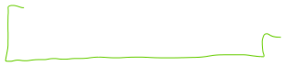

**m261: Plusses\_MFN\_T=30K\_0.5T**

Samstag, 1. Juni 2019

13:05

|  |  |
| --- | --- |
| Angle of sensor θ | *+10* |
|  |  |
|  |  |
|  | |  |  | | --- | --- | |  | *0.5 T Persistend Mode* | |
|  | R12 = 132/1000\*50 = 6,6  R13 = 45/1000\*10 = 0,45 |
|  |  |
| *Pre Amplifier (SR560)* | *Gain Mode: Low | Output: 50O -> Lock In Input A | Gain: 1e2*  Filter Cutoffs:  *Off | Coupling: AC* |
| *Signal Analyzer (SR785)* | *Freq - Span: 100 Hz / 50 Hz / 25 Hz* | *Avg: 50* |
| *Period of measurement (min)* | *23 min* |
| *He (l) level consumption* | *36,22 -> 36,22* |
| *Data files (rar)* | <<m261\_Longer\_MFN\_SR785.dat>> |
| *Plot* | zuanbeJd  0J0 |
|  | Sensor 26  3um  Tetrahedral CoFe nanostructures  D  B  x  A and B: old square ASI |

**m262: Plusses\_MFN\_T=30K\_0.5T I = 2.5μA**

Samstag, 1. Juni 2019

13:05

|  |  |
| --- | --- |
| Angle of sensor θ | *+10* |
|  |  |
|  |  |
|  | |  |  | | --- | --- | |  | *0.5 T Persistend Mode* | | *V\_x Balance* | *3.92 mV* | | *V\_y Balance* | *-4.1 mV* | |
|  | R12 = 132/1000\*50 = 6,6  R13 = 45/1000\*10 = 0,45 |
|  |  |
| *Pre Amplifier (SR560)* | *Gain Mode: Low | Output: 50O -> Lock In Input A | Gain: 1e2*  Filter Cutoffs:  *Off | Coupling: AC* |
| *Signal Analyzer (SR785)* | *Freq - Span: 100 Hz* | *Avg: 50* |
| *Period of measurement (min)* | *3,5 min* |
| *He (l) level consumption* | *36,22 -> 36,22* |
| *Data files (rar)* | <<m262\_Plusses\_MFN\_SR785\_second\_empty\_cross\_5-10.dat>> |
| *Plot* | Machine generated alternative text: *+2061 76438  *+226767378  omi  184  F requenz [Hz] |
|  | Sensor 26  3um  Tetrahedral CoFe nanostructures  D  B  x  A and B: old square ASI |

**m263: Plusses\_MFN\_T=30K\_0.5T I = 2μA**

Samstag, 1. Juni 2019

13:05

|  |  |
| --- | --- |
| Angle of sensor θ | *+10* |
|  |  |
|  |  |
|  | |  |  | | --- | --- | |  | *0.5 T Persistend Mode* | | *V\_x Balance* | *3.92 mV* | | *V\_y Balance* | *-4.1 mV* | |
|  | R12 = 132/1000\*50 = 6,6  R13 = 45/1000\*10 = 0,45 |
|  |  |
| *Pre Amplifier (SR560)* | *Gain Mode: Low | Output: 50O -> Lock In Input A | Gain: 1e2*  Filter Cutoffs:  *Off | Coupling: AC* |
| *Signal Analyzer (SR785)* | *Freq - Span: 100 Hz* | *Avg: 50* |
| *Period of measurement (min)* | *3,5 min* |
| *He (l) level consumption* | *36,22 -> 36,22* |
| *Data files (rar)* | <<m263\_Plusses\_MFN\_SR785\_second\_empty\_cross\_5-10\_I-2uA.dat>> |
| *Plot* | > 18 5  0101  1810  18  Frequenz[ 工 2一  + 4 65 04 e  + 1 71 e |
|  | Sensor 26  3um  Tetrahedral CoFe nanostructures  D  B  x  A and B: old square ASI |

**m264: Plusses\_MFN\_T=30K\_0.5T I = 1μA**

Samstag, 1. Juni 2019

13:05

|  |  |
| --- | --- |
| Angle of sensor θ | *+10* |
|  |  |
|  |  |
|  | |  |  | | --- | --- | |  | *0.5 T Persistend Mode* | | *V\_x Balance* | *3.92 mV* | | *V\_y Balance* | *-4.1 mV* | |
|  | R12 = 132/1000\*50 = 6,6  R13 = 45/1000\*10 = 0,45 |
|  |  |
| *Pre Amplifier (SR560)* | *Gain Mode: Low | Output: 50O -> Lock In Input A | Gain: 1e2*  Filter Cutoffs:  *Off | Coupling: AC* |
| *Signal Analyzer (SR785)* | *Freq - Span: 100 Hz* | *Avg: 50* |
| *Period of measurement (min)* | *3,5 min* |
| *He (l) level consumption* | *36,22 -> 36,22* |
| *Data files (rar)* | <<m264\_Plusses\_MFN\_SR785\_second\_empty\_cross\_5-10\_I-1uA.dat>> |
| *Plot* | Vx  Lheare An  1/f3•6  requerz [Hz]  「 OCOI  - 0 01  18  Frequenz[ 工 2一  + 37 93 e  + 31137 77 e |
|  | Sensor 26  3um  Tetrahedral CoFe nanostructures  D  B  x  A and B: old square ASI |

Comparing Scaling with I^2

Samstag, 1. Juni 2019

14:43

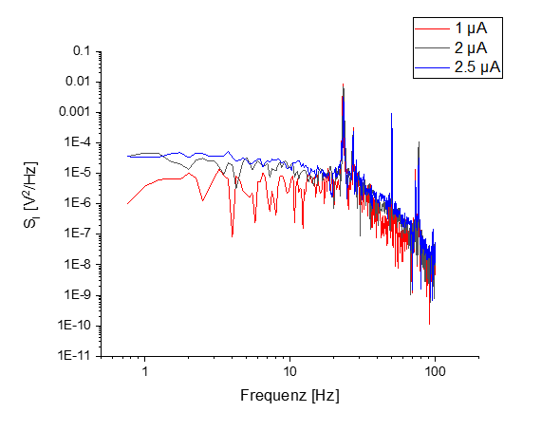

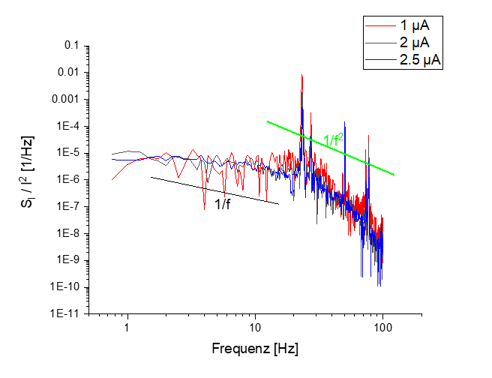

**m265: MFN\_Empty\_#2\_T=30K\_0.5T I = 1μA**

Samstag, 1. Juni 2019

13:05

|  |  |
| --- | --- |
| Angle of sensor θ | *+10* |
|  |  |
|  |  |
|  | |  |  | | --- | --- | |  | *0.5 T Persistend Mode* | |
|  | R12 = 132/1000\*50 = 6,6  R13 = 45/1000\*10 = 0,45 |
|  |  |
| *Pre Amplifier (SR560)* | *Gain Mode: Low | Output: 50O -> Lock In Input A | Gain: 1e2*  Filter Cutoffs:  *Off | Coupling: AC* |
| *Signal Analyzer (SR785)* | *Freq - Span: 100 Hz* | *Avg: 50* |
| *Period of measurement (min)* | *3,5 min* |
| *He (l) level consumption* | *36,22 -> 36,22* |
| *Data files (rar)* | <<m265\_MFN\_SR785\_second\_empty\_cross\_alone\_5-10\_I-1uA.dat>> |
| *Plot* | Machine generated alternative text: *+47183712 e  *+382250868  omi  184  F requenz [Hz] |
|  | Sensor 26  3um  Tetrahedral CoFe nanostructures  D  B  x  A and B: old square ASI |



**m266: MFN\_Empty\_Gradio\_T=30K\_0.5T I = 2.5μA**

Samstag, 1. Juni 2019

15:14

|  |  |
| --- | --- |
| Angle of sensor θ | *+10* |
|  |  |
|  |  |
|  | |  |  | | --- | --- | |  | *0.5 T Persistend Mode* | |
|  | R12 = 132/1000\*50 = 6,6  R13 = 45/1000\*10 = 0,45 |
|  |  |
| *Pre Amplifier (SR560)* | *Gain Mode: Low | Output: 50O -> Lock In Input A | Gain: 1e2*  Filter Cutoffs:  *Off | Coupling: AC* |
| *Signal Analyzer (SR785)* | *Freq - Span: 100 Hz* | *Avg: 50* |
| *Period of measurement (min)* | *3,5 min* |
| *He (l) level consumption* | *36,22 -> 36,22* |
| *Data files (rar)* | <<m266\_MFN\_SR785\_empty\_cross\_gradio\_I-2.5uA.dat>> |
| *Plot* | џк2 [ХАНЕ] |
|  | Sensor 26  3um  Tetrahedral CoFe nanostructures  D  B  x  A and B: old square ASI |

**m267: MFN\_Empty\_Gradio\_T=30K\_0.5T I = 2μA**

Samstag, 1. Juni 2019

15:14

|  |  |
| --- | --- |
| Angle of sensor θ | *+10* |
|  |  |
|  |  |
|  | |  |  | | --- | --- | |  | *0.5 T Persistend Mode* | |
|  | R12 = 132/1000\*50 = 6,6  R13 = 45/1000\*10 = 0,45 |
|  |  |
| *Pre Amplifier (SR560)* | *Gain Mode: Low | Output: 50O -> Lock In Input A | Gain: 1e2*  Filter Cutoffs:  *Off | Coupling: AC* |
| *Signal Analyzer (SR785)* | *Freq - Span: 100 Hz* | *Avg: 50* |
| *Period of measurement (min)* | *3,5 min* |
| *He (l) level consumption* | *36,22 -> 36,22* |
| *Data files (rar)* | <<m267\_MFN\_SR785\_empty\_cross\_gradio\_I-2uA.dat>> |
| *Plot* | Machine generated alternative text: #+ag76B1  omi  F requenz [Hz] |
|  | Sensor 26  3um  Tetrahedral CoFe nanostructures  D  B  x  A and B: old square ASI |

**m268: MFN\_Empty\_Gradio\_T=30K\_0.5T I = 1μA**

Samstag, 1. Juni 2019

15:14

|  |  |
| --- | --- |
| Angle of sensor θ | *+10* |
|  |  |
|  |  |
|  | |  |  | | --- | --- | |  | *0.5 T Persistend Mode* | |
|  | R12 = 132/1000\*50 = 6,6  R13 = 45/1000\*10 = 0,45 |
|  |  |
| *Pre Amplifier (SR560)* | *Gain Mode: Low | Output: 50O -> Lock In Input A | Gain: 1e2*  Filter Cutoffs:  *Off | Coupling: AC* |
| *Signal Analyzer (SR785)* | *Freq - Span: 100 Hz* | *Avg: 50* |
| *Period of measurement (min)* | *3,5 min* |
| *He (l) level consumption* | *36,22 -> 36,22* |
| *Data files (rar)* | <<m268\_MFN\_SR785\_empty\_cross\_gradio\_I-1uA.dat>> |
| *Plot* | Machine generated alternative text: *+53264084B  #+23N4263e  omi  F requenz [Hz] |
|  | Sensor 26  3um  Tetrahedral CoFe nanostructures  D  B  x  A and B: old square ASI |

**m269: MFN\_Empty\_Gradio\_T=30K\_0.5T I = 0.5μA**

Samstag, 1. Juni 2019

15:14

|  |  |
| --- | --- |
| Angle of sensor θ | *+10* |
|  |  |
|  |  |
|  | |  |  | | --- | --- | |  | *0.5 T Persistend Mode* | |
|  | R12 = 132/1000\*50 = 6,6  R13 = 45/1000\*10 = 0,45 |
|  |  |
| *Pre Amplifier (SR560)* | *Gain Mode: Low | Output: 50O -> Lock In Input A | Gain: 1e2*  Filter Cutoffs:  *Off | Coupling: AC* |
| *Signal Analyzer (SR785)* | *Freq - Span: 100 Hz* | *Avg: 50* |
| *Period of measurement (min)* | *3,5 min* |
| *He (l) level consumption* | *36,22 -> 36,22* |
| *Data files (rar)* | <<m269\_MFN\_SR785\_empty\_cross\_gradio\_I-0.5uA.dat>> |
| *Plot*  Machine generated alternative text: omi  F requenz [Hz] | Machine generated alternative text: omi  F requenz [Hz] |
|  | Sensor 26  3um  Tetrahedral CoFe nanostructures  D  B  x  A and B: old square ASI |

**Compare (m266 - m269)**

Montag, 3. Juni 2019

16:11

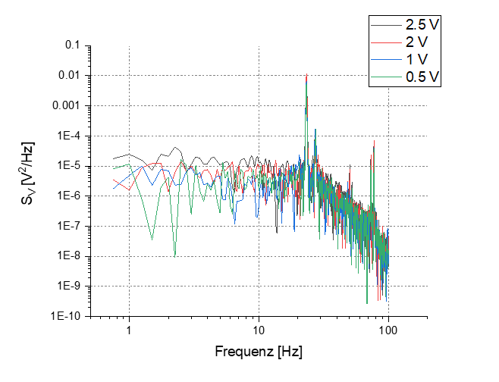

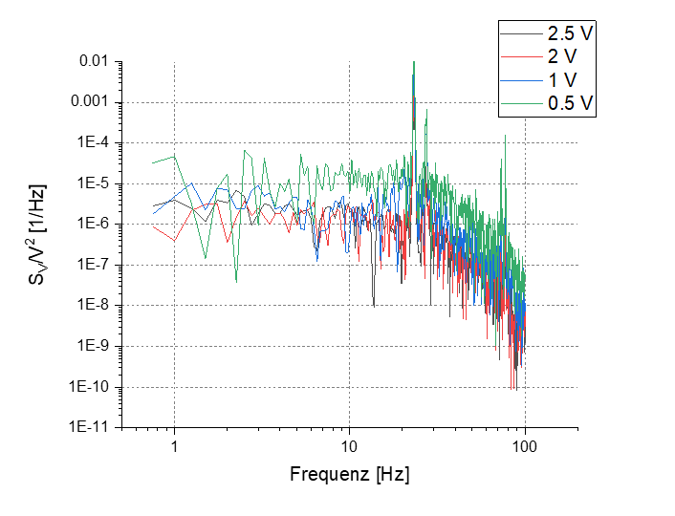

**m270: MFN\_Empty\_Gradio tc=1ms avg=200**

Samstag, 1. Juni 2019

15:14

|  |  |
| --- | --- |
| Angle of sensor θ | *+10* |
|  |  |
|  |  |
|  | |  |  | | --- | --- | |  | *0.5 T Persistend Mode* | |
|  | R12 = 132/1000\*50 = 6,6  R13 = 45/1000\*10 = 0,45 |
|  |  |
| *Pre Amplifier (SR560)* | *Gain Mode: Low | Output: 50O -> Lock In Input A | Gain: 1e2*  Filter Cutoffs:  *Off | Coupling: AC* |
| *Signal Analyzer (SR785)* | *Freq - Span: 50 Hz* | *Avg: 200* |
| *Period of measurement (min)* | *26.8 min* |
| *He (l) level consumption* | *36,22 -> 36,22* |
| *Data files (rar)* | <<m270\_MFN\_SR785\_empty\_cross\_gradio\_50Hz\_200Avg.dat>> |
| *Plot* | zuanbeJd  0J0  ZfA  ZXA |
|  | Sensor 26  3um  Tetrahedral CoFe nanostructures  D  B  x  A and B: old square ASI |

**m271: MFN\_Empty\_Gradio avg=1000 over night (15h)**

Samstag, 1. Juni 2019

17:00

|  |  |
| --- | --- |
| Angle of sensor θ | *+10* |
|  |  |
|  |  |
|  | |  |  | | --- | --- | |  | *0.5 T Persistend Mode* | |
|  | R12 = 132/1000\*50 = 6,6  R13 = 45/1000\*10 = 0,45 |
|  |  |
| *Pre Amplifier (SR560)* | *Gain Mode: Low | Output: 50O -> Lock In Input A | Gain: 1e2*  Filter Cutoffs:  *Off | Coupling: AC* |
| *Signal Analyzer (SR785)* | *Freq - Span: 200 / 100 / 25 / 12.5 Hz* | *Avg: 1000* |
| *Period of measurement (min)* | *900 min / measuring the Lock In (SR830) with EVE at the same time with readout timer of 0.25 s till monday* |
| *He (l) level consumption* | *36,22 -> 31,6* |
| *Data files*  <<m271\_MFN\_SR830\_empty\_cross\_gradio\_night\_measurement.dat>> | <<m271\_MFN\_SR785\_empty\_cross\_gradio\_1000Avg.dat>> |
| *Plot* | Machine generated alternative text: requetc |
|  | Sensor 26  3um  Tetrahedral CoFe nanostructures  D  B  x  A and B: old square ASI |

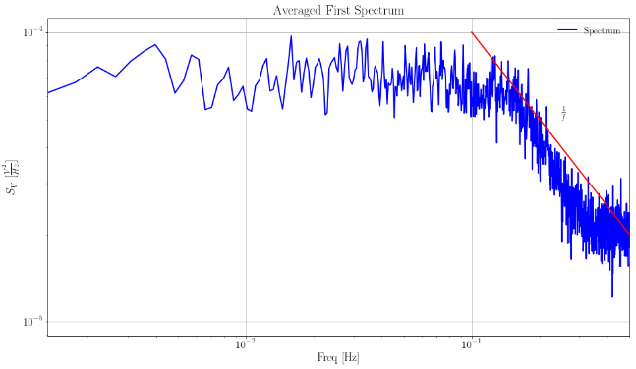

**Evaluate m271 (SR830, Vx)**

Montag, 3. Juni 2019

12:31

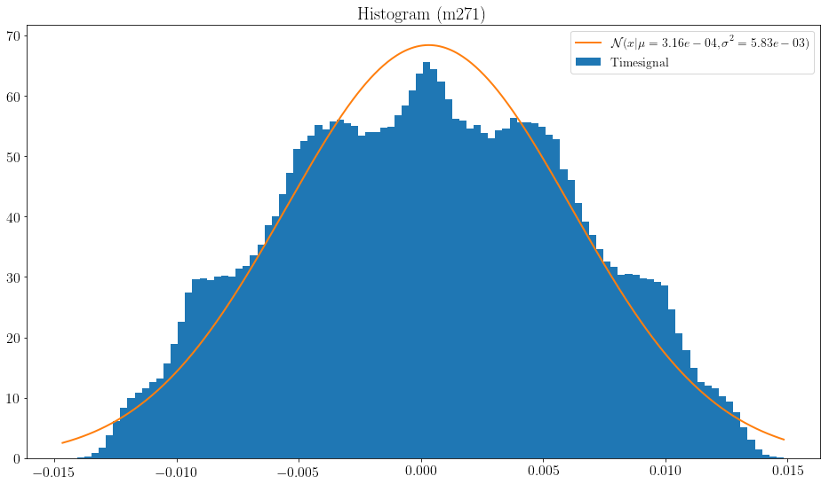

Averaged over 64 Spectra

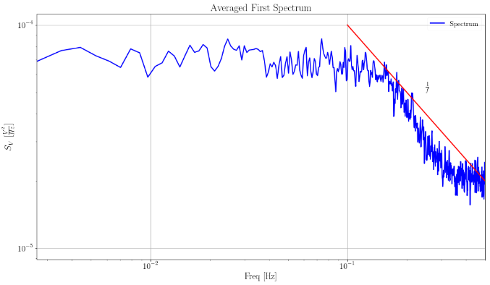

128 Spectra

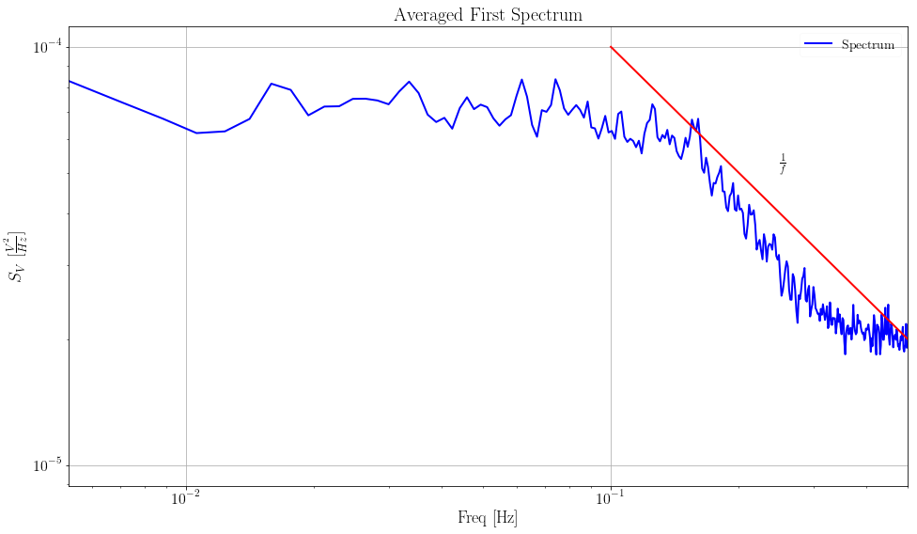

Averaged over 256 Spectra

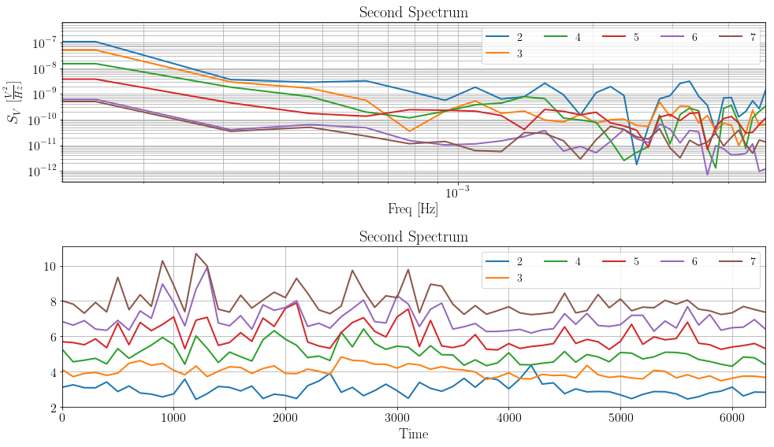

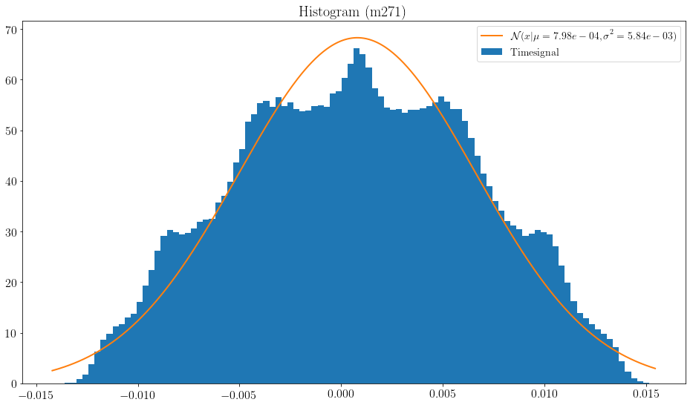

**Evaluate m271 (SR830, Vy)**

Montag, 3. Juni 2019

16:32

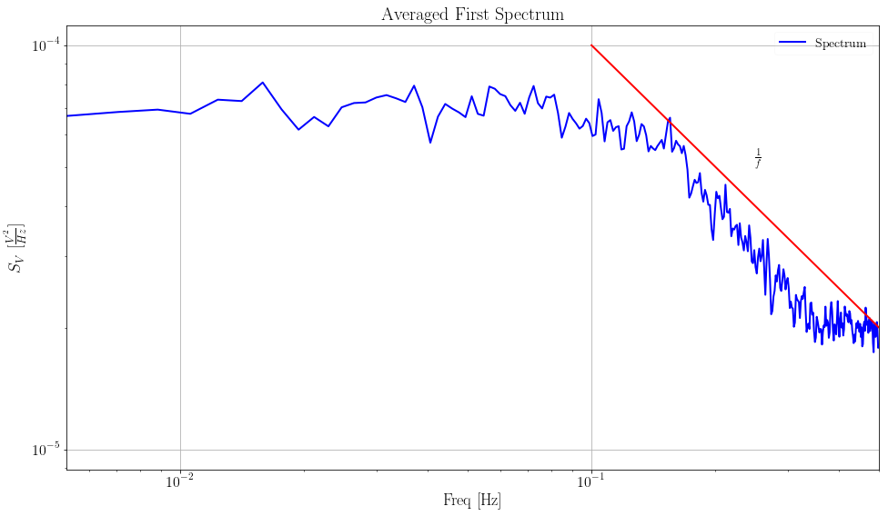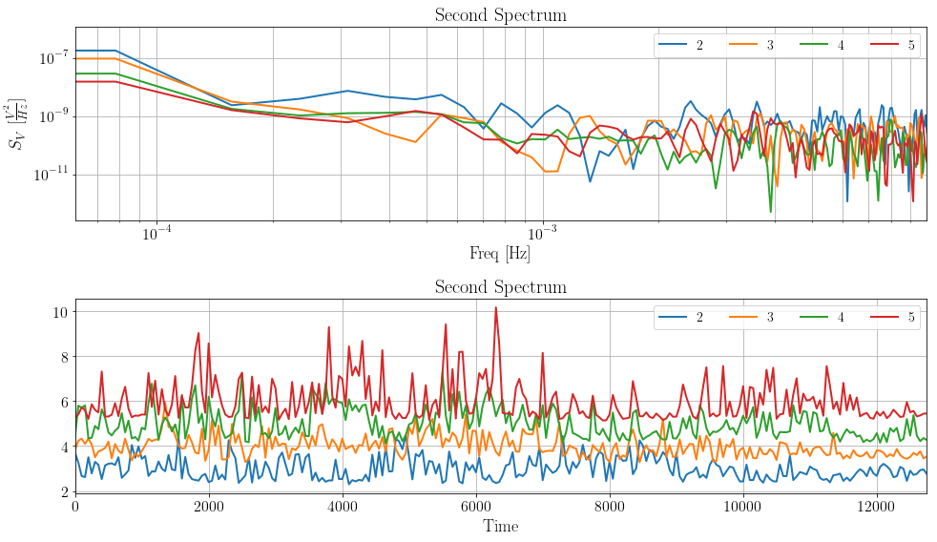

**Evaluate m271 (SR785)**

Montag, 3. Juni 2019

16:26

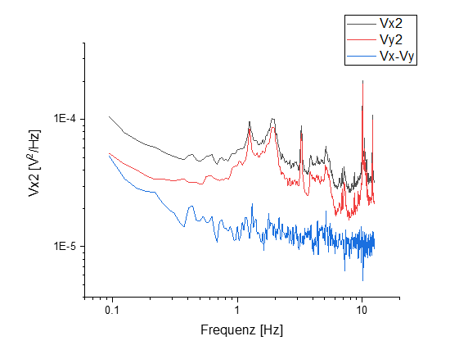

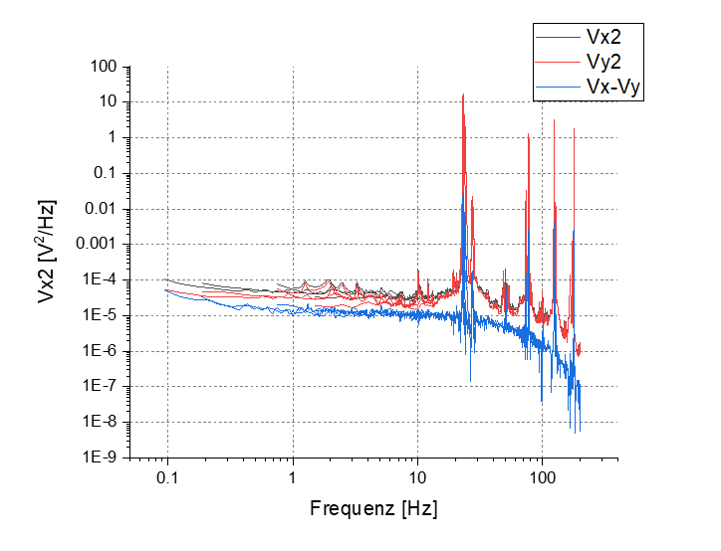

**m272: MFN\_Empty\_Gradio\_Background I=0V**

Montag, 3. Juni 2019

11:21

|  |  |
| --- | --- |
| Angle of sensor θ | *+10* |
|  |  |
|  |  |
|  | |  |  | | --- | --- | |  | *0.5 T Persistend Mode* | |
|  | R12 = 132/1000\*50 = 6,6  R13 = 45/1000\*10 = 0,45 |
|  |  |
| *Pre Amplifier (SR560)* | *Gain Mode: Low | Output: 50O -> Lock In Input A | Gain: 1e2*  Filter Cutoffs:  *Off | Coupling: AC* |
| *Signal Analyzer (SR785)* | |  |  |  |  | | --- | --- | --- | --- | | *Ch 1 (A)* |  | *Freq - Span:* | *100 Hz* | | *Ch 2 (A)* |  | *Averages:* | *100* | |
| *Period of measurement (min)* | *7 min* |
| *He (l) level consumption* |  |
| *Data files* | <<m272\_MFN\_SR785\_background.dat>> |
| *Plot* | Machine generated alternative text: *+31 40g274e  #+34g1  omi  F requenz [Hz] |
|  | Sensor 26  3um  Tetrahedral CoFe nanostructures  D  B  x  A and B: old square ASI |

**C: Changing angle (0) new Maximum 11,722 mv**

Dienstag, 2. April 2019

19:01

|  |  |
| --- | --- |
| Float/Ground: | Ground |
| AC/DC: | AC |
| A/A-B: | A-B |
| Reserve: | Normal |
| Source: | Internal |

|  |  |
| --- | --- |
| VH(max) (mV) | *11,164mV* |
| Angle of sensor calculator | **V\_H= Cos(0)\*11,164 = 11,164**  **Before changing: 10,962 mV**  **Measured: 11,722 mV** |
|  |  |
|  |  |
|  | |  |  | | --- | --- | |  | *1* | |
|  |  |

* + Some Test Measurements (Scaling \w 1.75 / 2.5 V): [m: MFN\_noise01/02](onenote:#m%20MFN_noise01\02&section-id={5FAD0518-E349-4A07-93E8-5D105BD4AEB4}&page-id={DD53CA68-3168-417B-8D5B-5DA5A37CC675}&end&base-path=https://goetheuniversitaet.sharepoint.com/sites/Project4/SiteAssets/Project%204%20Notebook/Magnetic%20Flux%20Noise.one)
    - Background at 0 V: [m: MFN\_noise03 Background](onenote:#m%20MFN_noise03%20Background&section-id={5FAD0518-E349-4A07-93E8-5D105BD4AEB4}&page-id={4A3CC5DC-27D5-470C-8277-8655C9CD237F}&end&base-path=https://goetheuniversitaet.sharepoint.com/sites/Project4/SiteAssets/Project%204%20Notebook/Magnetic%20Flux%20Noise.one)
    - Long Measurement: [m: MFN\_noise04 long over night](onenote:#m%20MFN_noise04%20long%20over%20night&section-id={5FAD0518-E349-4A07-93E8-5D105BD4AEB4}&page-id={40A345C2-FD42-467C-B7E4-680C7DE0B686}&end&base-path=https://goetheuniversitaet.sharepoint.com/sites/Project4/SiteAssets/Project%204%20Notebook/Magnetic%20Flux%20Noise.one)
    - Go To 4 V: [m:MFN\_noise05 morning by Jens](onenote:#mMFN_noise05%20morning%20by%20Jens&section-id={5FAD0518-E349-4A07-93E8-5D105BD4AEB4}&page-id={8003740D-E636-44D7-8CDC-BD1B494552CD}&end&base-path=https://goetheuniversitaet.sharepoint.com/sites/Project4/SiteAssets/Project%204%20Notebook/Magnetic%20Flux%20Noise.one)

|  |  |
| --- | --- |
| 2 T | [m: MFN\_noise06 morning 2T by Jens and Mohanad](onenote:#m%20MFN_noise06%20morning%202T%20by%20Jens%20and%20Mohanad&section-id={5FAD0518-E349-4A07-93E8-5D105BD4AEB4}&page-id={9C564204-87AA-4748-A058-A8C1E0BA8277}&end&base-path=https://goetheuniversitaet.sharepoint.com/sites/Project4/SiteAssets/Project%204%20Notebook/Magnetic%20Flux%20Noise.one) |
| 4 T | [m: MFN\_noise07 \_4T by Jens and Mohanad](onenote:#m%20MFN_noise07%20_4T%20by%20Jens%20and%20Mohanad&section-id={5FAD0518-E349-4A07-93E8-5D105BD4AEB4}&page-id={5F1FC1FB-AE0F-469D-9794-56C1ED676229}&end&base-path=https://goetheuniversitaet.sharepoint.com/sites/Project4/SiteAssets/Project%204%20Notebook/Magnetic%20Flux%20Noise.one) |
| .25 T | [m: MFN\_noise08 \_0.25T](onenote:#m%20MFN_noise08%20_0.25T&section-id={5FAD0518-E349-4A07-93E8-5D105BD4AEB4}&page-id={E94F79DD-2D0E-4380-9DCA-63F175F89023}&end&base-path=https://goetheuniversitaet.sharepoint.com/sites/Project4/SiteAssets/Project%204%20Notebook/Magnetic%20Flux%20Noise.one) |
| .025 T | [m: MFN\_noise09 \_0.025T\_over night](onenote:#m%20MFN_noise09%20_0.025T_over%20night&section-id={5FAD0518-E349-4A07-93E8-5D105BD4AEB4}&page-id={CF7A032D-2817-4BEB-B879-0E83462FE81A}&end&base-path=https://goetheuniversitaet.sharepoint.com/sites/Project4/SiteAssets/Project%204%20Notebook/Magnetic%20Flux%20Noise.one) |
| 0 T | [m: MFN\_noise10 \_0T](onenote:#m%20MFN_noise10%20_0T&section-id={5FAD0518-E349-4A07-93E8-5D105BD4AEB4}&page-id={69779FDC-4DDF-42E4-8E82-65A6014789EC}&end&base-path=https://goetheuniversitaet.sharepoint.com/sites/Project4/SiteAssets/Project%204%20Notebook/Magnetic%20Flux%20Noise.one) |

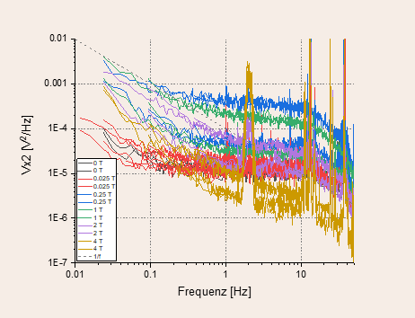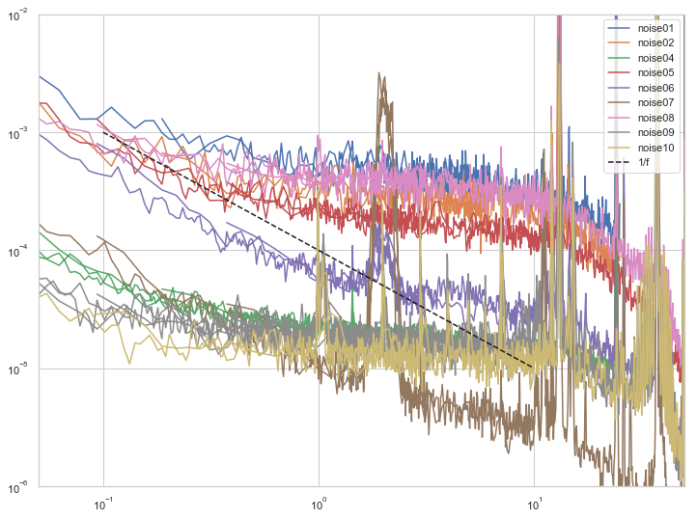

**MFN Measurements (0deg) perp**

Donnerstag, 13. Juni 2019

22:35

[m: MFN \_tests before solid measurments](onenote:#m%20MFN%20_tests%20before%20solid%20measurments&section-id={5FAD0518-E349-4A07-93E8-5D105BD4AEB4}&page-id={96AB3700-69EE-4737-926B-1E9E32CFD22F}&end&base-path=https://goetheuniversitaet.sharepoint.com/sites/Project4/SiteAssets/Project%204%20Notebook/Magnetic%20Flux%20Noise.one)

|  |  |  |  |  |  |
| --- | --- | --- | --- | --- | --- |
| Nr. | Structure | Magnetic Field (PM) | V\_in | Freq-Span [Hz] | Averages |
| [noise01/02](onenote:#m%20MFN_noise01\02&section-id={5FAD0518-E349-4A07-93E8-5D105BD4AEB4}&page-id={DD53CA68-3168-417B-8D5B-5DA5A37CC675}&end&base-path=https://goetheuniversitaet.sharepoint.com/sites/Project4/SiteAssets/Project%204%20Notebook/Magnetic%20Flux%20Noise.one) | C | 1 T | 2.5 / 1.75 | 25 / 6 | 25 |
| [03 Background](onenote:#m%20MFN_noise03%20Background&section-id={5FAD0518-E349-4A07-93E8-5D105BD4AEB4}&page-id={4A3CC5DC-27D5-470C-8277-8655C9CD237F}&end&base-path=https://goetheuniversitaet.sharepoint.com/sites/Project4/SiteAssets/Project%204%20Notebook/Magnetic%20Flux%20Noise.one) |  |  | 0 | 6 | 15 |
| [noise04 long](onenote:#m%20MFN_noise04%20long%20over%20night&section-id={5FAD0518-E349-4A07-93E8-5D105BD4AEB4}&page-id={40A345C2-FD42-467C-B7E4-680C7DE0B686}&end&base-path=https://goetheuniversitaet.sharepoint.com/sites/Project4/SiteAssets/Project%204%20Notebook/Magnetic%20Flux%20Noise.one) |  |  | 2.5 | *25 / 6 / 3 / 1* | 100 |
| [noise05](onenote:#mMFN_noise05%20morning%20by%20Jens&section-id={5FAD0518-E349-4A07-93E8-5D105BD4AEB4}&page-id={8003740D-E636-44D7-8CDC-BD1B494552CD}&end&base-path=https://goetheuniversitaet.sharepoint.com/sites/Project4/SiteAssets/Project%204%20Notebook/Magnetic%20Flux%20Noise.one) |  |  | 4 | *50/ 12.5/ 3.125* | 50 |
| [noise06](onenote:#m%20MFN_noise06%20morning%202T%20by%20Jens%20and%20Mohanad&section-id={5FAD0518-E349-4A07-93E8-5D105BD4AEB4}&page-id={9C564204-87AA-4748-A058-A8C1E0BA8277}&end&base-path=https://goetheuniversitaet.sharepoint.com/sites/Project4/SiteAssets/Project%204%20Notebook/Magnetic%20Flux%20Noise.one) |  | 2 T |  |  |  |
| [noise07](onenote:#m%20MFN_noise07%20_4T%20by%20Jens%20and%20Mohanad&section-id={5FAD0518-E349-4A07-93E8-5D105BD4AEB4}&page-id={5F1FC1FB-AE0F-469D-9794-56C1ED676229}&end&base-path=https://goetheuniversitaet.sharepoint.com/sites/Project4/SiteAssets/Project%204%20Notebook/Magnetic%20Flux%20Noise.one) |  | 4 T |  |  |  |
| [noise08](onenote:#m%20MFN_noise08%20_0.25T&section-id={5FAD0518-E349-4A07-93E8-5D105BD4AEB4}&page-id={E94F79DD-2D0E-4380-9DCA-63F175F89023}&end&base-path=https://goetheuniversitaet.sharepoint.com/sites/Project4/SiteAssets/Project%204%20Notebook/Magnetic%20Flux%20Noise.one) |  | 250 mT |  |  | 30 |
| [noise09](onenote:#m%20MFN_noise09%20_0.025T_over%20night&section-id={5FAD0518-E349-4A07-93E8-5D105BD4AEB4}&page-id={CF7A032D-2817-4BEB-B879-0E83462FE81A}&end&base-path=https://goetheuniversitaet.sharepoint.com/sites/Project4/SiteAssets/Project%204%20Notebook/Magnetic%20Flux%20Noise.one) |  | 25 mT |  | *100 / 50 / 25 / 12.5 / 6.25 / 3.125 / 1.5625* |  |
| [noise10](onenote:#m%20MFN_noise10%20_0T&section-id={5FAD0518-E349-4A07-93E8-5D105BD4AEB4}&page-id={69779FDC-4DDF-42E4-8E82-65A6014789EC}&end&base-path=https://goetheuniversitaet.sharepoint.com/sites/Project4/SiteAssets/Project%204%20Notebook/Magnetic%20Flux%20Noise.one) |  | 0 T |  |  |  |

[m273: CrossesEmpty\_Parallel Hloop\_(0)deg\_MFN edition](onenote:#m273%20CrossesEmpty_Parallel%20Hloop_(0)deg_MFN%20edition&section-id={5FAD0518-E349-4A07-93E8-5D105BD4AEB4}&page-id={D6D252C7-EEBD-4950-9F50-114743BB7A54}&end&base-path=https://goetheuniversitaet.sharepoint.com/sites/Project4/SiteAssets/Project%204%20Notebook/Magnetic%20Flux%20Noise.one) (Hysteresis Loop Crosses and Empty #1)

**m: MFN \_tests before solid measurments**

Dienstag, 4. Juni 2019

15:51

|  |  |
| --- | --- |
| Angle of sensor θ | *+10* |
|  |  |
|  | |  |  |  |  | | --- | --- | --- | --- | |  | ***2 - 12*** |  | ***10 - 5*** | | ***Gate (0V)*** | ***9 - 4*** |  | ***14 - 7*** | |
|  | |  |  | | --- | --- | |  | *1 T Persistend Mode* | | *V\_x Balance* | *mV* | | *V\_y Balance* | *mV* | |
|  |  |
|  | |  |  |  |  |  |  | | --- | --- | --- | --- | --- | --- | | Sens | 20 mV |  | 2.5 V | T | 30 K | |  | *1 MΩ* |  | 5,1 kΩ |  | 610 Ω | |  | *1 MΩ* |  | *5* |  | *8* | | *τ* | *1 ms* | *Input A* | *AC* | *Ground* | *Normal Reserve* | | *f* | *113 Hz* |  |  |  |  | |
| *Pre Amplifier (SR560)* | |  |  |  |  | | --- | --- | --- | --- | | *Gain Mode* | *Low* | *Gain:* | *1e2* | | *Coupling* | *AC* | *Output (50Ω)* | *LI Input A* | | *Filters:* | *Off* |  |  | |
| *Signal Analyzer (SR785)* | |  |  |  |  | | --- | --- | --- | --- | | *Ch 1 (A)* |  | *Freq - Span:* | *50Hz* | | *Ch 2 (A)* |  | *Averages:* | *15* | |
| *Period of measurement (min)* | *min* |
| *He (l) level consumption* |  |
| *Data files* |  |
| *Plot* |  |

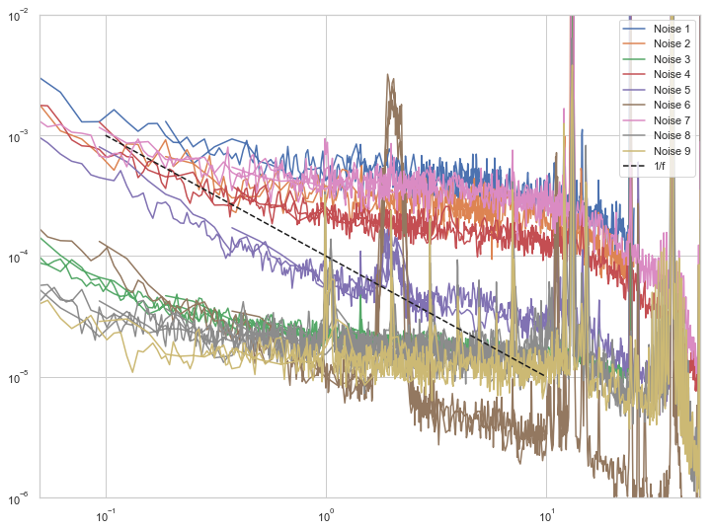

**m: MFN\_noise01/02**

Dienstag, 4. Juni 2019

16:34

|  |  |
| --- | --- |
| Angle of sensor θ | *+0* |
|  |  |
|  | |  |  |  |  | | --- | --- | --- | --- | |  | ***2 - 12*** |  | ***6 - 8*** | | ***Gate (0V)*** | ***9 - 4*** |  | ***14 - 7*** | |
|  | |  |  | | --- | --- | |  | *1 T Persistend Mode* | |
|  |  |
|  | |  |  |  |  |  |  | | --- | --- | --- | --- | --- | --- | | Sens | 2 mV |  | 2.5 V / 1.75 | T | 30 K | |  | *1 MΩ* |  | 5,1 kΩ |  | 450 Ω | |  | *1 MΩ* |  | *5* |  | *8* | | *τ* | *1 ms* | *Input A* | *AC* | *Ground* | *Normal Reserve* | |
| *Pre Amplifier (SR560)* | |  |  |  |  | | --- | --- | --- | --- | | *Gain Mode* | *Low* | *Gain:* | *1e1* | | *Coupling* | *AC* | *Output (50Ω)* | *LI Input A* | | *Filters:* | *Off* |  |  | |
| *Signal Analyzer (SR785)* | |  |  |  |  | | --- | --- | --- | --- | | *Ch 1 (A)* |  | *Freq - Span:* | *25 / 6 Hz* | | *Ch 2 (A)* |  | *Averages:* | *25* | |
| *Period of measurement (min)* | *min* |
| *He (l) level consumption* |  |
| *Data files* | *Noise01: V = 2.5 V*  *Noise02: V = 1.75 V* |
| *Plot* |  |

<<noise02.dat>>

<<noise01.dat>>

**m: MFN\_noise03 Background**

Dienstag, 4. Juni 2019

16:34

|  |  |
| --- | --- |
| Angle of sensor θ | *+0* |
|  |  |
|  | |  |  |  |  | | --- | --- | --- | --- | |  | ***2 - 12*** |  | ***6 - 8*** | | ***Gate (0V)*** | ***9 - 4*** |  | ***14 - 7*** | |
|  | |  |  | | --- | --- | |  | *1 T Persistend Mode* | |
|  |  |
|  | |  |  |  |  |  |  | | --- | --- | --- | --- | --- | --- | | Sens | 2 mV |  | 0 V | T | 30 K | |  | *1 MΩ* |  | 5,1 kΩ |  | 450 Ω | |  | *1 MΩ* |  | *5* |  | *8* | | *τ* | *1 ms* | *Input A* | *AC* | *Ground* | *Normal Reserve* | |
| *Pre Amplifier (SR560)* | |  |  |  |  | | --- | --- | --- | --- | | *Gain Mode* | *Low* | *Gain:* | *1e1* | | *Coupling* | *AC* | *Output (50Ω)* | *LI Input A* | | *Filters:* | *Off* |  |  | |
| *Signal Analyzer (SR785)* | |  |  |  |  | | --- | --- | --- | --- | | *Ch 1 (A)* |  | *Freq - Span:* | *6 Hz* | | *Ch 2 (A)* |  | *Averages:* | *15* | |
| *Period of measurement (min)* | *min* |
| *He (l) level consumption* |  |
| *Data files* | <<noise03\_bg.dat>> |
| *Plot* |  |

**m: MFN\_noise04 long over night**

Dienstag, 4. Juni 2019

18:25

|  |  |
| --- | --- |
| Angle of sensor θ | *+0* |
|  |  |
|  | |  |  |  |  | | --- | --- | --- | --- | |  | ***2 - 12*** |  | ***6 - 8*** | | ***Gate (0V)*** | ***9 - 4*** |  | ***14 - 7*** | |
|  | |  |  | | --- | --- | |  | *1 T Persistend Mode* | |
|  |  |
|  | |  |  |  |  |  |  | | --- | --- | --- | --- | --- | --- | | Sens | 5 mV |  | 2.5 V | T | 30 K | |  | *1 MΩ* |  | 5,1 kΩ |  | 450 Ω | |  | *1 MΩ* |  | *5* |  | *8* | | *τ* | *1 ms* | *Input A* | *AC* | *Ground* | *Normal Reserve* | |
| *Pre Amplifier (SR560)* | |  |  |  |  | | --- | --- | --- | --- | | *Gain Mode* | *Low* | *Gain:* | *1e1* | | *Coupling* | *AC* | *Output (50Ω)* | *LI Input A* | | *Filters:* | *Off* |  |  | |
| *Signal Analyzer (SR785)* | |  |  |  |  | | --- | --- | --- | --- | | *Ch 1 (A)* |  | *Freq - Span:* | *25 / 6 / 3 / 1 Hz* | | *Ch 2 (A)* |  | *Averages:* | *100* | |
| *Lock in SR830* | |  |  | | --- | --- | | *Status of saving data* | *ON* | | *Reading and saving time in EVE* | *0.1s* | |
| *Period of measurement (min)* | *770 min* |
| *He (l) level consumption* |  |
| *Data files* | <<noise04\_SR830.dat>>    <<noise04.dat>> |
| *Note:* | *Jens started new measurment 5\_ without noticing that the SR830 is still measureing I stoped it at 9:20 am* |

**m:MFN\_noise05 morning by Jens**

Mittwoch, 5. Juni 2019

09:18

|  |  |
| --- | --- |
| Angle of sensor θ | *+0* |
|  |  |
|  | |  |  |  |  | | --- | --- | --- | --- | |  | ***2 - 12*** |  | ***6 - 8*** | | ***Gate (0V)*** | ***9 - 4*** |  | ***14 - 7*** | |
|  | |  |  | | --- | --- | |  | *1 T Persistend Mode* | |
|  |  |
|  | |  |  |  |  |  |  | | --- | --- | --- | --- | --- | --- | | Sens | 5 mV |  | 4 V | T | 30 K | |  | *1 MΩ* |  | 5,1 kΩ |  | 450 Ω | |  | *1 MΩ* |  | *5* |  | *8* | | *τ* | *3 ms* | *Input A* | *AC* | *Ground* | *Normal Reserve* | |
| *Pre Amplifier (SR560)* | |  |  |  |  | | --- | --- | --- | --- | | *Gain Mode* | *Low* | *Gain:* | *1e1* | | *Coupling* | *AC* | *Output (50Ω)* | *LI Input A* | | *Filters:* | *Off* |  |  | |
| *Signal Analyzer (SR785)* | |  |  |  |  | | --- | --- | --- | --- | | *Ch 1 (A)* |  | *Freq - Span:* | *50/ 12.5/ 3.125 Hz* | | *Ch 2 (A)* |  | *Averages:* | *50* | |
| *Period of measurement (min)* | *About 2 hours* |
| *He (l) level consumption* |  |
| *Data files* | <<noise05.dat>> |
| *Plot* | Machine generated alternative text: Frequer2 {HzJ  100 |

**m: MFN\_noise06 morning 2T by Jens and Mohanad**

Mittwoch, 5. Juni 2019

11:36

|  |  |
| --- | --- |
| Angle of sensor θ | *+0* |
|  |  |
|  | |  |  |  |  | | --- | --- | --- | --- | |  | ***2 - 12*** |  | ***6 - 8*** | | ***Gate (0V)*** | ***9 - 4*** |  | ***14 - 7*** | |
|  | |  |  | | --- | --- | |  | *going to 2T Persistend Mode ( we have to re-balance the signal.* | |
|  |  |
|  | |  |  |  |  |  |  | | --- | --- | --- | --- | --- | --- | | Sens | 5 mV |  | 4 V | T | 30 K | |  | *1 MΩ* |  | 2.85 kΩ |  | 0 Ω | |  | *1 MΩ* |  | *5* |  | *8* | | *τ* | *3 ms* | *Input A* | *AC* | *Ground* | *Normal Reserve* | |
| *Pre Amplifier (SR560)* | |  |  |  |  | | --- | --- | --- | --- | | *Gain Mode* | *Low* | *Gain:* | *1e1* | | *Coupling* | *AC* | *Output (50Ω)* | *LI Input A* | | *Filters:* | *Off* |  |  | |
| *Signal Analyzer (SR785)* | |  |  |  |  | | --- | --- | --- | --- | | *Ch 1 (A)* |  | *Freq - Span:* | *50/ 12.5/ 3.125 Hz* | | *Ch 2 (A)* |  | *Averages:* | *50* | |
| *Period of measurement (min)* | *About 2 hours* |
| *He (l) level consumption* |  |
| *Data files* | <<noise06.dat>> |
| *Plot* | Machine generated alternative text: omi  F 'Equerr IHzJ |

**m: MFN\_noise07 \_4T by Jens and Mohanad**

Mittwoch, 5. Juni 2019

15:30

|  |  |
| --- | --- |
| Angle of sensor θ | *+0* |
|  |  |
|  | |  |  |  |  | | --- | --- | --- | --- | |  | ***2 - 12*** |  | ***6 - 8*** | | ***Gate (0V)*** | ***9 - 4*** |  | ***14 - 7*** | |
|  | |  |  | | --- | --- | |  | *going to 4T Persistend Mode ( we have to re-balance the signal.* | |
|  |  |
|  | |  |  |  |  |  |  | | --- | --- | --- | --- | --- | --- | | Sens | 20 mV ? |  | 4 V | T | 30 K | |  | *1 MΩ* |  | 3,4 kΩ |  | 0 Ω | |  | *1 MΩ* |  | *5* |  | *8* | | *τ* | *3 ms* | *Input A* | *AC* | *Ground* | *Normal Reserve* | |
| *Pre Amplifier (SR560)* | |  |  |  |  | | --- | --- | --- | --- | | *Gain Mode* | *Low* | *Gain:* | *1e1* | | *Coupling* | *AC* | *Output (50Ω)* | *LI Input A* | | *Filters:* | *Off* |  |  | |
| *Signal Analyzer (SR785)* | |  |  |  |  | | --- | --- | --- | --- | | *Ch 1 (A)* |  | *Freq - Span:* | *50/ 12.5/ 3.125 Hz* | | *Ch 2 (A)* |  | *Averages:* | *30* | |
| *Period of measurement (min)* | *About 2 hours* |
| *He (l) level consumption* |  |
| *Data files* | <<noise07.dat>> |
| *Plot* | Machine generated alternative text: oot  185  F requenz [Hz] |

**m: MFN\_noise08 \_0.25T**

Mittwoch, 5. Juni 2019

16:34

|  |  |
| --- | --- |
| Angle of sensor θ | *+0* |
|  |  |
|  | |  |  |  |  | | --- | --- | --- | --- | |  | ***2 - 12 crosses*** |  | ***6 - 8*** | | ***Gate (0V)*** | ***9 - 4*** |  | ***14 - 7*** | |
|  | |  |  | | --- | --- | |  | *going to 0.25T Persistend Mode ( we have to re-balance the signal.* | |
|  |  |
|  | |  |  |  |  |  |  | | --- | --- | --- | --- | --- | --- | | Sens | 500 µV |  | 4 V | T | 30 K | |  | *1 MΩ* |  | 15 kΩ |  | 0 Ω | |  | *1 MΩ* |  | *5* |  | *8* | | *τ* | *3 ms* | *Input A* | *AC* | *Ground* | *Normal Reserve* | | *f* | *113 Hz* |  |  |  |  | |
| *Pre Amplifier (SR560)* | |  |  |  |  | | --- | --- | --- | --- | | *Gain Mode* | *Low* | *Gain:* | *1e1* | | *Coupling* | *AC* | *Output (50Ω)* | *LI Input A* | | *Filters:* | *Off* |  |  | |
| *Signal Analyzer (SR785)* | |  |  |  |  | | --- | --- | --- | --- | | *Ch 1 (A)* |  | *Freq - Span:* | *50/ 12.5/ 3.125 Hz* | | *Ch 2 (A)* |  | *Averages:* | *30* | |
| *Period of measurement (min)* | *84* |
| *He (l) level consumption* |  |
| *Data files* | <<noise08\_.dat>> |
| *Plot* | Machine generated alternative text: *0101  184  F requenz [Hz] |

**Filling He(l)**

Mittwoch, 5. Juni 2019

18:16

|  |  |
| --- | --- |
| Filling date | 05.06.2019 |
| Before (in) | 23.23 |
| After (in) | 36.22 |
| consumption | Around 60 L |
| Person | MAM |

Notes:



'To do:

**m: MFN\_noise09 \_0.025T\_over night**

Mittwoch, 5. Juni 2019

19:05

|  |  |
| --- | --- |
| Angle of sensor θ | *+0* |
|  |  |
|  | |  |  |  |  | | --- | --- | --- | --- | |  | ***2 - 12 crosses*** |  | ***6 - 8*** | | ***Gate (0V)*** | ***9 - 4*** |  | ***14 - 7*** | |
|  | |  |  | | --- | --- | |  | *going to 0.025T Persistend Mode ( we have to re-balance the signal.* | |
|  |  |
|  | |  |  |  |  |  |  | | --- | --- | --- | --- | --- | --- | | Sens | 500 µV |  | 4 V | T | 30 K | |  | *1 MΩ* |  | 50kΩ |  | 0 Ω | |  | *1 MΩ* |  | *5* |  | *10* | | *τ* | *3 ms* | *Input A* | *AC* | *Ground* | *Normal Reserve* | | *f* | *113 Hz* |  |  |  |  | |
| *Pre Amplifier (SR560)* | |  |  |  |  | | --- | --- | --- | --- | | *Gain Mode* | *Low* | *Gain:* | *1e1* | | *Coupling* | *AC* | *Output (50Ω)* | *LI Input A* | | *Filters:* | *Off* |  |  | |
| *Signal Analyzer (SR785)* | |  |  |  |  | | --- | --- | --- | --- | | *Ch 1 (A)* |  | *Freq - Span:* | *100/50/25/12.5/6.25/3.125/1.5625 Hz* | | *Ch 2 (A)* |  | *Averages:* | *30* | |
| *Period of measurement (min)* | *254 min over the night* |
| *He (l) level consumption* |  |
| *Data files* | <<noise09\_.dat>> |
| *Plot* | Machine generated alternative text: 001  Soon  ne7  F requerz |

**m: MFN\_noise10 \_0T**

Mittwoch, 5. Juni 2019

16:34

|  |  |
| --- | --- |
| Angle of sensor θ | *+0* |
|  |  |
|  | |  |  |  |  | | --- | --- | --- | --- | |  | ***2 - 12 crosses*** |  | ***6 - 8*** | | ***Gate (0V)*** | ***9 - 4*** |  | ***14 - 7*** | |
|  | |  |  | | --- | --- | |  | *going to 0* | |
|  |  |
|  | |  |  |  |  |  |  | | --- | --- | --- | --- | --- | --- | | Sens | 500 µV |  | 4 V | T | 30 K | |  | *1 MΩ* |  | 50 kΩ |  | 0 Ω | |  | *1 MΩ* |  | *5* |  | *10* | | *τ* | *3 ms* | *Input A* | *AC* | *Ground* | *Normal Reserve* | | *f* | *113 Hz* |  |  |  |  | |
| *Pre Amplifier (SR560)* | |  |  |  |  | | --- | --- | --- | --- | | *Gain Mode* | *Low* | *Gain:* | *1e1* | | *Coupling* | *AC* | *Output (50Ω)* | *LI Input A* | | *Filters:* | *Off* |  |  | |
| *Signal Analyzer (SR785)* | |  |  |  |  | | --- | --- | --- | --- | | *Ch 1 (A)* |  | *Freq - Span:* | *50/ 12.5/ 3.125 Hz* | | *Ch 2 (A)* |  | *Averages:* | *30* | |
| *Period of measurement (min)* | *84* |
| *He (l) level consumption* |  |
| *Data files* | <<noise10.dat>> |
| *Plot* | Machine generated alternative text: — 004  F requetz |

**m273:** CrossesEmpty\_Parallel Hloop\_(0)deg\_MFN edition

Donnerstag, 6. Juni 2019

10:09

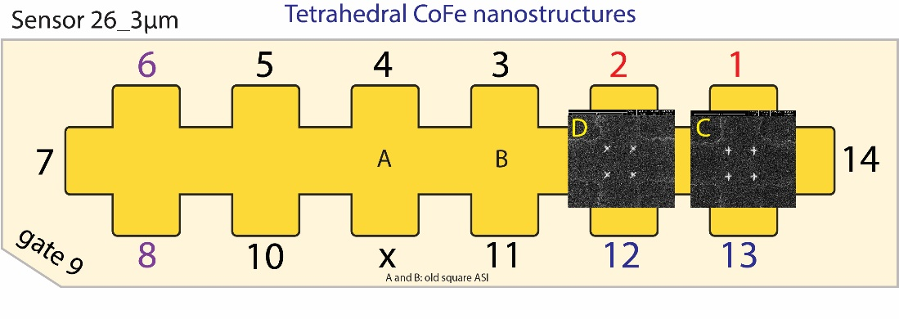

|  |  |
| --- | --- |
| Float/Ground: | Ground |
| AC/DC: | AC |
| A/A-B: | A-B |
| Reserve: | Normal |
| Source: | Internal |

|  |  |
| --- | --- |
| Angle of sensor θ | *0* |
|  |  |
|  |  |
|  | |  |  | | --- | --- | |  | *1* | |  | 1000 | |
|  | R12 = 40/1000\*50 = |
|  |  |
| *Period of measurement (min)* |  |
| *Notes* | Instruments Help  Single Measurements  5R830 111  Scheduled Measurements  X 5R830 11  Instruments  x  5R830  Offsets  Options  Vx [rnV]  Ampl 4  Sensitivity  Autosens  O  Internal  External  5R830  Options  Vx [rnV]  Ampl 4  Sensitivity  Autosens  Offsets  O  Internal  External  5R830 1  5R830  Options  Vx [rnV]  Ampl 2500  Sensitivity  Autosens  X IP51201  Offsets  Goto Set  Initialize  Internal  persistent mode  O  External  Setpoint [T]  Rate [T Imin]  300000  300000  IP5120 1  Goto Set  Goto Zero  No overload + only incr.  No overload + only incr.  No overload + only incr.  15340 Janis 1  *Here, we have measure Hall signal only for the Crosses and the empty cross since there is no free Lock-in for the plusses* |
| *Data files* | <<m273\_cros\_\_emp\_0deg\_Hloop\_down\_Parallel\_20190606\_1000\_I-7-14\_GB8-1-13\_GB9-2-12\_GB13-6-8\_Vin-2.5V\_R11-1MO\_C11-1\_C21-6\_T-30K\_SR-0.5-T-min\_B-1T\_gate-0V\_MFN edition.dat>>    <<m273\_cros\_\_emp\_0deg\_Hloop\_up\_Parallel\_20190606\_1000\_I-7-14\_GB8-1-13\_GB9-2-12\_GB13-6-8\_Vin-2.5V\_R11-1MO\_C11-1\_C21-6\_T-30K\_SR-0.5-T-min\_B-1T\_gate-0V\_MFN edition.dat>> |
| *Plot* |  |





**C: Changing angle (90) no Hall effect\_MFN edition**

Donnerstag, 6. Juni 2019

10:42

|  |  |
| --- | --- |
| Float/Ground: | Ground |
| AC/DC: | AC |
| A/A-B: | A-B |
| Reserve: | Normal |
| Source: | Internal |

|  |  |
| --- | --- |
| VH(max) (mV) | *11,164mV* |
| Angle of sensor calculator | **V\_H= Cos(90)\*11,164 =**  **Before changing: 11.693 mV**  **Measured: 0.001 mV**  **Cos(0)=1**  **Cos(90)=0** |
|  |  |
|  |  |
|  | |  |  | | --- | --- | |  | *1* | |
|  |  |

**measurements at 90deg (static field)**

Donnerstag, 6. Juni 2019

10:42

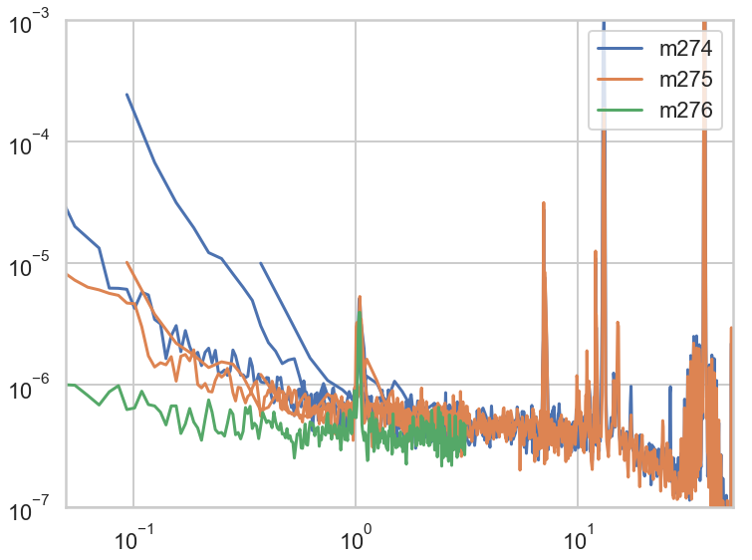

|  |  |  |  |  |  |
| --- | --- | --- | --- | --- | --- |
| Nr | Structure | Field (PM) [T] | freq-span [Hz] | avg | Gain |
| [m274](onenote:#m274%20MFN_noise%20test_N11%20_1T_90deg_crosses&section-id={5FAD0518-E349-4A07-93E8-5D105BD4AEB4}&page-id={85134F9D-A0E5-414B-9237-9770CE05279F}&end&base-path=https://goetheuniversitaet.sharepoint.com/sites/Project4/SiteAssets/Project%204%20Notebook/Magnetic%20Flux%20Noise.one) | C | 1 | *50/ 12.5/ 3.125* | 30 | 20 |
| [m275](onenote:#m275%20MFN_noise%20test_N12%20_1T_90deg_empty&section-id={5FAD0518-E349-4A07-93E8-5D105BD4AEB4}&page-id={B2B5911E-F781-48FF-B500-33A148753C93}&end&base-path=https://goetheuniversitaet.sharepoint.com/sites/Project4/SiteAssets/Project%204%20Notebook/Magnetic%20Flux%20Noise.one) | #1 | 1 |  |  |  |
| [m276](onenote:#m276%20MFN_noise%20test_N13_second_empty&section-id={5FAD0518-E349-4A07-93E8-5D105BD4AEB4}&page-id={06B2AE2E-7AD0-461A-B794-A66F3EA634AD}&end&base-path=https://goetheuniversitaet.sharepoint.com/sites/Project4/SiteAssets/Project%204%20Notebook/Magnetic%20Flux%20Noise.one) | #2 |  |  |  |  |
| [m277](onenote:#m277%20MFN_noise%20test_N14%20_4T_crosses&section-id={5FAD0518-E349-4A07-93E8-5D105BD4AEB4}&page-id={5F2615E8-6003-41AB-BE6F-77D517DA7FAD}&end&base-path=https://goetheuniversitaet.sharepoint.com/sites/Project4/SiteAssets/Project%204%20Notebook/Magnetic%20Flux%20Noise.one) | C | 4 |  |  |  |
| [m278](onenote:#m278%20MFN_4T_1&section-id={5FAD0518-E349-4A07-93E8-5D105BD4AEB4}&page-id={8D015CA0-2CBE-45A6-9800-0BD24EF5006A}&end&base-path=https://goetheuniversitaet.sharepoint.com/sites/Project4/SiteAssets/Project%204%20Notebook/Magnetic%20Flux%20Noise.one) | #1 |  |  |  |  |
| [m279](onenote:#m279%20MFN_4T_crosses_over%20night%20wide-ranging%20spans&section-id={5FAD0518-E349-4A07-93E8-5D105BD4AEB4}&page-id={A61F9C79-D8F9-4B8C-A786-91BFF0D24482}&end&base-path=https://goetheuniversitaet.sharepoint.com/sites/Project4/SiteAssets/Project%204%20Notebook/Magnetic%20Flux%20Noise.one) | C |  | + 1.5 (Long) |  |  |
| [m280](onenote:#m280%20MFN_0T_crosses_&section-id={5FAD0518-E349-4A07-93E8-5D105BD4AEB4}&page-id={AA59282F-2C5C-4BBA-80A7-D964F7C8242B}&end&base-path=https://goetheuniversitaet.sharepoint.com/sites/Project4/SiteAssets/Project%204%20Notebook/Magnetic%20Flux%20Noise.one) | C | 0 |  |  |  |
| [m281](onenote:#m281%20MFN_0T_Plusses_&section-id={5FAD0518-E349-4A07-93E8-5D105BD4AEB4}&page-id={738B923B-5F18-41B5-9E1E-41A46844A69C}&end&base-path=https://goetheuniversitaet.sharepoint.com/sites/Project4/SiteAssets/Project%204%20Notebook/Magnetic%20Flux%20Noise.one) | P |  |  |  |  |
| [m282](onenote:#m282%20MFN_-9.4mT_Down%20sweep_Plusses_&section-id={5FAD0518-E349-4A07-93E8-5D105BD4AEB4}&page-id={0D746806-D6CF-463C-B3AE-FB65D0A46F91}&end&base-path=https://goetheuniversitaet.sharepoint.com/sites/Project4/SiteAssets/Project%204%20Notebook/Magnetic%20Flux%20Noise.one) | P | -9.4 mT (down) |  |  |  |
| [m283](onenote:#m283%20MFN_-9.4mT_Down%20sweep_Crosses_&section-id={5FAD0518-E349-4A07-93E8-5D105BD4AEB4}&page-id={A04F5CA6-03C9-421B-8EA0-FE8CBEE77FAC}&end&base-path=https://goetheuniversitaet.sharepoint.com/sites/Project4/SiteAssets/Project%204%20Notebook/Magnetic%20Flux%20Noise.one) | C |  |  |  |  |
| [m286](onenote:#m286%20MFN_-2.824mT_Down%20sweep_Plusses_&section-id={5FAD0518-E349-4A07-93E8-5D105BD4AEB4}&page-id={D7DC7B99-8B46-44A3-8219-50ED11D97FD6}&end&base-path=https://goetheuniversitaet.sharepoint.com/sites/Project4/SiteAssets/Project%204%20Notebook/Magnetic%20Flux%20Noise.one) | P | -2.824 mT (down) |  |  |  |
| [m287](onenote:#m287%20MFN_-0.0063T_Down%20sweep_Plusses_&section-id={5FAD0518-E349-4A07-93E8-5D105BD4AEB4}&page-id={6758F13C-D8E0-4D9B-881E-0AB49234F68A}&end&base-path=https://goetheuniversitaet.sharepoint.com/sites/Project4/SiteAssets/Project%204%20Notebook/Magnetic%20Flux%20Noise.one) | P | -0.0063 T |  |  |  |
| [m288](onenote:#m288%20MFN_0.01247T_Down%20sweep_Plusses_&section-id={5FAD0518-E349-4A07-93E8-5D105BD4AEB4}&page-id={C7DF7A34-AC67-4241-964D-052D90D208AC}&end&base-path=https://goetheuniversitaet.sharepoint.com/sites/Project4/SiteAssets/Project%204%20Notebook/Magnetic%20Flux%20Noise.one) | P | 0.01247 |  |  |  |
| [m289](onenote:#m289%20MFN_0.015T_down%20sweep_Plusses_&section-id={5FAD0518-E349-4A07-93E8-5D105BD4AEB4}&page-id={D1509BE5-6789-44AE-8B5D-1B9F9CB432D0}&end&base-path=https://goetheuniversitaet.sharepoint.com/sites/Project4/SiteAssets/Project%204%20Notebook/Magnetic%20Flux%20Noise.one) | P | 0.015 |  |  |  |
| [m290](onenote:#m290%20MFN_0.03T_down%20sweep_Plusses_&section-id={5FAD0518-E349-4A07-93E8-5D105BD4AEB4}&page-id={D6D5E663-A423-47A2-808D-20F096D121AA}&end&base-path=https://goetheuniversitaet.sharepoint.com/sites/Project4/SiteAssets/Project%204%20Notebook/Magnetic%20Flux%20Noise.one) | P | 0.03 |  |  |  |
| [m291](onenote:#m291%20MFN_-0.57246T_down%20sweep_Plusses_overight%20%20most%20f-spans&section-id={5FAD0518-E349-4A07-93E8-5D105BD4AEB4}&page-id={B76F6E94-661C-44E3-8A49-89E4FAB796D2}&end&base-path=https://goetheuniversitaet.sharepoint.com/sites/Project4/SiteAssets/Project%204%20Notebook/Magnetic%20Flux%20Noise.one) | P | -0.57246 | + 1.5 / 0.8 (Long) |  |  |
| [m292](onenote:#m292%20MFN_-0.10422T_down%20sweep_Plusses&section-id={5FAD0518-E349-4A07-93E8-5D105BD4AEB4}&page-id={A3176DC8-A0B0-49A5-A60B-9BA3198EF9C2}&end&base-path=https://goetheuniversitaet.sharepoint.com/sites/Project4/SiteAssets/Project%204%20Notebook/Magnetic%20Flux%20Noise.one) | P | -0.10422 |  |  |  |
| [m293](onenote:#m293%20MFN_-4T_Plusses&section-id={5FAD0518-E349-4A07-93E8-5D105BD4AEB4}&page-id={3F3DB3E2-8FD4-467A-ACB9-701F4624860C}&end&base-path=https://goetheuniversitaet.sharepoint.com/sites/Project4/SiteAssets/Project%204%20Notebook/Magnetic%20Flux%20Noise.one) | P | -4 |  |  |  |
| [m294](onenote:#m294%20MFN_-4T_Crosses&section-id={5FAD0518-E349-4A07-93E8-5D105BD4AEB4}&page-id={4CBA40F4-603C-4857-9E41-0F00BC090E6A}&end&base-path=https://goetheuniversitaet.sharepoint.com/sites/Project4/SiteAssets/Project%204%20Notebook/Magnetic%20Flux%20Noise.one) | C | -4 |  |  |  |
| [m295](onenote:#m295%20MFN_-4T_empty%20cross%206-8&section-id={5FAD0518-E349-4A07-93E8-5D105BD4AEB4}&page-id={9C68142E-9DBB-4CE9-A930-E8D43F9A18E5}&end&base-path=https://goetheuniversitaet.sharepoint.com/sites/Project4/SiteAssets/Project%204%20Notebook/Magnetic%20Flux%20Noise.one) | #1 | -4 |  |  |  |
| [m296](onenote:#m296%20MFN_-4T_empty%20cross%205-10&section-id={5FAD0518-E349-4A07-93E8-5D105BD4AEB4}&page-id={2837BCBD-DE9C-46EF-8BFB-F85BD93B237D}&end&base-path=https://goetheuniversitaet.sharepoint.com/sites/Project4/SiteAssets/Project%204%20Notebook/Magnetic%20Flux%20Noise.one) | #2 | -4 |  |  |  |
| [m297](onenote:#m297%20MFN_-2.824mT_down%20sweep_Crosses_&section-id={5FAD0518-E349-4A07-93E8-5D105BD4AEB4}&page-id={6DF91419-B1B1-42CC-904F-4922D5CBAA5B}&end&base-path=https://goetheuniversitaet.sharepoint.com/sites/Project4/SiteAssets/Project%204%20Notebook/Magnetic%20Flux%20Noise.one) | C | -2.824 mT |  |  |  |
| [m298](onenote:#m298%20MFN_-0.0063T_down%20sweep_Crosses_&section-id={5FAD0518-E349-4A07-93E8-5D105BD4AEB4}&page-id={FF3A4E9C-05F0-4FC2-8E3A-59D82E63B3FB}&end&base-path=https://goetheuniversitaet.sharepoint.com/sites/Project4/SiteAssets/Project%204%20Notebook/Magnetic%20Flux%20Noise.one) | C | -0.0063 T |  |  |  |
| [m299](onenote:#m299%20MFN_-0.572500T_down%20sweep_Crosses_over%20ight%20wide%20ranging%20%20f-spans_&section-id={5FAD0518-E349-4A07-93E8-5D105BD4AEB4}&page-id={499645A2-763B-4E33-BF29-56233809960F}&end&base-path=https://goetheuniversitaet.sharepoint.com/sites/Project4/SiteAssets/Project%204%20Notebook/Magnetic%20Flux%20Noise.one) | C | -0.5725 | + 1.5 (Long) |  |  |
| [m300](onenote:#m300%20MFN_0.01247T_down%20sweep_Crosses_&section-id={5FAD0518-E349-4A07-93E8-5D105BD4AEB4}&page-id={2AE0DF03-B480-4397-9918-00D12F5569E7}&end&base-path=https://goetheuniversitaet.sharepoint.com/sites/Project4/SiteAssets/Project%204%20Notebook/Magnetic%20Flux%20Noise.one) | C | 0.01247 |  |  |  |
| [m301](onenote:#m301%20MFN_0.015T_down%20sweep_Crosses_&section-id={5FAD0518-E349-4A07-93E8-5D105BD4AEB4}&page-id={C767AAFA-A381-4C0E-B258-7DF604309527}&end&base-path=https://goetheuniversitaet.sharepoint.com/sites/Project4/SiteAssets/Project%204%20Notebook/Magnetic%20Flux%20Noise.one) | C | 0.015 |  |  |  |
|  |  |  |  |  |  |

**Analyzing Field Dependence (static)**

Donnerstag, 13. Juni 2019

23:48

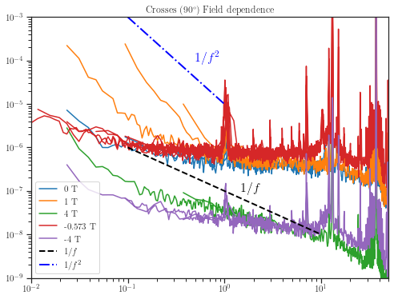

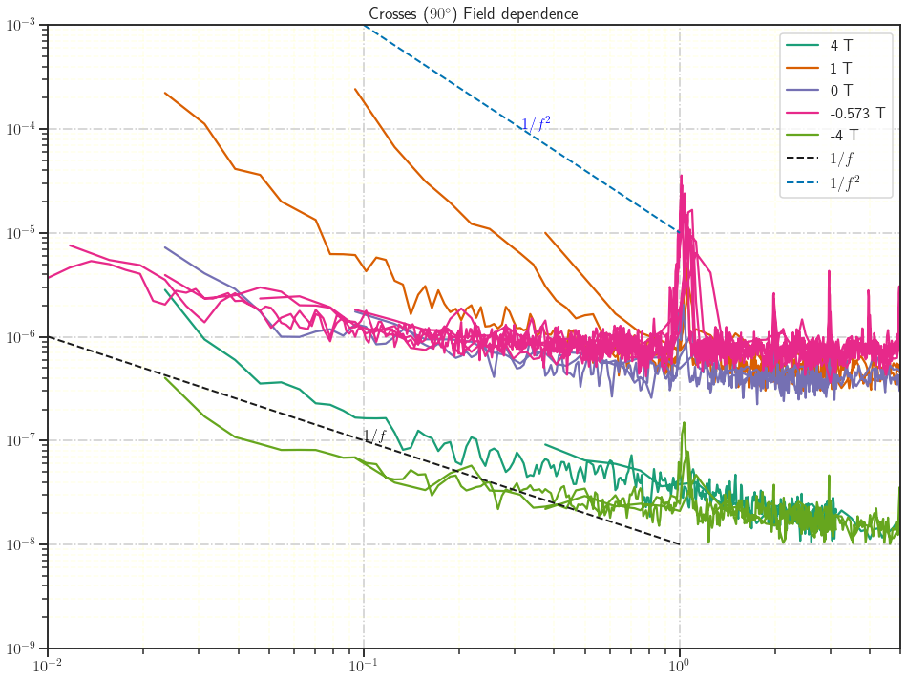

90deg HLoop

Friday, 7. June 2019

13:51

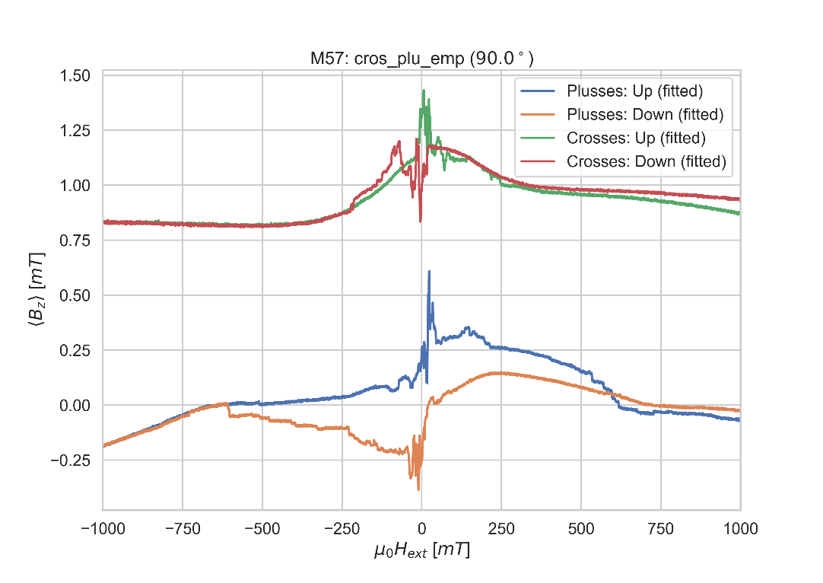

**m274: MFN\_noise test\_N11 \_1T\_90deg\_crosses**

Donnerstag, 6. Juni 2019

10:42

|  |  |
| --- | --- |
| Angle of sensor θ | *90 Parallel to the sensor (no Hall effect)* |
|  |  |
|  | |  |  |  |  | | --- | --- | --- | --- | |  | ***2 - 12 crosses*** |  |  | | ***Gate (0V)*** | ***9 - 4*** |  | ***14 - 7*** | |
|  | |  |  | | --- | --- | |  | *going to 1 T in P.M* | |
|  |  |
|  | |  |  |  |  |  |  | | --- | --- | --- | --- | --- | --- | | Sens | 5mV |  | 4 V | T | 30 K | |  | none |  | none |  | none | |  | none |  | *5* |  | *10* | | *τ* | *3 ms* | *Input A* | *AC* | *Ground* | *Normal Reserve* | | *f* | *113 Hz* |  |  |  |  | |
| *Pre Amplifier (SR560)* | |  |  |  |  | | --- | --- | --- | --- | | *Gain Mode* | *Low* | *Gain:* | *2e1* | | *Coupling* | *AC* | *Output (50Ω)* | *LI Input A* | | *Filters:* | *Off* |  |  | |
| *Signal Analyzer (SR785)* | |  |  |  |  | | --- | --- | --- | --- | | *Ch 1 (A)* |  | *Freq - Span:* | *50/ 12.5/ 3.125 Hz* | | *Ch 2 (A)* |  | *Averages:* | *30* | |
| *Period of measurement (min)* | *84* |
| *He (l) level consumption* |  |
| *Data files* | <<noise\_Test\_N11.dat>> |
| *Plot* | Machine generated alternative text: oco•,  -lee  F requetu |

**m275: MFN\_noise test\_N12 \_1T\_90deg\_empty**

Donnerstag, 6. Juni 2019

12:30

|  |  |
| --- | --- |
| Angle of sensor θ | *90 Parallel to the sensor (no Hall effect)* |
|  |  |
|  | |  |  |  |  | | --- | --- | --- | --- | |  | ***6 - 8 (empty)*** |  |  | | ***Gate (0V)*** | ***9 - 4*** |  | ***14 - 7*** | |
|  | |  |  | | --- | --- | |  | *going to 1 T in P.M* | |
|  |  |
|  | |  |  |  |  |  |  | | --- | --- | --- | --- | --- | --- | | Sens | 5mV |  | 4 V | T | 30 K | |  | none |  | none |  | none | |  | none |  | *5* |  | *10* | | *τ* | *3 ms* | *Input A* | *AC* | *Ground* | *Normal Reserve* | | *f* | *113 Hz* |  |  |  |  | |
| *Pre Amplifier (SR560)* | |  |  |  |  | | --- | --- | --- | --- | | *Gain Mode* | *Low* | *Gain:* | *2e1* | | *Coupling* | *AC* | *Output (50Ω)* | *LI Input A* | | *Filters:* | *Off* |  |  | |
| *Signal Analyzer (SR785)* | |  |  |  |  | | --- | --- | --- | --- | | *Ch 1 (A)* |  | *Freq - Span:* | *50/ 12.5/ 3.125 Hz* | | *Ch 2 (A)* |  | *Averages:* | *30* | |
| *Period of measurement (min)* | *84* |
| *He (l) level consumption* |  |
| *Data files* | <<noise\_Test\_N12.dat>> |
| *Plot* | Machine generated alternative text: omi  F requenz [Hz] |

**m276: MFN\_noise test\_N13\_second\_empty**

Donnerstag, 6. Juni 2019

14:14

|  |  |
| --- | --- |
| Angle of sensor θ | *+90* |
|  |  |
|  | |  |  |  |  | | --- | --- | --- | --- | |  |  |  | ***10 - 5*** | | ***Gate (0V)*** | ***9 - 4*** |  | ***14 - 7*** | |
|  | |  |  | | --- | --- | |  | *1 T Persistend Mode* | |
|  |  |
|  | |  |  |  |  |  |  | | --- | --- | --- | --- | --- | --- | | Sens | 5 mV |  | 4 V | T | 30 K | |  |  |  |  |  |  | |  | *1 MΩ* |  |  |  | *10* | | *τ* | *3 ms* | *Input A* | *AC* | *Ground* | *Normal Reserve* | |
| *Pre Amplifier (SR560)* | |  |  |  |  | | --- | --- | --- | --- | | *Gain Mode* | *Low* | *Gain:* | *2e2* | | *Coupling* | *AC* | *Output (50Ω)* | *LI Input A* | | *Filters:* | *Off* |  |  | |
| *Signal Analyzer (SR785)* | |  |  |  |  | | --- | --- | --- | --- | | *Ch 1 (A)* |  | *Freq - Span:* | *3 Hz* | | *Ch 2 (A)* |  | *Averages:* | *30* | |
| *Period of measurement (min)* | *65 min* |
| *He (l) level consumption* |  |
| *Data files* | <<noise\_Test\_N13.dat>> |
| *Plot* |  |

**m277: MFN\_noise test\_N14 \_4T\_crosses**

Donnerstag, 6. Juni 2019

15:13

|  |  |
| --- | --- |
| Angle of sensor θ | *+90* |
| Temp | 30 K |
|  | ***Crosses*** |
|  | |  |  |  |  | | --- | --- | --- | --- | |  |  |  | ***2-12 (crosses)*** | | ***Gate (0V)*** | ***9 - 4*** |  | ***14 - 7*** | |
|  | |  |  | | --- | --- | |  | ***Going*** *to 4 T Persistend Mode* | |
|  |  |
| Resistance Box | |  |  |  |  |  |  | | --- | --- | --- | --- | --- | --- | |  |  |  |  |  |  | |  | *1 MΩ* |  |  |  | *10* | |
|  | |  |  |  |  |  |  | | --- | --- | --- | --- | --- | --- | | Sens | 50 mV |  | 4 V |  |  | | *τ* | *3 ms* | *Input A* | *AC* | *Ground* | *Normal Reserve* | |
| Pre Amplifier (SR560) | |  |  |  |  | | --- | --- | --- | --- | | *Gain Mode* | *Low* | *Gain:* | *2e2* | | *Coupling* | *AC* | *Output (50Ω)* | *LI Input A* | | *Filters:* | *Off* |  |  | |
| Signal Analyzer (SR785) | |  |  |  |  | | --- | --- | --- | --- | | *Ch 1 (A)* |  | *Freq - Span:* | *50/3 Hz* | | *Ch 2 (A)* |  | *Averages:* | *30* | |
| Period of measurement (min) | *min* |
| He (l) level consumption |  |
| Data files |  |
| Plot |  |
|  |  |

**m: MFN\_**

Freitag, 7. Juni 2019

20:26

|  |  |
| --- | --- |
| Angle of sensor θ | *+90* |
| Temp | 30 K |
|  |  |
|  | |  |  |  |  | | --- | --- | --- | --- | |  | ***1 - 13*** |  | ***10 - 5*** | | ***Gate (0V)*** | ***9 - 4*** |  | ***14 - 7*** | |
|  | |  |  | | --- | --- | |  | *0.5 T Persistend Mode* | |
|  |  |
| Resistance Box | |  |  |  |  |  |  | | --- | --- | --- | --- | --- | --- | |  | *1 MΩ* |  | 6.6 kΩ |  | 450 Ω | |  | *1 MΩ* |  | *2* |  | *6* | |
|  | |  |  |  |  |  |  | | --- | --- | --- | --- | --- | --- | | Sens | 20 mV |  | 2.5 V |  |  | | *τ* | *3 ms* | *Input A* | *AC* | *Ground* | *Normal Reserve* | |
| Pre Amplifier (SR560) | |  |  |  |  | | --- | --- | --- | --- | | *Gain Mode* | *Low* | *Gain:* | *1e2* | | *Coupling* | *AC* | *Output (50Ω)* | *LI Input A* | | *Filters:* | *Off* |  |  | |
| Signal Analyzer (SR785) | |  |  |  |  | | --- | --- | --- | --- | | *Ch 1 (A)* |  | *Freq - Span:* | *3 Hz* | | *Ch 2 (A)* |  | *Averages:* | *30* | |
| Period of measurement (min) | *min* |
| He (l) level consumption |  |
| Data files |  |
| Plot |  |
|  |  |

**m278: MFN\_4T\_#1**

Donnerstag, 6. Juni 2019

16:36

|  |  |
| --- | --- |
| Angle of sensor θ | *+90* |
| Temp | 30 K |
|  | ***Empty Cross #1*** |
|  | |  |  |  |  | | --- | --- | --- | --- | |  |  |  | ***6-8 (#1)*** | | ***Gate (0V)*** | ***9 - 4*** |  | ***14 - 7*** | |
|  | |  |  | | --- | --- | |  | ***Going*** *to 4 T Persistend Mode* | |
|  |  |
| Resistance Box | |  |  |  |  |  |  | | --- | --- | --- | --- | --- | --- | |  |  |  |  |  |  | |  | *1 MΩ* |  |  |  | *10* | |
|  | |  |  |  |  |  |  | | --- | --- | --- | --- | --- | --- | | Sens | 50 mV |  | 4 V |  |  | | *τ* | *3 ms* | *Input A* | *AC* | *Ground* | *Normal Reserve* | |
| Pre Amplifier (SR560) | |  |  |  |  | | --- | --- | --- | --- | | *Gain Mode* | *Low* | *Gain:* | *2e2* | | *Coupling* | *AC* | *Output (50Ω)* | *LI Input A* | | *Filters:* | *Off* |  |  | |
| Signal Analyzer (SR785) | |  |  |  |  | | --- | --- | --- | --- | | *Ch 1 (A)* |  | *Freq - Span:* | *50/3 Hz* | | *Ch 2 (A)* |  | *Averages:* | *30* | |
| Period of measurement (min) | *min* |
| He (l) level consumption |  |
| Data files | <<m278\_empty1.dat>> |
| Plot | Machine generated alternative text: Nil  omi  184  F requenz [Hz] |
|  |  |

**m279: MFN\_4T\_crosses\_over night wide-ranging spans**

Donnerstag, 6. Juni 2019

18:13

|  |  |
| --- | --- |
| Angle of sensor θ | *+90* |
| Temp | 30 K |
|  | **Crosses** |
|  | |  |  |  |  | | --- | --- | --- | --- | |  | ***2-12*** | *Crosses* |  | | ***Gate (0V)*** | ***9 - 4*** |  | ***14 - 7 Preamp.*** | |
|  | |  |  | | --- | --- | |  | *4T Persistend Mode* | |
| Resistance Box | |  |  |  |  |  |  | | --- | --- | --- | --- | --- | --- | |  | *1 MΩ* |  |  |  |  | |  | *1 MΩ* |  |  |  | *10* | |
|  | |  |  |  |  |  |  | | --- | --- | --- | --- | --- | --- | | Sens | 50 mV |  | 4 V | *f* | *113 Hz* | | *τ* | *3 ms* | *Input A* | *AC* | *Ground* | *Normal Reserve* | |
| Pre Amplifier (SR560) | |  |  |  |  | | --- | --- | --- | --- | | *Gain Mode* | *Low* | *Gain:* | *2e2* | | *Coupling* | *AC* | *Output (50Ω)* | *LI Input A* | | *Filters:* | *Off* |  |  | |
| Signal Analyzer (SR785) | |  |  |  |  | | --- | --- | --- | --- | | *Ch 1 (A)* |  | *Freq - Span:* | *100,50,25,12.5,6.25,3.125, 1.5625 Hz* | | *Ch 2 (A)* |  | *Averages:* | *30* | |
| Period of measurement (min) | *254min* |
| He (l) level consumption |  |
| Data files | <<m279\_crosses\_wide\_spans\_overnight\_4T\_90deg\_4V.dat>> |
| Plot | Machine generated alternative text: omi  184  Nil  rn27g  rn27g  — rn277  — rn277  F requenz [Hz]  *Note 277 similar to 279 but diff f-spans* |

**m280: MFN\_0T\_crosses\_**

Freitag, 7. Juni 2019

10:33

|  |  |
| --- | --- |
| Angle of sensor θ | *+90* |
| Temp | 30 K |
|  | **Crosses** |
|  | |  |  |  |  | | --- | --- | --- | --- | |  | ***2-12*** | *Crosses* |  | | ***Gate (0V)*** | ***9 - 4*** |  | ***14 - 7 Preamp.*** | |
|  | |  |  | | --- | --- | |  | *0T Persistend Mode* | |
| Resistance Box | |  |  |  |  |  |  | | --- | --- | --- | --- | --- | --- | |  | *1 MΩ* |  |  |  |  | |  | *1 MΩ* |  |  |  | *10* | |
|  | |  |  |  |  |  |  | | --- | --- | --- | --- | --- | --- | | Sens | 5 mV |  | 4 V | *f* | *113 Hz* | | *τ* | *3 ms* | *Input A* | *AC* | *Ground* | *Normal Reserve* | |
| Pre Amplifier (SR560) | |  |  |  |  | | --- | --- | --- | --- | | *Gain Mode* | *Low* | *Gain:* | *2e2* | | *Coupling* | *AC* | *Output (50Ω)* | *LI Input A* | | *Filters:* | *Off* |  |  | |
| Signal Analyzer (SR785) | |  |  |  |  | | --- | --- | --- | --- | | *Ch 1 (A)* |  | *Freq - Span:* | *50,12.5,3.125 Hz* | | *Ch 2 (A)* |  | *Averages:* | *30* | |
| Period of measurement (min) | *84min* |
| He (l) level consumption |  |
| Data files |  |
| Plot |  |

**m281: MFN\_0T\_Plusses\_**

Freitag, 7. Juni 2019

10:33

|  |  |
| --- | --- |
| Angle of sensor θ | *+90* |
| Temp | 30 K |
|  | **Plusses** |
|  | |  |  |  |  | | --- | --- | --- | --- | |  | ***1-13*** | *Crosses* |  | | ***Gate (0V)*** | ***9 - 4*** |  | ***14 - 7 Preamp.*** | |
|  | |  |  | | --- | --- | |  | *0T Persistend Mode* | |
| Resistance Box | |  |  |  |  |  |  | | --- | --- | --- | --- | --- | --- | |  | *1 MΩ* |  |  |  |  | |  | *1 MΩ* |  |  |  | *10* | |
|  | |  |  |  |  |  |  | | --- | --- | --- | --- | --- | --- | | Sens | 5 mV |  | 4 V | *f* | *113 Hz* | | *τ* | *3 ms* | *Input A* | *AC* | *Ground* | *Normal Reserve* | |
| Pre Amplifier (SR560) | |  |  |  |  | | --- | --- | --- | --- | | *Gain Mode* | *Low* | *Gain:* | *2e2* | | *Coupling* | *AC* | *Output (50Ω)* | *LI Input A* | | *Filters:* | *Off* |  |  | |
| Signal Analyzer (SR785) | |  |  |  |  | | --- | --- | --- | --- | | *Ch 1 (A)* |  | *Freq - Span:* | *50,12.5,3.125 Hz* | | *Ch 2 (A)* |  | *Averages:* | *30* | |
| Period of measurement (min) | *84min* |
| He (l) level consumption |  |
| Data files |  |
| Plot |  |

**m282: MFN\_-9.4mT\_Down sweep\_Plusses\_**

Freitag, 7. Juni 2019

10:33

|  |  |
| --- | --- |
| Angle of sensor θ | *+90* |
| Temp | 30 K |
|  | **Plusses** |
|  | |  |  |  |  | | --- | --- | --- | --- | |  | ***1-13*** | *Crosses* |  | | ***Gate (0V)*** | ***9 - 4*** |  | ***14 - 7 Preamp.*** | |
|  | |  |  | | --- | --- | |  | *Down to -9.4 mT PM* | |
| Resistance Box | |  |  |  |  |  |  | | --- | --- | --- | --- | --- | --- | |  | *1 MΩ* |  |  |  |  | |  | *1 MΩ* |  |  |  | *10* | |
|  | |  |  |  |  |  |  | | --- | --- | --- | --- | --- | --- | | Sens | 5 mV |  | 4 V | *f* | *113 Hz* | | *τ* | *3 ms* | *Input A* | *AC* | *Ground* | *Normal Reserve* | |
| Pre Amplifier (SR560) | |  |  |  |  | | --- | --- | --- | --- | | *Gain Mode* | *Low* | *Gain:* | *2e2* | | *Coupling* | *AC* | *Output (50Ω)* | *LI Input A* | | *Filters:* | *Off* |  |  | |
| Signal Analyzer (SR785) | |  |  |  |  | | --- | --- | --- | --- | | *Ch 1 (A)* |  | *Freq - Span:* | *50,12.5,3.125 Hz* | | *Ch 2 (A)* |  | *Averages:* | *30* | |
| Period of measurement (min) | *84min* |
| He (l) level consumption |  |
| Data files | <<m282\_Plusses\_-9.4mT\_90deg\_4V\_downsweep.dat>> |
| Plot |  |

**m283: MFN\_-9.4mT\_Down sweep\_Crosses\_**

Freitag, 7. Juni 2019

10:33

|  |  |
| --- | --- |
| Angle of sensor θ | *+90* |
| Temp | 30 K |
|  | **Crosses** |
|  | |  |  |  |  | | --- | --- | --- | --- | |  | ***2-12*** | *Crosses* |  | | ***Gate (0V)*** | ***9 - 4*** |  | ***14 - 7 Preamp.*** | |
|  | |  |  | | --- | --- | |  | *Down to -9.4 mT PM* | |
| Resistance Box | |  |  |  |  |  |  | | --- | --- | --- | --- | --- | --- | |  | *1 MΩ* |  |  |  |  | |  | *1 MΩ* |  |  |  | *10* | |
|  | |  |  |  |  |  |  | | --- | --- | --- | --- | --- | --- | | Sens | 5 mV |  | 4 V | *f* | *113 Hz* | | *τ* | *3 ms* | *Input A* | *AC* | *Ground* | *Normal Reserve* | |
| Pre Amplifier (SR560) | |  |  |  |  | | --- | --- | --- | --- | | *Gain Mode* | *Low* | *Gain:* | *2e2* | | *Coupling* | *AC* | *Output (50Ω)* | *LI Input A* | | *Filters:* | *Off* |  |  | |
| Signal Analyzer (SR785) | |  |  |  |  | | --- | --- | --- | --- | | *Ch 1 (A)* |  | *Freq - Span:* | *50,12.5,3.125 Hz* | | *Ch 2 (A)* |  | *Averages:* | *30* | |
| Period of measurement (min) | *84min* |
| He (l) level consumption |  |
| Data files |  |
| Plot | *Important: this measurments had to be done over the weekend over low-ranging f-spans* |

**Filling He(l)**

Sonntag, 9. Juni 2019

19:38

|  |  |
| --- | --- |
| Filling date | 09.06.2019 |
| Before (in) | 25 |
| After (in) | 36.22 |
| consumption |  |
| Person | MAM |

Notes:



'To do:

**m284:** PlussesCrossesEmpty\_Parallel Hloop\_90deg\_1T\_10mTmin\_MFM edition\_over night\_wrong sensitivity chosen\_500µV

Sonntag, 9. Juni 2019

20:15

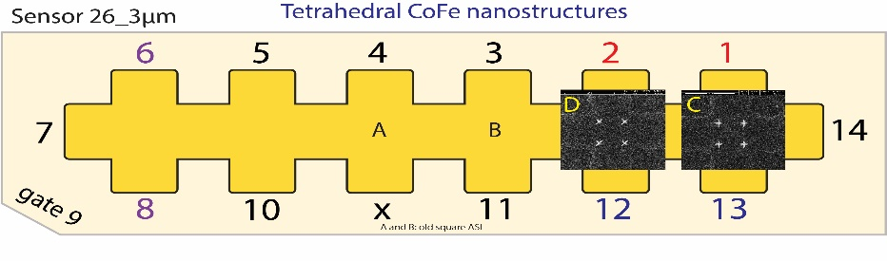

|  |  |
| --- | --- |
| Float/Ground: | Ground |
| AC/DC: | AC |
| A/A-B: | A-B |
| Reserve: | Normal |
| Source: | Internal |

|  |  |
| --- | --- |
| Angle of sensor θ | *90* |
|  |  |
|  |  |
|  | |  |  | | --- | --- | |  | *1* | |  | 10 Slow rate | |
|  | R12 = 40/1000\*50 = |
|  |  |
| *Period of measurement (min)* | *400 min (6.6 hr) over night* |
| *Notes* |  |
| *Data files* | <<m284\_Plusses\_cros\_\_emp\_90deg\_Hloop\_down\_Parallel\_20190609\_2000\_I-7-14\_GB8-1-13\_GB9-2-12\_GB13-6-8\_Vin-2.5V\_R11-1MO\_C11-1\_C21-6\_T-30K\_SR-10-mT-min\_B-1T\_gate-0V\_MFN edition.dat>>    <<m284\_Plusses\_cros\_\_emp\_90deg\_Hloop\_up\_Parallel\_20190609\_2000\_I-7-14\_GB8-1-13\_GB9-2-12\_GB13-6-8\_Vin-2.5V\_R11-1MO\_C11-1\_C21-6\_T-30K\_SR-10-mT-min\_B-1T\_gate-0V\_MFN edition.dat>> |
| *Plot* |  |

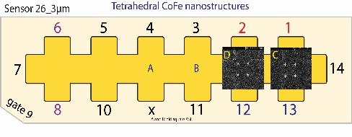

**Summary until here**

Montag, 10. Juni 2019

10:14

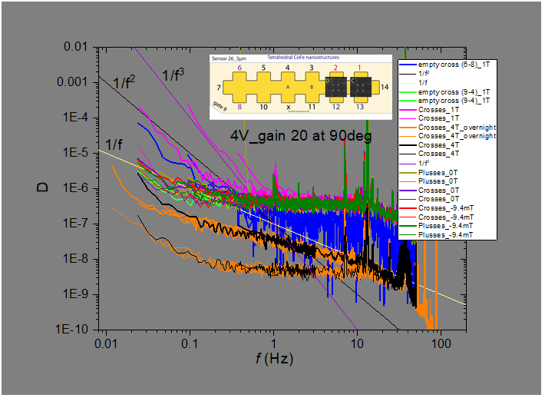

**m285:** PlussesCrossesEmpty\_Parallel Hloop\_90deg\_1T\_10mTmin\_MFM edition\_50µV\_30mTmin

Montag, 10. Juni 2019

11:23



|  |  |
| --- | --- |
| Float/Ground: | Ground |
| AC/DC: | AC |
| A/A-B: | A-B |
| Reserve: | Normal |
| Source: | Internal |

|  |  |
| --- | --- |
| Angle of sensor θ | *90* |
|  |  |
|  |  |
|  | |  |  | | --- | --- | |  | *1* | |  | 30 Slow rate | |
|  | R12 = 40/1000\*50 = |
|  |  |
| *Period of measurement (min)* | *133 min (2.2hr) over daylight* |
| *Notes* |  |
| *Data files* |  |
| *Plot* |  |

**m286: MFN\_-2.824mT\_Down sweep\_Plusses\_**

Montag, 10. Juni 2019

13:57

|  |  |
| --- | --- |
| Angle of sensor θ | *+90* |
| Temp | 30 K |
|  | **Plusses** |
|  | |  |  |  |  | | --- | --- | --- | --- | |  | ***1-13*** | *Crosses* |  | | ***Gate (0V)*** | ***9 - 4*** |  | ***14 - 7 Preamp.*** | |
|  | |  |  | | --- | --- | |  | *-0.02824T in down sweep and PM*  -0.05 | |
| Resistance Box | |  |  |  |  |  |  | | --- | --- | --- | --- | --- | --- | |  | *1 MΩ* |  |  |  |  | |  | *1 MΩ* |  |  |  | *10* | |
|  | |  |  |  |  |  |  | | --- | --- | --- | --- | --- | --- | | Sens | 5 mV |  | 4 V | *f* | *113 Hz* | | *τ* | *3 ms* | *Input A* | *AC* | *Ground* | *Normal Reserve* | |
| Pre Amplifier (SR560) | |  |  |  |  | | --- | --- | --- | --- | | *Gain Mode* | *Low* | *Gain:* | *2e2* | | *Coupling* | *AC* | *Output (50Ω)* | *LI Input A* | | *Filters:* | *Off* |  |  | |
| Signal Analyzer (SR785) | |  |  |  |  | | --- | --- | --- | --- | | *Ch 1 (A)* |  | *Freq - Span:* | *50,12.5,3.125 Hz* | | *Ch 2 (A)* |  | *Averages:* | *30* | |
| Period of measurement (min) | *84min* |
| He (l) level consumption |  |
| Data files | <<m286\_Plusses\_-0.02824T\_90deg\_4V\_DS.dat>> |
| Plot |  |

**m287: MFN\_-0.0063T\_Down sweep\_Plusses\_**

Montag, 10. Juni 2019

15:38

|  |  |
| --- | --- |
| Angle of sensor θ | *+90* |
| Temp | 30 K |
|  | **Plusses** |
|  | |  |  |  |  | | --- | --- | --- | --- | |  | ***1-13*** | *Crosses* |  | | ***Gate (0V)*** | ***9 - 4*** |  | ***14 - 7 Preamp.*** | |
|  | |  |  | | --- | --- | |  | *-0.0063 in down sweep and PM* | |
| Resistance Box | |  |  |  |  |  |  | | --- | --- | --- | --- | --- | --- | |  | *1 MΩ* |  |  |  |  | |  | *1 MΩ* |  |  |  | *10* | |
|  | |  |  |  |  |  |  | | --- | --- | --- | --- | --- | --- | | Sens | 5 mV |  | 4 V | *f* | *113 Hz* | | *τ* | *3 ms* | *Input A* | *AC* | *Ground* | *Normal Reserve* | |
| Pre Amplifier (SR560) | |  |  |  |  | | --- | --- | --- | --- | | *Gain Mode* | *Low* | *Gain:* | *2e2* | | *Coupling* | *AC* | *Output (50Ω)* | *LI Input A* | | *Filters:* | *Off* |  |  | |
| Signal Analyzer (SR785) | |  |  |  |  | | --- | --- | --- | --- | | *Ch 1 (A)* |  | *Freq - Span:* | *50,12.5,3.125 Hz* | | *Ch 2 (A)* |  | *Averages:* | *30* | |
| Period of measurement (min) | *84min* |
| He (l) level consumption |  |
| Data files | To do next:  -0.01695  *-0.0063*  <<m287\_Plusses\_-0.0063T\_90deg\_4V\_DS.dat>>  *1.6E-4*  *0.01247*  *-0.57246* |
| Plot | m286\_Plusses\_-0.02824T\_90deg\_4V\_DS.dat |

**m288: MFN\_0.01247T\_Down sweep\_Plusses\_**

Montag, 10. Juni 2019

17:06

|  |  |
| --- | --- |
| Angle of sensor θ | *+90* |
| Temp | 30 K |
|  | **Plusses** |
|  | |  |  |  |  | | --- | --- | --- | --- | |  | ***1-13*** | *Crosses* |  | | ***Gate (0V)*** | ***9 - 4*** |  | ***14 - 7 Preamp.*** | |
|  | |  |  | | --- | --- | |  | *0.01247 in down sweep and PM* | |
| Resistance Box | |  |  |  |  |  |  | | --- | --- | --- | --- | --- | --- | |  | *1 MΩ* |  |  |  |  | |  | *1 MΩ* |  |  |  | *10* | |
|  | |  |  |  |  |  |  | | --- | --- | --- | --- | --- | --- | | Sens | 5 mV |  | 4 V | *f* | *113 Hz* | | *τ* | *3 ms* | *Input A* | *AC* | *Ground* | *Normal Reserve* | |
| Pre Amplifier (SR560) | |  |  |  |  | | --- | --- | --- | --- | | *Gain Mode* | *Low* | *Gain:* | *2e2* | | *Coupling* | *AC* | *Output (50Ω)* | *LI Input A* | | *Filters:* | *Off* |  |  | |
| Signal Analyzer (SR785) | |  |  |  |  | | --- | --- | --- | --- | | *Ch 1 (A)* |  | *Freq - Span:* | *50,12.5,3.125 Hz* | | *Ch 2 (A)* |  | *Averages:* | *30* | |
| Period of measurement (min) | *84min* |
| He (l) level consumption |  |
| Data files | To do next:  -0.01695  *-0.0063*  *1.6E-4*  *0.01247*  *-0.57246* |
| Plot | m286\_Plusses\_-0.02824T\_90deg\_4V\_DS.dat |

<<m288\_Plusses\_0.01247T\_90deg\_4V\_DS.dat>>

**m289: MFN\_0.015T\_down sweep\_Plusses\_**

Montag, 10. Juni 2019

17:06

|  |  |
| --- | --- |
| Angle of sensor θ | *+90* |
| Temp | 30 K |
|  | **Plusses** |
|  | |  |  |  |  | | --- | --- | --- | --- | |  | ***1-13*** | *Crosses* |  | | ***Gate (0V)*** | ***9 - 4*** |  | ***14 - 7 Preamp.*** | |
|  | |  |  | | --- | --- | |  | *0.015 in down sweep and PM* | |
| Resistance Box | |  |  |  |  |  |  | | --- | --- | --- | --- | --- | --- | |  | *1 MΩ* |  |  |  |  | |  | *1 MΩ* |  |  |  | *10* | |
|  | |  |  |  |  |  |  | | --- | --- | --- | --- | --- | --- | | Sens | 5 mV |  | 4 V | *f* | *113 Hz* | | *τ* | *3 ms* | *Input A* | *AC* | *Ground* | *Normal Reserve* | |
| Pre Amplifier (SR560) | |  |  |  |  | | --- | --- | --- | --- | | *Gain Mode* | *Low* | *Gain:* | *2e2* | | *Coupling* | *AC* | *Output (50Ω)* | *LI Input A* | | *Filters:* | *Off* |  |  | |
| Signal Analyzer (SR785) | |  |  |  |  | | --- | --- | --- | --- | | *Ch 1 (A)* |  | *Freq - Span:* | *50,12.5,3.125 Hz* | | *Ch 2 (A)* |  | *Averages:* | *30* | |
| Period of measurement (min) | *84min* |
| He (l) level consumption |  |
| Data files | To do next:  -0.0169  <<m289\_Plusses\_0.015T\_90deg\_4V\_DS.dat>>  5  *-0.0063*  *1.6E-4*  *0.01247*  *-0.57246* |
| Plot | m286\_Plusses\_-0.02824T\_90deg\_4V\_DS.dat |

**m290: MFN\_0.03T\_down sweep\_Plusses\_**

Montag, 10. Juni 2019

21:52

|  |  |
| --- | --- |
| Angle of sensor θ | *+90* |
| Temp | 30 K |
|  | **Plusses** |
|  | |  |  |  |  | | --- | --- | --- | --- | |  | ***1-13*** | *Crosses* |  | | ***Gate (0V)*** | ***9 - 4*** |  | ***14 - 7 Preamp.*** | |
|  | |  |  | | --- | --- | |  | *0.03 in down sweep and PM* | |
| Resistance Box | |  |  |  |  |  |  | | --- | --- | --- | --- | --- | --- | |  | *1 MΩ* |  |  |  |  | |  | *1 MΩ* |  |  |  | *10* | |
|  | |  |  |  |  |  |  | | --- | --- | --- | --- | --- | --- | | Sens | 5 mV |  | 4 V | *f* | *113 Hz* | | *τ* | *3 ms* | *Input A* | *AC* | *Ground* | *Normal Reserve* | |
| Pre Amplifier (SR560) | |  |  |  |  | | --- | --- | --- | --- | | *Gain Mode* | *Low* | *Gain:* | *2e2* | | *Coupling* | *AC* | *Output (50Ω)* | *LI Input A* | | *Filters:* | *Off* |  |  | |
| Signal Analyzer (SR785) | |  |  |  |  | | --- | --- | --- | --- | | *Ch 1 (A)* |  | *Freq - Span:* | *50,12.5,3.125 Hz* | | *Ch 2 (A)* |  | *Averages:* | *30* | |
| Period of measurement (min) | *84min* |
| He (l) level consumption |  |
| Data files | To do next:  -0.01695  <<m290\_Plusses\_0.03T\_90deg\_4V\_DS.dat>>  *-0.0063*  *1.6E-4*  *0.01247*  *-0.57246* |
| Plot | m286\_Plusses\_-0.02824T\_90deg\_4V\_DS.dat |

**m291: MFN\_-0.57246T\_down sweep\_Plusses\_overight most f-spans**



Montag, 10. Juni 2019

23:20

|  |  |
| --- | --- |
| Angle of sensor θ | *+90* |
| Temp | 30 K |
|  | **Plusses** |
|  | |  |  |  |  | | --- | --- | --- | --- | |  | ***1-13*** | *Crosses* |  | | ***Gate (0V)*** | ***9 - 4*** |  | ***14 - 7 Preamp.*** | |
|  | |  |  | | --- | --- | |  | ***-0.57246*** *in down sweep and PM* | |
| Resistance Box | |  |  |  |  |  |  | | --- | --- | --- | --- | --- | --- | |  | *1 MΩ* |  |  |  |  | |  | *1 MΩ* |  |  |  | *10* | |
|  | |  |  |  |  |  |  | | --- | --- | --- | --- | --- | --- | | Sens | 5 mV |  | 4 V | *f* | *113 Hz* | | *τ* | *3 ms* | *Input A* | *AC* | *Ground* | *Normal Reserve* | |
| Pre Amplifier (SR560) | |  |  |  |  | | --- | --- | --- | --- | | *Gain Mode* | *Low* | *Gain:* | *2e2* | | *Coupling* | *AC* | *Output (50Ω)* | *LI Input A* | | *Filters:* | *Off* |  |  | |
| Signal Analyzer (SR785) | |  |  |  |  | | --- | --- | --- | --- | | *Ch 1 (A)* |  | *Freq - Span:* | *50,25, 12.5, 6.25, 3.125, 1.5625, 0.78125 Hz* | | *Ch 2 (A)* |  | *Averages:* | *30* | |
| Period of measurement (min) | *507 min (8.4hr) overnight started at 23:24* |
| He (l) level consumption |  |
| Data files | <<m291\_Plusses\_-0.57246T\_90deg\_4V\_DS\_\_.dat>> |
| Plot |  |

**m292: MFN\_-0.10422T\_down sweep\_Plusses**

Dienstag, 11. Juni 2019

08:00



|  |  |
| --- | --- |
| Angle of sensor θ | *+90* |
| Temp | 30 K |
|  | **Plusses** |
|  | |  |  |  |  | | --- | --- | --- | --- | |  | ***1-13*** | *Crosses* |  | | ***Gate (0V)*** | ***9 - 4*** |  | ***14 - 7 Preamp.*** | |
|  | |  |  | | --- | --- | |  | *-0.10422 in down sweep and PM*  Machine generated alternative text: -0.05 | |
| Resistance Box | |  |  |  |  |  |  | | --- | --- | --- | --- | --- | --- | |  | *1 MΩ* |  |  |  |  | |  | *1 MΩ* |  |  |  | *10* | |
|  | |  |  |  |  |  |  | | --- | --- | --- | --- | --- | --- | | Sens | 5 mV |  | 4 V | *f* | *113 Hz* | | *τ* | *3 ms* | *Input A* | *AC* | *Ground* | *Normal Reserve* | |
| Pre Amplifier (SR560) | |  |  |  |  | | --- | --- | --- | --- | | *Gain Mode* | *Low* | *Gain:* | *2e2* | | *Coupling* | *AC* | *Output (50Ω)* | *LI Input A* | | *Filters:* | *Off* |  |  | |
| Signal Analyzer (SR785) | |  |  |  |  | | --- | --- | --- | --- | | *Ch 1 (A)* |  | *Freq - Span:* | *50,12.5,3.125 Hz* | | *Ch 2 (A)* |  | *Averages:* | *30* | |
| Period of measurement (min) |  |
| He (l) level consumption |  |
| Data files | <<m292\_Plusses\_-0.10422T\_90deg\_4V\_DS\_\_.dat>> |
| Plot |  |



**m293: MFN\_-4T\_Plusses**

Dienstag, 11. Juni 2019

09:49

|  |  |
| --- | --- |
| Angle of sensor θ | *+90* |
| Temp | 30 K |
|  | **Plusses** |
|  | |  |  |  |  | | --- | --- | --- | --- | |  | ***1-13*** | *Crosses* |  | | ***Gate (0V)*** | ***9 - 4*** |  | ***14 - 7 Preamp.*** | |
|  | |  |  | | --- | --- | |  | *-4 in down sweep and PM* | |
| Resistance Box | |  |  |  |  |  |  | | --- | --- | --- | --- | --- | --- | |  | *1 MΩ* |  |  |  |  | |  | *1 MΩ* |  |  |  | *10* | |
|  | |  |  |  |  |  |  | | --- | --- | --- | --- | --- | --- | | Sens | 50mV |  | 4 V | *f* | *113 Hz* | | *τ* | *3 ms* | *Input A* | *AC* | *Ground* | *Normal Reserve* | |
| Pre Amplifier (SR560) | |  |  |  |  | | --- | --- | --- | --- | | *Gain Mode* | *Low* | *Gain:* | *2e2* | | *Coupling* | *AC* | *Output (50Ω)* | *LI Input A* | | *Filters:* | *Off* |  |  | |
| Signal Analyzer (SR785) | |  |  |  |  | | --- | --- | --- | --- | | *Ch 1 (A)* |  | *Freq - Span:* | *50,12.5,3.125 Hz* | | *Ch 2 (A)* |  | *Averages:* | *30* | |
| Period of measurement (min) |  |
| He (l) level consumption |  |
| Data files | <<m293\_Plusses\_-4T\_90deg\_4V\_.dat>> |
| Plot |  |



**m294: MFN\_-4T\_Crosses**

Dienstag, 11. Juni 2019

09:49

|  |  |
| --- | --- |
| Angle of sensor θ | *+90* |
| Temp | 30 K |
|  | **Crosses** |
|  | |  |  |  |  | | --- | --- | --- | --- | |  | ***2-12*** | *Crosses* |  | | ***Gate (0V)*** | ***9 - 4*** |  | ***14 - 7 Preamp.*** | |
|  | |  |  | | --- | --- | |  | *-4 in down sweep and PM* | |
| Resistance Box | |  |  |  |  |  |  | | --- | --- | --- | --- | --- | --- | |  | *1 MΩ* |  |  |  |  | |  | *1 MΩ* |  |  |  | *10* | |
|  | |  |  |  |  |  |  | | --- | --- | --- | --- | --- | --- | | Sens | 50mV |  | 4 V | *f* | *113 Hz* | | *τ* | *3 ms* | *Input A* | *AC* | *Ground* | *Normal Reserve* | |
| Pre Amplifier (SR560) | |  |  |  |  | | --- | --- | --- | --- | | *Gain Mode* | *Low* | *Gain:* | *2e2* | | *Coupling* | *AC* | *Output (50Ω)* | *LI Input A* | | *Filters:* | *Off* |  |  | |
| Signal Analyzer (SR785) | |  |  |  |  | | --- | --- | --- | --- | | *Ch 1 (A)* |  | *Freq - Span:* | *50,12.5,3.125 Hz* | | *Ch 2 (A)* |  | *Averages:* | *30* | |
| Period of measurement (min) |  |
| He (l) level consumption |  |
| Data files | <<m294\_Crosses\_-4T\_90deg\_4V\_.dat>> |
| Plot |  |

To do next

-0.01695

*-0.0063*

*1.6E-4*

*0.01247*

*-0.57246*

*-4T*



**m295: MFN\_-4T\_empty cross 6-8**

Dienstag, 11. Juni 2019

14:13

|  |  |
| --- | --- |
| Angle of sensor θ | *+90* |
| Temp | 30 K |
|  | **Empty cross 6-8** |
|  | |  |  |  |  | | --- | --- | --- | --- | |  | ***6-8*** | *Crosses* |  | | ***Gate (0V)*** | ***9 - 4*** |  | ***14 - 7 Preamp.*** | |
|  | |  |  | | --- | --- | |  | *-4 in down sweep and PM* | |
| Resistance Box | |  |  |  |  |  |  | | --- | --- | --- | --- | --- | --- | |  | *1 MΩ* |  |  |  |  | |  | *1 MΩ* |  |  |  | *10* | |
|  | |  |  |  |  |  |  | | --- | --- | --- | --- | --- | --- | | Sens | 50mV |  | 4 V | *f* | *113 Hz* | | *τ* | *3 ms* | *Input A* | *AC* | *Ground* | *Normal Reserve* | |
| Pre Amplifier (SR560) | |  |  |  |  | | --- | --- | --- | --- | | *Gain Mode* | *Low* | *Gain:* | *2e2* | | *Coupling* | *AC* | *Output (50Ω)* | *LI Input A* | | *Filters:* | *Off* |  |  | |
| Signal Analyzer (SR785) | |  |  |  |  | | --- | --- | --- | --- | | *Ch 1 (A)* |  | *Freq - Span:* | *50,12.5,3.125 Hz* | | *Ch 2 (A)* |  | *Averages:* | *30* | |
| Period of measurement (min) |  |
| He (l) level consumption |  |
| Data files | <<m295\_empty (6-8)\_-4T\_90deg\_4V\_.dat>> |
| Plot |  |

To do next

-0.01695

*-0.0063*

*1.6E-4*

*0.01247*

*-0.57246*

*-4T*

**Summary until here**

11 June 2019

15:54

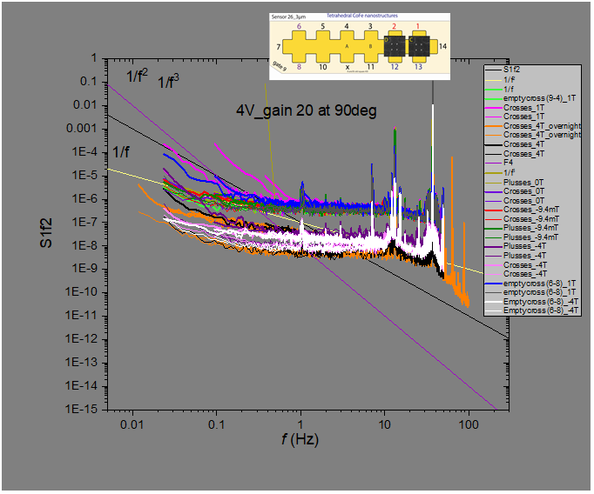



**m296: MFN\_-4T\_empty cross 5-10**

Dienstag, 11. Juni 2019

15:59

|  |  |
| --- | --- |
| Angle of sensor θ | *+90* |
| Temp | 30 K |
|  | **Empty cross 5-10** |
|  | |  |  |  |  | | --- | --- | --- | --- | |  | ***5-10*** | *Crosses* |  | | ***Gate (0V)*** | ***9 - 4*** |  | ***14 - 7 Preamp.*** | |
|  | |  |  | | --- | --- | |  | *-4 in down sweep and PM* | |
| Resistance Box | |  |  |  |  |  |  | | --- | --- | --- | --- | --- | --- | |  | *1 MΩ* |  |  |  |  | |  | *1 MΩ* |  |  |  | *10* | |
|  | |  |  |  |  |  |  | | --- | --- | --- | --- | --- | --- | | Sens | 50mV |  | 4 V | *f* | *113 Hz* | | *τ* | *3 ms* | *Input A* | *AC* | *Ground* | *Normal Reserve* | |
| Pre Amplifier (SR560) | |  |  |  |  | | --- | --- | --- | --- | | *Gain Mode* | *Low* | *Gain:* | *2e2* | | *Coupling* | *AC* | *Output (50Ω)* | *LI Input A* | | *Filters:* | *Off* |  |  | |
| Signal Analyzer (SR785) | |  |  |  |  | | --- | --- | --- | --- | | *Ch 1 (A)* |  | *Freq - Span:* | *50,12.5,3.125 Hz* | | *Ch 2 (A)* |  | *Averages:* | *30* | |
| Period of measurement (min) |  |
| He (l) level consumption |  |
| Data files | <<m296\_empty (5-10)\_-4T\_90deg\_4V\_.dat>> |
| Plot |  |

To do next

-0.01695

*-0.0063*

*1.6E-4*

*0.01247*

*-0.57246*

*-4T*

**Summary untill here -4T version**

12 June 2019

09:42

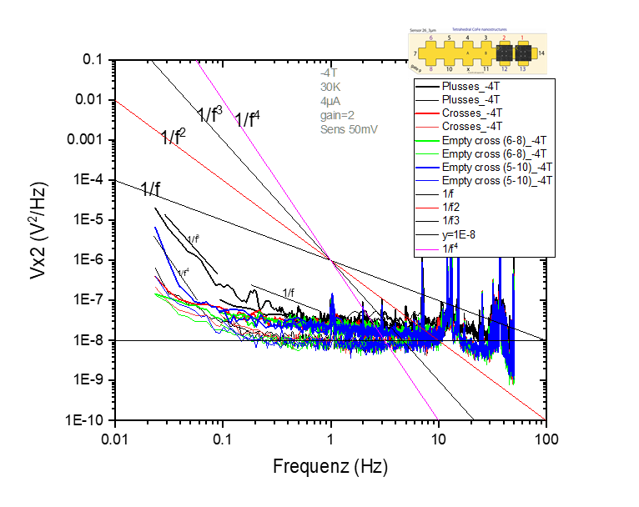

**m297: MFN\_-2.824mT\_down sweep\_Crosses\_**

Dienstag, 11. Juni 2019

17:45

|  |  |
| --- | --- |
| Angle of sensor θ | *+90* |
| Temp | 30 K |
|  | **Crosses** |
|  | |  |  |  |  | | --- | --- | --- | --- | |  | ***2-12*** | *Crosses* |  | | ***Gate (0V)*** | ***9 - 4*** |  | ***14 - 7 Preamp.*** | |
|  | |  |  | | --- | --- | |  | *-0.02824T in down sweep and PM*  -0.05 | |
| Resistance Box | |  |  |  |  |  |  | | --- | --- | --- | --- | --- | --- | |  | *1 MΩ* |  |  |  |  | |  | *1 MΩ* |  |  |  | *10* | |
|  | |  |  |  |  |  |  | | --- | --- | --- | --- | --- | --- | | Sens | 5 mV |  | 4 V | *f* | *113 Hz* | | *τ* | *3 ms* | *Input A* | *AC* | *Ground* | *Normal Reserve* | |
| Pre Amplifier (SR560) | |  |  |  |  | | --- | --- | --- | --- | | *Gain Mode* | *Low* | *Gain:* | *2e2* | | *Coupling* | *AC* | *Output (50Ω)* | *LI Input A* | | *Filters:* | *Off* |  |  | |
| Signal Analyzer (SR785) | |  |  |  |  | | --- | --- | --- | --- | | *Ch 1 (A)* |  | *Freq - Span:* | *50,12.5,3.125 Hz* | | *Ch 2 (A)* |  | *Averages:* | *30* | |
| Period of measurement (min) | *84min* |
| He (l) level consumption | <<m297\_Crosses (2-12)\_-0.02824T\_90deg\_4V\_.dat>> |
| Data files |  |
| Plot |  |

**m298: MFN\_-0.0063T\_down sweep\_Crosses\_**

Dienstag, 11. Juni 2019

20:26

|  |  |
| --- | --- |
| Angle of sensor θ | *+90* |
| Temp | 30 K |
|  | **Crosses** |
|  | |  |  |  |  | | --- | --- | --- | --- | |  | ***2-12*** | *Crosses* |  | | ***Gate (0V)*** | ***9 - 4*** |  | ***14 - 7 Preamp.*** | |
|  | |  |  | | --- | --- | |  | ***-0.0063****T in down sweep and PM*  -0.05 | |
| Resistance Box | |  |  |  |  |  |  | | --- | --- | --- | --- | --- | --- | |  | *1 MΩ* |  |  |  |  | |  | *1 MΩ* |  |  |  | *10* | |
|  | |  |  |  |  |  |  | | --- | --- | --- | --- | --- | --- | | Sens | 5 mV |  | 4 V | *f* | *113 Hz* | | *τ* | *3 ms* | *Input A* | *AC* | *Ground* | *Normal Reserve* | |
| Pre Amplifier (SR560) | |  |  |  |  | | --- | --- | --- | --- | | *Gain Mode* | *Low* | *Gain:* | *2e2* | | *Coupling* | *AC* | *Output (50Ω)* | *LI Input A* | | *Filters:* | *Off* |  |  | |
| Signal Analyzer (SR785) | |  |  |  |  | | --- | --- | --- | --- | | *Ch 1 (A)* |  | *Freq - Span:* | *50,12.5,3.125 Hz* | | *Ch 2 (A)* |  | *Averages:* | *30* | |
| Period of measurement (min) | *84min* |
| He (l) level consumption |  |
| Data files |  |
| Plot |  |

**m299: MFN\_-0.572500T\_down sweep\_Crosses\_over ight wide ranging f-spans\_**

Dienstag, 11. Juni 2019

22:23

|  |  |
| --- | --- |
| Angle of sensor θ | *+90* |
| Temp | 30 K |
|  | **Crosses** |
|  | |  |  |  |  | | --- | --- | --- | --- | |  | ***2-12*** | *Crosses* |  | | ***Gate (0V)*** | ***9 - 4*** |  | ***14 - 7 Preamp.*** | |
|  | |  |  | | --- | --- | |  | *-0.572500T in down sweep and PM* | |
| Resistance Box | |  |  |  |  |  |  | | --- | --- | --- | --- | --- | --- | |  | *1 MΩ* |  |  |  |  | |  | *1 MΩ* |  |  |  | *10* | |
|  | |  |  |  |  |  |  | | --- | --- | --- | --- | --- | --- | | Sens | 5 mV |  | 4 V | *f* | *113 Hz* | | *τ* | *3 ms* | *Input A* | *AC* | *Ground* | *Normal Reserve* | |
| Pre Amplifier (SR560) | |  |  |  |  | | --- | --- | --- | --- | | *Gain Mode* | *Low* | *Gain:* | *2e2* | | *Coupling* | *AC* | *Output (50Ω)* | *LI Input A* | | *Filters:* | *Off* |  |  | |
| Signal Analyzer (SR785) | |  |  |  |  | | --- | --- | --- | --- | | *Ch 1 (A)* |  | *Freq - Span:* | *50,25, 12.5, 6.25, 3.125, 1.5625, 0.78125 Hz* | | *Ch 2 (A)* |  | *Averages:* | *30* | |
| Period of measurement (min) | *507 min (8.4hr) overnight started at 23:24* |
| He (l) level consumption |  |
| Data files | <<m299\_Crosses (2-12)\_-0.572500T\_90deg\_4V\_.dat>> |
| Plot |  |

**m300: MFN\_0.01247T\_down sweep\_Crosses\_**

Mittwoch, 12. Juni 2019

07:11

|  |  |
| --- | --- |
| Angle of sensor θ | *+90* |
| Temp | 30 K |
|  | **Crosses** |
|  | |  |  |  |  | | --- | --- | --- | --- | |  | ***2-12*** | *Crosses* |  | | ***Gate (0V)*** | ***9 - 4*** |  | ***14 - 7 Preamp.*** | |
|  | |  |  | | --- | --- | |  | ***0.01247*** *T in down sweep and PM*  -0.05 | |
| Resistance Box | |  |  |  |  |  |  | | --- | --- | --- | --- | --- | --- | |  | *1 MΩ* |  |  |  |  | |  | *1 MΩ* |  |  |  | *10* | |
|  | |  |  |  |  |  |  | | --- | --- | --- | --- | --- | --- | | Sens | 5 mV |  | 4 V | *f* | *113 Hz* | | *τ* | *3 ms* | *Input A* | *AC* | *Ground* | *Normal Reserve* | |
| Pre Amplifier (SR560) | |  |  |  |  | | --- | --- | --- | --- | | *Gain Mode* | *Low* | *Gain:* | *2e2* | | *Coupling* | *AC* | *Output (50Ω)* | *LI Input A* | | *Filters:* | *Off* |  |  | |
| Signal Analyzer (SR785) | |  |  |  |  | | --- | --- | --- | --- | | *Ch 1 (A)* |  | *Freq - Span:* | *50,12.5,3.125 Hz* | | *Ch 2 (A)* |  | *Averages:* | *30* | |
| Period of measurement (min) | *84min* |
| He (l) level consumption |  |
| Data files | <<m300\_Crosses (2-12)\_0.01247T\_90deg\_4V\_.dat>> |
| Plot |  |

**m301: MFN\_0.015T\_down sweep\_Crosses\_**

Mittwoch, 12. Juni 2019

09:10

|  |  |
| --- | --- |
| Angle of sensor θ | *+90* |
| Temp | 30 K |
|  | **Crosses** |
|  | |  |  |  |  | | --- | --- | --- | --- | |  | ***2-12*** | *Crosses* |  | | ***Gate (0V)*** | ***9 - 4*** |  | ***14 - 7 Preamp.*** | |
|  | |  |  | | --- | --- | |  | ***0.015*** *T in down sweep and PM*  -0.05 | |
| Resistance Box | |  |  |  |  |  |  | | --- | --- | --- | --- | --- | --- | |  | *1 MΩ* |  |  |  |  | |  | *1 MΩ* |  |  |  | *10* | |
|  | |  |  |  |  |  |  | | --- | --- | --- | --- | --- | --- | | Sens | 5 mV |  | 4 V | *f* | *113 Hz* | | *τ* | *3 ms* | *Input A* | *AC* | *Ground* | *Normal Reserve* | |
| Pre Amplifier (SR560) | |  |  |  |  | | --- | --- | --- | --- | | *Gain Mode* | *Low* | *Gain:* | *2e2* | | *Coupling* | *AC* | *Output (50Ω)* | *LI Input A* | | *Filters:* | *Off* |  |  | |
| Signal Analyzer (SR785) | |  |  |  |  | | --- | --- | --- | --- | | *Ch 1 (A)* |  | *Freq - Span:* | *50,12.5,3.125 Hz* | | *Ch 2 (A)* |  | *Averages:* | *30* | |
| Period of measurement (min) | *84min* |
| He (l) level consumption |  |
| Data files | <<m301\_Crosses (2-12)\_0.015T\_90deg\_4V\_.dat>> |
| Plot |  |



**Measurements while sweeping field**

Donnerstag, 13. Juni 2019

14:06

# Sweeping from ± 2 T

|  |  |  |  |  |
| --- | --- | --- | --- | --- |
| From | To | Structures | Sweeping Rate [mT/min] | Measurement |
| + |  | Crosses | 48 | [m302](onenote:#m302_m302.1%20MFN_down%20sweeping%20%202T%20to%20-2T&section-id={5FAD0518-E349-4A07-93E8-5D105BD4AEB4}&page-id={661773AF-F247-4763-AF8F-80C64C681846}&end&base-path=https://goetheuniversitaet.sharepoint.com/sites/Project4/SiteAssets/Project%204%20Notebook/Magnetic%20Flux%20Noise.one) |
|  | + | Crosses | 48 | [m303](onenote:#m303_m303.1%20MFN_up%20sweeping%20%20-2T%20to%202T&section-id={5FAD0518-E349-4A07-93E8-5D105BD4AEB4}&page-id={EB705DBD-2C72-4184-9BE4-A7C270A1AE43}&end&base-path=https://goetheuniversitaet.sharepoint.com/sites/Project4/SiteAssets/Project%204%20Notebook/Magnetic%20Flux%20Noise.one) |
| + |  | Plusses | 48 | [m304](onenote:#m304_m304.1%20MFN_down%20sweeping%20%20-2T%20to%202T&section-id={5FAD0518-E349-4A07-93E8-5D105BD4AEB4}&page-id={9C733169-D5CF-4B48-921A-B533F8EE3C7D}&end&base-path=https://goetheuniversitaet.sharepoint.com/sites/Project4/SiteAssets/Project%204%20Notebook/Magnetic%20Flux%20Noise.one) |
| + |  | Empty #1 | 48 | [m305](onenote:#m305_m305.1%20MFN_down%20sweeping%202T%20to%20-2T&section-id={5FAD0518-E349-4A07-93E8-5D105BD4AEB4}&page-id={A641346D-5ABA-4B34-99CE-80D7DDD0B11C}&end&base-path=https://goetheuniversitaet.sharepoint.com/sites/Project4/SiteAssets/Project%204%20Notebook/Magnetic%20Flux%20Noise.one) |
| + |  | Plusses | 7.86 | [m306](onenote:#m306_m306.1%20MFN_down%20sweeping%20%20-2T%20to%202T&section-id={5FAD0518-E349-4A07-93E8-5D105BD4AEB4}&page-id={89B28326-DCC6-4031-ACA5-93F235A08EAE}&end&base-path=https://goetheuniversitaet.sharepoint.com/sites/Project4/SiteAssets/Project%204%20Notebook/Magnetic%20Flux%20Noise.one) |

# Sweeping down and up again

|  |  |  |  |  |
| --- | --- | --- | --- | --- |
| Limit [± mT] | Structures | Sweeping Rate [mT/min] | Measurement | . |
| ± 250 | Plusses | 11.86 | [m307](onenote:#m307_m308.1%20MFN_down%20and%20up%20sweeping%200.25T&section-id={5FAD0518-E349-4A07-93E8-5D105BD4AEB4}&page-id={32FC4D94-FE71-4BD4-B863-349BD9FDE1D2}&end&base-path=https://goetheuniversitaet.sharepoint.com/sites/Project4/SiteAssets/Project%204%20Notebook/Magnetic%20Flux%20Noise.one) |  |
| ± 500 | Plusses | 23.7 | [m308](onenote:#m308_m308.1%20MFN_down%20and%20up%20sweeping%200.5T&section-id={5FAD0518-E349-4A07-93E8-5D105BD4AEB4}&page-id={15D6D76C-DD01-4EAC-9A30-321373CE0D3A}&end&base-path=https://goetheuniversitaet.sharepoint.com/sites/Project4/SiteAssets/Project%204%20Notebook/Magnetic%20Flux%20Noise.one) |  |
| ± 100 | Plusses | 4.7 | [m309](onenote:#m309_m309.1%20MFN_down%20and%20up%20sweeping%200.1T&section-id={5FAD0518-E349-4A07-93E8-5D105BD4AEB4}&page-id={E1DA1348-EC34-4A9B-AB57-21BF33F58678}&end&base-path=https://goetheuniversitaet.sharepoint.com/sites/Project4/SiteAssets/Project%204%20Notebook/Magnetic%20Flux%20Noise.one) |  |

**Analyzing Field Sweeps**

Freitag, 14. Juni 2019

01:25

**m302\_m302.1: MFN\_down sweeping 2T to -2T\_ 48mTmin\_measuring MFN for Crosses**

Mittwoch, 12. Juni 2019

11:13

|  |  |
| --- | --- |
| Angle of sensor θ | *+90* |
| Temp | 30 K |
|  | **Crosses** |
|  | |  |  |  |  | | --- | --- | --- | --- | |  | ***2-12*** | *Crosses* |  | | ***Gate (0V)*** | ***9 - 4*** |  | ***14 - 7 Preamp.*** | |
|  | |  |  | | --- | --- | |  | **Down sweeping 2T to -2T\_ measuring MFN for Crosses** | | *Sweeping rate* | **48 mT/min \_overall time 83.33 min** | |
| Resistance Box | |  |  |  |  |  |  | | --- | --- | --- | --- | --- | --- | |  | *1 MΩ* |  |  |  |  | |  | *1 MΩ* |  |  |  | *10* | |
|  | |  |  |  |  |  |  | | --- | --- | --- | --- | --- | --- | | Sens | 10mV |  | 4 V | *f* | *113 Hz* | | *τ* | *3 ms* | *Input A* | *AC* | *Ground* | *Normal Reserve* | |
| Pre Amplifier (SR560) | |  |  |  |  | | --- | --- | --- | --- | | *Gain Mode* | *Low* | *Gain:* | *2e2* | | *Coupling* | *AC* | *Output (50Ω)* | *LI Input A* | | *Filters:* | *Off* |  |  | |
| Signal Analyzer (SR785) | |  |  |  |  | | --- | --- | --- | --- | | *Ch 1 (A)* |  | *Freq - Span:* | *50,12.5,3.125 Hz* | | *Ch 2 (A)* |  | *Averages:* | *30* | |
| Period of measurement (min) | *84min for MFN* |
| He (l) level consumption |  |
| Data files | <<m302.1\_\_VH file\_sweeping 2T to -2T\_48 mTmin\_measuring MFN for Crosses\_90deg\_4V\_.dat>>  <<m302\_\_MFN file\_sweeping 2T to -2T\_48 mTmin\_measuring MFN for Crosses\_90deg\_4V\_.dat>> |
| Plot | Machine generated alternative text: 12/06/2019 141046  omi  187  Frequenz (Hz) |
| *Note:* | ***There are two files one for MFN (m302) and one for VH (m302.1)*** |

**m303\_m303.1: MFN\_up sweeping -2T to 2T\_ 48mTmin\_measuring MFN for Crosses**

Mittwoch, 12. Juni 2019

13:27

|  |  |
| --- | --- |
| Angle of sensor θ | *+90* |
| Temp | 30 K |
|  | **Crosses** |
|  | |  |  |  |  | | --- | --- | --- | --- | |  | ***2-12*** | *Crosses* |  | | ***Gate (0V)*** | ***9 - 4*** |  | ***14 - 7 Preamp.*** | |
|  | |  |  | | --- | --- | |  | **up sweeping -2T to 2T\_ measuring MFN for Crosses** | | *Sweeping rate* | **48 mT/min \_overall time 83.33 min** | |
| Resistance Box | |  |  |  |  |  |  | | --- | --- | --- | --- | --- | --- | |  | *1 MΩ* |  |  |  |  | |  | *1 MΩ* |  |  |  | *10* | |
|  | |  |  |  |  |  |  | | --- | --- | --- | --- | --- | --- | | Sens | 10mV |  | 4 V | *f* | *113 Hz* | | *τ* | *3 ms* | *Input A* | *AC* | *Ground* | *Normal Reserve* | |
| Pre Amplifier (SR560) | |  |  |  |  | | --- | --- | --- | --- | | *Gain Mode* | *Low* | *Gain:* | *2e2* | | *Coupling* | *AC* | *Output (50Ω)* | *LI Input A* | | *Filters:* | *Off* |  |  | |
| Signal Analyzer (SR785) | |  |  |  |  | | --- | --- | --- | --- | | *Ch 1 (A)* |  | *Freq - Span:* | *50,12.5,3.125 Hz* | | *Ch 2 (A)* |  | *Averages:* | *30* | |
| Period of measurement (min) | *84min for MFN* |
| He (l) level consumption |  |
| Data files | ig9b73  <<m303.1\_\_VH file\_sweeping -2T to 2T\_48 mTmin\_measuring MFN for Crosses\_90deg\_4V\_.dat>>    <<m303\_\_MFN file\_sweeping -2T to 2T\_48 mTmin\_measuring MFN for Crosses\_90deg\_4V\_.dat>> |
| Plot | Machine generated alternative text: 12/06/2019 141046  omi  187  Frequenz (Hz) |
| *Note:* | ***There are two files one for MFN (m303) and one for VH (m303.1)*** |

**m304\_m304.1: MFN\_down sweeping -2T to 2T\_ 48mTmin\_measuring MFN for Plusses**

Mittwoch, 12. Juni 2019

15:13

|  |  |
| --- | --- |
| Angle of sensor θ | *+90* |
| Temp | 30 K |
|  | **Plusses** |
|  | |  |  |  |  | | --- | --- | --- | --- | |  | ***1-13*** | *Plusses* |  | | ***Gate (0V)*** | ***9 - 4*** |  | ***14 - 7 Preamp.*** | |
|  | |  |  | | --- | --- | |  | **Down sweeping 2T to -2T\_ measuring MFN for Plusses** | | *Sweeping rate* | **48 mT/min \_overall time 83.33 min** | |
| Resistance Box | |  |  |  |  |  |  | | --- | --- | --- | --- | --- | --- | |  | *1 MΩ* |  |  |  |  | |  | *1 MΩ* |  |  |  | *10* | |
|  | |  |  |  |  |  |  | | --- | --- | --- | --- | --- | --- | | Sens | 10mV |  | 4 V | *f* | *113 Hz* | | *τ* | *3 ms* | *Input A* | *AC* | *Ground* | *Normal Reserve* | |
| Pre Amplifier (SR560) | |  |  |  |  | | --- | --- | --- | --- | | *Gain Mode* | *Low* | *Gain:* | *2e2* | | *Coupling* | *AC* | *Output (50Ω)* | *LI Input A* | | *Filters:* | *Off* |  |  | |
| Signal Analyzer (SR785) | |  |  |  |  | | --- | --- | --- | --- | | *Ch 1 (A)* |  | *Freq - Span:* | *50,12.5,3.125 Hz* | | *Ch 2 (A)* |  | *Averages:* | *30* | |
| Period of measurement (min) | *84min for MFN* |
| He (l) level consumption |  |
| Data files | ig9b73    <<m304\_\_MFN file\_sweeping 2T to -2T\_48 mTmin\_measuring MFN for Plusses\_90deg\_4V\_.dat>>    <<m304.1\_\_VH file\_sweeping -2T to 2T\_48 mTmin\_measuring MFN for Plusses\_90deg\_4V\_.dat>> |
| Plot | Machine generated alternative text: 12/06/2019 1746: 17  omi  187  Frequenz (Hz) |
| *Note:* | ***There are two files one for MFN (m303) and one for VH (m303.1)*** |

**Filling He(l)**

Mittwoch, 12. Juni 2019

16:45

|  |  |
| --- | --- |
| Filling date | 12.06.2019 |
| Before (in) | 28.77 |
| After (in) | 36.22 |
| consumption | 162-129=33 L |
| Person | MAM |

Notes:



'To do:

**m305\_m305.1: MFN\_down sweeping 2T to -2T\_ 48mTmin\_measuring MFN for empty cross 6-8**

Mittwoch, 12. Juni 2019

17:39

|  |  |
| --- | --- |
| Angle of sensor θ | *+90* |
| Temp | 30 K |
|  | **Empty cross 6-8** |
|  | |  |  |  |  | | --- | --- | --- | --- | |  | *Empty* |  |  | | ***Gate (0V)*** | ***9 - 4*** |  | ***14 - 7 Preamp.*** | |
|  | |  |  | | --- | --- | |  | **Down sweeping 2T to -2T\_ measuring MFN for empty cross 6-8** | | *Sweeping rate* | **48 mT/min \_overall time 83.33 min** | |
| Resistance Box | |  |  |  |  |  |  | | --- | --- | --- | --- | --- | --- | |  | *1 MΩ* |  |  |  |  | |  | *1 MΩ* |  |  |  | *10* | |
|  | |  |  |  |  |  |  | | --- | --- | --- | --- | --- | --- | | Sens | 20mV |  | 4 V | *f* | *113 Hz* | | *τ* | *3 ms* | *Input A* | *AC* | *Ground* | *Normal Reserve* | |
| Pre Amplifier (SR560) | |  |  |  |  | | --- | --- | --- | --- | | *Gain Mode* | *Low* | *Gain:* | *2e2* | | *Coupling* | *AC* | *Output (50Ω)* | *LI Input A* | | *Filters:* | *Off* |  |  | |
| Signal Analyzer (SR785) | |  |  |  |  | | --- | --- | --- | --- | | *Ch 1 (A)* |  | *Freq - Span:* | *50,12.5,3.125 Hz* | | *Ch 2 (A)* |  | *Averages:* | *30* | |
| Period of measurement (min) | *84min for MFN* |
| He (l) level consumption |  |
| Data files | ig9b73  <<m305.1\_\_VH file\_sweeping 2T to - 2T\_48 mTmin\_measuring MFN for Empty cross 6-8\_90deg\_4V\_.dat>>    <<m305\_\_MFN file\_sweeping 2T to -2T\_48 mTmin\_measuring MFN for Empty cross 6-8\_90deg\_4V\_ses20mV.dat>> |
| Plot | Machine generated alternative text: 13/082019  omi  187  1310  Frequenz (Hz) |
| *Note:* | ***There are two files one for MFN (m305) and one for VH (m305.1)*** |

**m306\_m306.1: MFN\_down sweeping -2T to 2T\_ 7.86422mTmin\_measuring MFN for Plusses\_over night wide-f-spans**

Mittwoch, 12. Juni 2019

20:57

|  |  |
| --- | --- |
| Angle of sensor θ | *+90* |
| Temp | 30 K |
|  | **Plusses** |
|  | |  |  |  |  | | --- | --- | --- | --- | |  | ***1-13*** | *Plusses* |  | | ***Gate (0V)*** | ***9 - 4*** |  | ***14 - 7 Preamp.*** | |
|  | |  |  | | --- | --- | |  | **Down sweeping 2T to -2T\_ measuring MFN for Plusses** | | *Sweeping rate* | **7.86422 mT/min \_overall time 507min** | |
| Resistance Box | |  |  |  |  |  |  | | --- | --- | --- | --- | --- | --- | |  | *1 MΩ* |  |  |  |  | |  | *1 MΩ* |  |  |  | *10* | |
|  | |  |  |  |  |  |  | | --- | --- | --- | --- | --- | --- | | Sens | 5mV |  | 4 V | *f* | *113 Hz* | | *τ* | *3 ms* | *Input A* | *AC* | *Ground* | *Normal Reserve* | |
| Pre Amplifier (SR560) | |  |  |  |  | | --- | --- | --- | --- | | *Gain Mode* | *Low* | *Gain:* | *2e2* | | *Coupling* | *AC* | *Output (50Ω)* | *LI Input A* | | *Filters:* | *Off* |  |  | |
| Signal Analyzer (SR785) | |  |  |  |  | | --- | --- | --- | --- | | *Ch 1 (A)* |  | *Freq - Span:* | *50,25, 12.5, 6.25, 3.125, 1.5625, 0.78125 Hz* | | *Ch 2 (A)* |  | *Averages:* | *30* | |
| Period of measurement (min) | *507 min for MFN* |
| He (l) level consumption |  |
| Data files | ig9b73          <<m306\_MFN file\_sweeping 2T to -2T\_7.86422 mTmin\_measuring MFN for Plusses\_90deg\_4V\_ses5mV\_over night wide\_f-spans.dat>>    <<m306.1\_\_VH file\_sweeping 2T to -2T\_7.86422 mTmin\_measuring MFN for Plusses\_90deg\_4V\_ses5mV\_over night wide\_f-spans.dat>> |
| Plot | Machine generated alternative text: 13/06/201 g 0949:59  omi  185  187  Frequenz (Hz) |
| *Note:* | ***There are two files one for MFN (m306) and one for VH (m306.1)*** |

**m307\_m308.1: MFN\_down and up sweeping 0.25T\_ 11.862mTmin\_measuring MFN for Plusses**

Donnerstag, 13. Juni 2019

07:37

|  |  |
| --- | --- |
| Angle of sensor θ | *+90* |
| Temp | 30 K |
|  | **Plusses 1-13** |
|  | |  |  |  |  | | --- | --- | --- | --- | |  | ***1-13*** | *Plusses* |  | | ***Gate (0V)*** | ***9 - 4*** |  | ***14 - 7 Preamp.*** | |
|  | |  |  | | --- | --- | |  | **0.25T down and up sweep** | | *Sweeping rate* | **11.86 mT/min \_overall time 83.33 min** | |
| Resistance Box | |  |  |  |  |  |  | | --- | --- | --- | --- | --- | --- | |  | *1 MΩ* |  |  |  |  | |  | *1 MΩ* |  |  |  | *10* | |
|  | |  |  |  |  |  |  | | --- | --- | --- | --- | --- | --- | | Sens | 5mV |  | 4 V | *f* | *113 Hz* | | *τ* | *3 ms* | *Input A* | *AC* | *Ground* | *Normal Reserve* | |
| Pre Amplifier (SR560) | |  |  |  |  | | --- | --- | --- | --- | | *Gain Mode* | *Low* | *Gain:* | *2e2* | | *Coupling* | *AC* | *Output (50Ω)* | *LI Input A* | | *Filters:* | *Off* |  |  | |
| Signal Analyzer (SR785) | |  |  |  |  | | --- | --- | --- | --- | | *Ch 1 (A)* |  | *Freq - Span:* | *50,12.5,3.125 Hz* | | *Ch 2 (A)* |  | *Averages:* | *30* | |
| Period of measurement (min) | *84min for MFN* |
| He (l) level consumption |  |
| Data files | ig9b73      <<m307.1\_VH file\_sweeping 0.25T to -0.25T and\_ 0.25T to -0.25T\_11.862 mTmin\_measuring MFN for Plusses\_90deg\_4V\_ses5mV.dat>>        <<m307\_\_MFN file\_sweeping 0.25T to -0.25T and\_ 0.25T to -0.25T\_11.862 mTmin\_measuring MFN for Plusses\_90deg\_4V\_ses5mV.dat>> |
| Plot | Machine generated alternative text: 1306/2019 100801  omi  187  Frequenz (Hz) |
| *Note:* | ***There are two files one for MFN (m307) and one for VH (m307.1)*** |

**m308\_m308.1: MFN\_down and up sweeping 0.5T\_ 23.7mTmin\_measuring MFN for Plusses**

Donnerstag, 13. Juni 2019

10:02

|  |  |
| --- | --- |
| Angle of sensor θ | *+90* |
| Temp | 30 K |
|  | **Plusses 1-13** |
|  | |  |  |  |  | | --- | --- | --- | --- | |  | ***1-13*** | *Plusses* |  | | ***Gate (0V)*** | ***9 - 4*** |  | ***14 - 7 Preamp.*** | |
|  | |  |  | | --- | --- | |  | **0.5T down and up sweep** | | *Sweeping rate* | **23.7 mT/min \_overall time 83.33 min** | |
| Resistance Box | |  |  |  |  |  |  | | --- | --- | --- | --- | --- | --- | |  | *1 MΩ* |  |  |  |  | |  | *1 MΩ* |  |  |  | *10* | |
|  | |  |  |  |  |  |  | | --- | --- | --- | --- | --- | --- | | Sens | 5mV |  | 4 V | *f* | *113 Hz* | | *τ* | *3 ms* | *Input A* | *AC* | *Ground* | *Normal Reserve* | |
| Pre Amplifier (SR560) | |  |  |  |  | | --- | --- | --- | --- | | *Gain Mode* | *Low* | *Gain:* | *2e2* | | *Coupling* | *AC* | *Output (50Ω)* | *LI Input A* | | *Filters:* | *Off* |  |  | |
| Signal Analyzer (SR785) | |  |  |  |  | | --- | --- | --- | --- | | *Ch 1 (A)* |  | *Freq - Span:* | *50,12.5,3.125 Hz* | | *Ch 2 (A)* |  | *Averages:* | *30* | |
| Period of measurement (min) | *84min for MFN* |
| He (l) level consumption |  |
| Data files | ig9b73  <<m308\_\_MFN file\_sweeping 0.5T to -0.5T and\_ -0.5T to 0.5T\_23.7 mTmin\_measuring MFN for Plusses\_90deg\_4V\_ses5mV.dat>>    <<m308.1\_\_VH file\_sweeping 0.5T to -0.5T and\_ -0.5T to 0.5T\_23.7 mTmin\_measuring MFN for Plusses\_90deg\_4V\_ses5mV.dat>> |
| Plot | Machine generated alternative text: 1306/2019 11:31: 16  omi  187  Frequenz (Hz) |
| *Note:* | ***There are two files one for MFN (m308) and one for VH (m308.1)*** |

**m309\_m309.1: MFN\_down and up sweeping 0.1T\_ 4.7mTmin\_measuring MFN for Plusses**

Donnerstag, 13. Juni 2019

11:45

|  |  |
| --- | --- |
| Angle of sensor θ | *+90* |
| Temp | 30 K |
|  | **Plusses 1-13** |
|  | |  |  |  |  | | --- | --- | --- | --- | |  | ***1-13*** | *Plusses* |  | | ***Gate (0V)*** | ***9 - 4*** |  | ***14 - 7 Preamp.*** | |
|  | |  |  | | --- | --- | |  | **0.1T down and up sweep** | | *Sweeping rate* | **4.7 mT/min \_overall time 83.33 min** | |
| Resistance Box | |  |  |  |  |  |  | | --- | --- | --- | --- | --- | --- | |  | *1 MΩ* |  |  |  |  | |  | *1 MΩ* |  |  |  | *10* | |
|  | |  |  |  |  |  |  | | --- | --- | --- | --- | --- | --- | | Sens | 5mV |  | 4 V | *f* | *113 Hz* | | *τ* | *3 ms* | *Input A* | *AC* | *Ground* | *Normal Reserve* | |
| Pre Amplifier (SR560) | |  |  |  |  | | --- | --- | --- | --- | | *Gain Mode* | *Low* | *Gain:* | *2e2* | | *Coupling* | *AC* | *Output (50Ω)* | *LI Input A* | | *Filters:* | *Off* |  |  | |
| Signal Analyzer (SR785) | |  |  |  |  | | --- | --- | --- | --- | | *Ch 1 (A)* |  | *Freq - Span:* | *50,12.5,3.125 Hz* | | *Ch 2 (A)* |  | *Averages:* | *30* | |
| Period of measurement (min) | *84.3min for MFN* |
| He (l) level consumption |  |
| Data files | <<m309\_\_MFN file\_sweeping 0.1T to -0.1T and\_ -0.1T to 0.1T\_4.74 mTmin\_measuring MFN for Plusses\_90deg\_4V\_ses5mV.dat>>    <<m309.1\_\_VH file\_sweeping 0.1T to -0.1T and\_ -0.1T to 0.1T\_4.74 mTmin\_measuring MFN for Plusses\_90deg\_4V\_ses5mV.dat>> |
| Plot | Machine generated alternative text: 1306/2019 11:31: 16  omi  134  137  Frequenz (Hz) |
| *Note:* | ***There are two files one for MFN (m309) and one for VH (m309.1)*** |

**Measurement Plan #2**

Donnerstag, 13. Juni 2019

16:41

Static Field (compare with [measurements at 90deg (static field)](onenote:#measurements%20at%2090deg%20(static%20field)&section-id={5FAD0518-E349-4A07-93E8-5D105BD4AEB4}&page-id={319207B4-D488-4405-82E8-C67B1992E815}&end&base-path=https://goetheuniversitaet.sharepoint.com/sites/Project4/SiteAssets/Project%204%20Notebook/Magnetic%20Flux%20Noise.one))

|  |  |  |  |  |  |  |
| --- | --- | --- | --- | --- | --- | --- |
| Nr | Struct | Field | PM? | F-Span | Avg | Time |
| [m310](onenote:#m310%20MFN_1_0T_PM&section-id={5FAD0518-E349-4A07-93E8-5D105BD4AEB4}&page-id={095095A7-1F24-485F-93B8-FDFB7ECFB753}&end&base-path=https://goetheuniversitaet.sharepoint.com/sites/Project4/SiteAssets/Project%204%20Notebook/Magnetic%20Flux%20Noise.one) | #1 Empty | 0 | PM | 6 / 3 | 30 | 90 min |
| [m311](onenote:#m311%20MFN_-0.572500T_down%20sweep_%20Empty_over%20night&section-id={5FAD0518-E349-4A07-93E8-5D105BD4AEB4}&page-id={B365CF1D-484A-410C-8892-037075463356}&end&base-path=https://goetheuniversitaet.sharepoint.com/sites/Project4/SiteAssets/Project%204%20Notebook/Magnetic%20Flux%20Noise.one) |  | -572.5 mT | PM | 12 / 6 / 3 / 1 / 0.78 | 30 | 500 min |
| [m312](onenote:#m312%20MFN_250mT_up%20sweep_Empty&section-id={5FAD0518-E349-4A07-93E8-5D105BD4AEB4}&page-id={414B1D4F-2371-46B8-804B-A9915637E48C}&end&base-path=https://goetheuniversitaet.sharepoint.com/sites/Project4/SiteAssets/Project%204%20Notebook/Magnetic%20Flux%20Noise.one) |  | 250 mT | PM | *3.125, 1.5625Hz* | 30 |  |
| [m313](onenote:#m313%20MFN_500mT_up%20sweep_Empty&section-id={5FAD0518-E349-4A07-93E8-5D105BD4AEB4}&page-id={9D4CD50A-5CA9-429E-8D11-D84AB4F9D6CA}&end&base-path=https://goetheuniversitaet.sharepoint.com/sites/Project4/SiteAssets/Project%204%20Notebook/Magnetic%20Flux%20Noise.one) |  | 500 mT | PM | *3.125, 1.5625Hz* | 30 |  |
| [m314](onenote:#m314%20MFN_1.5T_up%20sweep_Empty&section-id={5FAD0518-E349-4A07-93E8-5D105BD4AEB4}&page-id={934479EB-32BA-4849-B2FB-2539246FED44}&end&base-path=https://goetheuniversitaet.sharepoint.com/sites/Project4/SiteAssets/Project%204%20Notebook/Magnetic%20Flux%20Noise.one) |  | 1.5 T | PM | *3.125, 1.5625Hz* | 30 |  |
| [m319:](onenote:#m319%20MFN_2T_Empty%20&section-id={5FAD0518-E349-4A07-93E8-5D105BD4AEB4}&page-id={DA906FED-A6E4-41F1-A610-E456F09AF024}&end&base-path=https://goetheuniversitaet.sharepoint.com/sites/Project4/SiteAssets/Project%204%20Notebook/Magnetic%20Flux%20Noise.one) |  | 2 T | PM | *1.56 / 0.78 Hz* | 30 |  |
| [m315](onenote:#m315%20MFN_250mT_up%20sweep_Crosses&section-id={5FAD0518-E349-4A07-93E8-5D105BD4AEB4}&page-id={34FAA85F-F6E1-4707-9D63-67B5127E9D34}&end&base-path=https://goetheuniversitaet.sharepoint.com/sites/Project4/SiteAssets/Project%204%20Notebook/Magnetic%20Flux%20Noise.one) | Crosses | 250 mT | PM | *1.56 / 0.78 Hz* | 30 |  |
| [m316](onenote:#M316%20MFN_500mT_Crosses&section-id={5FAD0518-E349-4A07-93E8-5D105BD4AEB4}&page-id={CF372427-82BC-48C7-9592-EC31EB532D3B}&end&base-path=https://goetheuniversitaet.sharepoint.com/sites/Project4/SiteAssets/Project%204%20Notebook/Magnetic%20Flux%20Noise.one) |  | 500 mT | PM | *1.56 / 0.78 Hz* | 30 |  |
| [m317:](onenote:#m317%20MFN_1.5T_Crosses&section-id={5FAD0518-E349-4A07-93E8-5D105BD4AEB4}&page-id={C2016F98-40C1-4E8B-A319-46B6320553E6}&end&base-path=https://goetheuniversitaet.sharepoint.com/sites/Project4/SiteAssets/Project%204%20Notebook/Magnetic%20Flux%20Noise.one) |  | 1.5 T | PM | *1.56 / 0.78 Hz* | 30 |  |
| [m318:](onenote:#m318%20MFN_2T_Crosses&section-id={5FAD0518-E349-4A07-93E8-5D105BD4AEB4}&page-id={179FB950-EB2F-42C8-8B3B-B2B38D3D1A86}&end&base-path=https://goetheuniversitaet.sharepoint.com/sites/Project4/SiteAssets/Project%204%20Notebook/Magnetic%20Flux%20Noise.one) |  | 2 T | PM | *1.56 / 0.78 Hz* | 30 |  |

Sweeping Field (compare with [Measurements while sweeping field](onenote:#Measurements%20while%20sweeping%20field&section-id={5FAD0518-E349-4A07-93E8-5D105BD4AEB4}&page-id={03B9AE70-0C9E-4DF3-8E0A-B28A5EA8879D}&end&base-path=https://goetheuniversitaet.sharepoint.com/sites/Project4/SiteAssets/Project%204%20Notebook/Magnetic%20Flux%20Noise.one) )

|  |  |  |  |  |  |  |  |
| --- | --- | --- | --- | --- | --- | --- | --- |
| Nr | Struct | Field From | Field To | SR [mT/min] | F-Span | Avg | Time [min] |
| [m320](onenote:#m320%20MFN_sweep_2T-1T_Empty&section-id={5FAD0518-E349-4A07-93E8-5D105BD4AEB4}&page-id={431B31EF-F373-4BD3-8984-B58D984A43E2}&end&base-path=https://goetheuniversitaet.sharepoint.com/sites/Project4/SiteAssets/Project%204%20Notebook/Magnetic%20Flux%20Noise.one) | #1 Empty | 2T | 1 T | 9.434 | 1.5625 | 25 | 107 |
| [m321](onenote:#m321%20MFN_sweep_2T-1T_Empty&section-id={5FAD0518-E349-4A07-93E8-5D105BD4AEB4}&page-id={D5C6A9D2-DD0F-4AAA-89E7-4C530619DAF7}&end&base-path=https://goetheuniversitaet.sharepoint.com/sites/Project4/SiteAssets/Project%204%20Notebook/Magnetic%20Flux%20Noise.one) |  |  |  | 4,7 | 0.78 |  | 214 |
| [m322](onenote:#m322%20MFN_sweep_500mT_Empty&section-id={5FAD0518-E349-4A07-93E8-5D105BD4AEB4}&page-id={AB71DA5D-16DC-48A7-A910-03C171CDA367}&end&base-path=https://goetheuniversitaet.sharepoint.com/sites/Project4/SiteAssets/Project%204%20Notebook/Magnetic%20Flux%20Noise.one) |  | 500 mT | -500 mT | 9.4 | 1.56 |  | 107 |
|  |  |  |  | 4.7 | 0.78 |  | 214 |
| [m323](onenote:#m323%20MFN_sweep_1T_Empty&section-id={5FAD0518-E349-4A07-93E8-5D105BD4AEB4}&page-id={85421CEF-782C-463C-BF01-4AB2ACAAB2FD}&end&base-path=https://goetheuniversitaet.sharepoint.com/sites/Project4/SiteAssets/Project%204%20Notebook/Magnetic%20Flux%20Noise.one) |  | 1 T | -1 T | 9.4 | 0.78 |  | 214 |
| [m324](onenote:#m324%20MFN_sweep_1T_Empty_long&section-id={5FAD0518-E349-4A07-93E8-5D105BD4AEB4}&page-id={668CE667-FFA9-40E1-A502-4B3DB9776BB4}&end&base-path=https://goetheuniversitaet.sharepoint.com/sites/Project4/SiteAssets/Project%204%20Notebook/Magnetic%20Flux%20Noise.one) |  |  |  | 4.7 | 0.39 |  | 407 |
| [m325](onenote:#m325%20MFN_sweep_2T%20to%201T_Crosses&section-id={5FAD0518-E349-4A07-93E8-5D105BD4AEB4}&page-id={C799963E-FEFB-4C02-882C-22440DCBD0F1}&end&base-path=https://goetheuniversitaet.sharepoint.com/sites/Project4/SiteAssets/Project%204%20Notebook/Magnetic%20Flux%20Noise.one) | Crosses | 2 T | 1 T | 9.4 | 1.56 |  | 107 |
| [m326:](onenote:#m326%20MFN_sweep_2T%20to%201T_4.7mT.min_Crosses_0.78%20Hz&section-id={5FAD0518-E349-4A07-93E8-5D105BD4AEB4}&page-id={FDB6250B-488A-406A-B585-F28871412D03}&end&base-path=https://goetheuniversitaet.sharepoint.com/sites/Project4/SiteAssets/Project%204%20Notebook/Magnetic%20Flux%20Noise.one) |  |  |  | 4.7 | 0.78 |  | 214 |
| [m327:](onenote:#m327%20MFN_sweep_0.5T%20to%20-0.5T_9.4mT.min_Crosses_1.56%20Hz&section-id={5FAD0518-E349-4A07-93E8-5D105BD4AEB4}&page-id={38409C27-EF24-4E1F-82E7-F7F257F77988}&end&base-path=https://goetheuniversitaet.sharepoint.com/sites/Project4/SiteAssets/Project%204%20Notebook/Magnetic%20Flux%20Noise.one) |  | 500 mT | -500 mT | 9.4 | 1.56 |  | 107 |
| [m328:](onenote:#m328%20MFN_sweep_0.5T%20to%20-0.5T_4.7mT.min_Crosses_0.78125%20Hz&section-id={5FAD0518-E349-4A07-93E8-5D105BD4AEB4}&page-id={704608EA-B37C-4082-A674-A02144907535}&end&base-path=https://goetheuniversitaet.sharepoint.com/sites/Project4/SiteAssets/Project%204%20Notebook/Magnetic%20Flux%20Noise.one) |  |  |  | 4.7 | 0.78 |  | 214 |
| [m329:](onenote:#m329%20MFN_sweep_1T%20to%20-1T_9.4mT.min_Crosses_0.78%20Hz&section-id={5FAD0518-E349-4A07-93E8-5D105BD4AEB4}&page-id={1BF227F9-DD77-411A-89F3-D5BE75BDC375}&end&base-path=https://goetheuniversitaet.sharepoint.com/sites/Project4/SiteAssets/Project%204%20Notebook/Magnetic%20Flux%20Noise.one) |  | 1 T | -1 T | 9.4 | 0.78 |  | 214 |
| [m330:](onenote:#m330%20MFN_sweep_1T%20to%20-1T_4.9mT.min_Crosses_0.39%20Hz&section-id={5FAD0518-E349-4A07-93E8-5D105BD4AEB4}&page-id={2EBD7CAA-E741-4117-9DD9-5A6471172E96}&end&base-path=https://goetheuniversitaet.sharepoint.com/sites/Project4/SiteAssets/Project%204%20Notebook/Magnetic%20Flux%20Noise.one) |  |  |  | 4.7 | 0.39 |  | 407 |
| [m331:](onenote:#m331%20MFN_sweep_0.5T%20to%20-0.5T_9.4mT.min_Crosses_1.5Hz&section-id={5FAD0518-E349-4A07-93E8-5D105BD4AEB4}&page-id={C1207692-2116-49B8-A662-61B2B830389F}&end&base-path=https://goetheuniversitaet.sharepoint.com/sites/Project4/SiteAssets/Project%204%20Notebook/Magnetic%20Flux%20Noise.one) |  | 500 mT | -500 mT | 9.4 | 1.56 | 25 | 107 |
| [m332:](onenote:#m332%20MFN_sweep_0.3T%20to%20-0.3T_2.8mT.min_Crosses_0.78Hz&section-id={5FAD0518-E349-4A07-93E8-5D105BD4AEB4}&page-id={CBE52222-7C7C-4E14-BA8E-77669E7BEF0E}&end&base-path=https://goetheuniversitaet.sharepoint.com/sites/Project4/SiteAssets/Project%204%20Notebook/Magnetic%20Flux%20Noise.one) |  | 300 | -300 | 2.8 | 0.78 | 25 | 214 |
| [m333:](onenote:#m333%20MFN_sweep_0.75T%20to%20-0.75T_2.8mT.min_Crosses_0.78Hz&section-id={5FAD0518-E349-4A07-93E8-5D105BD4AEB4}&page-id={BDEF478E-1C2F-44C8-A0E8-934E6774B562}&end&base-path=https://goetheuniversitaet.sharepoint.com/sites/Project4/SiteAssets/Project%204%20Notebook/Magnetic%20Flux%20Noise.one) |  | 750 | -750 | 7 | 0.78 | 25 | 214 |
| [m334:](onenote:#m334%20MFN_sweep_0.1T%20to%20-0.1T_0.093mT.min_Crosses_0.78Hz&section-id={5FAD0518-E349-4A07-93E8-5D105BD4AEB4}&page-id={55FAE8CC-0FCC-49EB-8B89-DFA96C9571B5}&end&base-path=https://goetheuniversitaet.sharepoint.com/sites/Project4/SiteAssets/Project%204%20Notebook/Magnetic%20Flux%20Noise.one) |  | 0.1 | 0.1 | 0.093 | 0.78 | 25 | 214 |
| [m335:](onenote:#m335%20MFN_sweep_0.5T%20to%20-0.5T_9.4mT.min_Empty_1.5Hz_repeated%20to%20compare&section-id={5FAD0518-E349-4A07-93E8-5D105BD4AEB4}&page-id={9B288ADD-F6A0-43BB-82B5-2AB17141AA50}&end&base-path=https://goetheuniversitaet.sharepoint.com/sites/Project4/SiteAssets/Project%204%20Notebook/Magnetic%20Flux%20Noise.one) | #1 Empty | 500 mT | -500 mT | 9.4 | 1.56 | 25 | 107 |
| [m336:](onenote:#m336%20MFN_sweep_0.5T%20to%20-0.5T_9.4mT.min_Plusses_1.5Hz_&section-id={5FAD0518-E349-4A07-93E8-5D105BD4AEB4}&page-id={D8CAFE0F-A941-4CD8-8ECF-85A69072AB20}&end&base-path=https://goetheuniversitaet.sharepoint.com/sites/Project4/SiteAssets/Project%204%20Notebook/Magnetic%20Flux%20Noise.one) | Plusses | 500 mT | -500 mT | 9.4 | 1.56 | 25 | 107 |
| [m337:](onenote:#m337%20MFN_sweep_0.05T%20to%20-0.05T_0.934mT.min_Plusses_1.5Hz_&section-id={5FAD0518-E349-4A07-93E8-5D105BD4AEB4}&page-id={0CC3C076-26F7-41AE-81DA-08D02639C6CC}&end&base-path=https://goetheuniversitaet.sharepoint.com/sites/Project4/SiteAssets/Project%204%20Notebook/Magnetic%20Flux%20Noise.one) |  | 50 mT | -50 mT | 0.934 | 1.56 | 25 | 107 |
| [m338:](onenote:#m338%20MFN_sweep_0.025T%20to%20-0.025T_0.934mT.min_Plusses_1.5Hz_&section-id={5FAD0518-E349-4A07-93E8-5D105BD4AEB4}&page-id={16756AA0-797F-46A5-8256-76748349590D}&end&base-path=https://goetheuniversitaet.sharepoint.com/sites/Project4/SiteAssets/Project%204%20Notebook/Magnetic%20Flux%20Noise.one) |  | 25 mT | -25mT | 0.46 | 1.56 | 25 | 107 |
| [m339:](onenote:#m339%20MFN_sweep_0T%20to%20-0.5T_4.6mT.min_Plusses_1.5Hz_&section-id={5FAD0518-E349-4A07-93E8-5D105BD4AEB4}&page-id={A8B27469-2B16-4AAB-BA21-2E9D5F7B1409}&end&base-path=https://goetheuniversitaet.sharepoint.com/sites/Project4/SiteAssets/Project%204%20Notebook/Magnetic%20Flux%20Noise.one) |  | 0 | 0.5 | 4.6 | 1.56 | 25 | 107 |
|  | #1 Empty | 25 mT | -25mT | 0.46 | 1.56 | 25 | 107 |
|  | Plusses | 5mT | -5mT | 9.3e-5 |  |  |  |

**Evaluating Field Sweeps (m320 - m329)**

Dienstag, 25. Juni 2019

19:51

**Evaluating Field Sweeps (new)**

Dienstag, 2. Juli 2019

08:25

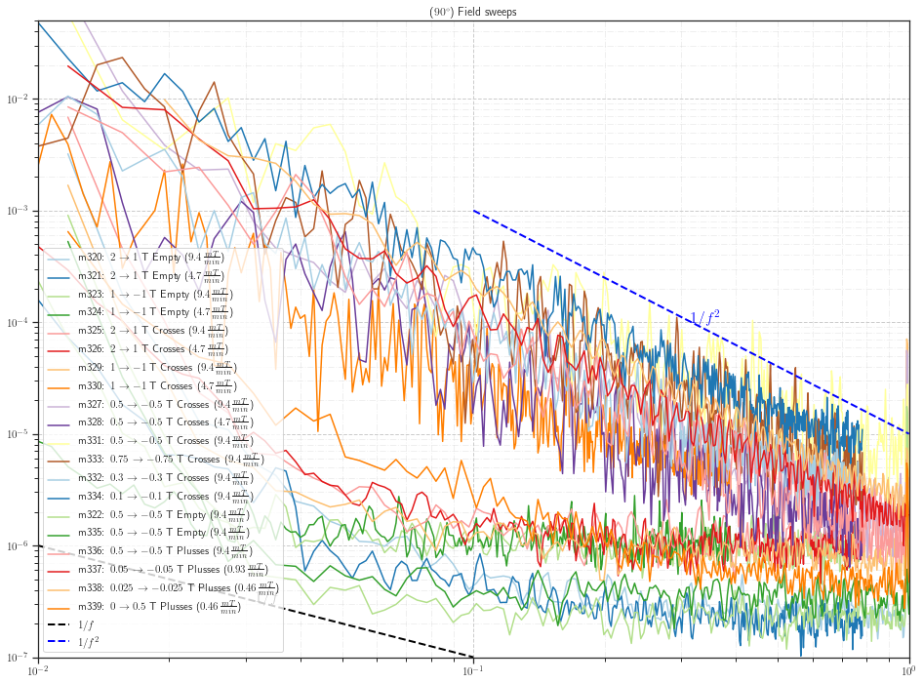

**Δ1T Sweeps**

Dienstag, 2. Juli 2019

08:33

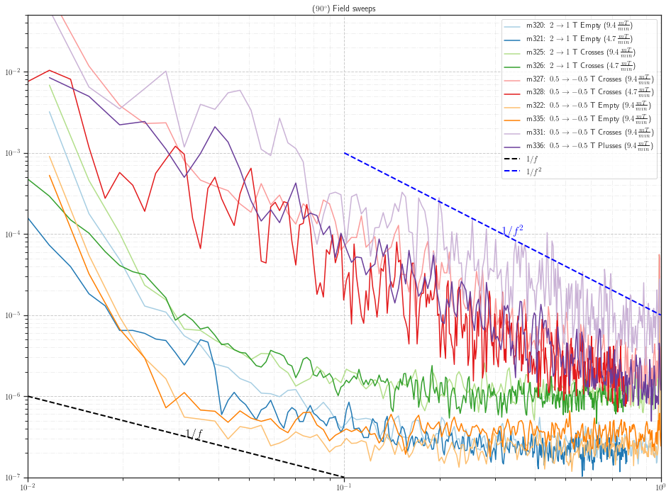

**Low Fields Sweeps ( < .5 T)**

Dienstag, 2. Juli 2019

08:41

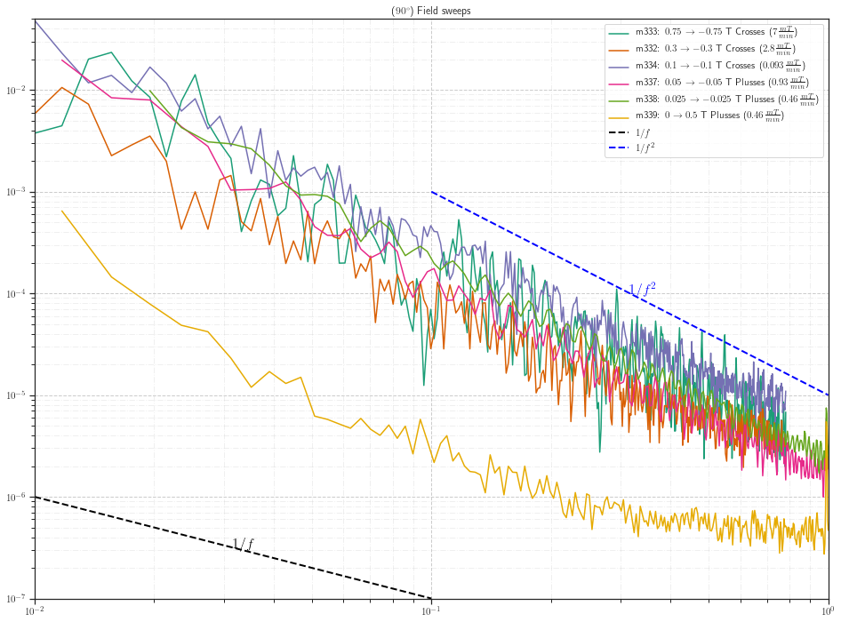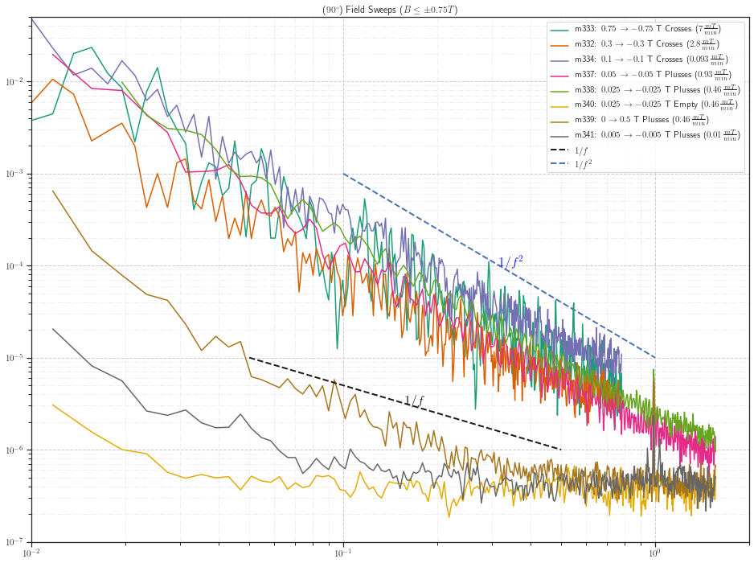

**Compare Fast SR (Empty/Crosses)**

Donnerstag, 27. Juni 2019

14:00

**2 → 1 T**

Donnerstag, 27. Juni 2019

11:52

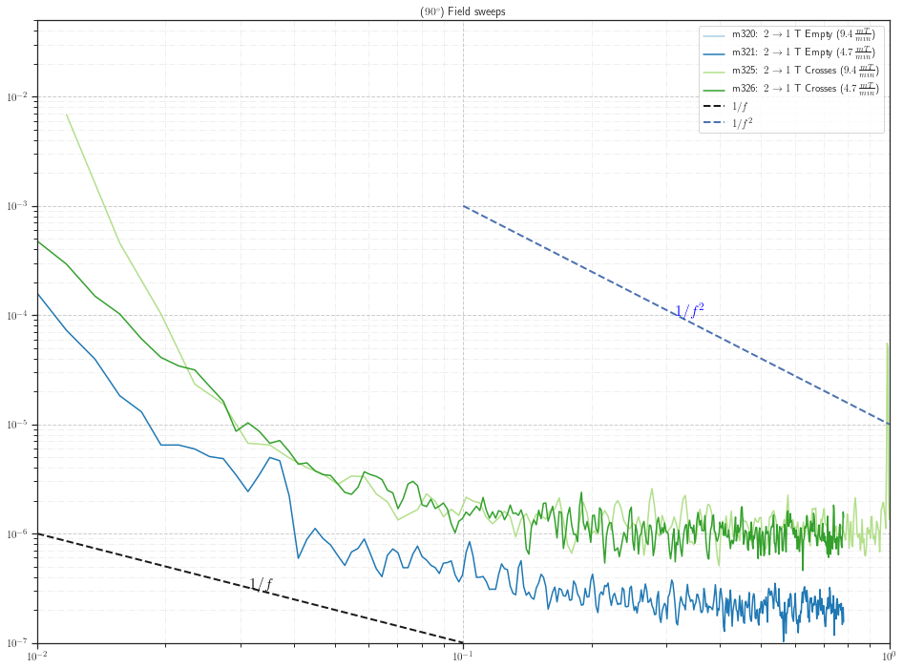

**0.5 → -0.5 T**

Donnerstag, 27. Juni 2019

11:53

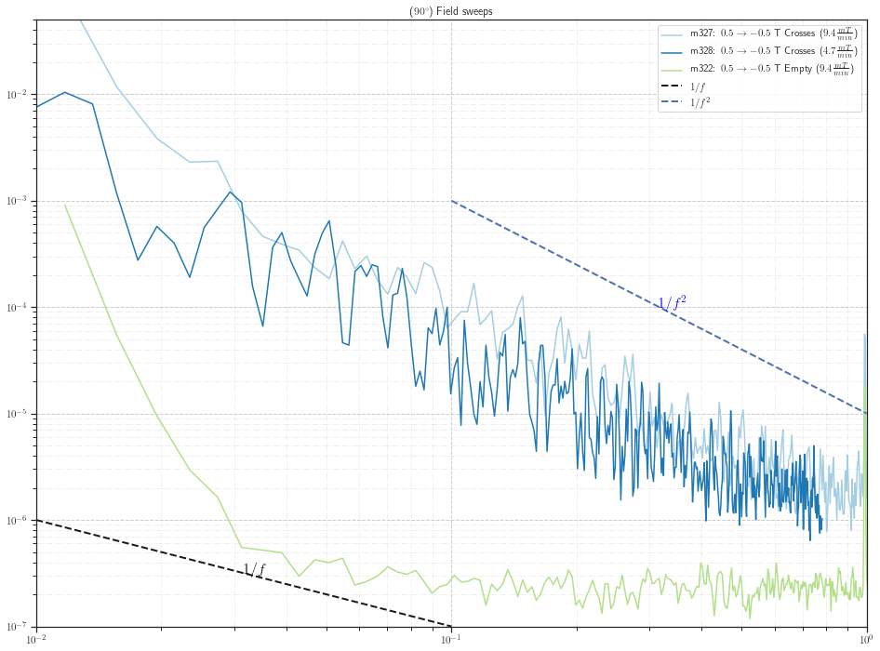

**1 → -1 T**

Donnerstag, 27. Juni 2019

11:54

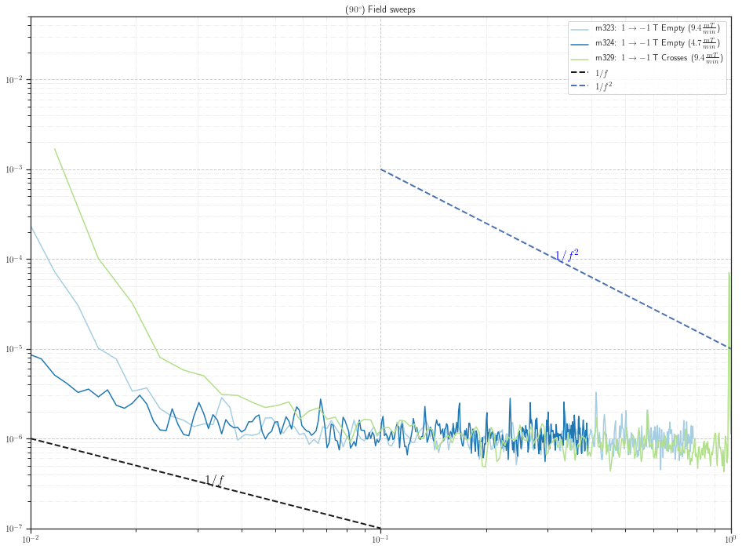

**Evaluating Static Fields**

Dienstag, 25. Juni 2019

20:01

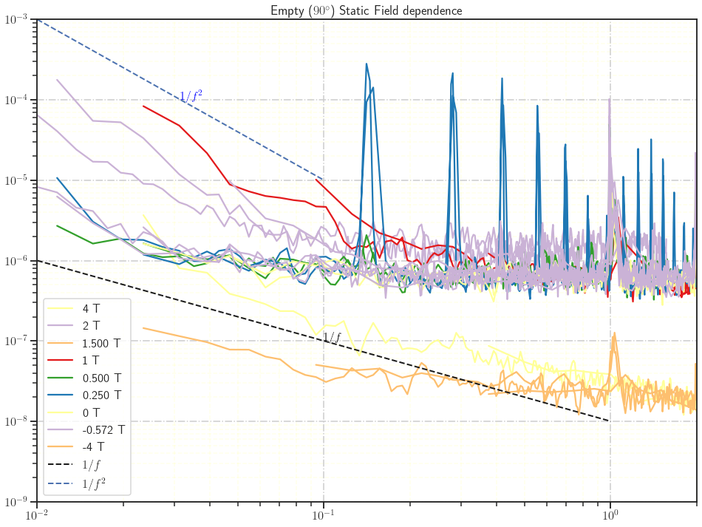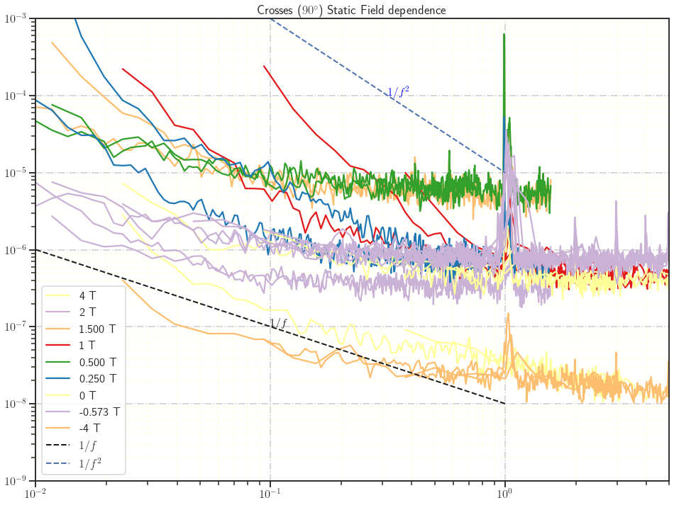

**m310: MFN\_#1\_0T\_PM**

Donnerstag, 13. Juni 2019

16:51

|  |  |
| --- | --- |
| Angle of sensor θ | *+90* |
| Temp | 30 K |
|  |  |
|  | |  |  |  |  | | --- | --- | --- | --- | |  | ***6 - 8*** |  |  | | ***Gate (0V)*** | ***9 - 4*** |  | ***14 - 7*** | |
|  | |  |  | | --- | --- | |  | *0 T Persistend Mode* | |
|  |  |
| Resistance Box | |  |  |  |  |  |  | | --- | --- | --- | --- | --- | --- | |  | *1 MΩ* |  | 6.6 kΩ |  | 450 Ω | |  | *1 MΩ* |  | *2* |  | *10* | |
|  | |  |  |  |  |  |  | | --- | --- | --- | --- | --- | --- | | Sens | 5 mV |  | 4 V |  |  | | *τ* | *3 ms* | *Input A* | *AC* | *Ground* | *Normal Reserve* | |
| Pre Amplifier (SR560) | |  |  |  |  | | --- | --- | --- | --- | | *Gain Mode* | *Low* | *Gain:* | *2e2* | | *Coupling* | *AC* | *Output (50Ω)* | *LI Input A* | | *Filters:* | *Off* |  |  | |
| Signal Analyzer (SR785) | |  |  |  |  | | --- | --- | --- | --- | | *Ch 1 (A)* |  | *Freq - Span:* | *6 / 3 Hz* | | *Ch 2 (A)* |  | *Averages:* | *30* | |
| Period of measurement (min) | *96 min* |
| He (l) level consumption |  |
| Data files | <<m310\_MFN\_Empty\_0T.dat>> |
| Plot |  |
|  |  |

**m311: MFN\_-0.572500T\_down sweep\_ Empty\_over night wide ranging f-spans\_**

Dienstag, 11. Juni 2019

22:23

|  |  |
| --- | --- |
| Angle of sensor θ | *+90* |
| Temp | 30 K |
|  | **Empty #1** |
|  | |  |  |  |  | | --- | --- | --- | --- | |  | ***6 - 8*** | *Crosses* |  | | ***Gate (0V)*** | ***9 - 4*** |  | ***14 - 7 Preamp.*** | |
|  | |  |  | | --- | --- | |  | *-0.572500T in down sweep and PM* | |
| Resistance Box | |  |  |  |  |  |  | | --- | --- | --- | --- | --- | --- | |  | *1 MΩ* |  |  |  |  | |  | *1 MΩ* |  |  |  | *10* | |
|  | |  |  |  |  |  |  | | --- | --- | --- | --- | --- | --- | | Sens | 5 mV |  | 4 V | *f* | *113 Hz* | | *τ* | *3 ms* | *Input A* | *AC* | *Ground* | *Normal Reserve* | |
| Pre Amplifier (SR560) | |  |  |  |  | | --- | --- | --- | --- | | *Gain Mode* | *Low* | *Gain:* | *2e2* | | *Coupling* | *AC* | *Output (50Ω)* | *LI Input A* | | *Filters:* | *Off* |  |  | |
| Signal Analyzer (SR785) | |  |  |  |  | | --- | --- | --- | --- | | *Ch 1 (A)* |  | *Freq - Span:* | *50,25, 12.5, 6.25, 3.125, 1.5625, 0.78125 Hz* | | *Ch 2 (A)* |  | *Averages:* | *30* | |
| Period of measurement (min) | *507 min (8.4hr) overnight started at 19:24* |
| He (l) level consumption |  |
| Data files | <<m311\_MFN\_Empty\_-0.572500T\_down sweep\_over\_night.dat>> |
| Plot |  |

**m312: MFN\_250mT\_up sweep\_Empty**

Freitag, 14. Juni 2019

15:00

|  |  |
| --- | --- |
| Angle of sensor θ | *+90* |
| Temp | 30 K |
|  | **Empty #1** |
|  | |  |  |  |  | | --- | --- | --- | --- | |  | ***6 - 8*** | *Crosses* |  | | ***Gate (0V)*** | ***9 - 4*** |  | ***14 - 7 Preamp.*** | |
|  | |  |  | | --- | --- | |  | *250 mT PM* | |
| Resistance Box | |  |  |  |  |  |  | | --- | --- | --- | --- | --- | --- | |  | *1 MΩ* |  |  |  |  | |  | *1 MΩ* |  |  |  | *10* | |
|  | |  |  |  |  |  |  | | --- | --- | --- | --- | --- | --- | | Sens | 5 mV |  | 4 V | *f* | *113 Hz* | | *τ* | *3 ms* | *Input A* | *AC* | *Ground* | *Normal Reserve* | |
| Pre Amplifier (SR560) | |  |  |  |  | | --- | --- | --- | --- | | *Gain Mode* | *Low* | *Gain:* | *2e2* | | *Coupling* | *AC* | *Output (50Ω)* | *LI Input A* | | *Filters:* | *Off* |  |  | |
| Signal Analyzer (SR785) | |  |  |  |  | | --- | --- | --- | --- | | *Ch 1 (A)* |  | *Freq - Span:* | *3.125, 1.5625Hz* | | *Ch 2 (A)* |  | *Averages:* | *30* | |
| Period of measurement (min) | *192 min (3:11 h)* |
| He (l) level consumption |  |
| Data files | <<m312\_MFN\_Empty\_0.25T\_down sweep.dat>>    <<m312\_MFN\_Empty\_0.25T\_SR785.dat>> |
| Plot |  |

**m313: MFN\_500mT\_up sweep\_Empty**

Freitag, 14. Juni 2019

19:00

|  |  |
| --- | --- |
| Angle of sensor θ | *+90* |
| Temp | 30 K |
|  | **Empty #1** |
|  | |  |  |  |  | | --- | --- | --- | --- | |  | ***6 - 8*** | *Crosses* |  | | ***Gate (0V)*** | ***9 - 4*** |  | ***14 - 7 Preamp.*** | |
|  | |  |  | | --- | --- | |  | *500 mT PM* | |
| Resistance Box | |  |  |  |  |  |  | | --- | --- | --- | --- | --- | --- | |  | *1 MΩ* |  |  |  |  | |  | *1 MΩ* |  |  |  | *10* | |
|  | |  |  |  |  |  |  | | --- | --- | --- | --- | --- | --- | | Sens | 5 mV |  | 4 V | *f* | *113 Hz* | | *τ* | *3 ms* | *Input A* | *AC* | *Ground* | *Normal Reserve* | |
| Pre Amplifier (SR560) | |  |  |  |  | | --- | --- | --- | --- | | *Gain Mode* | *Low* | *Gain:* | *2e2* | | *Coupling* | *AC* | *Output (50Ω)* | *LI Input A* | | *Filters:* | *Off* |  |  | |
| Signal Analyzer (SR785) | |  |  |  |  | | --- | --- | --- | --- | | *Ch 1 (A)* |  | *Freq - Span:* | *3.125, 1.5625Hz* | | *Ch 2 (A)* |  | *Averages:* | *30* | |
| Period of measurement (min) | *192 min (3:11 h)* |
| He (l) level consumption |  |
| Data files | <<m313\_MFN\_Empty\_0.5T\_SR830.dat>>    <<m313\_MFN\_Empty\_0.5T\_SR785.dat>> |
| Plot |  |

**m314: MFN\_1.5T\_up sweep\_Empty**

Freitag, 14. Juni 2019

22:47

|  |  |
| --- | --- |
| Angle of sensor θ | *+90* |
| Temp | 30 K |
|  | **Empty #1** |
|  | |  |  |  |  | | --- | --- | --- | --- | |  | ***6 - 8*** | *Crosses* |  | | ***Gate (0V)*** | ***9 - 4*** |  | ***14 - 7 Preamp.*** | |
|  | |  |  | | --- | --- | |  | *1.5 T PM* | |
| Resistance Box | |  |  |  |  |  |  | | --- | --- | --- | --- | --- | --- | |  | *1 MΩ* |  |  |  |  | |  | *1 MΩ* |  |  |  | *10* | |
|  | |  |  |  |  |  |  | | --- | --- | --- | --- | --- | --- | | Sens | 5 mV |  | 4 V | *f* | *113 Hz* | | *τ* | *3 ms* | *Input A* | *AC* | *Ground* | *Normal Reserve* |   *new DAQ mode still not working fine.* |
| Pre Amplifier (SR560) | |  |  |  |  | | --- | --- | --- | --- | | *Gain Mode* | *Low* | *Gain:* | *2e2* | | *Coupling* | *AC* | *Output (50Ω)* | *LI Input A* | | *Filters:* | *Off* |  |  | |
| Signal Analyzer (SR785) | |  |  |  |  | | --- | --- | --- | --- | | *Ch 1 (A)* |  | *Freq - Span:* | *3.125, 1.5625, 0.78 Hz* | | *Ch 2 (A)* |  | *Averages:* | *30* | |
| Period of measurement (min) | *448 min* |
| He (l) level consumption |  |
| Data files | <<m314\_MFN\_Empty\_1.5T\_SR830\_long.dat>> |
| Plot |  |

**Filling He(l)**

Samstag, 15. Juni 2019

10:47

|  |  |
| --- | --- |
| Filling date | 15.06.2019 |
| Before (in) | 28.23 |
| After (in) | 36.22 |
| consumption | 162-129=33 L |
| Person | MAM |

Notes:



'To do:

**m315: MFN\_250mT\_1.56 / 0.78 Hz\_Crosses**

Samstag, 15. Juni 2019

11:18

|  |  |
| --- | --- |
| Angle of sensor θ | *+90* |
| Temp | 30 K |
|  | **Crosses** |
|  | |  |  |  |  | | --- | --- | --- | --- | |  | ***2/12*** | *Crosses* |  | | ***Gate (0V)*** | ***9 - 4*** |  | ***14 - 7 Preamp.*** | |
|  | |  |  | | --- | --- | |  | *250mT PM* | |
| Resistance Box | |  |  |  |  |  |  | | --- | --- | --- | --- | --- | --- | |  | *1 MΩ* |  |  |  |  | |  | *1 MΩ* |  |  |  | *10* | |
|  | |  |  |  |  |  |  | | --- | --- | --- | --- | --- | --- | | Sens | 5 mV |  | 4 V | *f* | *113 Hz* | | *τ* | *3 ms* | *Input A* | *AC* | *Ground* | *Normal Reserve* |   *new DAQ mode still not working fine.* |
| Pre Amplifier (SR560) | |  |  |  |  | | --- | --- | --- | --- | | *Gain Mode* | *Low* | *Gain:* | *2e2* | | *Coupling* | *AC* | *Output (50Ω)* | *LI Input A* | | *Filters:* | *Off* |  |  | |
| Signal Analyzer (SR785) | |  |  |  |  | | --- | --- | --- | --- | | *Ch 1 (A)* |  | *Freq - Span:* | *1.56 / 0.78 Hz* | | *Ch 2 (A)* |  | *Averages:* | *30* | |
| Period of measurement (min) | *384 min (6,4 h)* |
| He (l) level consumption |  |
| Data files | <<m315\_MFN\_Crosses\_250mT\_SR785\_long.dat>> |
| Plot |  |

**M316: MFN\_500mT\_1.56 / 0.78 Hz\_Crosses**

16 June 2019

10:28

|  |  |
| --- | --- |
| Angle of sensor θ | *+90* |
| Temp | 30 K |
|  | **Crosses** |
|  | |  |  |  |  | | --- | --- | --- | --- | |  | ***2/12*** | *Crosses* |  | | ***Gate (0V)*** | ***9 - 4*** |  | ***14 - 7 Preamp.*** | |
|  | |  |  | | --- | --- | |  | *500mT PM* | |
| Resistance Box | |  |  |  |  |  |  | | --- | --- | --- | --- | --- | --- | |  | *1 MΩ* |  |  |  |  | |  | *1 MΩ* |  |  |  | *10* | |
|  | |  |  |  |  |  |  | | --- | --- | --- | --- | --- | --- | | Sens | 2 mV |  | 4 V | *f* | *113 Hz* | | *τ* | *3 ms* | *Input A* | *AC* | *Ground* | *Normal Reserve* |   *new DAQ mode still not working fine.* |
| Pre Amplifier (SR560) | |  |  |  |  | | --- | --- | --- | --- | | *Gain Mode* | *Low* | *Gain:* | *2e2* | | *Coupling* | *AC* | *Output (50Ω)* | *LI Input A* | | *Filters:* | *Off* |  |  | |
| Signal Analyzer (SR785) | |  |  |  |  | | --- | --- | --- | --- | | *Ch 1 (A)* |  | *Freq - Span:* | *1.56 / 0.78 Hz* | | *Ch 2 (A)* |  | *Averages:* | *30* | |
| Period of measurement (min) | *384.2 min (6,4 h) started at 10:30 on Sunday* |
| He (l) level consumption |  |
| Data files | <<m316\_MFN\_Crosses\_500mT\_SR785\_long.dat>> |
| Plot |  |

**m317: MFN\_1.5T\_1.56 / 0.78 Hz\_Crosses**

Sonntag, 16. Juni 2019

17:37

|  |  |
| --- | --- |
| Angle of sensor θ | *+90* |
| Temp | 30 K |
|  | **Crosses** |
|  | |  |  |  |  | | --- | --- | --- | --- | |  | ***2/12*** | *Crosses* |  | | ***Gate (0V)*** | ***9 - 4*** |  | ***14 - 7 Preamp.*** | |
|  | |  |  | | --- | --- | |  | *1.5 T PM* | |
| Resistance Box | |  |  |  |  |  |  | | --- | --- | --- | --- | --- | --- | |  | *1 MΩ* |  |  |  |  | |  | *1 MΩ* |  |  |  | *10* | |
|  | |  |  |  |  |  |  | | --- | --- | --- | --- | --- | --- | | Sens | 2 mV |  | 4 V | *f* | *113 Hz* | | *τ* | *3 ms* | *Input A* | *AC* | *Ground* | *Normal Reserve* |   *new DAQ mode still not working fine.* |
| Pre Amplifier (SR560) | |  |  |  |  | | --- | --- | --- | --- | | *Gain Mode* | *Low* | *Gain:* | *2e2* | | *Coupling* | *AC* | *Output (50Ω)* | *LI Input A* | | *Filters:* | *Off* |  |  | |
| Signal Analyzer (SR785) | |  |  |  |  | | --- | --- | --- | --- | | *Ch 1 (A)* |  | *Freq - Span:* | *1.56 / 0.78 Hz* | | *Ch 2 (A)* |  | *Averages:* | *30* | |
| Period of measurement (min) | *384 min (6,4 h)* |
| He (l) level consumption | <<m317\_MFN\_Crosses\_1.5T\_SR785\_long.dat>> |
| Data files |  |
| Plot |  |

**m318: MFN\_2T\_1.56 / 0.78 Hz\_Crosses**

Montag, 17. Juni 2019

00:26

|  |  |
| --- | --- |
| Angle of sensor θ | *+90* |
| Temp | 30 K |
|  | **Crosses** |
|  | |  |  |  |  | | --- | --- | --- | --- | |  | ***2/12*** | *Crosses* |  | | ***Gate (0V)*** | ***9 - 4*** |  | ***14 - 7 Preamp.*** | |
|  | |  |  | | --- | --- | |  | *250mT PM* | |
| Resistance Box | |  |  |  |  |  |  | | --- | --- | --- | --- | --- | --- | |  | *1 MΩ* |  |  |  |  | |  | *1 MΩ* |  |  |  | *10* | |
|  | |  |  |  |  |  |  | | --- | --- | --- | --- | --- | --- | | Sens | 10 mV |  | 4 V | *f* | *113 Hz* | | *τ* | *3 ms* | *Input A* | *AC* | *Ground* | *Normal Reserve* |   *new DAQ mode still not working fine.* |
| Pre Amplifier (SR560) | |  |  |  |  | | --- | --- | --- | --- | | *Gain Mode* | *Low* | *Gain:* | *2e2* | | *Coupling* | *AC* | *Output (50Ω)* | *LI Input A* | | *Filters:* | *Off* |  |  | |
| Signal Analyzer (SR785) | |  |  |  |  | | --- | --- | --- | --- | | *Ch 1 (A)* |  | *Freq - Span:* | *1.56 / 0.78 Hz* | | *Ch 2 (A)* |  | *Averages:* | *30* | |
| Period of measurement (min) | *384 min (6,4 h)* |
| He (l) level consumption |  |
| Data files | <<m315\_MFN\_Crosses\_250mT\_SR785\_long.dat>> |
| Plot |  |

**m319: MFN\_2T\_3.125, 1.5625, 0.78 Hz\_Empty**

Montag, 17. Juni 2019

07:13

|  |  |
| --- | --- |
| Angle of sensor θ | *+90* |
| Temp | 30 K |
|  | **Empty #1** |
|  | |  |  |  |  | | --- | --- | --- | --- | |  | ***6 - 8*** |  |  | | ***Gate (0V)*** | ***9 - 4*** |  | ***14 - 7 Preamp.*** | |
|  | |  |  | | --- | --- | |  | *2 T PM* | |
| Resistance Box | |  |  |  |  |  |  | | --- | --- | --- | --- | --- | --- | |  | *1 MΩ* |  |  |  |  | |  | *1 MΩ* |  |  |  | *10* | |
|  | |  |  |  |  |  |  | | --- | --- | --- | --- | --- | --- | | Sens | 5 mV |  | 4 V | *f* | *113 Hz* | | *τ* | *3 ms* | *Input A* | *AC* | *Ground* | *Normal Reserve* | |
| Pre Amplifier (SR560) | |  |  |  |  | | --- | --- | --- | --- | | *Gain Mode* | *Low* | *Gain:* | *2e2* | | *Coupling* | *AC* | *Output (50Ω)* | *LI Input A* | | *Filters:* | *Off* |  |  | |
| Signal Analyzer (SR785) | |  |  |  |  | | --- | --- | --- | --- | | *Ch 1 (A)* |  | *Freq - Span:* | *3.125, 1.5625, 0.78 Hz* | | *Ch 2 (A)* |  | *Averages:* | *30* | |
| Period of measurement (min) | *384 min (6,4 h) started 7:15 am* |
| He (l) level consumption |  |
| Data files | <<m319\_MFN\_Empty\_2T\_SR785\_long.dat>> |
| Plot |  |

**m320: MFN\_sweep\_2T-1T\_ 9.4 mT/min\_Empty 1.5625Hz**

Montag, 17. Juni 2019

07:13

|  |  |
| --- | --- |
| Angle of sensor θ | *+90* |
| Temp | 30 K |
|  | **Empty #1** |
|  | |  |  |  |  | | --- | --- | --- | --- | |  | ***6 - 8*** |  |  | | ***Gate (0V)*** | ***9 - 4*** |  | ***14 - 7 Preamp.*** | |
|  | |  |  | | --- | --- | |  | *2 T -- 1 T* | | *Sweeprate* | *9.4 mT/min* | |
| Resistance Box | |  |  |  |  |  |  | | --- | --- | --- | --- | --- | --- | |  | *1 MΩ* |  |  |  |  | |  | *1 MΩ* |  |  |  | *10* | |
|  | |  |  |  |  |  |  | | --- | --- | --- | --- | --- | --- | | Sens | 10 mV |  | 4 V | *f* | *113 Hz* | | *τ* | *3 ms* | *Input A* | *AC* | *Ground* | *Normal Reserve* | |
| Pre Amplifier (SR560) | |  |  |  |  | | --- | --- | --- | --- | | *Gain Mode* | *Low* | *Gain:* | *2e2* | | *Coupling* | *AC* | *Output (50Ω)* | *LI Input A* | | *Filters:* | *Off* |  |  | |
| Signal Analyzer (SR785) | |  |  |  |  | | --- | --- | --- | --- | | *Ch 1 (A)* |  | *Freq - Span:* | *1.5625* | | *Ch 2 (A)* |  | *Averages:* | *25* | |
| Period of measurement (min) | *106 min (1:46 h)* |
| He (l) level consumption |  |
| Data files | <<m320\_MFN\_Empty\_sweep\_2T-1T\_SR785\_real.dat>> |
| Plot |  |

**m321: MFN\_sweep\_2T-1T\_4.7 mT/min\_Empty\_0.78Hz**

Montag, 17. Juni 2019

16:24

|  |  |
| --- | --- |
| Angle of sensor θ | *+90* |
| Temp | 30 K |
|  | **Empty #1** |
|  | |  |  |  |  | | --- | --- | --- | --- | |  | ***6 - 8*** |  |  | | ***Gate (0V)*** | ***9 - 4*** |  | ***14 - 7 Preamp.*** | |
|  | |  |  | | --- | --- | |  | *2 T -- 1 T* | | *Sweeprate* | *4.7 mT/min* | |
| Resistance Box | |  |  |  |  |  |  | | --- | --- | --- | --- | --- | --- | |  | *1 MΩ* |  |  |  |  | |  | *1 MΩ* |  |  |  | *10* | |
|  | |  |  |  |  |  |  | | --- | --- | --- | --- | --- | --- | | Sens | 10 mV |  | 4 V | *f* | *113 Hz* | | *τ* | *3 ms* | *Input A* | *AC* | *Ground* | *Normal Reserve* | |
| Pre Amplifier (SR560) | |  |  |  |  | | --- | --- | --- | --- | | *Gain Mode* | *Low* | *Gain:* | *2e2* | | *Coupling* | *AC* | *Output (50Ω)* | *LI Input A* | | *Filters:* | *Off* |  |  | |
| Signal Analyzer (SR785) | |  |  |  |  | | --- | --- | --- | --- | | *Ch 1 (A)* |  | *Freq - Span:* | *0.78* | | *Ch 2 (A)* |  | *Averages:* | *25* | |
| Period of measurement (min) | *214 min (3:34 h)* |
| He (l) level consumption |  |
| Data files | <<m321\_MFN\_Empty\_sweep\_2T-1T\_SR785\_real.dat>> |
| Plot |  |

**m322: MFN\_sweep\_0.5T to-0.5T\_9.4 mT/min Empty\_1.5625Hz**

Montag, 17. Juni 2019

19:39

|  |  |
| --- | --- |
| Angle of sensor θ | *+90* |
| Temp | 30 K |
|  | **Empty #1** |
|  | |  |  |  |  | | --- | --- | --- | --- | |  | ***6 - 8*** |  |  | | ***Gate (0V)*** | ***9 - 4*** |  | ***14 - 7 Preamp.*** | |
|  | |  |  | | --- | --- | |  | *+500 mT → -500 mT* | | *Sweeprate* | *9.4 mT/min* | |
| Resistance Box | |  |  |  |  |  |  | | --- | --- | --- | --- | --- | --- | |  | *1 MΩ* |  |  |  |  | |  | *1 MΩ* |  |  |  | *10* | |
|  | |  |  |  |  |  |  | | --- | --- | --- | --- | --- | --- | | Sens | 10 mV |  | 4 V | *f* | *113 Hz* | | *τ* | *3 ms* | *Input A* | *AC* | *Ground* | *Normal Reserve* | |
| Pre Amplifier (SR560) | |  |  |  |  | | --- | --- | --- | --- | | *Gain Mode* | *Low* | *Gain:* | *2e2* | | *Coupling* | *AC* | *Output (50Ω)* | *LI Input A* | | *Filters:* | *Off* |  |  | |
| Signal Analyzer (SR785) | |  |  |  |  | | --- | --- | --- | --- | | *Ch 1 (A)* |  | *Freq - Span:* | *1.5625* | | *Ch 2 (A)* |  | *Averages:* | *25* | |
| Period of measurement (min) | *106 min (1:46 h)* |
| He (l) level consumption |  |
| Data files | <<m322\_MFN\_Empty\_sweep\_500mT\_9.4mTmin\_SR785\_real.dat>> |
| Plot |  |

**m322: MFN\_sweep\_0.5T to-0.5T\_9.4 mT/min Empty\_1.5625Hz**

Montag, 17. Juni 2019

19:39

|  |  |
| --- | --- |
| Angle of sensor θ | *+90* |
| Temp | 30 K |
|  | **Empty #1** |
|  | |  |  |  |  | | --- | --- | --- | --- | |  | ***6 - 8*** |  |  | | ***Gate (0V)*** | ***9 - 4*** |  | ***14 - 7 Preamp.*** | |
|  | |  |  | | --- | --- | |  | *+500 mT → -500 mT* | | *Sweeprate* | *9.4 mT/min* | |
| Resistance Box | |  |  |  |  |  |  | | --- | --- | --- | --- | --- | --- | |  | *1 MΩ* |  |  |  |  | |  | *1 MΩ* |  |  |  | *10* | |
|  | |  |  |  |  |  |  | | --- | --- | --- | --- | --- | --- | | Sens | 10 mV |  | 4 V | *f* | *113 Hz* | | *τ* | *3 ms* | *Input A* | *AC* | *Ground* | *Normal Reserve* | |
| Pre Amplifier (SR560) | |  |  |  |  | | --- | --- | --- | --- | | *Gain Mode* | *Low* | *Gain:* | *2e2* | | *Coupling* | *AC* | *Output (50Ω)* | *LI Input A* | | *Filters:* | *Off* |  |  | |
| Signal Analyzer (SR785) | |  |  |  |  | | --- | --- | --- | --- | | *Ch 1 (A)* |  | *Freq - Span:* | *1.5625* | | *Ch 2 (A)* |  | *Averages:* | *25* | |
| Period of measurement (min) | *106 min (1:46 h)* |
| He (l) level consumption |  |
| Data files | <<m322\_MFN\_Empty\_sweep\_500mT\_9.4mTmin\_SR785\_real.dat>> |
| Plot |  |

**m323: MFN\_sweep\_1T\_9.4 mT/min\_Empty\_0.78Hz**

Montag, 17. Juni 2019

21:34

|  |  |
| --- | --- |
| Angle of sensor θ | *+90* |
| Temp | 30 K |
|  | **Empty #1** |
|  | |  |  |  |  | | --- | --- | --- | --- | |  | ***6 - 8*** |  |  | | ***Gate (0V)*** | ***9 - 4*** |  | ***14 - 7 Preamp.*** | |
|  | |  |  | | --- | --- | |  | *1 T → -1 T* | | *Sweeprate* | *9.4 mT/min* | |
| Resistance Box | |  |  |  |  |  |  | | --- | --- | --- | --- | --- | --- | |  | *1 MΩ* |  |  |  |  | |  | *1 MΩ* |  |  |  | *10* | |
|  | |  |  |  |  |  |  | | --- | --- | --- | --- | --- | --- | | Sens | 5 mV |  | 4 V | *f* | *113 Hz* | | *τ* | *3 ms* | *Input A* | *AC* | *Ground* | *Normal Reserve* | |
| Pre Amplifier (SR560) | |  |  |  |  | | --- | --- | --- | --- | | *Gain Mode* | *Low* | *Gain:* | *2e2* | | *Coupling* | *AC* | *Output (50Ω)* | *LI Input A* | | *Filters:* | *Off* |  |  | |
| Signal Analyzer (SR785) | |  |  |  |  | | --- | --- | --- | --- | | *Ch 1 (A)* |  | *Freq - Span:* | *0.78* | | *Ch 2 (A)* |  | *Averages:* | *25* | |
| Period of measurement (min) | *214 min (3:34 h)* |
| He (l) level consumption |  |
| Data files | <<m323\_MFN\_Empty\_sweep\_1T\_9.4mTmin\_SR785\_real.dat>> |
| Plot |  |

**m324: MFN\_sweep\_-1T to 1T \_4.7 mT/min\_Empty\_0.3906Hz**

Dienstag, 18. Juni 2019

01:15

|  |  |
| --- | --- |
| Angle of sensor θ | *+90* |
| Temp | 30 K |
|  | **Empty #1** |
|  | |  |  |  |  | | --- | --- | --- | --- | |  | ***6 - 8*** |  |  | | ***Gate (0V)*** | ***9 - 4*** |  | ***14 - 7 Preamp.*** | |
|  | |  |  | | --- | --- | |  | *-1 T → 1 T* | | *Sweeprate* | *4.7 mT/min* | |
| Resistance Box | |  |  |  |  |  |  | | --- | --- | --- | --- | --- | --- | |  | *1 MΩ* |  |  |  |  | |  | *1 MΩ* |  |  |  | *10* | |
|  | |  |  |  |  |  |  | | --- | --- | --- | --- | --- | --- | | Sens | 5 mV |  | 4 V | *f* | *113 Hz* | | *τ* | *3 ms* | *Input A* | *AC* | *Ground* | *Normal Reserve* | |
| Pre Amplifier (SR560) | |  |  |  |  | | --- | --- | --- | --- | | *Gain Mode* | *Low* | *Gain:* | *2e2* | | *Coupling* | *AC* | *Output (50Ω)* | *LI Input A* | | *Filters:* | *Off* |  |  | |
| Signal Analyzer (SR785) | |  |  |  |  | | --- | --- | --- | --- | | *Ch 1 (A)* |  | *Freq - Span:* | *0.3906* | | *Ch 2 (A)* |  | *Averages:* | *25* | |
| Period of measurement (min) | *407 min* |
| He (l) level consumption |  |
| Data files | <<m324\_MFN\_Empty\_sweep\_1T\_4.7mTmin\_SR785\_real.dat>> |
| Plot |  |

**m325: MFN\_sweep\_2T to 1T\_4.7mT.min\_Crosses\_1.56 Hz**

Dienstag, 18. Juni 2019

09:59

|  |  |
| --- | --- |
| Angle of sensor θ | *+90* |
| Temp | 30 K |
|  | **Crosses 2-12** |
|  | |  |  |  |  | | --- | --- | --- | --- | |  | ***2-12*** |  |  | | ***Gate (0V)*** | ***9 - 4*** |  | ***14 - 7 Preamp.*** | |
|  | |  |  | | --- | --- | |  | *2T → 1 T* | | *Sweeprate* | *4.7 mT/min* | |
| Resistance Box | |  |  |  |  |  |  | | --- | --- | --- | --- | --- | --- | |  | *1 MΩ* |  |  |  |  | |  | *1 MΩ* |  |  |  | *10* | |
|  | |  |  |  |  |  |  | | --- | --- | --- | --- | --- | --- | | Sens | 5 mV |  | 4 V | *f* | *113 Hz* | | *τ* | *3 ms* | *Input A* | *AC* | *Ground* | *Normal Reserve* | |
| Pre Amplifier (SR560) | |  |  |  |  | | --- | --- | --- | --- | | *Gain Mode* | *Low* | *Gain:* | *2e2* | | *Coupling* | *AC* | *Output (50Ω)* | *LI Input A* | | *Filters:* | *Off* |  |  | |
| Signal Analyzer (SR785) | |  |  |  |  | | --- | --- | --- | --- | | *Ch 1 (A)* |  | *Freq - Span:* | *1.56 Hz* | | *Ch 2 (A)* |  | *Averages:* | *25* | |
| Period of measurement (min) | *106.7 min* |
| He (l) level consumption |  |
| Data files | <<m325\_MFN\_Crosses\_sweep\_2T to 1T\_9.4mTmin\_SR785\_\_\_.dat>> |
| Plot |  |

**m326: MFN\_sweep\_2T to 1T\_4.7mT.min\_Crosses\_0.78 Hz**

Dienstag, 18. Juni 2019

14:40

|  |  |
| --- | --- |
| Angle of sensor θ | *+90* |
| Temp | 30 K |
|  | **Crosses (2-12)** |
|  | |  |  |  |  | | --- | --- | --- | --- | |  | ***2 - 12*** |  |  | | ***Gate (0V)*** | ***9 - 4*** |  | ***14 - 7 Preamp.*** | |
|  | |  |  | | --- | --- | |  | *2 T -- 1 T* | | *Sweeprate* |  | |
| Resistance Box | |  |  |  |  |  |  | | --- | --- | --- | --- | --- | --- | |  | *1 MΩ* |  |  |  |  | |  | *1 MΩ* |  |  |  | *10* | |
|  | |  |  |  |  |  |  | | --- | --- | --- | --- | --- | --- | | Sens | 5 mV |  | 4 V | *f* | *113 Hz* | | *τ* | *3 ms* | *Input A* | *AC* | *Ground* | *Normal Reserve* | |
| Pre Amplifier (SR560) | |  |  |  |  | | --- | --- | --- | --- | | *Gain Mode* | *Low* | *Gain:* | *2e2* | | *Coupling* | *AC* | *Output (50Ω)* | *LI Input A* | | *Filters:* | *Off* |  |  | |
| Signal Analyzer (SR785) | |  |  |  |  | | --- | --- | --- | --- | | *Ch 1 (A)* |  | *Freq - Span:* | *.78* | | *Ch 2 (A)* |  | *Averages:* | *25* | |
| Period of measurement (min) | *214 min* |
| He (l) level consumption |  |
| Data files | <<m326\_MFN\_Crosses\_sweep\_2T to 1T\_4.7mTmin\_SR785\_\_\_.dat>> |
| Plot |  |

[*https://mems-news.mems-exchange.narkive.com/yWEVvHnN/damaging-of-boats-during-nickel-evaporation*](https://mems-news.mems-exchange.narkive.com/yWEVvHnN/damaging-of-boats-during-nickel-evaporation)

**Filling He(l)**

Mittwoch, 19. Juni 2019

08:30

|  |  |
| --- | --- |
| Filling date | 19.06.2019 |
| Before (in) | 25.23 |
| After (in) | 36.22 |
| consumption | 180-136=44 L |
| Person | MAM |

Notes:



'To do:

**m327: MFN\_sweep\_0.5T to -0.5T\_9.4mT.min\_Crosses\_1.56 Hz**

Mittwoch, 19. Juni 2019

09:21

|  |  |
| --- | --- |
| Angle of sensor θ | *+90* |
| Temp | 30 K |
|  | **Crosses (2-12)** |
|  | |  |  |  |  | | --- | --- | --- | --- | |  | ***2 - 12*** |  |  | | ***Gate (0V)*** | ***9 - 4*** |  | ***14 - 7 Preamp.*** | |
|  | |  |  | | --- | --- | |  | *0.5 to -0.5T* | | *Sweeprate* | *9.4mT/min* | |
| Resistance Box | |  |  |  |  |  |  | | --- | --- | --- | --- | --- | --- | |  | *1 MΩ* |  |  |  |  | |  | *1 MΩ* |  |  |  | *10* | |
|  | |  |  |  |  |  |  | | --- | --- | --- | --- | --- | --- | | Sens | 5 mV |  | 4 V | *f* | *113 Hz* | | *τ* | *3 ms* | *Input A* | *AC* | *Ground* | *Normal Reserve* | |
| Pre Amplifier (SR560) | |  |  |  |  | | --- | --- | --- | --- | | *Gain Mode* | *Low* | *Gain:* | *2e2* | | *Coupling* | *AC* | *Output (50Ω)* | *LI Input A* | | *Filters:* | *Off* |  |  | |
| Signal Analyzer (SR785) | |  |  |  |  | | --- | --- | --- | --- | | *Ch 1 (A)* |  | *Freq - Span:* | *1.56* | | *Ch 2 (A)* |  | *Averages:* | *25* | |
| Period of measurement (min) | *106 min* |
| He (l) level consumption |  |
| Data files | <<m327\_MFN\_Crosses\_sweep\_0.5T to -0.5T\_9.4mTmin\_SR785\_\_\_.dat>>  <<m327\_MFN\_Crosses\_sweep\_0.5T to -0.5T\_9.4mTmin\_SR785\_\_\_.dat>> |
| Plot |  |

**m328: MFN\_sweep\_0.5T to -0.5T\_4.7mT.min\_Crosses\_0.78125 Hz**

Mittwoch, 19. Juni 2019

11:20

|  |  |
| --- | --- |
| Angle of sensor θ | *+90* |
| Temp | 30 K |
|  | **Crosses (2-12)** |
|  | |  |  |  |  | | --- | --- | --- | --- | |  | ***2 - 12*** |  |  | | ***Gate (0V)*** | ***9 - 4*** |  | ***14 - 7 Preamp.*** | |
|  | |  |  | | --- | --- | |  | *0.5 to -0.5T* | | *Sweeprate* | *4.7mT/min* | |
| Resistance Box | |  |  |  |  |  |  | | --- | --- | --- | --- | --- | --- | |  | *1 MΩ* |  |  |  |  | |  | *1 MΩ* |  |  |  | *10* | |
|  | |  |  |  |  |  |  | | --- | --- | --- | --- | --- | --- | | Sens | 5 mV |  | 4 V | *f* | *113 Hz* | | *τ* | *3 ms* | *Input A* | *AC* | *Ground* | *Normal Reserve* | |
| Pre Amplifier (SR560) | |  |  |  |  | | --- | --- | --- | --- | | *Gain Mode* | *Low* | *Gain:* | *2e2* | | *Coupling* | *AC* | *Output (50Ω)* | *LI Input A* | | *Filters:* | *Off* |  |  | |
| Signal Analyzer (SR785) | |  |  |  |  | | --- | --- | --- | --- | | *Ch 1 (A)* |  | *Freq - Span:* | *0.78125* | | *Ch 2 (A)* |  | *Averages:* | *25* | |
| Period of measurement (min) | *213 min* |
| He (l) level consumption |  |
| Data files | <<m328\_MFN\_Crosses\_sweep\_0.5T to -0.5T\_4.7mTmin\_SR785\_\_\_.dat>> |
| Plot |  |

**Filling He(l)**

Freitag, 21. Juni 2019

17:02

|  |  |
| --- | --- |
| Filling date | 21.06.2019 |
| Before (in) | 30.2 |
| After (in) | 36.22 |
| consumption | 180-136=44 L |
| Person | MAM |

Notes:



'To do:

**Filling He(l)**

Dienstag, 25. Juni 2019

17:29

|  |  |
| --- | --- |
| Filling date | 25.06.2019 |
| Before (in) | 24 |
| After (in) | 36.22 |
| consumption | 180-136=44 L |
| Person | MAM |

Notes:



'To do:

**Filling He(l)**

Freitag, 28. Juni 2019

16:23

|  |  |
| --- | --- |
| Filling date | 28.06.2019 |
| Before (in) | 29 |
| After (in) |  |
| consumption | 180-136=44 L |
| Person | MAM |

Notes:



'To do:

**m329: MFN\_sweep\_1T to -1T\_9.4mT.min\_Crosses\_0.78 Hz**

Samstag, 29. Juni 2019

11:45

|  |  |
| --- | --- |
| Angle of sensor θ | *+90* |
| Temp | 30 K |
|  | **Crosses (2-12)** |
|  | |  |  |  |  | | --- | --- | --- | --- | |  | ***2 - 12*** |  |  | | ***Gate (0V)*** | ***9 - 4*** |  | ***14 - 7 Preamp.*** | |
|  | |  |  | | --- | --- | |  | *1T to -1T* | | *Sweeprate* | *9.4mT/min* | |
| Resistance Box | |  |  |  |  |  |  | | --- | --- | --- | --- | --- | --- | |  | *1 MΩ* |  |  |  |  | |  | *1 MΩ* |  |  |  | *10* | |
|  | |  |  |  |  |  |  | | --- | --- | --- | --- | --- | --- | | Sens | 2 mV |  | 4 V | *f* | *113 Hz* | | *τ* | *3 ms* | *Input A* | *AC* | *Ground* | *Normal Reserve* | |
| Pre Amplifier (SR560) | |  |  |  |  | | --- | --- | --- | --- | | *Gain Mode* | *Low* | *Gain:* | *2e2* | | *Coupling* | *AC* | *Output (50Ω)* | *LI Input A* | | *Filters:* | *Off* |  |  | |
| Signal Analyzer (SR785) | |  |  |  |  | | --- | --- | --- | --- | | *Ch 1 (A)* |  | *Freq - Span:* | *0.78* | | *Ch 2 (A)* |  | *Averages:* | *25* | |
| Period of measurement (min) | *213min* |
| He (l) level consumption |  |
| Data files | <<m329\_MFN\_Crosses\_sweep\_1T to -1T\_9.4mTmin\_SR785\_0.79Hz\_\_\_after fixing EVE.dat>> |
| Plot |  |

**Introducing the decoupler**

Thursday, 4. July 2019

19:34

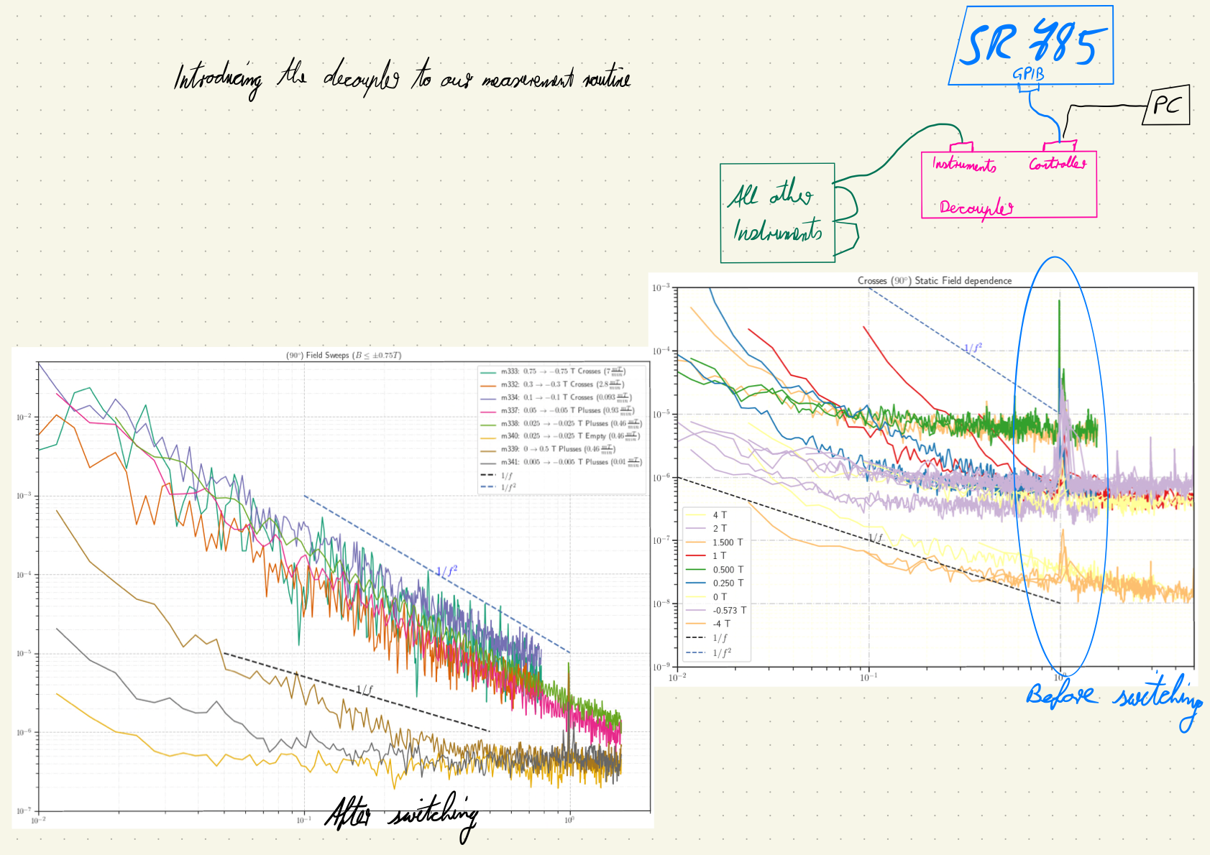<<Lab-Book-4.pdf>>

**Changing Cables**

28 June 2019

14:00

Signal Analyzer has changed the GPIB Cable.

**m330: MFN\_sweep\_1T to -1T\_4.9mT.min\_Crosses\_0.39 Hz**

Sonntag, 30. Juni 2019

01:30

|  |  |
| --- | --- |
| Angle of sensor θ | *+90* |
| Temp | 30 K |
|  | **Crosses (2-12)** |
|  | |  |  |  |  | | --- | --- | --- | --- | |  | ***2 - 12*** |  |  | | ***Gate (0V)*** | ***9 - 4*** |  | ***14 - 7 Preamp.*** | |
|  | |  |  | | --- | --- | |  | *1T to -1T* | | *Sweeprate* | *4.9mT/min* | |
| Resistance Box | |  |  |  |  |  |  | | --- | --- | --- | --- | --- | --- | |  | *1 MΩ* |  |  |  |  | |  | *1 MΩ* |  |  |  | *10* | |
|  | |  |  |  |  |  |  | | --- | --- | --- | --- | --- | --- | | Sens | 2 mV |  | 4 V | *f* | *113 Hz* | | *τ* | *3 ms* | *Input A* | *AC* | *Ground* | *Normal Reserve* | |
| Pre Amplifier (SR560) | |  |  |  |  | | --- | --- | --- | --- | | *Gain Mode* | *Low* | *Gain:* | *2e2* | | *Coupling* | *AC* | *Output (50Ω)* | *LI Input A* | | *Filters:* | *Off* |  |  | |
| Signal Analyzer (SR785) | |  |  |  |  | | --- | --- | --- | --- | | *Ch 1 (A)* |  | *Freq - Span:* | *0.39* | | *Ch 2 (A)* |  | *Averages:* | *25* | |
| Period of measurement (min) | *213min* |
| He (l) level consumption |  |
| Data files | <<m330\_MFN\_Crosses\_sweep\_1T to -1T\_4.9mTmin\_SR785\_0.39Hz\_\_.dat>> |
| Plot |  |

**m331: MFN\_sweep\_0.5T to -0.5T\_9.4mT.min\_Crosses\_1.5Hz\_repeated to compare**

Sonntag, 30. Juni 2019

09:35

|  |  |
| --- | --- |
| Angle of sensor θ | *+90* |
| Temp | 30 K |
|  | **Crosses (2-12)** |
|  | |  |  |  |  | | --- | --- | --- | --- | |  | ***2 - 12*** |  |  | | ***Gate (0V)*** | ***9 - 4*** |  | ***14 - 7 Preamp.*** | |
|  | |  |  | | --- | --- | |  | *0.5T to -0.5T* | | *Sweeprate* | *9.4mT/min* | |
| Resistance Box | |  |  |  |  |  |  | | --- | --- | --- | --- | --- | --- | |  | *1 MΩ* |  |  |  |  | |  | *1 MΩ* |  |  |  | *10* | |
|  | |  |  |  |  |  |  | | --- | --- | --- | --- | --- | --- | | Sens | 2 mV |  | 4 V | *f* | *113 Hz* | | *τ* | *3 ms* | *Input A* | *AC* | *Ground* | *Normal Reserve* | |
| Pre Amplifier (SR560) | |  |  |  |  | | --- | --- | --- | --- | | *Gain Mode* | *Low* | *Gain:* | *2e2* | | *Coupling* | *AC* | *Output (50Ω)* | *LI Input A* | | *Filters:* | *Off* |  |  | |
| Signal Analyzer (SR785) | |  |  |  |  | | --- | --- | --- | --- | | *Ch 1 (A)* |  | *Freq - Span:* | *1.5* | | *Ch 2 (A)* |  | *Averages:* | *25* | |
| Period of measurement (min) | *106min* |
| He (l) level consumption |  |
| Data files | <<m331\_MFN\_Crosses\_sweep\_0.5T to -0.5T\_9.4mTmin\_SR785\_1.5Hz\_\_.dat>> |
| Plot |  |

**m332: MFN\_sweep\_0.3T to -0.3T\_2.8mT.min\_Crosses\_0.78Hz**

Sonntag, 30. Juni 2019

12:34

|  |  |
| --- | --- |
| Angle of sensor θ | *+90* |
| Temp | 30 K |
|  | **Crosses (2-12)** |
|  | |  |  |  |  | | --- | --- | --- | --- | |  | ***2 - 12*** |  |  | | ***Gate (0V)*** | ***9 - 4*** |  | ***14 - 7 Preamp.*** | |
|  | |  |  | | --- | --- | |  | *0.3T to -0.3T* | | *Sweeprate* | *2.8mT/min* | |
| Resistance Box | |  |  |  |  |  |  | | --- | --- | --- | --- | --- | --- | |  | *1 MΩ* |  |  |  |  | |  | *1 MΩ* |  |  |  | *10* | |
|  | |  |  |  |  |  |  | | --- | --- | --- | --- | --- | --- | | Sens | 2 mV |  | 4 V | *f* | *113 Hz* | | *τ* | *3 ms* | *Input A* | *AC* | *Ground* | *Normal Reserve* | |
| Pre Amplifier (SR560) | |  |  |  |  | | --- | --- | --- | --- | | *Gain Mode* | *Low* | *Gain:* | *2e2* | | *Coupling* | *AC* | *Output (50Ω)* | *LI Input A* | | *Filters:* | *Off* |  |  | |
| Signal Analyzer (SR785) | |  |  |  |  | | --- | --- | --- | --- | | *Ch 1 (A)* |  | *Freq - Span:* | *0.78* | | *Ch 2 (A)* |  | *Averages:* | *25* | |
| Period of measurement (min) | *106min* |
| He (l) level consumption |  |
| Data files | <<m332\_MFN\_Crosses\_sweep\_0.3T to -0.3T\_2.8mTmin\_SR785\_0.78Hz\_\_\_\_.dat>> |
| Plot |  |

**m333: MFN\_sweep\_0.75T to -0.75T\_2.8mT.min\_Crosses\_0.78Hz**

Sonntag, 30. Juni 2019

16:21

|  |  |
| --- | --- |
| Angle of sensor θ | *+90* |
| Temp | 30 K |
|  | **Crosses (2-12)** |
|  | |  |  |  |  | | --- | --- | --- | --- | |  | ***2 - 12*** |  |  | | ***Gate (0V)*** | ***9 - 4*** |  | ***14 - 7 Preamp.*** | |
|  | |  |  | | --- | --- | |  | *0.75T to -0.75T* | | *Sweeprate* | *7mT/min* | |
| Resistance Box | |  |  |  |  |  |  | | --- | --- | --- | --- | --- | --- | |  | *1 MΩ* |  |  |  |  | |  | *1 MΩ* |  |  |  | *10* | |
|  | |  |  |  |  |  |  | | --- | --- | --- | --- | --- | --- | | Sens | 2 mV |  | 4 V | *f* | *113 Hz* | | *τ* | *3 ms* | *Input A* | *AC* | *Ground* | *Normal Reserve* | |
| Pre Amplifier (SR560) | |  |  |  |  | | --- | --- | --- | --- | | *Gain Mode* | *Low* | *Gain:* | *2e2* | | *Coupling* | *AC* | *Output (50Ω)* | *LI Input A* | | *Filters:* | *Off* |  |  | |
| Signal Analyzer (SR785) | |  |  |  |  | | --- | --- | --- | --- | | *Ch 1 (A)* |  | *Freq - Span:* | *0.78* | | *Ch 2 (A)* |  | *Averages:* | *25* | |
| Period of measurement (min) | *214min* |
| He (l) level consumption |  |
| Data files | <<m333\_MFN\_Crosses\_sweep\_0.75T to -0.75T\_7mTmin\_SR785\_0.78Hz\_\_\_\_.dat>> |
| Plot |  |

**m334: MFN\_sweep\_0.1T to -0.1T\_0.093mT.min\_Crosses\_0.78Hz**

Sonntag, 30. Juni 2019

19:57

|  |  |
| --- | --- |
| Angle of sensor θ | *+90* |
| Temp | 30 K |
|  | **Crosses (2-12)** |
|  | |  |  |  |  | | --- | --- | --- | --- | |  | ***2 - 12*** |  |  | | ***Gate (0V)*** | ***9 - 4*** |  | ***14 - 7 Preamp.*** | |
|  | |  |  | | --- | --- | |  | *0.1T to -0.1T* | | *Sweeprate* | *0.093mT/min* | |
| Resistance Box | |  |  |  |  |  |  | | --- | --- | --- | --- | --- | --- | |  | *1 MΩ* |  |  |  |  | |  | *1 MΩ* |  |  |  | *10* | |
|  | |  |  |  |  |  |  | | --- | --- | --- | --- | --- | --- | | Sens | 2 mV |  | 4 V | *f* | *113 Hz* | | *τ* | *3 ms* | *Input A* | *AC* | *Ground* | *Normal Reserve* | |
| Pre Amplifier (SR560) | |  |  |  |  | | --- | --- | --- | --- | | *Gain Mode* | *Low* | *Gain:* | *2e2* | | *Coupling* | *AC* | *Output (50Ω)* | *LI Input A* | | *Filters:* | *Off* |  |  | |
| Signal Analyzer (SR785) | |  |  |  |  | | --- | --- | --- | --- | | *Ch 1 (A)* |  | *Freq - Span:* | *0.78* | | *Ch 2 (A)* |  | *Averages:* | *25* | |
| Period of measurement (min) | *214min* |
| He (l) level consumption |  |
| Data files | <<m334\_MFN\_Crosses\_sweep\_0.1T to -0.1T\_0.093mTmin\_SR785\_0.78Hz\_\_\_\_.dat>> |
| Plot |  |

**m335: MFN\_sweep\_0.5T to -0.5T\_9.4mT.min\_Empty\_1.5Hz\_**

Montag, 1. Juli 2019

06:30

|  |  |
| --- | --- |
| Angle of sensor θ | *+90* |
| Temp | 30 K |
|  | **empty(6-8)** |
|  | |  |  |  |  | | --- | --- | --- | --- | |  | ***2 - 12*** |  |  | | ***Gate (0V)*** | ***9 - 4*** |  | ***14 - 7 Preamp.*** | |
|  | |  |  | | --- | --- | |  | *0.5T to -0.5T* | | *Sweeprate* | *9.4mT/min* | |
| Resistance Box | |  |  |  |  |  |  | | --- | --- | --- | --- | --- | --- | |  | *1 MΩ* |  |  |  |  | |  | *1 MΩ* |  |  |  | *10* | |
|  | |  |  |  |  |  |  | | --- | --- | --- | --- | --- | --- | | Sens | 5 mV |  | 4 V | *f* | *113 Hz* | | *τ* | *3 ms* | *Input A* | *AC* | *Ground* | *Normal Reserve* | |
| Pre Amplifier (SR560) | |  |  |  |  | | --- | --- | --- | --- | | *Gain Mode* | *Low* | *Gain:* | *2e2* | | *Coupling* | *AC* | *Output (50Ω)* | *LI Input A* | | *Filters:* | *Off* |  |  | |
| Signal Analyzer (SR785) | |  |  |  |  | | --- | --- | --- | --- | | *Ch 1 (A)* |  | *Freq - Span:* | *1.5* | | *Ch 2 (A)* |  | *Averages:* | *25* | |
| Period of measurement (min) | *106min* |
| He (l) level consumption |  |
| Data files | <<m335\_MFN\_Empty\_sweep\_0.5T to -0.5T\_9.4mTmin\_SR785\_1.5Hz\_\_.dat>> |
| Plot |  |

**m336: MFN\_sweep\_0.5T to -0.5T\_9.4mT.min\_Plusses\_1.5Hz\_**

01 July 2019

08:30

|  |  |
| --- | --- |
| Angle of sensor θ | *+90* |
| Temp | 30 K |
|  | **Plusses(1-13)** |
|  | |  |  |  |  | | --- | --- | --- | --- | |  | ***1-13*** |  |  | | ***Gate (0V)*** | ***9 - 4*** |  | ***14 - 7 Preamp.*** | |
|  | |  |  | | --- | --- | |  | *0.5T to -0.5T* | | *Sweeprate* | *9.4mT/min* | |
| Resistance Box | |  |  |  |  |  |  | | --- | --- | --- | --- | --- | --- | |  | *1 MΩ* |  |  |  |  | |  | *1 MΩ* |  |  |  | *10* | |
|  | |  |  |  |  |  |  | | --- | --- | --- | --- | --- | --- | | Sens | 5 mV |  | 4 V | *f* | *113 Hz* | | *τ* | *3 ms* | *Input A* | *AC* | *Ground* | *Normal Reserve* | |
| Pre Amplifier (SR560) | |  |  |  |  | | --- | --- | --- | --- | | *Gain Mode* | *Low* | *Gain:* | *2e2* | | *Coupling* | *AC* | *Output (50Ω)* | *LI Input A* | | *Filters:* | *Off* |  |  | |
| Signal Analyzer (SR785) | |  |  |  |  | | --- | --- | --- | --- | | *Ch 1 (A)* |  | *Freq - Span:* | *1.5* | | *Ch 2 (A)* |  | *Averages:* | *25* | |
| Period of measurement (min) | *106min* |
| He (l) level consumption |  |
| Data files | <<m336\_MFN\_Plusses\_sweep\_0.5T to -0.5T\_9.4mTmin\_SR785\_1.5Hz\_\_.dat>> |
| Plot |  |

**m337: MFN\_sweep\_0.05T to -0.05T\_0.934mT.min\_Plusses\_1.5Hz\_**

Montag, 1. Juli 2019

10:46

|  |  |
| --- | --- |
| Angle of sensor θ | *+90* |
| Temp | 30 K |
|  | **Plusses(1-13)** |
|  | |  |  |  |  | | --- | --- | --- | --- | |  | ***1-13*** |  |  | | ***Gate (0V)*** | ***9 - 4*** |  | ***14 - 7 Preamp.*** | |
|  | |  |  | | --- | --- | |  | *0.05T to -0.05T* | | *Sweeprate* | *0.934mT/min* | |
| Resistance Box | |  |  |  |  |  |  | | --- | --- | --- | --- | --- | --- | |  | *1 MΩ* |  |  |  |  | |  | *1 MΩ* |  |  |  | *10* | |
|  | |  |  |  |  |  |  | | --- | --- | --- | --- | --- | --- | | Sens | 5 mV |  | 4 V | *f* | *113 Hz* | | *τ* | *3 ms* | *Input A* | *AC* | *Ground* | *Normal Reserve* | |
| Pre Amplifier (SR560) | |  |  |  |  | | --- | --- | --- | --- | | *Gain Mode* | *Low* | *Gain:* | *2e2* | | *Coupling* | *AC* | *Output (50Ω)* | *LI Input A* | | *Filters:* | *Off* |  |  | |
| Signal Analyzer (SR785) | |  |  |  |  | | --- | --- | --- | --- | | *Ch 1 (A)* |  | *Freq - Span:* | *1.5* | | *Ch 2 (A)* |  | *Averages:* | *25* | |
| Period of measurement (min) | *106min* |
| He (l) level consumption |  |
| Data files |  |
| Plot |  |

<<m337\_MFN\_Plusses\_sweep\_0.05T to -0.05T\_0.934mTmin\_SR785\_1.5Hz\_\_.dat>>

**m338: MFN\_sweep\_0.025T to -0.025T\_0.934mT.min\_Plusses\_1.5Hz\_**

Montag, 1. Juli 2019

13:09

|  |  |
| --- | --- |
| Angle of sensor θ | *+90* |
| Temp | 30 K |
|  | **Plusses(1-13)** |
|  | |  |  |  |  | | --- | --- | --- | --- | |  | ***1-13*** |  |  | | ***Gate (0V)*** | ***9 - 4*** |  | ***14 - 7 Preamp.*** | |
|  | |  |  | | --- | --- | |  | *0.025T to -0.025T* | | *Sweeprate* | *0.467mT/min* | |
| Resistance Box | |  |  |  |  |  |  | | --- | --- | --- | --- | --- | --- | |  | *1 MΩ* |  |  |  |  | |  | *1 MΩ* |  |  |  | *10* | |
|  | |  |  |  |  |  |  | | --- | --- | --- | --- | --- | --- | | Sens | 5 mV |  | 4 V | *f* | *113 Hz* | | *τ* | *3 ms* | *Input A* | *AC* | *Ground* | *Normal Reserve* | |
| Pre Amplifier (SR560) | |  |  |  |  | | --- | --- | --- | --- | | *Gain Mode* | *Low* | *Gain:* | *2e2* | | *Coupling* | *AC* | *Output (50Ω)* | *LI Input A* | | *Filters:* | *Off* |  |  | |
| Signal Analyzer (SR785) | |  |  |  |  | | --- | --- | --- | --- | | *Ch 1 (A)* |  | *Freq - Span:* | *1.5* | | *Ch 2 (A)* |  | *Averages:* | *25* | |
| Period of measurement (min) | *106min* |
| He (l) level consumption |  |
| Data files | <<m338\_MFN\_Plusses\_sweep\_0.025T to -0.025T\_0.46mTmin\_SR785\_1.5Hz\_\_.dat>> |
| Plot |  |

**m339: MFN\_sweep\_0T to -0.5T\_4.6mT.min\_Plusses\_1.5Hz\_**

Montag, 1. Juli 2019

15:02

|  |  |
| --- | --- |
| Angle of sensor θ | *+90* |
| Temp | 30 K |
|  | **Plusses(1-13)** |
|  | |  |  |  |  | | --- | --- | --- | --- | |  | ***1-13*** |  |  | | ***Gate (0V)*** | ***9 - 4*** |  | ***14 - 7 Preamp.*** | |
|  | |  |  | | --- | --- | |  | *0T to 0.5T* | | *Sweeprate* | *4.6mT/min* | |
| Resistance Box | |  |  |  |  |  |  | | --- | --- | --- | --- | --- | --- | |  | *1 MΩ* |  |  |  |  | |  | *1 MΩ* |  |  |  | *10* | |
|  | |  |  |  |  |  |  | | --- | --- | --- | --- | --- | --- | | Sens | 5 mV |  | 4 V | *f* | *113 Hz* | | *τ* | *3 ms* | *Input A* | *AC* | *Ground* | *Normal Reserve* | |
| Pre Amplifier (SR560) | |  |  |  |  | | --- | --- | --- | --- | | *Gain Mode* | *Low* | *Gain:* | *2e2* | | *Coupling* | *AC* | *Output (50Ω)* | *LI Input A* | | *Filters:* | *Off* |  |  | |
| Signal Analyzer (SR785) | |  |  |  |  | | --- | --- | --- | --- | | *Ch 1 (A)* |  | *Freq - Span:* | *1.5* | | *Ch 2 (A)* |  | *Averages:* | *25* | |
| Period of measurement (min) | *106min* |
| He (l) level consumption |  |
| Data files | <<m339\_MFN\_Plusses\_sweep\_0.5T to 0T\_4.6mTmin\_SR785\_1.5Hz\_\_.dat>> |
| Plot |  |

**m340: MFN\_sweep\_0.025T to -0.025T\_mT.min\_Empty\_1.5Hz\_**

01 July 2019

16:56

|  |  |
| --- | --- |
| Angle of sensor θ | *+90* |
| Temp | 30 K |
|  | **empty(6-8)** |
|  | |  |  |  |  | | --- | --- | --- | --- | |  | ***6- 8*** |  |  | | ***Gate (0V)*** | ***9 - 4*** |  | ***14 - 7 Preamp.*** | |
|  | |  |  | | --- | --- | |  | *0.025T to -0.025T* | | *Sweeprate* | *0.46mT/min* | |
| Resistance Box | |  |  |  |  |  |  | | --- | --- | --- | --- | --- | --- | |  | *1 MΩ* |  |  |  |  | |  | *1 MΩ* |  |  |  | *10* | |
|  | |  |  |  |  |  |  | | --- | --- | --- | --- | --- | --- | | Sens | 5 mV |  | 4 V | *f* | *113 Hz* | | *τ* | *3 ms* | *Input A* | *AC* | *Ground* | *Normal Reserve* | |
| Pre Amplifier (SR560) | |  |  |  |  | | --- | --- | --- | --- | | *Gain Mode* | *Low* | *Gain:* | *2e2* | | *Coupling* | *AC* | *Output (50Ω)* | *LI Input A* | | *Filters:* | *Off* |  |  | |
| Signal Analyzer (SR785) | |  |  |  |  | | --- | --- | --- | --- | | *Ch 1 (A)* |  | *Freq - Span:* | *1.5* | | *Ch 2 (A)* |  | *Averages:* | *25* | |
| Period of measurement (min) | *106min* |
| He (l) level consumption |  |
| Data files | <<m340\_MFN\_Empty\_sweep\_0.025T to -0.025T\_0.46mTmin\_SR785\_1.5Hz\_\_.dat>> |
| Plot |  |

**m341: MFN\_sweep\_0.005T to -0.005T\_mT.min\_Plusses\_1.5Hz\_**

Dienstag, 2. Juli 2019

16:27

|  |  |
| --- | --- |
| Angle of sensor θ | *+90* |
| Temp | 30 K |
|  | **Plusses (1-13)** |
|  | |  |  |  |  | | --- | --- | --- | --- | |  | ***6- 8*** |  |  | | ***Gate (0V)*** | ***9 - 4*** |  | ***14 - 7 Preamp.*** | |
|  | |  |  | | --- | --- | |  | *0.005T to -0.005T* | | *Sweeprate* | *0.093mT/min* | |
| Resistance Box | |  |  |  |  |  |  | | --- | --- | --- | --- | --- | --- | |  | *1 MΩ* |  |  |  |  | |  | *1 MΩ* |  |  |  | *10* | |
|  | |  |  |  |  |  |  | | --- | --- | --- | --- | --- | --- | | Sens | 5 mV |  | 4 V | *f* | *113 Hz* | | *τ* | *3 ms* | *Input A* | *AC* | *Ground* | *Normal Reserve* | |
| Pre Amplifier (SR560) | |  |  |  |  | | --- | --- | --- | --- | | *Gain Mode* | *Low* | *Gain:* | *2e1* | | *Coupling* | *AC* | *Output (50Ω)* | *LI Input A* | | *Filters:* | *Off* |  |  | |
| Signal Analyzer (SR785) | |  |  |  |  | | --- | --- | --- | --- | | *Ch 1 (A)* |  | *Freq - Span:* | *1.5* | | *Ch 2 (A)* |  | *Averages:* | *25* | |
| Period of measurement (min) | *106min* |
| He (l) level consumption |  |
| Data files | <<m341\_MFN\_Plusses\_sweep\_5mT to -5mT\_0.093mTmin\_SR785\_1.5Hz\_.dat>> |
| Plot |  |

**Filling He(l)**

Dienstag, 2. Juli 2019

16:17

|  |  |
| --- | --- |
| Filling date | 02.07.2019 |
| Before (in) | 20 |
| After (in) |  |
| consumption | 149-123=26 L |
| Person | MAM\_JP |

Notes:



'To do:

**Meeting Notes**

Thursday, 4. July 2019

19:32

<<Lab-Book-3.pdf>>

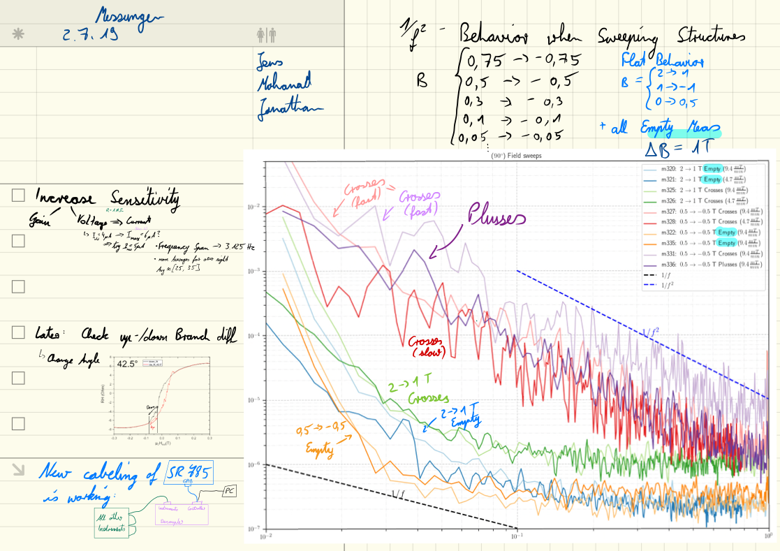

**Measurement Plan #3\_magnetic field effect**

02 June 2019

17:30

Field Sweeps (ΔB = T)

|  |  |  |  |  |  |  |  |  |  |  |
| --- | --- | --- | --- | --- | --- | --- | --- | --- | --- | --- |
| Nr | Struct | Field From | Field To | Hloop\_branch | SR [mT/min] | F-Span | Vin(V)/sens (mV)/gain | Avg | Time [min, Hr] | Date |
| [m342:](onenote:#m342%20MFN_Plusses_sweep%20after%20+%20saturation%20at%201T_0.005T%20to%20-0.005T_mT.min_1.5,%200.78Hz_5V&section-id={5FAD0518-E349-4A07-93E8-5D105BD4AEB4}&page-id={0664508E-5C60-4D50-9F2A-99136D158CE7}&end&base-path=https://goetheuniversitaet.sharepoint.com/sites/Project4/SiteAssets/Project%204%20Notebook/Magnetic%20Flux%20Noise.one) | Plusses | 25 mT | -25 mT | +Saturated | 0.11 | 1.5/0.7 | 5/5/20 | 35 | 448\_7.4 | 02.07.2019 |
| [m343:](onenote:#m343%20MFN_Plusses_sweep%20after%20-%20saturation%20at%201T_0.005T%20to%20-0.005T_mT.min_1.5,%200.78Hz_5V&section-id={5FAD0518-E349-4A07-93E8-5D105BD4AEB4}&page-id={9D1A8DBE-486A-444C-9890-8A4FB60E50D2}&end&base-path=https://goetheuniversitaet.sharepoint.com/sites/Project4/SiteAssets/Project%204%20Notebook/Magnetic%20Flux%20Noise.one) | Plusses | -25 mT | 25 mT | -Saturated | 0.11 | 1.5/0.7 | 5/5/20 | 35 | 448\_7.4 | 03.07.2019 |
| [m344:](onenote:#m344%20MFN_Plusses_sweep%20after_saturation%20at%20+1T_-0.443T%20to%20-0.611T_2.352mT.min_1.5,%200.78Hz_5V&section-id={5FAD0518-E349-4A07-93E8-5D105BD4AEB4}&page-id={C53AAB46-C98F-4039-8C24-F8153D391688}&end&base-path=https://goetheuniversitaet.sharepoint.com/sites/Project4/SiteAssets/Project%204%20Notebook/Magnetic%20Flux%20Noise.one) | Plusses | -443 mT | -611 mT | +Saturated | 2.352 | 1.5/0.7 | 5/5/20 | 35 | 448\_7.4 | 03.07.2019 |
| [m345:](onenote:#m345%20MFN_Plusses_sweep%20after_saturation%20at%20+1T_%20-0.2913%20T%20to%20-0.443%20T_1.638mT.min_1.5,%200.78Hz_5V&section-id={5FAD0518-E349-4A07-93E8-5D105BD4AEB4}&page-id={0BD41550-00B9-4E21-A600-12F3044B3C99}&end&base-path=https://goetheuniversitaet.sharepoint.com/sites/Project4/SiteAssets/Project%204%20Notebook/Magnetic%20Flux%20Noise.one) | Plusses | **-291 mT** | -443 mT | +Saturated | 0.5 | 1.5/0.7 | 5/5/20 | 24 | 303\_5 | 03.07.2019 |
| [m346:](onenote:#m346%20MFN_Plusses_sweep%20after_saturation%20at%20+1T_%20-0.06798%20T%20to%20-0.2913%20T_1.638mT.min_1.5,%200.78Hz_5V&section-id={5FAD0518-E349-4A07-93E8-5D105BD4AEB4}&page-id={5FCA0077-B82E-4798-A046-B161DE856008}&end&base-path=https://goetheuniversitaet.sharepoint.com/sites/Project4/SiteAssets/Project%204%20Notebook/Magnetic%20Flux%20Noise.one) | Plusses | 36.56mT | **-291.13 mT** | +Saturated | 0.5 | 1.5/0.7 | 5/5/20 | 51 | 655\_10.9 | 04.07.2019 |
| [m347:](onenote:#m347%20MFN_Plusses_sweep%20after_saturation%20at%20-1T_%20-0.03656%20T%20to%200.2913%20T_0.5mT.min_1.5%20Hz_5V_averages%20153&section-id={5FAD0518-E349-4A07-93E8-5D105BD4AEB4}&page-id={16C4D18A-3947-458C-ADD2-F4CBD3355863}&end&base-path=https://goetheuniversitaet.sharepoint.com/sites/Project4/SiteAssets/Project%204%20Notebook/Magnetic%20Flux%20Noise.one) | Plusses | -36.56mT | **-291.13 mT** | -Saturated | 0.5 | 1.5 | 5/5/20 | 153 | 652\_10.9 | 04.07.2019\_Thursday night |
| [m348:](onenote:#m348%20MFN_Empty_sweep%20after_saturation%20at%20-1T_%20-0.03656%20T%20to%200.2913%20T_0.5mT.min_1.5%20Hz_5V_averages%20153&section-id={5FAD0518-E349-4A07-93E8-5D105BD4AEB4}&page-id={A8F12604-CEF9-4037-97CE-1E62BF0761C2}&end&base-path=https://goetheuniversitaet.sharepoint.com/sites/Project4/SiteAssets/Project%204%20Notebook/Magnetic%20Flux%20Noise.one) | Empty | 36.56mT | **-291.13 mT** | -Saturated | 0.5 | 1.5 | 5/5/20 | 153 | 652\_10.9 | 05.07.2019\_Friday |
| [m349:](onenote:#m349%20MFN_Empty_sweep%20after_saturation%20at%20-1T_%20-0.025T%20to%200.025%20T_0.5mT.min_1.5%20Hz_5V_averages%2024&section-id={5FAD0518-E349-4A07-93E8-5D105BD4AEB4}&page-id={A1A7C247-1384-40EE-842C-EAC6A278714F}&end&base-path=https://goetheuniversitaet.sharepoint.com/sites/Project4/SiteAssets/Project%204%20Notebook/Magnetic%20Flux%20Noise.one) | Empty | -25 mT | +25 mT | -Saturated | 0.5 | 1.5 | 5/5/20 | 24 | 100 | 06.07.2019\_midnight\_Saturday |
| [m350:](onenote:#m350%20MFN_Plusses_sweep%20after_saturation%20at%20-1T_%20-0.025T%20to%200.025%20T_0.5mT.min_1.5%20Hz_5V_averages%2024&section-id={5FAD0518-E349-4A07-93E8-5D105BD4AEB4}&page-id={1EA829B7-965C-4961-9B23-F96DDD8F9E7F}&end&base-path=https://goetheuniversitaet.sharepoint.com/sites/Project4/SiteAssets/Project%204%20Notebook/Magnetic%20Flux%20Noise.one) | Plusses | -25 mT | +25 mT | -Saturated | 0.5 | 1.5 | 5/5/20 | 24 | 100 | 06.07.2019\_Saturday\_afternoon |
| [m351:](onenote:#m351%20MFN_Plusses_sweep%20after_saturation%20at%20-1T_%20-0.025T%20to%200.025%20T_1mT.min_1.5%20Hz_5V_averages%2012&section-id={5FAD0518-E349-4A07-93E8-5D105BD4AEB4}&page-id={046961AE-ADE6-41BF-B254-AA185E078B79}&end&base-path=https://goetheuniversitaet.sharepoint.com/sites/Project4/SiteAssets/Project%204%20Notebook/Magnetic%20Flux%20Noise.one) | Plusses | -25 mT | 25 mT | -Saturated | 1 | 1.5 | 5/5/20 | 12 | 50 | 06.07.2019\_Saturday\_evening |
| [m352:](onenote:#m352%20MFN_Plusses_sweep%20after_saturation%20at%20-1T_%20-0.025T%20to%200.025%20T_0.1mT.min_1.5%20Hz_5V_averages%20117&section-id={5FAD0518-E349-4A07-93E8-5D105BD4AEB4}&page-id={87401F82-7B5F-4BD6-9B30-CDD5C3F109BF}&end&base-path=https://goetheuniversitaet.sharepoint.com/sites/Project4/SiteAssets/Project%204%20Notebook/Magnetic%20Flux%20Noise.one) | Plusses | -25 mT | 25 mT | -Saturated | 0.1 | 1.5 | 5/5/20 | 117 | 500 | 06.07.2019\_Saturday\_night |
| [m353:](onenote:#m353%20MFN_Plusses_sweep%20after_saturation%20at%20-1T_%20-0.025T%20to%200.025%20T_0.25mT.min_1.5%20Hz_5V_averages%2047&section-id={5FAD0518-E349-4A07-93E8-5D105BD4AEB4}&page-id={FE9092E1-169E-4347-9969-D12D8CB66BD4}&end&base-path=https://goetheuniversitaet.sharepoint.com/sites/Project4/SiteAssets/Project%204%20Notebook/Magnetic%20Flux%20Noise.one) | Plusses | -25 mT | 25 mT | -Saturated | 0.25 | 1.5 | 5/5/20 | 47 | 200 | 07.07.2019\_Sunday\_morning |
| [m354:](onenote:#m354%20MFN_Plusses_sweep%20after_saturation%20at%20-1T_%20-0.025T%20to%200.025%20T_2mT.min_1.5%20Hz_5V_averages%206&section-id={5FAD0518-E349-4A07-93E8-5D105BD4AEB4}&page-id={962BDDFC-8A50-4AB8-A318-6997909CE9D1}&end&base-path=https://goetheuniversitaet.sharepoint.com/sites/Project4/SiteAssets/Project%204%20Notebook/Magnetic%20Flux%20Noise.one) | Plusses | -25 mT | 25 mT | -Saturated | 2 | 1.5 | 5/5/20 | 6 | 25 | 07.07.2019\_Sunday\_lunch time |

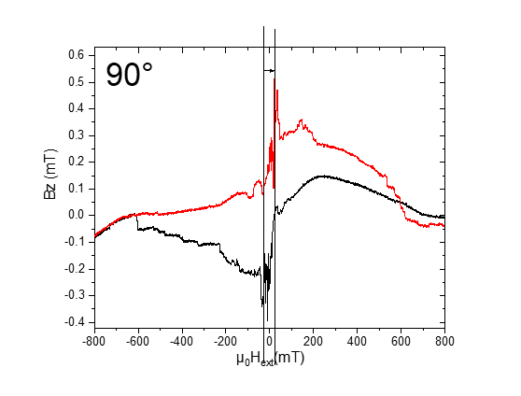



Plan 3 summary

Saturday, 7. December 2019

21:26

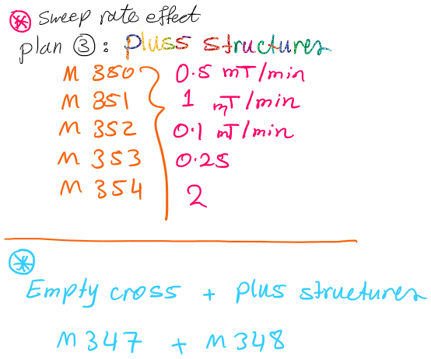

**HLoop**

Montag, 8. Juli 2019

18:21

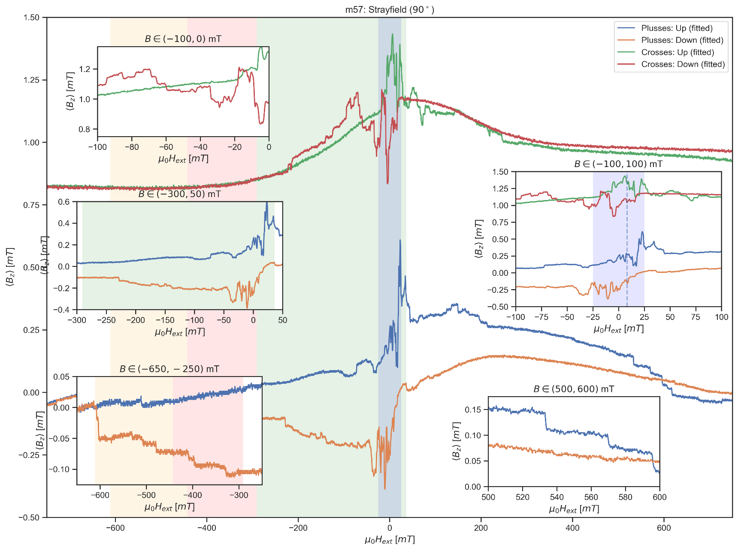

**Evaluate Measurement Plan #3**

Montag, 8. Juli 2019

18:21

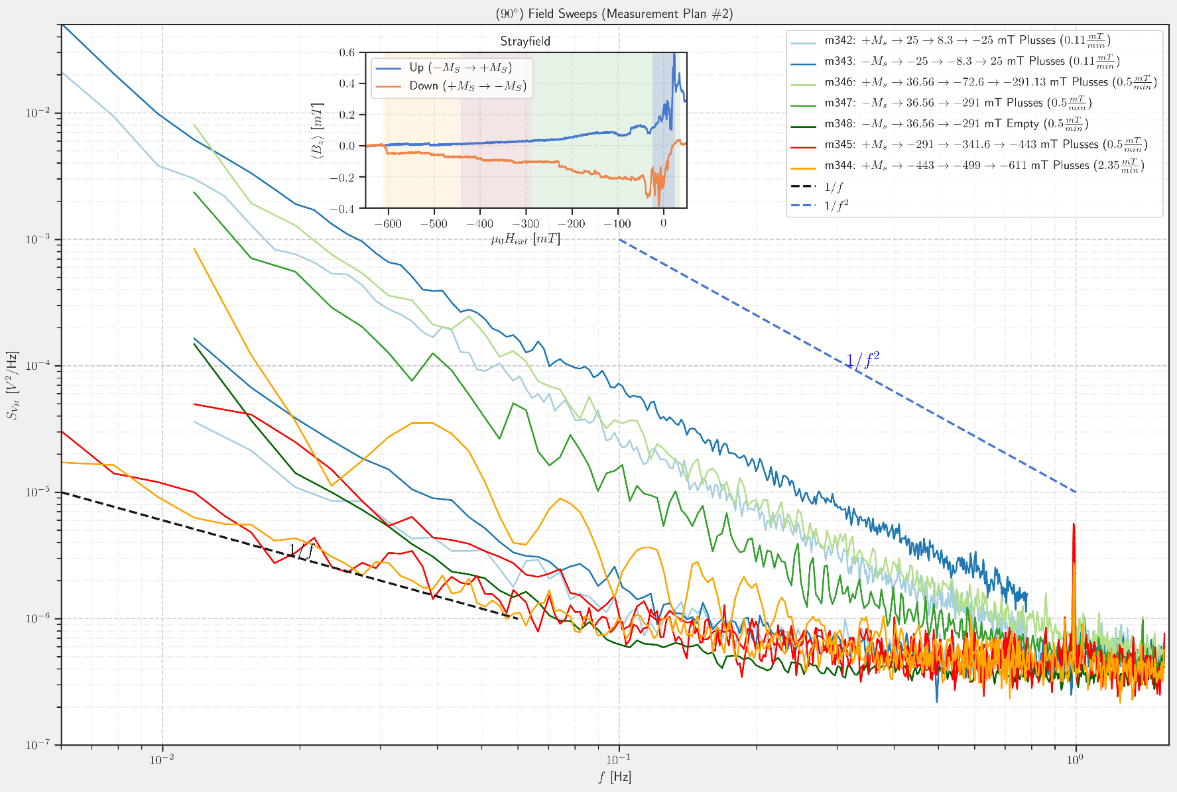

**25 mT Sweeps**

Montag, 8. Juli 2019

18:18

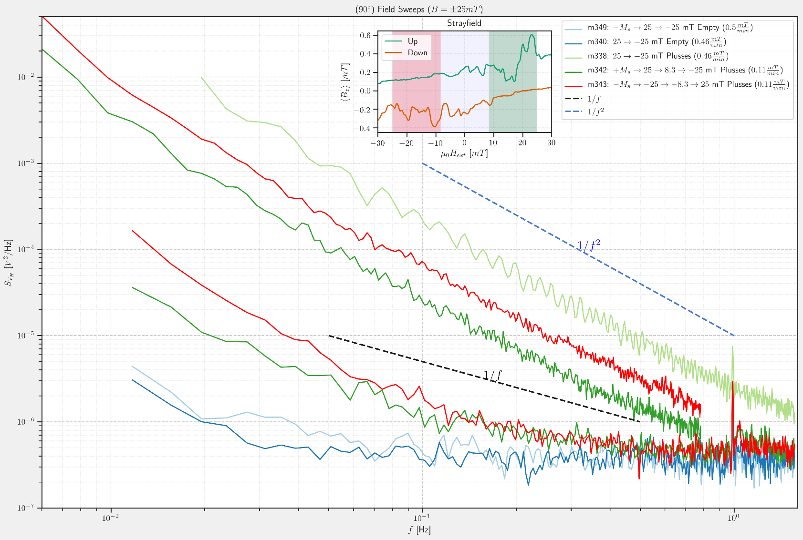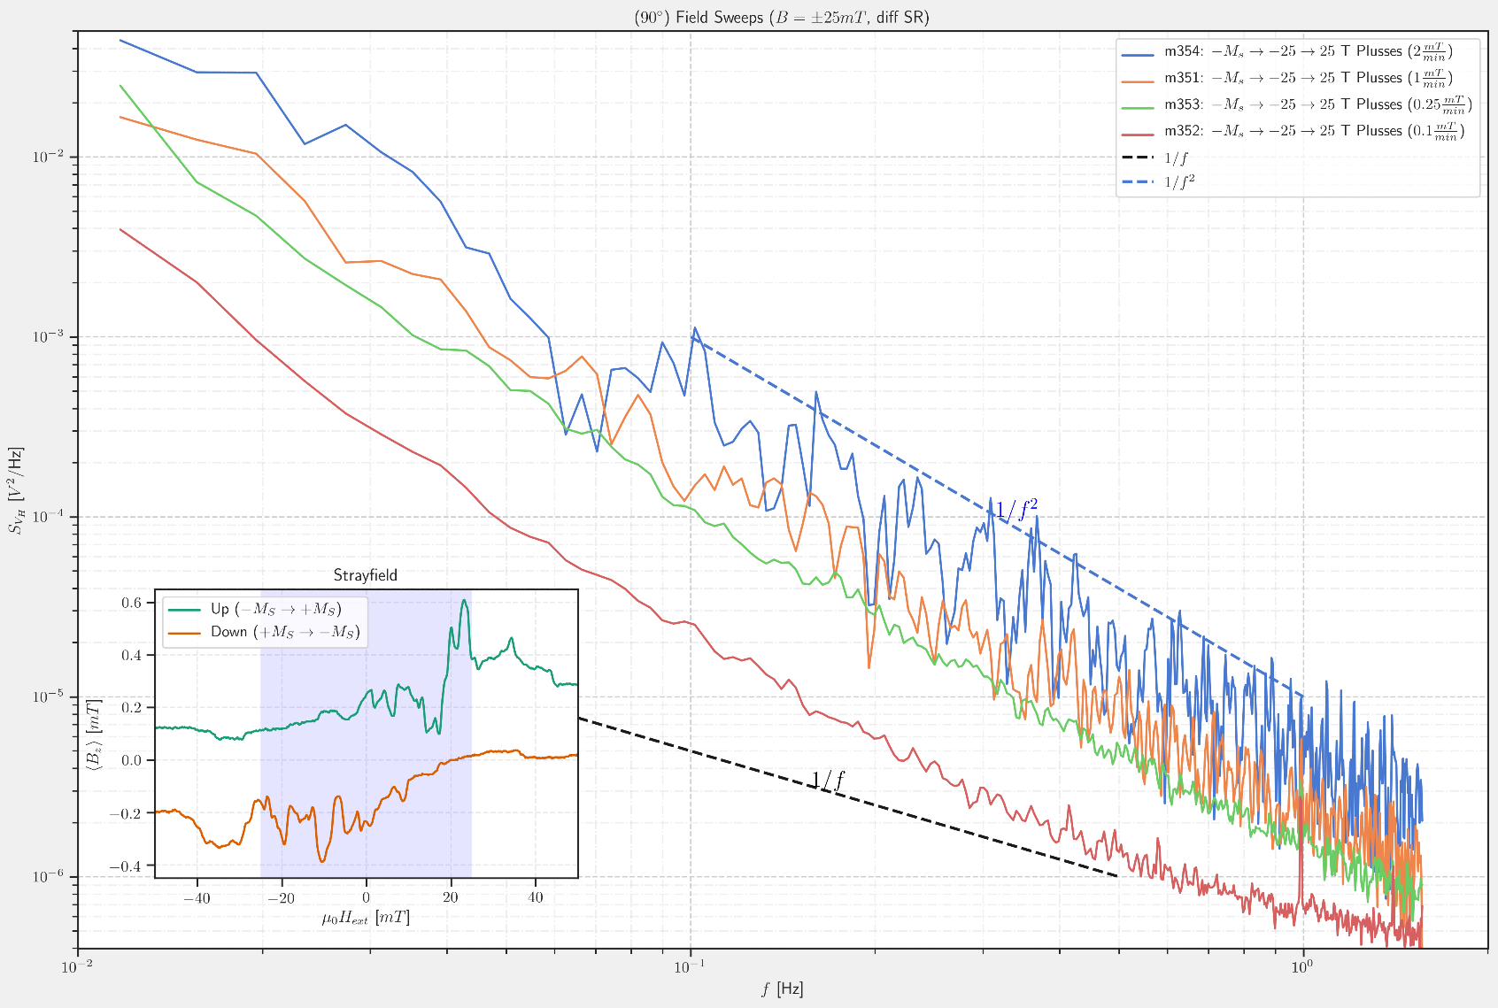

**m342: MFN\_Plusses\_sweep after\_saturation at+ 1T\_0.025T to -0.025T\_0.111 mT.min\_1.5, 0.78Hz\_5V**

Dienstag, 2. Juli 2019

22:41

|  |  |
| --- | --- |
| Angle of sensor θ | *+90* |
| Temp | 30 K |
|  | **Plusses(1-13)** |
|  | |  |  |  |  | | --- | --- | --- | --- | |  | ***1-13*** |  |  | | ***Gate (0V)*** | ***9 - 4*** |  | ***14 - 7 Preamp.*** | |
|  | |  |  | | --- | --- | |  | *0.025T to -0.025T* | | *Sweeprate* | *0.111 mT/min* | |
| Resistance Box | |  |  |  |  |  |  | | --- | --- | --- | --- | --- | --- | |  | *1 MΩ* |  |  |  |  | |  | *1 MΩ* |  |  |  | *10* | |
|  | |  |  |  |  |  |  | | --- | --- | --- | --- | --- | --- | | Sens | 5 mV |  | 5 V | *f* | *113 Hz* | | *τ* | *3 ms* | *Input A* | *AC* | *Ground* | *Normal Reserve* | |
| Pre Amplifier (SR560) | |  |  |  |  | | --- | --- | --- | --- | | *Gain Mode* | *Low* | *Gain:* | *2e1* | | *Coupling* | *AC* | *Output (50Ω)* | *LI Input A* | | *Filters:* | *Off* |  |  | |
| Signal Analyzer (SR785) | |  |  |  |  | | --- | --- | --- | --- | | *Ch 1 (A)* |  | *Freq - Span:* | *1.5,0.78* | | *Ch 2 (A)* |  | *Averages:* | *35* | |
| Period of measurement (min) | *448min over night started 22:40 finshed around 6:00 am next day* |
| He (l) level consumption |  |
| Data files | <<m342\_MFN\_Plusses\_sweep\_25mT to -25mT\_at +1T saturation\_Rate 0.111mTmin\_SR785\_1.5\_0.78Hz\_Vin 5V\_sens 5mV .dat>> |
| Plot | Machine generated alternative text: Foal  185  187 |

**m343: MFN\_Plusses\_sweep after\_saturation at -1T\_0.025T to -0.025T\_0.111mT.min\_1.5, 0.78Hz\_5V**

Mittwoch, 3. Juli 2019

06:23

|  |  |
| --- | --- |
| Angle of sensor θ | *+90* |
| Temp | 30 K |
|  | **Plusses(1-13)** |
|  | |  |  |  |  | | --- | --- | --- | --- | |  | ***1-13*** |  |  | | ***Gate (0V)*** | ***9 - 4*** |  | ***14 - 7 Preamp.*** | |
|  | |  |  | | --- | --- | |  | *-0.025T to 0.025T* | | *Sweeprate* | *0.111 mT/min* | |
| Resistance Box | |  |  |  |  |  |  | | --- | --- | --- | --- | --- | --- | |  | *1 MΩ* |  |  |  |  | |  | *1 MΩ* |  |  |  | *10* | |
|  | |  |  |  |  |  |  | | --- | --- | --- | --- | --- | --- | | Sens | 5 mV |  | 5 V | *f* | *113 Hz* | | *τ* | *3 ms* | *Input A* | *AC* | *Ground* | *Normal Reserve* | |
| Pre Amplifier (SR560) | |  |  |  |  | | --- | --- | --- | --- | | *Gain Mode* | *Low* | *Gain:* | *2e1* | | *Coupling* | *AC* | *Output (50Ω)* | *LI Input A* | | *Filters:* | *Off* |  |  | |
| Signal Analyzer (SR785) | |  |  |  |  | | --- | --- | --- | --- | | *Ch 1 (A)* |  | *Freq - Span:* | *1.5,0.78* | | *Ch 2 (A)* |  | *Averages:* | *35* | |
| Period of measurement (min) | *448min over daylight started 6:23 finshed around 14:00* |
| He (l) level consumption |  |
| Data files | <<m343\_MFN\_Plusses\_sweep\_-25mT to 25mT\_at -1T saturation\_Rate 0.111mTmin\_SR785\_1.5\_0.78Hz\_Vin 5V\_sens 5mV .dat>> |
| Plot | Machine generated alternative text: 25mT_+1T  å25mT_- IT  10101 |

**m344: MFN\_Plusses\_sweep after\_saturation at +1T\_-0.443T to -0.611T\_2.352mT.min\_1.5, 0.78Hz\_5V\_field sweeping finished before MFN at 109min\_might need to be repeated**

03 July 2019

14:50

|  |  |
| --- | --- |
| Angle of sensor θ | *+90* |
| Temp | 30 K |
|  | **Plusses(1-13)** |
|  | |  |  |  |  | | --- | --- | --- | --- | |  | ***1-13*** |  |  | | ***Gate (0V)*** | ***9 - 4*** |  | ***14 - 7 Preamp.*** | |
|  | |  |  | | --- | --- | |  | ***-0.443*** *T to* ***-0.611*** *T*  Machine generated alternative text: | | *Sweep rate* | *2.352 mT/min* | |
| Resistance Box | |  |  |  |  |  |  | | --- | --- | --- | --- | --- | --- | |  | *1 MΩ* |  |  |  |  | |  | *1 MΩ* |  |  |  | *10* | |
|  | |  |  |  |  |  |  | | --- | --- | --- | --- | --- | --- | | Sens | 5 mV |  | 5 V | *f* | *113 Hz* | | *τ* | *3 ms* | *Input A* | *AC* | *Ground* | *Normal Reserve* | |
| Pre Amplifier (SR560) | |  |  |  |  | | --- | --- | --- | --- | | *Gain Mode* | *Low* | *Gain:* | *2e1* | | *Coupling* | *AC* | *Output (50Ω)* | *LI Input A* | | *Filters:* | *Off* |  |  | |
| Signal Analyzer (SR785) | |  |  |  |  | | --- | --- | --- | --- | | *Ch 1 (A)* |  | *Freq - Span:* | *1.5,0.78* | | *Ch 2 (A)* |  | *Averages:* | *35* | |
| Period of measurement (min) | *448min over daylight started 14:50 Finished 22:18* |
| He (l) level consumption |  |
| Data files | <<m344\_MFN\_Plusses\_sweep\_-443mT to -611 mT\_at +1T saturation\_Rate 2.352mTmin\_SR785\_1.5\_0.78Hz\_Vin 5V\_sens 5mV .dat>> |
| Plot |  |

*Important note: I found the magnetic field sweeping finished at 109 min of MFN measurement due to wrong calculattion of field range :(*



**m344.1: MFN\_Plusses\_sweep after\_saturation at +1T\_-0.443T to -0.611T\_0.5mT.min\_1.5, 0.78Hz\_5V\_field\_to be decided**

03 July 2019

14:50

|  |  |
| --- | --- |
| Angle of sensor θ | *+90* |
| Temp | 30 K |
|  | **Plusses(1-13)** |
|  | |  |  |  |  | | --- | --- | --- | --- | |  | ***1-13*** |  |  | | ***Gate (0V)*** | ***9 - 4*** |  | ***14 - 7 Preamp.*** | |
|  | |  |  | | --- | --- | |  | ***-0.443*** *T to* ***-0.611*** *T*  Machine generated alternative text: | | *Sweep rate* | *2.352 mT/min* | |
| Resistance Box | |  |  |  |  |  |  | | --- | --- | --- | --- | --- | --- | |  | *1 MΩ* |  |  |  |  | |  | *1 MΩ* |  |  |  | *10* | |
|  | |  |  |  |  |  |  | | --- | --- | --- | --- | --- | --- | | Sens | 5 mV |  | 5 V | *f* | *113 Hz* | | *τ* | *3 ms* | *Input A* | *AC* | *Ground* | *Normal Reserve* | |
| Pre Amplifier (SR560) | |  |  |  |  | | --- | --- | --- | --- | | *Gain Mode* | *Low* | *Gain:* | *2e1* | | *Coupling* | *AC* | *Output (50Ω)* | *LI Input A* | | *Filters:* | *Off* |  |  | |
| Signal Analyzer (SR785) | |  |  |  |  | | --- | --- | --- | --- | | *Ch 1 (A)* |  | *Freq - Span:* | *1.5,0.78* | | *Ch 2 (A)* |  | *Averages:* | *26* | |
| Period of measurement (min) | *448min over daylight started 14:50 Finished 22:18* |
| He (l) level consumption |  |
| Data files |  |
| Plot |  |



**m345: MFN\_Plusses\_sweep after\_saturation at +1T\_ -0.2913 T to -0.443 T\_0.5mT.min\_1.5, 0.78Hz\_5V\_averages 24**

Mittwoch, 3. Juli 2019

22:53

|  |  |
| --- | --- |
| Angle of sensor θ | *+90* |
| Temp | 30 K |
|  | **Plusses(1-13)** |
|  | |  |  |  |  | | --- | --- | --- | --- | |  | ***1-13*** |  |  | | ***Gate (0V)*** | ***9 - 4*** |  | ***14 - 7 Preamp.*** | |
|  | |  |  | | --- | --- | |  | ***-0.2913*** *T to* ***-0.443*** *T Delta=0.1517T*    Machine generated alternative text: | | *Sweep rate* | *0.5mT/min 0.0005T/min* | |
| Resistance Box | |  |  |  |  |  |  | | --- | --- | --- | --- | --- | --- | |  | *1 MΩ* |  |  |  |  | |  | *1 MΩ* |  |  |  | *10* | |
|  | |  |  |  |  |  |  | | --- | --- | --- | --- | --- | --- | | Sens | 5 mV |  | 5 V | *f* | *113 Hz* | | *τ* | *3 ms* | *Input A* | *AC* | *Ground* | *Normal Reserve* | |
| Pre Amplifier (SR560) | |  |  |  |  | | --- | --- | --- | --- | | *Gain Mode* | *Low* | *Gain:* | *2e1* | | *Coupling* | *AC* | *Output (50Ω)* | *LI Input A* | | *Filters:* | *Off* |  |  | |
| Signal Analyzer (SR785) | |  |  |  |  | | --- | --- | --- | --- | | *Ch 1 (A)* |  | *Freq - Span:* | *1.5,0.78* | | *Ch 2 (A)* |  | *Averages:* | *24* | |
| Period of measurement (min) | *303.4 min over over night started 22:53 Finished 04:00* |
| He (l) level consumption |  |
| Data files | <<m345\_MFN\_Plusses\_sweep\_-291mT to -443 mT\_at +1T saturation\_Rate 0.5mTmin\_SR785\_1.5\_0.78Hz\_\_aver 24\_Vin 5V\_sens 5mV .dat>> |
| Plot |  |

*Important note: I tried here to adjust constant sweeping rate for magnetic field range by keeping the f-spans constant and changing only the averages.*



**m346: MFN\_Plusses\_sweep after\_saturation at +1T\_ 0.03656 T to -0.2913 T\_0.5mT.min\_1.5, 0.78Hz\_5V\_averages 51**

04 July 2019

07:09

|  |  |
| --- | --- |
| Angle of sensor θ | *+90* |
| Temp | 30 K |
|  | **Plusses(1-13)** |
|  | |  |  |  |  | | --- | --- | --- | --- | |  | ***1-13*** |  |  | | ***Gate (0V)*** | ***9 - 4*** |  | ***14 - 7 Preamp.*** | |
|  | |  |  | | --- | --- | |  | *0.03656 T to* ***-0.2913*** *T Delta=0.3278T*    Machine generated alternative text: -200 | | *Sweep rate* | *0.5mT/min 0.0005T/min* | |
| Resistance Box | |  |  |  |  |  |  | | --- | --- | --- | --- | --- | --- | |  | *1 MΩ* |  |  |  |  | |  | *1 MΩ* |  |  |  | *10* | |
|  | |  |  |  |  |  |  | | --- | --- | --- | --- | --- | --- | | Sens | 5 mV |  | 5 V | *f* | *113 Hz* | | *τ* | *3 ms* | *Input A* | *AC* | *Ground* | *Normal Reserve* | |
| Pre Amplifier (SR560) | |  |  |  |  | | --- | --- | --- | --- | | *Gain Mode* | *Low* | *Gain:* | *2e1* | | *Coupling* | *AC* | *Output (50Ω)* | *LI Input A* | | *Filters:* | *Off* |  |  | |
| Signal Analyzer (SR785) | |  |  |  |  | | --- | --- | --- | --- | | *Ch 1 (A)* |  | *Freq - Span:* | *1.5,0.78* | | *Ch 2 (A)* |  | *Averages:* | *51* | |
| Period of measurement (min) | *655 min over over daylight started 07:00 Finished 17:53* |
| He (l) level consumption |  |
| Data files | <<m346\_MFN\_Plusses\_sweep\_36.56mT to -291 mT\_at +1T saturation\_Rate 0.5mTmin\_SR785\_1.5\_0.78Hz\_\_aver 51\_Vin 5V\_sens 5mV .dat>> |
| Plot |  |



**m347: MFN\_Plusses\_sweep after\_saturation at -1T\_ -0.03656 T to 0.2913 T\_0.5mT.min\_1.5 Hz\_5V\_averages 153**

Donnerstag, 4. Juli 2019

23:36

|  |  |
| --- | --- |
| Angle of sensor θ | *+90* |
| Temp | 30 K |
|  | **Plusses(1-13)** |
|  | |  |  |  |  | | --- | --- | --- | --- | |  | ***1-13*** |  |  | | ***Gate (0V)*** | ***9 - 4*** |  | ***14 - 7 Preamp.*** | |
|  | |  |  | | --- | --- | |  | *-0.03656 T to*  ***0.2913*** *T Delta=0.3278T*    Machine generated alternative text: -200 | | *Sweep rate* | *0.5mT/min 0.0005T/min* | |
| Resistance Box | |  |  |  |  |  |  | | --- | --- | --- | --- | --- | --- | |  | *1 MΩ* |  |  |  |  | |  | *1 MΩ* |  |  |  | *10* | |
|  | |  |  |  |  |  |  | | --- | --- | --- | --- | --- | --- | | Sens | 5 mV |  | 5 V | *f* | *113 Hz* | | *τ* | *3 ms* | *Input A* | *AC* | *Ground* | *Normal Reserve* | |
| Pre Amplifier (SR560) | |  |  |  |  | | --- | --- | --- | --- | | *Gain Mode* | *Low* | *Gain:* | *2e1* | | *Coupling* | *AC* | *Output (50Ω)* | *LI Input A* | | *Filters:* | *Off* |  |  | |
| Signal Analyzer (SR785) | |  |  |  |  | | --- | --- | --- | --- | | *Ch 1 (A)* |  | *Freq - Span:* | *1.5* | | *Ch 2 (A)* |  | *Averages:* | *153* | |
| Period of measurement (min) |  |
| He (l) level consumption |  |
| Data files | <<m347\_MFN\_Plusses\_sweep\_-36.56mT to +291 mT\_at -1T saturation\_Rate 0.5mTmin\_SR785\_1.5Hz\_\_aver 153\_Vin 5V\_sens 5mV .dat>> |
| Plot | Machine generated alternative text: omi |



**Filling He(l)**

Freitag, 5. Juli 2019

12:24

|  |  |
| --- | --- |
| Filling date | 05.07.2019 |
| Before (in) | 27 |
| After (in) | 36.22 |
| consumption | 214-123=26 L |
| Person | MAM |

Notes:



'To do:

**m348: MFN\_Empty\_sweep after\_saturation at -1T\_ -0.03656 T to 0.2913 T\_0.5mT.min\_1.5 Hz\_5V\_averages 153**

Freitag, 5. Juli 2019

13:00

|  |  |
| --- | --- |
| Angle of sensor θ | *+90* |
| Temp | 30 K |
|  | **Empty(6-8)** |
|  | |  |  |  |  | | --- | --- | --- | --- | |  | ***6-8*** |  |  | | ***Gate (0V)*** | ***9 - 4*** |  | ***14 - 7 Preamp.*** | |
|  | |  |  | | --- | --- | |  | *-0.03656 T to*  ***0.2913*** *T Delta=0.3278T* | | *Sweep rate* | *0.5mT/min 0.0005T/min* | |
| Resistance Box | |  |  |  |  |  |  | | --- | --- | --- | --- | --- | --- | |  | *1 MΩ* |  |  |  |  | |  | *1 MΩ* |  |  |  | *10* | |
|  | |  |  |  |  |  |  | | --- | --- | --- | --- | --- | --- | | Sens | 10 mV |  | 5 V | *f* | *113 Hz* | | *τ* | *3 ms* | *Input A* | *AC* | *Ground* | *Normal Reserve* | |
| Pre Amplifier (SR560) | |  |  |  |  | | --- | --- | --- | --- | | *Gain Mode* | *Low* | *Gain:* | *2e1* | | *Coupling* | *AC* | *Output (50Ω)* | *LI Input A* | | *Filters:* | *Off* |  |  | |
| Signal Analyzer (SR785) | |  |  |  |  | | --- | --- | --- | --- | | *Ch 1 (A)* |  | *Freq - Span:* | *1.5* | | *Ch 2 (A)* |  | *Averages:* | *153* | |
| Period of measurement (min) | 652 min started at 13:00 Friday Finsihed at 23:52 |
| He (l) level consumption |  |
| Data files | <<m348\_MFN\_Empty\_sweep\_-36.56mT to +291 mT\_at -1T saturation\_Rate 0.5mTmin\_SR785\_1.5Hz\_\_aver 153\_Vin 5V\_sens 5mV .dat>> |
| Plot | Machine generated alternative text: omi  Plusæs  Errptf |



**m349: MFN\_Empty\_sweep after\_saturation at -1T\_ -0.025T to 0.025 T\_0.5mT.min\_1.5 Hz\_5V\_averages 24**

Samstag, 6. Juli 2019

00:15

|  |  |
| --- | --- |
| Angle of sensor θ | *+90* |
| Temp | 30 K |
|  | **Empty(6-8)** |
|  | |  |  |  |  | | --- | --- | --- | --- | |  | ***6-8*** |  |  | | ***Gate (0V)*** | ***9 - 4*** |  | ***14 - 7 Preamp.*** | |
|  | |  |  | | --- | --- | |  | *-0.025T to*  ***0.025*** *T Delta=0.5* | | *Sweep rate* | *0.5mT/min 0.0005T/min* | |
| Resistance Box | |  |  |  |  |  |  | | --- | --- | --- | --- | --- | --- | |  | *1 MΩ* |  |  |  |  | |  | *1 MΩ* |  |  |  | *10* | |
|  | |  |  |  |  |  |  | | --- | --- | --- | --- | --- | --- | | Sens | 10 mV |  | 5 V | *f* | *113 Hz* | | *τ* | *3 ms* | *Input A* | *AC* | *Ground* | *Normal Reserve* | |
| Pre Amplifier (SR560) | |  |  |  |  | | --- | --- | --- | --- | | *Gain Mode* | *Low* | *Gain:* | *2e1* | | *Coupling* | *AC* | *Output (50Ω)* | *LI Input A* | | *Filters:* | *Off* |  |  | |
| Signal Analyzer (SR785) | |  |  |  |  | | --- | --- | --- | --- | | *Ch 1 (A)* |  | *Freq - Span:* | *1.5* | | *Ch 2 (A)* |  | *Averages:* | *24* | |
| Period of measurement (min) | 100 min started at 00:07 Saturday Finsihed at |
| He (l) level consumption |  |
| Data files | <<m349\_MFN\_Empty\_sweep\_-25mT to +25 mT\_at -1T saturation\_Rate 0.5mTmin\_SR785\_1.5Hz\_\_aver 24\_Vin 5V\_sens 5mV .dat>> |
| Plot |  |

**m350: MFN\_Plusses\_sweep after\_saturation at -1T\_ -0.025T to 0.025 T\_0.5mT.min\_1.5 Hz\_5V\_averages 24**

06 July 2019

15:46

|  |  |
| --- | --- |
| Angle of sensor θ | *+90* |
| Temp | 30 K |
|  | **Plusses(1-13)** |
|  | |  |  |  |  | | --- | --- | --- | --- | |  |  |  |  | | ***Gate (0V)*** | ***9 - 4*** |  | ***14 - 7 Preamp.*** | |
|  | |  |  | | --- | --- | |  | *-0.025T to*  ***0.025*** *T Delta=0.5* | | *Sweep rate* | *0.5mT/min 0.0005T/min* | |
| Resistance Box | |  |  |  |  |  |  | | --- | --- | --- | --- | --- | --- | |  | *1 MΩ* |  |  |  |  | |  | *1 MΩ* |  |  |  | *10* | |
|  | |  |  |  |  |  |  | | --- | --- | --- | --- | --- | --- | | Sens | 10 mV |  | 5 V | *f* | *113 Hz* | | *τ* | *3 ms* | *Input A* | *AC* | *Ground* | *Normal Reserve* | |
| Pre Amplifier (SR560) | |  |  |  |  | | --- | --- | --- | --- | | *Gain Mode* | *Low* | *Gain:* | *2e1* | | *Coupling* | *AC* | *Output (50Ω)* | *LI Input A* | | *Filters:* | *Off* |  |  | |
| Signal Analyzer (SR785) | |  |  |  |  | | --- | --- | --- | --- | | *Ch 1 (A)* |  | *Freq - Span:* | *1.5* | | *Ch 2 (A)* |  | *Averages:* | *24* | |
| Period of measurement (min) | 100 min started at 15:46 Saturday finished at 17:35 |
| He (l) level consumption |  |
| Data files | <<m350\_MFN\_Plusses\_sweep\_-25mT to +25 mT\_at -1T saturation\_Rate 0.5mTmin\_SR785\_1.5Hz\_\_aver 24\_Vin 5V\_sens 5mV .dat>> |
| Plot |  |

**m351: MFN\_Plusses\_sweep after\_saturation at -1T\_ -0.025T to 0.025 T\_1mT.min\_1.5 Hz\_5V\_averages 12**

Samstag, 6. Juli 2019

21:37

|  |  |
| --- | --- |
| Angle of sensor θ | *+90* |
| Temp | 30 K |
|  | **Plusses(1-13)** |
|  | |  |  |  |  | | --- | --- | --- | --- | |  |  |  |  | | ***Gate (0V)*** | ***9 - 4*** |  | ***14 - 7 Preamp.*** | |
|  | |  |  | | --- | --- | |  | *-0.025T to*  ***0.025*** *T Delta=0.5* | | *Sweep rate* | *1mT/min 0.0005T/min* | |
| Resistance Box | |  |  |  |  |  |  | | --- | --- | --- | --- | --- | --- | |  | *1 MΩ* |  |  |  |  | |  | *1 MΩ* |  |  |  | *10* | |
|  | |  |  |  |  |  |  | | --- | --- | --- | --- | --- | --- | | Sens | 10 mV |  | 5 V | *f* | *113 Hz* | | *τ* | *3 ms* | *Input A* | *AC* | *Ground* | *Normal Reserve* | |
| Pre Amplifier (SR560) | |  |  |  |  | | --- | --- | --- | --- | | *Gain Mode* | *Low* | *Gain:* | *2e1* | | *Coupling* | *AC* | *Output (50Ω)* | *LI Input A* | | *Filters:* | *Off* |  |  | |
| Signal Analyzer (SR785) | |  |  |  |  | | --- | --- | --- | --- | | *Ch 1 (A)* |  | *Freq - Span:* | *1.5* | | *Ch 2 (A)* |  | *Averages:* | *12* | |
| Period of measurement (min) | 50 min |
| He (l) level consumption |  |
| Data files | <<m351\_MFN\_Plusses\_sweep\_-25mT to +25 mT\_at -1T saturation\_Rate 1mTmin\_SR785\_1.5Hz\_\_aver 12\_Vin 5V\_sens 5mV .dat>> |
| Plot | Machine generated alternative text: 1 mTjmin  omi  184 |

**m352: MFN\_Plusses\_sweep after\_saturation at -1T\_ -0.025T to 0.025 T\_0.1mT.min\_1.5 Hz\_5V\_averages 117**

Samstag, 6. Juli 2019

22:39

|  |  |
| --- | --- |
| Angle of sensor θ | *+90* |
| Temp | 30 K |
|  | **Plusses(1-13)** |
|  | |  |  |  |  | | --- | --- | --- | --- | |  |  |  |  | | ***Gate (0V)*** | ***9 - 4*** |  | ***14 - 7 Preamp.*** | |
|  | |  |  | | --- | --- | |  | *-0.025T to*  ***0.025*** *T Delta=0.5* | | *Sweep rate* | *0.1mT/min 0.0001T/min* | |
| Resistance Box | |  |  |  |  |  |  | | --- | --- | --- | --- | --- | --- | |  | *1 MΩ* |  |  |  |  | |  | *1 MΩ* |  |  |  | *10* | |
|  | |  |  |  |  |  |  | | --- | --- | --- | --- | --- | --- | | Sens | 10 mV |  | 5 V | *f* | *113 Hz* | | *τ* | *3 ms* | *Input A* | *AC* | *Ground* | *Normal Reserve* | |
| Pre Amplifier (SR560) | |  |  |  |  | | --- | --- | --- | --- | | *Gain Mode* | *Low* | *Gain:* | *2e1* | | *Coupling* | *AC* | *Output (50Ω)* | *LI Input A* | | *Filters:* | *Off* |  |  | |
| Signal Analyzer (SR785) | |  |  |  |  | | --- | --- | --- | --- | | *Ch 1 (A)* |  | *Freq - Span:* | *1.5* | | *Ch 2 (A)* |  | *Averages:* | *117* | |
| Period of measurement (min) | 500 min |
| He (l) level consumption |  |
| Data files | <<m352\_MFN\_Plusses\_sweep\_-25mT to +25 mT\_at -1T saturation\_Rate 0.1mTmin\_SR785\_1.5Hz\_\_aver 117\_Vin 5V\_sens 5mV .dat>> |
| Plot | otrnT1rnin  1 mTjrnin  oro 1  184 |

**m353: MFN\_Plusses\_sweep after\_saturation at -1T\_ -0.025T to 0.025 T\_0.25mT.min\_1.5 Hz\_5V\_averages 47**

Sonntag, 7. Juli 2019

08:50

|  |  |
| --- | --- |
| Angle of sensor θ | *+90* |
| Temp | 30 K |
|  | **Plusses(1-13)** |
|  | |  |  |  |  | | --- | --- | --- | --- | |  |  |  |  | | ***Gate (0V)*** | ***9 - 4*** |  | ***14 - 7 Preamp.*** | |
|  | |  |  | | --- | --- | |  | *-0.025T to*  ***0.025*** *T Delta=0.5* | | *Sweep rate* | *0.1mT/min 0.0001T/min* | |
| Resistance Box | |  |  |  |  |  |  | | --- | --- | --- | --- | --- | --- | |  | *1 MΩ* |  |  |  |  | |  | *1 MΩ* |  |  |  | *10* | |
|  | |  |  |  |  |  |  | | --- | --- | --- | --- | --- | --- | | Sens | 10 mV |  | 5 V | *f* | *113 Hz* | | *τ* | *3 ms* | *Input A* | *AC* | *Ground* | *Normal Reserve* | |
| Pre Amplifier (SR560) | |  |  |  |  | | --- | --- | --- | --- | | *Gain Mode* | *Low* | *Gain:* | *2e1* | | *Coupling* | *AC* | *Output (50Ω)* | *LI Input A* | | *Filters:* | *Off* |  |  | |
| Signal Analyzer (SR785) | |  |  |  |  | | --- | --- | --- | --- | | *Ch 1 (A)* |  | *Freq - Span:* | *1.5* | | *Ch 2 (A)* |  | *Averages:* | *47* | |
| Period of measurement (min) | 200 min |
| He (l) level consumption |  |
| Data files | <<m353\_MFN\_Plusses\_sweep\_-25mT to +25 mT\_at -1T saturation\_Rate 0.25mTmin\_SR785\_1.5Hz\_\_aver 47\_Vin 5V\_sens 5mV .dat>> |
| Plot | Machine generated alternative text: Sweep rate  0031  165  167  flHz]  0.1m Tm i |

**m354: MFN\_Plusses\_sweep after\_saturation at -1T\_ -0.025T to 0.025 T\_2mT.min\_1.5 Hz\_5V\_averages 6**

Sonntag, 7. Juli 2019

12:28

|  |  |
| --- | --- |
| Angle of sensor θ | *+90* |
| Temp | 30 K |
|  | **Plusses(1-13)** |
|  | |  |  |  |  | | --- | --- | --- | --- | |  |  |  |  | | ***Gate (0V)*** | ***9 - 4*** |  | ***14 - 7 Preamp.*** | |
|  | |  |  | | --- | --- | |  | *-0.025T to*  ***0.025*** *T Delta=0.5* | | *Sweep rate* | *0.1mT/min 0.0001T/min* | |
| Resistance Box | |  |  |  |  |  |  | | --- | --- | --- | --- | --- | --- | |  | *1 MΩ* |  |  |  |  | |  | *1 MΩ* |  |  |  | *10* | |
|  | |  |  |  |  |  |  | | --- | --- | --- | --- | --- | --- | | Sens | 10 mV |  | 5 V | *f* | *113 Hz* | | *τ* | *3 ms* | *Input A* | *AC* | *Ground* | *Normal Reserve* | |
| Pre Amplifier (SR560) | |  |  |  |  | | --- | --- | --- | --- | | *Gain Mode* | *Low* | *Gain:* | *2e1* | | *Coupling* | *AC* | *Output (50Ω)* | *LI Input A* | | *Filters:* | *Off* |  |  | |
| Signal Analyzer (SR785) | |  |  |  |  | | --- | --- | --- | --- | | *Ch 1 (A)* |  | *Freq - Span:* | *1.5* | | *Ch 2 (A)* |  | *Averages:* | *6* | |
| Period of measurement (min) | 25min |
| He (l) level consumption |  |
| Data files | <<m354\_MFN\_Plusses\_sweep\_-25mT to +25 mT\_at -1T saturation\_Rate 2mTmin\_SR785\_1.5Hz\_\_aver 6\_Vin 5V\_sens 5mV .dat>> |
| Plot | Machine generated alternative text: |

**Measurement Plan #4\_Temp effect**

07 July 2019

12:37

Field Sweeps and Tamperature effect (ΔB = T)

|  |  |  |  |  |  |  |  |  |  |  |  |
| --- | --- | --- | --- | --- | --- | --- | --- | --- | --- | --- | --- |
| Nr | Struct | Field From | Field To | Hloop\_branch | T (K) | SR [mT/min] | F-Span | Vin(V)/sens (mV)/gain | Avg | Time [min, Hr] | Date |
| [m355](onenote:#m355%20MFN_Plusses_sweep%20after_saturation%20at%20-1T_%20-0.025T%20to%200.025%20T_0.5mT.min_1.5%20Hz_5V_averages%2024_T=25K&section-id={5FAD0518-E349-4A07-93E8-5D105BD4AEB4}&page-id={0BD37287-724C-40D7-B71A-65A41899F1A8}&end&base-path=https://goetheuniversitaet.sharepoint.com/sites/Project4/SiteAssets/Project%204%20Notebook/Magnetic%20Flux%20Noise.one): | Plusses | -25 mT | 25 mT | -Saturated | 25 | 0.5 | 1.5 | 5/5/20 | 24 | 100 | 07.07.2019\_Sunday\_ |
| [m356:](onenote:#m356%20MFN_Plusses_sweep%20after_saturation%20at%20-1T_%20-0.025T%20to%200.025%20T_0.5mT.min_1.5%20Hz_5V_averages%2024_T=20K&section-id={5FAD0518-E349-4A07-93E8-5D105BD4AEB4}&page-id={F66849CE-F3F6-4A85-AD3D-E5DB646F6115}&end&base-path=https://goetheuniversitaet.sharepoint.com/sites/Project4/SiteAssets/Project%204%20Notebook/Magnetic%20Flux%20Noise.one) | Plusses | -25 mT | 25 mT | -Saturated | 20 | 0.5 | 1.5 | 5/5/20 | 24 | 100 | 07.07.2019\_Sunday\_ |
| [m357:](onenote:#m357%20MFN_Plusses_sweep%20after_saturation%20at%20-1T_%20-0.025T%20to%200.025%20T_0.5mT.min_1.5%20Hz_5V_averages%2024_T=15K&section-id={5FAD0518-E349-4A07-93E8-5D105BD4AEB4}&page-id={96C85B6D-787A-45EA-85A6-26D6982E2511}&end&base-path=https://goetheuniversitaet.sharepoint.com/sites/Project4/SiteAssets/Project%204%20Notebook/Magnetic%20Flux%20Noise.one) | Plusses | -25 mT | 25 mT | -Saturated | 15 | 0.5 | 1.5 | 5/5/20 | 24 | 100 | 07.07.2019\_Sunday\_midnight |
| [m358:](onenote:#m358%20MFN_Plusses_sweep%20after_saturation%20at%20-1T_%20-0.025T%20to%200.025%20T_0.5mT.min_1.5%20Hz_5V_averages%2024_T=15K&section-id={5FAD0518-E349-4A07-93E8-5D105BD4AEB4}&page-id={7C829A4C-512E-4F2C-8F33-F5DBB0CEF4C1}&end&base-path=https://goetheuniversitaet.sharepoint.com/sites/Project4/SiteAssets/Project%204%20Notebook/Magnetic%20Flux%20Noise.one) | Plusses | -25 mT | 25 mT | -Saturated | 10 | 0.5 | 1.5 | 5/5/20 | 24 | 100 | 08.07.2019\_Monday\_early morning |
| [m359:](onenote:#m359%20MFN_Plusses_sweep%20after_saturation%20at%20-1T_%20-0.025T%20to%200.025%20T_0.5mT.min_1.5%20Hz_5V_averages%2024_T=5K&section-id={5FAD0518-E349-4A07-93E8-5D105BD4AEB4}&page-id={3E121EEF-21D7-4425-A0FC-FBBD08CFEF72}&end&base-path=https://goetheuniversitaet.sharepoint.com/sites/Project4/SiteAssets/Project%204%20Notebook/Magnetic%20Flux%20Noise.one) | Plusses | -25 mT | 25 mT | -Saturated | 5 | 0.5 | 1.5 | 5/5/20 | 24 | 100 | 08.07.2019\_Monday\_early morning |

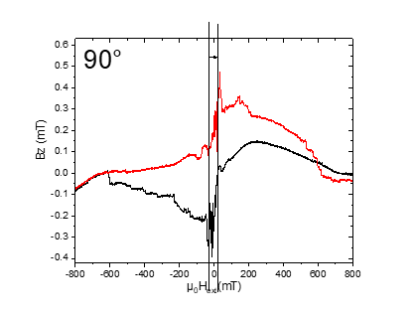

**m355: MFN\_Plusses\_sweep after\_saturation at -1T\_ -0.025T to 0.025 T\_0.5mT.min\_1.5 Hz\_5V\_averages 24\_T=25K**

Sonntag, 7. Juli 2019

16:43

|  |  |
| --- | --- |
| Angle of sensor θ | *+90* |
| Temp | 25 K |
|  | **Plusses(1-13)** |
|  | |  |  |  |  | | --- | --- | --- | --- | |  |  |  |  | | ***Gate (0V)*** | ***9 - 4*** |  | ***14 - 7 Preamp.*** | |
|  | |  |  | | --- | --- | |  | *-0.025T to*  ***0.025*** *T Delta=0.5* | | *Sweep rate* | *0.5mT/min 0.00005T/min* | |
| Resistance Box | |  |  |  |  |  |  | | --- | --- | --- | --- | --- | --- | |  | *1 MΩ* |  |  |  |  | |  | *1 MΩ* |  |  |  | *10* | |
|  | |  |  |  |  |  |  | | --- | --- | --- | --- | --- | --- | | Sens | 10 mV |  | 5 V | *f* | *113 Hz* | | *τ* | *3 ms* | *Input A* | *AC* | *Ground* | *Normal Reserve* | |
| Pre Amplifier (SR560) | |  |  |  |  | | --- | --- | --- | --- | | *Gain Mode* | *Low* | *Gain:* | *2e1* | | *Coupling* | *AC* | *Output (50Ω)* | *LI Input A* | | *Filters:* | *Off* |  |  | |
| Signal Analyzer (SR785) | |  |  |  |  | | --- | --- | --- | --- | | *Ch 1 (A)* |  | *Freq - Span:* | *1.5* | | *Ch 2 (A)* |  | *Averages:* | *24* | |
| Period of measurement (min) | 100min |
| He (l) level consumption |  |
| Data files | <<m355\_MFN\_Plusses\_T25K\_sweep\_-25mT to +25 mT\_at -1T saturation\_Rate 0.5mTmin\_SR785\_1.5Hz\_\_aver 24\_Vin 5V\_sens 5mV .dat>> |
| Plot | Machine generated alternative text: Temperature  XJK_09n |

**m356: MFN\_Plusses\_sweep after\_saturation at -1T\_ -0.025T to 0.025 T\_0.5mT.min\_1.5 Hz\_5V\_averages 24\_T=20K**

Sonntag, 7. Juli 2019

22:24

|  |  |
| --- | --- |
| Angle of sensor θ | *+90* |
| Temp | 20 K |
|  | **Plusses(1-13)** |
|  | |  |  |  |  | | --- | --- | --- | --- | |  |  |  |  | | ***Gate (0V)*** | ***9 - 4*** |  | ***14 - 7 Preamp.*** | |
|  | |  |  | | --- | --- | |  | *-0.025T to*  ***0.025*** *T Delta=0.5* | | *Sweep rate* | *0.5mT/min 0.00005T/min* | |
| Resistance Box | |  |  |  |  |  |  | | --- | --- | --- | --- | --- | --- | |  | *1 MΩ* |  |  |  |  | |  | *1 MΩ* |  |  |  | *10* | |
|  | |  |  |  |  |  |  | | --- | --- | --- | --- | --- | --- | | Sens | 5 mV |  | 5 V | *f* | *113 Hz* | | *τ* | *3 ms* | *Input A* | *AC* | *Ground* | *Normal Reserve* | |
| Pre Amplifier (SR560) | |  |  |  |  | | --- | --- | --- | --- | | *Gain Mode* | *Low* | *Gain:* | *2e1* | | *Coupling* | *AC* | *Output (50Ω)* | *LI Input A* | | *Filters:* | *Off* |  |  | |
| Signal Analyzer (SR785) | |  |  |  |  | | --- | --- | --- | --- | | *Ch 1 (A)* |  | *Freq - Span:* | *1.5* | | *Ch 2 (A)* |  | *Averages:* | *24* | |
| Period of measurement (min) | 100min |
| He (l) level consumption |  |
| Data files | <<m356\_MFN\_Plusses\_T20K\_sweep\_-25mT to +25 mT\_at -1T saturation\_Rate 0.5mTmin\_SR785\_1.5Hz\_\_aver 24\_Vin 5V\_sens 5mV .dat>> |
| Plot | Machine generated alternative text: Temperature  omi  184 |

**m357: MFN\_Plusses\_sweep after\_saturation at -1T\_ -0.025T to 0.025 T\_0.5mT.min\_1.5 Hz\_5V\_averages 24\_T=15K**

Sonntag, 7. Juli 2019

23:26

|  |  |
| --- | --- |
| Angle of sensor θ | *+90* |
| Temp | 15 K |
|  | **Plusses(1-13)** |
|  | |  |  |  |  | | --- | --- | --- | --- | |  |  |  |  | | ***Gate (0V)*** | ***9 - 4*** |  | ***14 - 7 Preamp.*** | |
|  | |  |  | | --- | --- | |  | *-0.025T to*  ***0.025*** *T Delta=0.5* | | *Sweep rate* | *0.5mT/min 0.00005T/min* | |
| Resistance Box | |  |  |  |  |  |  | | --- | --- | --- | --- | --- | --- | |  | *1 MΩ* |  |  |  |  | |  | *1 MΩ* |  |  |  | *10* | |
|  | |  |  |  |  |  |  | | --- | --- | --- | --- | --- | --- | | Sens | 10 mV |  | 5 V | *f* | *113 Hz* | | *τ* | *3 ms* | *Input A* | *AC* | *Ground* | *Normal Reserve* | |
| Pre Amplifier (SR560) | |  |  |  |  | | --- | --- | --- | --- | | *Gain Mode* | *Low* | *Gain:* | *2e1* | | *Coupling* | *AC* | *Output (50Ω)* | *LI Input A* | | *Filters:* | *Off* |  |  | |
| Signal Analyzer (SR785) | |  |  |  |  | | --- | --- | --- | --- | | *Ch 1 (A)* |  | *Freq - Span:* | *1.5* | | *Ch 2 (A)* |  | *Averages:* | *24* | |
| Period of measurement (min) | 100min |
| He (l) level consumption |  |
| Data files | <<m357\_MFN\_Plusses\_T15K\_sweep\_-25mT to +25 mT\_at -1T saturation\_Rate 0.5mTmin\_SR785\_1.5Hz\_\_aver 24\_Vin 5V\_sens 5mV .dat>> |
| Plot |  |

**m358: MFN\_Plusses\_sweep after\_saturation at -1T\_ -0.025T to 0.025 T\_0.5mT.min\_1.5 Hz\_5V\_averages 24\_T=10K**

Montag, 8. Juli 2019

05:02

|  |  |
| --- | --- |
| Angle of sensor θ | *+90* |
| Temp | 10 K |
|  | **Plusses(1-13)** |
|  | |  |  |  |  | | --- | --- | --- | --- | |  |  |  |  | | ***Gate (0V)*** | ***9 - 4*** |  | ***14 - 7 Preamp.*** | |
|  | |  |  | | --- | --- | |  | *-0.025T to*  ***0.025*** *T Delta=0.5* | | *Sweep rate* | *0.5mT/min 0.00005T/min* | |
| Resistance Box | |  |  |  |  |  |  | | --- | --- | --- | --- | --- | --- | |  | *1 MΩ* |  |  |  |  | |  | *1 MΩ* |  |  |  | *10* | |
|  | |  |  |  |  |  |  | | --- | --- | --- | --- | --- | --- | | Sens | 5 mV |  | 5 V | *f* | *113 Hz* | | *τ* | *3 ms* | *Input A* | *AC* | *Ground* | *Normal Reserve* | |
| Pre Amplifier (SR560) | |  |  |  |  | | --- | --- | --- | --- | | *Gain Mode* | *Low* | *Gain:* | *2e1* | | *Coupling* | *AC* | *Output (50Ω)* | *LI Input A* | | *Filters:* | *Off* |  |  | |
| Signal Analyzer (SR785) | |  |  |  |  | | --- | --- | --- | --- | | *Ch 1 (A)* |  | *Freq - Span:* | *1.5* | | *Ch 2 (A)* |  | *Averages:* | *24* | |
| Period of measurement (min) | 100min |
| He (l) level consumption |  |
| Data files | <<m358\_MFN\_Plusses\_T10K\_sweep\_-25mT to +25 mT\_at -1T saturation\_Rate 0.5mTmin\_SR785\_1.5Hz\_\_aver 24\_Vin 5V\_sens 5mV .dat>> |
| Plot | Machine generated alternative text: Temperatu re  a scorn I.  a smrnr.  ZWkasmrn |

**m359: MFN\_Plusses\_sweep after\_saturation at -1T\_ -0.025T to 0.025 T\_0.5mT.min\_1.5 Hz\_5V\_averages 24\_T=5K**

Montag, 8. Juli 2019

07:11

|  |  |
| --- | --- |
| Angle of sensor θ | *+90* |
| Temp | 5 K |
|  | **Plusses(1-13)** |
|  | |  |  |  |  | | --- | --- | --- | --- | |  |  |  |  | | ***Gate (0V)*** | ***9 - 4*** |  | ***14 - 7 Preamp.*** | |
|  | |  |  | | --- | --- | |  | *-0.025T to*  ***0.025*** *T Delta=0.5* | | *Sweep rate* | *0.5mT/min 0.00005T/min* | |
| Resistance Box | |  |  |  |  |  |  | | --- | --- | --- | --- | --- | --- | |  | *1 MΩ* |  |  |  |  | |  | *1 MΩ* |  |  |  | *10* | |
|  | |  |  |  |  |  |  | | --- | --- | --- | --- | --- | --- | | Sens | 10 mV |  | 5 V | *f* | *113 Hz* | | *τ* | *3 ms* | *Input A* | *AC* | *Ground* | *Normal Reserve* | |
| Pre Amplifier (SR560) | |  |  |  |  | | --- | --- | --- | --- | | *Gain Mode* | *Low* | *Gain:* | *2e1* | | *Coupling* | *AC* | *Output (50Ω)* | *LI Input A* | | *Filters:* | *Off* |  |  | |
| Signal Analyzer (SR785) | |  |  |  |  | | --- | --- | --- | --- | | *Ch 1 (A)* |  | *Freq - Span:* | *1.5* | | *Ch 2 (A)* |  | *Averages:* | *24* | |
| Period of measurement (min) | 100min |
| He (l) level consumption |  |
| Data files | <<m359\_MFN\_Plusses\_T5K\_sweep\_-25mT to +25 mT\_at -1T saturation\_Rate 0.5mTmin\_SR785\_1.5Hz\_\_aver 24\_Vin 5V\_sens 5mV .dat>> |
| Plot | Machine generated alternative text: Ternperature effect  f (Hzl  osmTn  15K_osmT |

**Measurement Plan #5\_Static field effect**



08 July 2019

12:37



Static field effect

|  |  |  |  |  |  |  |  |  |  |
| --- | --- | --- | --- | --- | --- | --- | --- | --- | --- |
| Nr | Struct | Field static at | Hloop\_branch | T (K) | F-Span | Vin(V)/sens (mV)/gain | Avg | Time [min, Hr] | Date |
| [m360:](onenote:#m360%20MFN_Plusses_sweep%20after_saturation%20at%20-1T_static%20at%200.025%20T_0.5mT.min_1.5%20Hz_5V_averages%2024_T=5K&section-id={5FAD0518-E349-4A07-93E8-5D105BD4AEB4}&page-id={F2ADB3B1-7681-4A2A-8E8D-CC443B04987B}&end&base-path=https://goetheuniversitaet.sharepoint.com/sites/Project4/SiteAssets/Project%204%20Notebook/Magnetic%20Flux%20Noise.one) | Plusses | 25 mT | -Saturated | 5 | 1.5 | 5/5/20 | 24 | 100 | 08.07.2019\_Monday\_ |
| [m361:](onenote:#m361%20MFN_Plusses_sweep%20after_saturation%20at%20+1T_static%20at%20-0.025%20T_0.5mT.min_1.5%20Hz_5V_averages%2024_T=5K&section-id={5FAD0518-E349-4A07-93E8-5D105BD4AEB4}&page-id={603A009E-7A04-4FFF-A631-14BAA91EB45F}&end&base-path=https://goetheuniversitaet.sharepoint.com/sites/Project4/SiteAssets/Project%204%20Notebook/Magnetic%20Flux%20Noise.one) | Plusses | -25 mT | +Saturated | 5 | 1.5 | 5/5/20 | 24 | 100 | 08.07.2019\_Monday\_ |
|  |  |  |  |  |  |  |  |  |  |



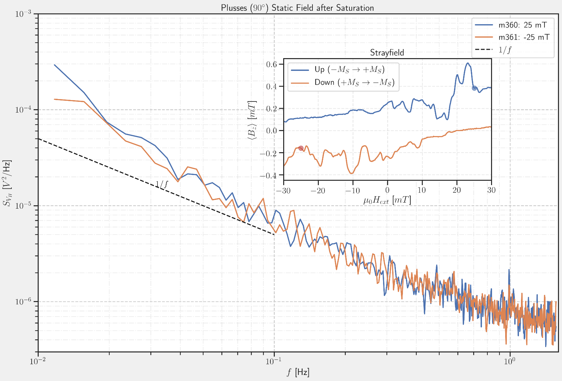

**m360: MFN\_Plusses\_sweep after\_saturation at -1T\_static at 0.025 T\_0.5mT.min\_1.5 Hz\_5V\_averages 24\_T=5K**

Montag, 8. Juli 2019

10:08

|  |  |
| --- | --- |
| Angle of sensor θ | *+90* |
| Temp | 5 K |
|  | **Plusses(1-13)** |
|  | |  |  |  |  | | --- | --- | --- | --- | |  |  |  |  | | ***Gate (0V)*** | ***9 - 4*** |  | ***14 - 7 Preamp.*** | |
|  | |  |  | | --- | --- | |  | ***Static at 0.025*** *T* | | *Sweep rate* | *0.5mT/min 0.00005T/min* | |
| Resistance Box | |  |  |  |  |  |  | | --- | --- | --- | --- | --- | --- | |  | *1 MΩ* |  |  |  |  | |  | *1 MΩ* |  |  |  | *10* | |
|  | |  |  |  |  |  |  | | --- | --- | --- | --- | --- | --- | | Sens | 10 mV |  | 5 V | *f* | *113 Hz* | | *τ* | *3 ms* | *Input A* | *AC* | *Ground* | *Normal Reserve* | |
| Pre Amplifier (SR560) | |  |  |  |  | | --- | --- | --- | --- | | *Gain Mode* | *Low* | *Gain:* | *2e1* | | *Coupling* | *AC* | *Output (50Ω)* | *LI Input A* | | *Filters:* | *Off* |  |  | |
| Signal Analyzer (SR785) | |  |  |  |  | | --- | --- | --- | --- | | *Ch 1 (A)* |  | *Freq - Span:* | *1.5* | | *Ch 2 (A)* |  | *Averages:* | *24* | |
| Period of measurement (min) | 100min |
| He (l) level consumption |  |
| Data files | <<m360\_MFN\_Plusses\_T5K\_static at +25 mT\_at -1T saturation\_SR785\_1.5Hz\_\_aver 24\_Vin 5V\_sens 5mV .dat>> |
| Plot | Machine generated alternative text: SED::  omi |

**m361: MFN\_Plusses\_sweep after\_saturation at +1T\_static at -0.025 T\_0.5mT.min\_1.5 Hz\_5V\_averages 24\_T=5K**

Montag, 8. Juli 2019

12:06

|  |  |
| --- | --- |
| Angle of sensor θ | *+90* |
| Temp | 5 K |
|  | **Plusses(1-13)** |
|  | |  |  |  |  | | --- | --- | --- | --- | |  |  |  |  | | ***Gate (0V)*** | ***9 - 4*** |  | ***14 - 7 Preamp.*** | |
|  | |  |  | | --- | --- | |  | ***Static at -0.025*** *T* | | *Sweep rate* | *0.5mT/min 0.00005T/min* | |
| Resistance Box | |  |  |  |  |  |  | | --- | --- | --- | --- | --- | --- | |  | *1 MΩ* |  |  |  |  | |  | *1 MΩ* |  |  |  | *10* | |
|  | |  |  |  |  |  |  | | --- | --- | --- | --- | --- | --- | | Sens | 10 mV |  | 5 V | *f* | *113 Hz* | | *τ* | *3 ms* | *Input A* | *AC* | *Ground* | *Normal Reserve* | |
| Pre Amplifier (SR560) | |  |  |  |  | | --- | --- | --- | --- | | *Gain Mode* | *Low* | *Gain:* | *2e1* | | *Coupling* | *AC* | *Output (50Ω)* | *LI Input A* | | *Filters:* | *Off* |  |  | |
| Signal Analyzer (SR785) | |  |  |  |  | | --- | --- | --- | --- | | *Ch 1 (A)* |  | *Freq - Span:* | *1.5* | | *Ch 2 (A)* |  | *Averages:* | *24* | |
| Period of measurement (min) | 100min |
| He (l) level consumption |  |
| Data files | <<m361\_MFN\_Plusses\_T5K\_static at -25 mT\_at +1T saturation\_SR785\_1.5Hz\_\_aver 24\_Vin 5V\_sens 5mV .dat>> |
| Plot | Machine generated alternative text: T=5K  les |

**Measurement Plan #6\_dynamic field interval effect**



08 July 2019

12:37



Dynamic field interval effect

|  |  |  |  |  |  |  |  |  |  |  |
| --- | --- | --- | --- | --- | --- | --- | --- | --- | --- | --- |
| Nr | Struct | Field From | Field To | Hloop\_branch | SR [mT/min] | F-Span | Vin(V)/sens (mV)/gain | Avg | Time [min, Hr] | Date |
| [m362:](onenote:#m362%20MFN_Plusses_sweep%20after_saturation%20at%20-1T_%20-0.05T%20to%200.05%20T_2mT.min_1.5%20Hz_5V_averages%2012_T=5K&section-id={5FAD0518-E349-4A07-93E8-5D105BD4AEB4}&page-id={8B485E50-50D6-4E44-9DEC-F6329CE40B69}&end&base-path=https://goetheuniversitaet.sharepoint.com/sites/Project4/SiteAssets/Project%204%20Notebook/Magnetic%20Flux%20Noise.one) | Plusses | -50mT | 50mT | -Saturated | 2 | 1.5 | 5/5/20 | 12 | 50 | 08.07.2019\_Monday\_ |
| [m363:](onenote:#m363%20MFN_Plusses_sweep%20after_saturation%20at%20-1T_%20-0.075T%20to%200.075%20T_2mT.min_1.5%20Hz_5V_averages%2018_T=5K&section-id={5FAD0518-E349-4A07-93E8-5D105BD4AEB4}&page-id={783C9E1C-FBF3-42CF-B766-D39BC033182C}&end&base-path=https://goetheuniversitaet.sharepoint.com/sites/Project4/SiteAssets/Project%204%20Notebook/Magnetic%20Flux%20Noise.one) | Plusses | -75 mT | 75mT | -Saturated | 2 | 1.5 | 5/5/20 | 18 | 75 | 08.07.2019\_Monday\_ |
| [m364:](onenote:#m364%20MFN_Plusses_sweep%20after_saturation%20at%20-1T_%20-0.01T%20to%200.01%20T_2mT.min_1.5%20Hz_5V_averages%2024_T=5K&section-id={5FAD0518-E349-4A07-93E8-5D105BD4AEB4}&page-id={1AF50FBB-AD26-4941-B347-432783927251}&end&base-path=https://goetheuniversitaet.sharepoint.com/sites/Project4/SiteAssets/Project%204%20Notebook/Magnetic%20Flux%20Noise.one) | Plusses | -100 mT | 100mT | -Saturated | 2 | 1.5 | 5/5/20 | 35 | 100 | 08.07.2019\_Monday\_ |
| [m366:](onenote:#m366%20MFN_Plusses_sweep%20after_saturation%20at%20-1T_%20-0.125T%20to%200.125%20T_2mT.min_1.5%20Hz_5V_averages%2029_T=5K&section-id={5FAD0518-E349-4A07-93E8-5D105BD4AEB4}&page-id={A262E013-0290-43C2-A689-DB1196B5CA4F}&end&base-path=https://goetheuniversitaet.sharepoint.com/sites/Project4/SiteAssets/Project%204%20Notebook/Magnetic%20Flux%20Noise.one) | Plusses | -125mT | 125mT | -Saturated | 2 | 1.5 | 5/5/20 | 35 | 75 | 09.07.2019\_Tuesday after midnight\_ |
| [m365:](onenote:#m365%20MFN_Plusses_sweep%20after_saturation%20at%20-1T_%20-0.15T%20to%200.15T_2mT.min_1.5%20Hz_5V_averages%2035_T=5K&section-id={5FAD0518-E349-4A07-93E8-5D105BD4AEB4}&page-id={4D6B25D1-7B89-4CFF-9CD8-C86D64AA46B0}&end&base-path=https://goetheuniversitaet.sharepoint.com/sites/Project4/SiteAssets/Project%204%20Notebook/Magnetic%20Flux%20Noise.one) | Plusses | -150 mT | 150mT | -Saturated | 2 | 1.5 | 5/5/20 | 35 | 150 | 09.07.2019\_Early morning\_ |

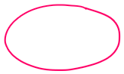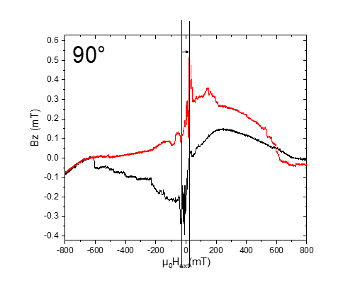

**m362: MFN\_Plusses\_sweep after\_saturation at -1T\_ -0.05T to 0.05 T\_2mT.min\_1.5 Hz\_5V\_averages 12\_T=5K**

08 July 2019

14:41

|  |  |
| --- | --- |
| Angle of sensor θ | *+90* |
| Temp | 5 K |
|  | **Plusses(1-13)** |
|  | |  |  |  |  | | --- | --- | --- | --- | |  |  |  |  | | ***Gate (0V)*** | ***9 - 4*** |  | ***14 - 7 Preamp.*** | |
|  | |  |  | | --- | --- | |  | *-0.05 to*  ***0.05*** *T Delta=0.5* | | *Sweep rate* | *2mT/min 0.002T/min* | |
| Resistance Box | |  |  |  |  |  |  | | --- | --- | --- | --- | --- | --- | |  | *1 MΩ* |  |  |  |  | |  | *1 MΩ* |  |  |  | *10* | |
|  | |  |  |  |  |  |  | | --- | --- | --- | --- | --- | --- | | Sens | 5mV |  | 5 V | *f* | *113 Hz* | | *τ* | *3 ms* | *Input A* | *AC* | *Ground* | *Normal Reserve* | |
| Pre Amplifier (SR560) | |  |  |  |  | | --- | --- | --- | --- | | *Gain Mode* | *Low* | *Gain:* | *2e1* | | *Coupling* | *AC* | *Output (50Ω)* | *LI Input A* | | *Filters:* | *Off* |  |  | |
| Signal Analyzer (SR785) | |  |  |  |  | | --- | --- | --- | --- | | *Ch 1 (A)* |  | *Freq - Span:* | *1.5* | | *Ch 2 (A)* |  | *Averages:* | *12* | |
| Period of measurement (min) | 50min |
| He (l) level consumption |  |
| Data files | <<m362\_MFN\_Plusses\_T5K\_sweep\_-50mT to +50 mT\_at -1T saturation\_Rate 2mTmin\_SR785\_1.5Hz\_\_aver 12\_Vin 5V\_sens 5mV .dat>> |
| Plot | Machine generated alternative text: T=5K  001  1+6 |

**Filling He(l)**

Montag, 8. Juli 2019

16:12

|  |  |
| --- | --- |
| Filling date | 08.07.2019 |
| Before (in) | 27 |
| After (in) | 36.22 |
| consumption | 214-123=26 L |
| Person | MAM |

Notes:



'To do:

**m363: MFN\_Plusses\_sweep after\_saturation at -1T\_ -0.075T to 0.075 T\_2mT.min\_1.5 Hz\_5V\_averages 18\_T=5K**

Montag, 8. Juli 2019

16:25

|  |  |
| --- | --- |
| Angle of sensor θ | *+90* |
| Temp | 5 K |
|  | **Plusses(1-13)** |
|  | |  |  |  |  | | --- | --- | --- | --- | |  |  |  |  | | ***Gate (0V)*** | ***9 - 4*** |  | ***14 - 7 Preamp.*** | |
|  | |  |  | | --- | --- | |  | *-0.075to*  ***0.075*** *T Delta=0.5* | | *Sweep rate* | *2mT/min 0.002T/min* | |
| Resistance Box | |  |  |  |  |  |  | | --- | --- | --- | --- | --- | --- | |  | *1 MΩ* |  |  |  |  | |  | *1 MΩ* |  |  |  | *10* | |
|  | |  |  |  |  |  |  | | --- | --- | --- | --- | --- | --- | | Sens | 5mV |  | 5 V | *f* | *113 Hz* | | *τ* | *3 ms* | *Input A* | *AC* | *Ground* | *Normal Reserve* | |
| Pre Amplifier (SR560) | |  |  |  |  | | --- | --- | --- | --- | | *Gain Mode* | *Low* | *Gain:* | *2e1* | | *Coupling* | *AC* | *Output (50Ω)* | *LI Input A* | | *Filters:* | *Off* |  |  | |
| Signal Analyzer (SR785) | |  |  |  |  | | --- | --- | --- | --- | | *Ch 1 (A)* |  | *Freq - Span:* | *1.5* | | *Ch 2 (A)* |  | *Averages:* | *18* | |
| Period of measurement (min) | 75min |
| He (l) level consumption |  |
| Data files | <<m363\_MFN\_Plusses\_T5K\_sweep\_-75mT to +75 mT\_at -1T saturation\_Rate 2mTmin\_SR785\_1.5Hz\_\_aver 18\_Vin 5V\_sens 5mV .dat>> |
| Plot | Machine generated alternative text: T=5K  0031 |

**m364: MFN\_Plusses\_sweep after\_saturation at -1T\_ -0.01T to 0.01 T\_2mT.min\_1.5 Hz\_5V\_averages 24\_T=5K**

Montag, 8. Juli 2019

20:15

|  |  |
| --- | --- |
| Angle of sensor θ | *+90* |
| Temp | 5 K |
|  | **Plusses(1-13)** |
|  | |  |  |  |  | | --- | --- | --- | --- | |  |  |  |  | | ***Gate (0V)*** | ***9 - 4*** |  | ***14 - 7 Preamp.*** | |
|  | |  |  | | --- | --- | |  | *-0.01 to*  ***0.01****T Delta=0.5* | | *Sweep rate* | *2mT/min 0.002T/min* | |
| Resistance Box | |  |  |  |  |  |  | | --- | --- | --- | --- | --- | --- | |  | *1 MΩ* |  |  |  |  | |  | *1 MΩ* |  |  |  | *10* | |
|  | |  |  |  |  |  |  | | --- | --- | --- | --- | --- | --- | | Sens | 5mV |  | 5 V | *f* | *113 Hz* | | *τ* | *3 ms* | *Input A* | *AC* | *Ground* | *Normal Reserve* | |
| Pre Amplifier (SR560) | |  |  |  |  | | --- | --- | --- | --- | | *Gain Mode* | *Low* | *Gain:* | *2e1* | | *Coupling* | *AC* | *Output (50Ω)* | *LI Input A* | | *Filters:* | *Off* |  |  | |
| Signal Analyzer (SR785) | |  |  |  |  | | --- | --- | --- | --- | | *Ch 1 (A)* |  | *Freq - Span:* | *1.5* | | *Ch 2 (A)* |  | *Averages:* | *18* | |
| Period of measurement (min) | 100min |
| He (l) level consumption |  |
| Data files | <<m364.1\_MFN\_Plusses\_T5K\_sweep\_-100mT to +100 mT\_at -1T saturation\_Rate 2mTmin\_SR785\_1.5Hz\_\_aver 24\_Vin 5V\_sens 5mV .dat>> |
| Plot |  |

**m365: MFN\_Plusses\_sweep after\_saturation at -1T\_ -0.15T to 0.15T\_2mT.min\_1.5 Hz\_5V\_averages 35\_T=5K**

Dienstag, 9. Juli 2019

02:46

|  |  |
| --- | --- |
| Angle of sensor θ | *+90* |
| Temp | 5 K |
|  | **Plusses(1-13)** |
|  | |  |  |  |  | | --- | --- | --- | --- | |  |  |  |  | | ***Gate (0V)*** | ***9 - 4*** |  | ***14 - 7 Preamp.*** | |
|  | |  |  | | --- | --- | |  | *-0.015 to*  ***0.015****T Delta=0.5* | | *Sweep rate* | *2mT/min 0.002T/min* | |
| Resistance Box | |  |  |  |  |  |  | | --- | --- | --- | --- | --- | --- | |  | *1 MΩ* |  |  |  |  | |  | *1 MΩ* |  |  |  | *10* | |
|  | |  |  |  |  |  |  | | --- | --- | --- | --- | --- | --- | | Sens | 5mV |  | 5 V | *f* | *113 Hz* | | *τ* | *3 ms* | *Input A* | *AC* | *Ground* | *Normal Reserve* | |
| Pre Amplifier (SR560) | |  |  |  |  | | --- | --- | --- | --- | | *Gain Mode* | *Low* | *Gain:* | *2e1* | | *Coupling* | *AC* | *Output (50Ω)* | *LI Input A* | | *Filters:* | *Off* |  |  | |
| Signal Analyzer (SR785) | |  |  |  |  | | --- | --- | --- | --- | | *Ch 1 (A)* |  | *Freq - Span:* | *1.5* | | *Ch 2 (A)* |  | *Averages:* | *35* | |
| Period of measurement (min) | 100min |
| He (l) level consumption |  |
| Data files | <<m365\_MFN\_Plusses\_T5K\_sweep\_-150mT to +150 mT\_at -1T saturation\_Rate 2mTmin\_SR785\_1.5Hz\_\_aver 35\_Vin 5V\_sens 5mV .dat>> |
| Plot |  |

**m366: MFN\_Plusses\_sweep after\_saturation at -1T\_ -0.125T to 0.125 T\_2mT.min\_1.5 Hz\_5V\_averages 29\_T=5K**

Dienstag, 9. Juli 2019

05:19

|  |  |
| --- | --- |
| Angle of sensor θ | *+90* |
| Temp | 5 K |
|  | **Plusses(1-13)** |
|  | |  |  |  |  | | --- | --- | --- | --- | |  |  |  |  | | ***Gate (0V)*** | ***9 - 4*** |  | ***14 - 7 Preamp.*** | |
|  | |  |  | | --- | --- | |  | *-0.0125 to*  ***0.0125****T Delta=0.5* | | *Sweep rate* | *2mT/min 0.002T/min* | |
| Resistance Box | |  |  |  |  |  |  | | --- | --- | --- | --- | --- | --- | |  | *1 MΩ* |  |  |  |  | |  | *1 MΩ* |  |  |  | *10* | |
|  | |  |  |  |  |  |  | | --- | --- | --- | --- | --- | --- | | Sens | 5mV |  | 5 V | *f* | *113 Hz* | | *τ* | *3 ms* | *Input A* | *AC* | *Ground* | *Normal Reserve* | |
| Pre Amplifier (SR560) | |  |  |  |  | | --- | --- | --- | --- | | *Gain Mode* | *Low* | *Gain:* | *2e1* | | *Coupling* | *AC* | *Output (50Ω)* | *LI Input A* | | *Filters:* | *Off* |  |  | |
| Signal Analyzer (SR785) | |  |  |  |  | | --- | --- | --- | --- | | *Ch 1 (A)* |  | *Freq - Span:* | *1.5* | | *Ch 2 (A)* |  | *Averages:* | *29* | |
| Period of measurement (min) | 100min |
| He (l) level consumption |  |
| Data files | <<m366\_MFN\_Plusses\_T5K\_sweep\_-125mT to +125 mT\_at -1T saturation\_Rate 2mTmin\_SR785\_1.5Hz\_\_aver 29\_Vin 5V\_sens 5mV .dat>> |
| Plot |  |

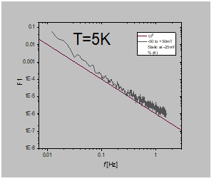

**Eval Meas Plan 234**

Tuesday, 9. July 2019

09:23

<<Measurement Plan 234.pdf>>

**Measurement Plan #7\_dynamic field fast and slow sweep rate\_waiting at 0T**

08 July 2019

12:37

Fast and slow sweep rate

|  |  |  |  |  |  |  |  |  |  |  |  |  |  |
| --- | --- | --- | --- | --- | --- | --- | --- | --- | --- | --- | --- | --- | --- |
| Nr | Struct | Field From | SR [mT/min] | Field To | SR [mT/min] | Field To | SR [mT/min] | Field To | F-Span | Vin(V)/sens (mV)/gain | Avg | Time [min, Hr] | Date |
| [m367:](onenote:#m367%20&section-id={5FAD0518-E349-4A07-93E8-5D105BD4AEB4}&page-id={50DAB2EB-CEC9-4125-B8D2-9703C8ECF565}&end&base-path=https://goetheuniversitaet.sharepoint.com/sites/Project4/SiteAssets/Project%204%20Notebook/Magnetic%20Flux%20Noise.one) | Plusses | 1000mT | 50 | 25 mT | 2 | -25 mT | 50 | -1000mT | 1.5 | 5/5/20 | 15 | 64 | 09.07.2019\_Tuesday\_ |
| [m368\_](onenote:#m368_MFN_Plusses_T5K_%20Fast%20sweep%20+1T%20to%20+0.025mT_50mTmin_%20slow%20sweep_to%20-0.025mT_2mTmin_to%20-1T_50mTmin_SR785_1.5Hz__aver%209_Vin%205V_sens%205mV%20_usuing%20routine%20for%20the%20magnet&section-id={5FAD0518-E349-4A07-93E8-5D105BD4AEB4}&page-id={7152769F-6F86-46B5-806E-012A161999D7}&end&base-path=https://goetheuniversitaet.sharepoint.com/sites/Project4/SiteAssets/Project%204%20Notebook/Magnetic%20Flux%20Noise.one) | Plusses | 1000mT | 50 |  |  |  | 50 | -1000mT | 1.5 | 5/5/20 | 9 | 64 | 09.07.2019\_Tuesday\_ |
| [M369](onenote:#M369_MFN_Plusses_T5K_%20Fast%20sweep%20+1T%20to%200mT_30mTmin_wait%2020min%20at%200%20and%20sweep%20fast%20to%20-1T_30mTmin_SR785_1.5Hz__aver%209_Vin%205V_sens%205mV%20_usuing%20routine%20for%20the%20magnet&section-id={5FAD0518-E349-4A07-93E8-5D105BD4AEB4}&page-id={4684022F-8EAD-47CB-917E-118A0156C508}&end&base-path=https://goetheuniversitaet.sharepoint.com/sites/Project4/SiteAssets/Project%204%20Notebook/Magnetic%20Flux%20Noise.one) | Plusses | 1000mT | 30 | 0 wait here 20 min |  |  | 30 | -1000mT | 1.5 | 5/5/20 | 20 | 86 | 09.07.2019\_Tuesday\_ |
| [m370](onenote:#m370_MFN_Plusses_T5K_%20Fast%20sweep%20+1T%20to%200%20wait%2010%20min%20and%20sweep%20to%20-1T_30mTmin_SR785_1.5Hz__aver%2018_Vin%205V_sens%205mV%20&section-id={5FAD0518-E349-4A07-93E8-5D105BD4AEB4}&page-id={34C045CE-39AE-42BF-9CCD-7C5F658EC4DD}&end&base-path=https://goetheuniversitaet.sharepoint.com/sites/Project4/SiteAssets/Project%204%20Notebook/Magnetic%20Flux%20Noise.one) | Plusses | 1000mT | 30 | 0 wait here 10 min |  |  | 30 | -1000mT | 1.5 | 5/5/20 | 18 | 76 | 09.07.2019\_Tuesday\_ |
| [m371](onenote:#m371_MFN_Plusses_T5K_%20Fast%20sweep%20+1T%20to%200%20wait%2010%20min%20and%20sweep%20to%20-1T_30mTmin_SR785_1.5Hz__aver%2023_Vin%205V_sens%205mV%20&section-id={5FAD0518-E349-4A07-93E8-5D105BD4AEB4}&page-id={85222F49-5AE1-47C1-BF10-52CB4400EAA2}&end&base-path=https://goetheuniversitaet.sharepoint.com/sites/Project4/SiteAssets/Project%204%20Notebook/Magnetic%20Flux%20Noise.one) | Plusses | 1000mT | 30 | 0 wait here 30 min |  |  | 30 | -1000mT | 1.5 | 5/5/20 | 23 | 96 | 09.07.2019\_Tuesday\_ |



**m367\_MFN\_Plusses\_T5K\_ Fast sweep +1T to +0.025mT\_50mTmin\_ slow sweep\_to -0.025mT\_2mTmin\_to -1T\_50mTmin\_SR785\_1.5Hz\_\_aver 15\_Vin 5V\_sens 5mV \_usuing routine for the magnet**

Dienstag, 9. Juli 2019

12:30

|  |  |
| --- | --- |
| Angle of sensor θ | *+90* |
| Temp | 5 K |
|  | **Plusses(1-13)** |
|  | |  |  |  |  | | --- | --- | --- | --- | |  |  |  |  | | ***Gate (0V)*** | ***9 - 4*** |  | ***14 - 7 Preamp.*** | |
|  | **Fast sweep +1T to +0.025mT\_50mTmin\_ to -0.025mT\_2mTmin\_to -1T\_50mTmin** |
| Resistance Box | |  |  |  |  |  |  | | --- | --- | --- | --- | --- | --- | |  | *1 MΩ* |  |  |  |  | |  | *1 MΩ* |  |  |  | *10* | |
|  | |  |  |  |  |  |  | | --- | --- | --- | --- | --- | --- | | Sens | 5mV |  | 5 V | *f* | *113 Hz* | | *τ* | *3 ms* | *Input A* | *AC* | *Ground* | *Normal Reserve* | |
| Pre Amplifier (SR560) | |  |  |  |  | | --- | --- | --- | --- | | *Gain Mode* | *Low* | *Gain:* | *2e1* | | *Coupling* | *AC* | *Output (50Ω)* | *LI Input A* | | *Filters:* | *Off* |  |  | |
| Signal Analyzer (SR785) | |  |  |  |  | | --- | --- | --- | --- | | *Ch 1 (A)* |  | *Freq - Span:* | *1.5* | | *Ch 2 (A)* |  | *Averages:* | *29* | |
| Period of measurement (min) | 100min |
| He (l) level consumption |  |
| Data files | Saving data from SR830, SR785  <<m367\_MFN\_Plusses\_T5K\_ Fast sweep +1T to +0.025mT\_50mTmin\_ slow sweep\_to -0.025mT\_2mTmin\_fast sweep to -1T\_50mTmin\_SR785\_1.5Hz\_\_aver 15\_Vin 5V\_sens 5mV .dat>>  <<m367.1\_SR830.dat>> |
| Plot |  |

**m368\_MFN\_Plusses\_T5K\_ Fast sweep +1T \_to -1T\_50mTmin\_SR785\_1.5Hz\_\_aver 9\_Vin 5V\_sens 5mV \_**

Dienstag, 9. Juli 2019

13:56

|  |  |
| --- | --- |
| Angle of sensor θ | *+90* |
| Temp | 5 K |
|  | **Plusses(1-13)** |
|  | |  |  |  |  | | --- | --- | --- | --- | |  |  |  |  | | ***Gate (0V)*** | ***9 - 4*** |  | ***14 - 7 Preamp.*** | |
|  | **Fast sweep +1T \_to -1T\_50mTmin** |
| Resistance Box | |  |  |  |  |  |  | | --- | --- | --- | --- | --- | --- | |  | *1 MΩ* |  |  |  |  | |  | *1 MΩ* |  |  |  | *10* | |
|  | |  |  |  |  |  |  | | --- | --- | --- | --- | --- | --- | | Sens | 5mV |  | 5 V | *f* | *113 Hz* | | *τ* | *3 ms* | *Input A* | *AC* | *Ground* | *Normal Reserve* | |
| Pre Amplifier (SR560) | |  |  |  |  | | --- | --- | --- | --- | | *Gain Mode* | *Low* | *Gain:* | *2e1* | | *Coupling* | *AC* | *Output (50Ω)* | *LI Input A* | | *Filters:* | *Off* |  |  | |
| Signal Analyzer (SR785) | |  |  |  |  | | --- | --- | --- | --- | | *Ch 1 (A)* |  | *Freq - Span:* | *1.5* | | *Ch 2 (A)* |  | *Averages:* | *29* | |
| Period of measurement (min) | 100min |
| He (l) level consumption |  |
| Data files | Saving data from SR830, SR785      <<m368\_MFN\_Plusses\_T5K\_ Fast sweep +1T to -1T\_50mTmin\_SR785\_1.5Hz\_\_aver 9\_Vin 5V\_sens 5mV .dat>>    <<m368.1\_SR830.dat>> |
| Plot |  |

**m369\_MFN\_Plusses\_T5K\_ Fast sweep +1T to 0 wait 20 min and sweep to -1T\_30mTmin\_SR785\_1.5Hz\_\_aver 20\_Vin 5V\_sens 5mV**

Dienstag, 9. Juli 2019

15:00

|  |  |
| --- | --- |
| Angle of sensor θ | *+90* |
| Temp | 5 K |
|  | **Plusses(1-13)** |
|  | |  |  |  |  | | --- | --- | --- | --- | |  |  |  |  | | ***Gate (0V)*** | ***9 - 4*** |  | ***14 - 7 Preamp.*** | |
|  | **Fast sweep +1T to 0 wait 20 min and sweep to -1T\_30mTmin** |
| Resistance Box | |  |  |  |  |  |  | | --- | --- | --- | --- | --- | --- | |  | *1 MΩ* |  |  |  |  | |  | *1 MΩ* |  |  |  | *10* | |
|  | |  |  |  |  |  |  | | --- | --- | --- | --- | --- | --- | | Sens | 5mV |  | 5 V | *f* | *113 Hz* | | *τ* | *3 ms* | *Input A* | *AC* | *Ground* | *Normal Reserve* | |
| Pre Amplifier (SR560) | |  |  |  |  | | --- | --- | --- | --- | | *Gain Mode* | *Low* | *Gain:* | *2e1* | | *Coupling* | *AC* | *Output (50Ω)* | *LI Input A* | | *Filters:* | *Off* |  |  | |
| Signal Analyzer (SR785) | |  |  |  |  | | --- | --- | --- | --- | | *Ch 1 (A)* |  | *Freq - Span:* | *1.5* | | *Ch 2 (A)* |  | *Averages:* | *20* | |
| Period of measurement (min) | 100min |
| He (l) level consumption |  |
| Data files | Saving data from SR830, SR785    <<m369\_MFN\_Plusses\_T5K\_ Fast sweep +1T to 0 wait 20 min and sweep to -1T\_30mTmin\_SR785\_1.5Hz\_\_aver 9\_Vin 5V\_sens 5mV .dat>>    <<m369.1\_SR830.dat>> |
| Plot |  |

**m370\_MFN\_Plusses\_T5K\_ Fast sweep +1T to 0 wait 10 min and sweep to -1T\_30mTmin\_SR785\_1.5Hz\_\_aver 18\_Vin 5V\_sens 5mV**

Dienstag, 9. Juli 2019

15:00

|  |  |
| --- | --- |
| Angle of sensor θ | *+90* |
| Temp | 5 K |
|  | **Plusses(1-13)** |
|  | |  |  |  |  | | --- | --- | --- | --- | |  |  |  |  | | ***Gate (0V)*** | ***9 - 4*** |  | ***14 - 7 Preamp.*** | |
|  | **Fast sweep +1T to 0 wait 20 min and sweep to -1T\_30mTmin** |
| Resistance Box | |  |  |  |  |  |  | | --- | --- | --- | --- | --- | --- | |  | *1 MΩ* |  |  |  |  | |  | *1 MΩ* |  |  |  | *10* | |
|  | |  |  |  |  |  |  | | --- | --- | --- | --- | --- | --- | | Sens | 5mV |  | 5 V | *f* | *113 Hz* | | *τ* | *3 ms* | *Input A* | *AC* | *Ground* | *Normal Reserve* | |
| Pre Amplifier (SR560) | |  |  |  |  | | --- | --- | --- | --- | | *Gain Mode* | *Low* | *Gain:* | *2e1* | | *Coupling* | *AC* | *Output (50Ω)* | *LI Input A* | | *Filters:* | *Off* |  |  | |
| Signal Analyzer (SR785) | |  |  |  |  | | --- | --- | --- | --- | | *Ch 1 (A)* |  | *Freq - Span:* | *1.5* | | *Ch 2 (A)* |  | *Averages:* | *18* | |
| Period of measurement (min) | 100min |
| He (l) level consumption |  |
| Data files | Saving data from SR830, SR785      <<m370\_MFN\_Plusses\_T5K\_ Fast sweep +1T to 0 wait 10 min and sweep to -1T\_30mTmin\_SR785\_1.5Hz\_\_aver 18\_Vin 5V\_sens 5mV .dat>>    <<m370.1\_SR830.dat>> |
| Plot |  |

**m371\_MFN\_Plusses\_T5K\_ Fast sweep +1T to 0 wait 30 min and sweep to -1T\_30mTmin\_SR785\_1.5Hz\_\_aver 23\_Vin 5V\_sens 5mV**

Dienstag, 9. Juli 2019

15:00

|  |  |
| --- | --- |
| Angle of sensor θ | *+90* |
| Temp | 5 K |
|  | **Plusses(1-13)** |
|  | |  |  |  |  | | --- | --- | --- | --- | |  |  |  |  | | ***Gate (0V)*** | ***9 - 4*** |  | ***14 - 7 Preamp.*** | |
|  | **Fast sweep +1T to 0 wait 30 min and sweep to -1T\_30mTmin** |
| Resistance Box | |  |  |  |  |  |  | | --- | --- | --- | --- | --- | --- | |  | *1 MΩ* |  |  |  |  | |  | *1 MΩ* |  |  |  | *10* | |
|  | |  |  |  |  |  |  | | --- | --- | --- | --- | --- | --- | | Sens | 5mV |  | 5 V | *f* | *113 Hz* | | *τ* | *3 ms* | *Input A* | *AC* | *Ground* | *Normal Reserve* | |
| Pre Amplifier (SR560) | |  |  |  |  | | --- | --- | --- | --- | | *Gain Mode* | *Low* | *Gain:* | *2e1* | | *Coupling* | *AC* | *Output (50Ω)* | *LI Input A* | | *Filters:* | *Off* |  |  | |
| Signal Analyzer (SR785) | |  |  |  |  | | --- | --- | --- | --- | | *Ch 1 (A)* |  | *Freq - Span:* | *1.5* | | *Ch 2 (A)* |  | *Averages:* | *23* | |
| Period of measurement (min) | 100min |
| He (l) level consumption |  |
| Data files | Saving data from SR830, SR785          <<m371\_MFN\_Plusses\_T5K\_ Fast sweep +1T to 0 wait 30 min and sweep to -1T\_30mTmin\_SR785\_1.5Hz\_\_aver 23\_Vin 5V\_sens 5mV .dat>>    <<m371.1\_SR830.dat>> |
| Plot |  |

**Measurement Plan #8\_winde-ranging field with slow sweeping\_comparison magnetic crosses and empty**

08 July 2019

12:37



winde-ranging field with slow sweeping from positive saturation

|  |  |  |  |  |  |  |  |  |  |
| --- | --- | --- | --- | --- | --- | --- | --- | --- | --- |
| Nr | Struct | Field From | Field To | SR [mT/min] | F-Span | Vin(V)/sens (mV)/gain | Avg | Time [min, Hr] | Date |
| [m372:](onenote:#m372%20MFN_Plusses_sweep%20after_saturation%20at%20+1T_%20+1T%20to%20-1%20T_5mT.min_1.5%20Hz_5V_averages%2094_T=5K_over%20night&section-id={5FAD0518-E349-4A07-93E8-5D105BD4AEB4}&page-id={91317C38-6FED-49CC-9C1B-EEDC985316EB}&end&base-path=https://goetheuniversitaet.sharepoint.com/sites/Project4/SiteAssets/Project%204%20Notebook/Magnetic%20Flux%20Noise.one) | Plusses | +1T | -1T | 5 | 1.5 | 5/5/20 | 94 | 400min | 09.07.2019\_Tuesday\_ |
| [m373:](onenote:#m373%20MFN_Crosses_sweep%20after_saturation%20at%20+1T_%20+1T%20to%20-1%20T_5mT.min_1.5%20Hz_5V_averages%2094_T=5K_sens%202mV&section-id={5FAD0518-E349-4A07-93E8-5D105BD4AEB4}&page-id={F41B0352-E6FC-4BDF-A6ED-6807B9F63B65}&end&base-path=https://goetheuniversitaet.sharepoint.com/sites/Project4/SiteAssets/Project%204%20Notebook/Magnetic%20Flux%20Noise.one) | Crosses | +1T | -1T | 5 | 1.5 | 5/2/20 | 94 | 400min | 10.07.2019\_Wednesday\_ |
| [m374:](onenote:#m374%20MFN_Empty_sweep%20after_saturation%20at%20+1T_%20+1T%20to%20-1%20T_5mT.min_1.5%20Hz_5V_averages%2094_T=5K_sens%202mV&section-id={5FAD0518-E349-4A07-93E8-5D105BD4AEB4}&page-id={139029EC-DF8B-4905-9701-5A494592797E}&end&base-path=https://goetheuniversitaet.sharepoint.com/sites/Project4/SiteAssets/Project%204%20Notebook/Magnetic%20Flux%20Noise.one) | Empty | +1T | -1T | 5 | 1.5 | 5/5/20 | 94 | 400min | 10.07.2019\_Wednesday\_ |

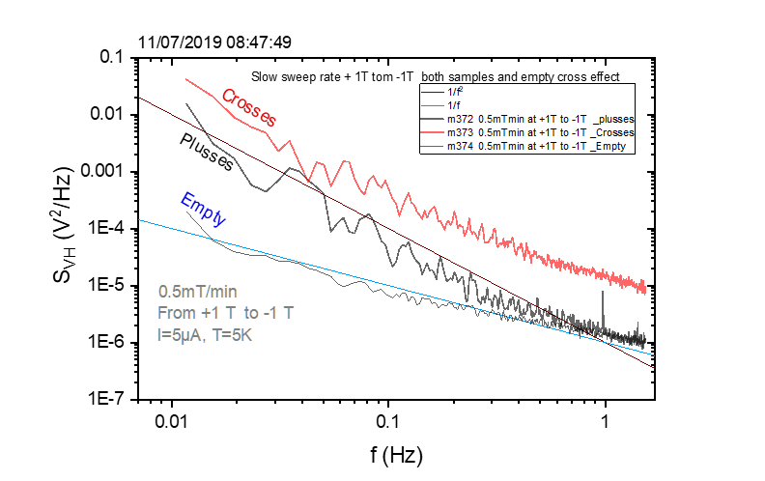

**m372: MFN\_Plusses\_sweep after\_saturation at +1T\_ +1T to -1 T\_5mT.min\_1.5 Hz\_5V\_averages 94\_T=5K\_over night**

Dienstag, 9. Juli 2019

22:49

|  |  |
| --- | --- |
| Angle of sensor θ | *+90* |
| Temp | 5 K |
|  | **Plusses(1-13)** |
|  | |  |  |  |  | | --- | --- | --- | --- | |  |  |  |  | | ***Gate (0V)*** | ***9 - 4*** |  | ***14 - 7 Preamp.*** | |
|  | **sweep after\_saturation at +1T\_ 1T to -1 T\_5mT.min** |
| Resistance Box | |  |  |  |  |  |  | | --- | --- | --- | --- | --- | --- | |  | *1 MΩ* |  |  |  |  | |  | *1 MΩ* |  |  |  | *10* | |
|  | |  |  |  |  |  |  | | --- | --- | --- | --- | --- | --- | | Sens | 5mV |  | 5 V | *f* | *113 Hz* | | *τ* | *3 ms* | *Input A* | *AC* | *Ground* | *Normal Reserve* | |
| Pre Amplifier (SR560) | |  |  |  |  | | --- | --- | --- | --- | | *Gain Mode* | *Low* | *Gain:* | *2e1* | | *Coupling* | *AC* | *Output (50Ω)* | *LI Input A* | | *Filters:* | *Off* |  |  | |
| Signal Analyzer (SR785) | |  |  |  |  | | --- | --- | --- | --- | | *Ch 1 (A)* |  | *Freq - Span:* | *1.5* | | *Ch 2 (A)* |  | *Averages:* | *94* | |
| Period of measurement (min) | 400min 0ver night |
| He (l) level consumption |  |
| Data files | <<m372\_MFN\_Plusses\_T5K\_sweep\_1000mT to -1000 mT\_at +1T saturation\_Rate 5mTmin\_SR785\_1.5Hz\_\_aver 94\_Vin 5V\_sens 5mV .dat>> |
| Plot |  |

**m373: MFN\_Crosses\_sweep after\_saturation at +1T\_ +1T to -1 T\_5mT.min\_1.5 Hz\_5V\_averages 94\_T=5K\_sens 2mV**

Mittwoch, 10. Juli 2019

07:15

|  |  |
| --- | --- |
| Angle of sensor θ | *+90* |
| Temp | 5 K |
|  | **Crosses (2-12)** |
|  | |  |  |  |  | | --- | --- | --- | --- | |  |  |  |  | | ***Gate (0V)*** | ***9 - 4*** |  | ***14 - 7 Preamp.*** | |
|  | **sweep after\_saturation at +1T\_ 1T to -1 T\_5mT.min** |
| Resistance Box | |  |  |  |  |  |  | | --- | --- | --- | --- | --- | --- | |  | *1 MΩ* |  |  |  |  | |  | *1 MΩ* |  |  |  | *10* | |
|  | |  |  |  |  |  |  | | --- | --- | --- | --- | --- | --- | | Sens | 2mV |  | 5 V | *f* | *113 Hz* | | *τ* | *3 ms* | *Input A* | *AC* | *Ground* | *Normal Reserve* | |
| Pre Amplifier (SR560) | |  |  |  |  | | --- | --- | --- | --- | | *Gain Mode* | *Low* | *Gain:* | *2e1* | | *Coupling* | *AC* | *Output (50Ω)* | *LI Input A* | | *Filters:* | *Off* |  |  | |
| Signal Analyzer (SR785) | |  |  |  |  | | --- | --- | --- | --- | | *Ch 1 (A)* |  | *Freq - Span:* | *1.5* | | *Ch 2 (A)* |  | *Averages:* | *94* | |
| Period of measurement (min) | 400min |
| He (l) level consumption |  |
| Data files | <<m373\_MFN\_Crosses\_T5K\_sweep\_1000mT to -1000 mT\_at +1T saturation\_Rate 5mTmin\_SR785\_1.5Hz\_\_aver 94\_Vin 5V\_sens 2mV .dat>> |
| Plot |  |

**m374: MFN\_Empty\_sweep after\_saturation at +1T\_ +1T to -1 T\_5mT.min\_1.5 Hz\_5V\_averages 94\_T=5K\_sens 5mV**

Mittwoch, 10. Juli 2019

14:42

|  |  |
| --- | --- |
| Angle of sensor θ | *+90* |
| Temp | 5 K |
|  | **Empty (6-8)** |
|  | |  |  |  |  | | --- | --- | --- | --- | |  |  |  |  | | ***Gate (0V)*** | ***9 - 4*** |  | ***14 - 7 Preamp.*** | |
|  | **sweep after\_saturation at +1T\_ 1T to -1 T\_5mT.min** |
| Resistance Box | |  |  |  |  |  |  | | --- | --- | --- | --- | --- | --- | |  | *1 MΩ* |  |  |  |  | |  | *1 MΩ* |  |  |  | *10* | |
|  | |  |  |  |  |  |  | | --- | --- | --- | --- | --- | --- | | Sens | 5 mV |  | 5 V | *f* | *113 Hz* | | *τ* | *3 ms* | *Input A* | *AC* | *Ground* | *Normal Reserve* | |
| Pre Amplifier (SR560) | |  |  |  |  | | --- | --- | --- | --- | | *Gain Mode* | *Low* | *Gain:* | *2e1* | | *Coupling* | *AC* | *Output (50Ω)* | *LI Input A* | | *Filters:* | *Off* |  |  | |
| Signal Analyzer (SR785) | |  |  |  |  | | --- | --- | --- | --- | | *Ch 1 (A)* |  | *Freq - Span:* | *1.5* | | *Ch 2 (A)* |  | *Averages:* | *94* | |
| Period of measurement (min) | 400min |
| He (l) level consumption |  |
| Data files | <<m374\_MFNEmpty\_T5K\_sweep\_1000mT to -1000 mT\_at +1T saturation\_Rate 5mTmin\_SR785\_1.5Hz\_\_aver 94\_Vin 5V\_sens 5mV .dat>> |
| Plot |  |

**Filling He(l)**

Freitag, 12. Juli 2019

08:36

|  |  |
| --- | --- |
| Filling date | 12.07.2019 |
| Before (in) | 26 |
| After (in) | 36.22 |
| consumption | 214-123=26 L |
| Person | MAM |

Notes:



'To do:

**Schematic for Janis He (L) level**

12 July 2019

13:17

<<Schematic for Janis He level.pdf>>

**Measurement Plan #9\_winde-ranging field with slow sweeping\_comparison magnetic crosses and empty**

Freitag, 12. Juli 2019

08:42

winde-ranging field with slow sweeping\_from negative saturation

|  |  |  |  |  |  |  |  |  |  |
| --- | --- | --- | --- | --- | --- | --- | --- | --- | --- |
| Nr | Struct | Field From | Field To | SR [mT/min] | F-Span | Vin(V)/sens (mV)/gain | Avg | Time [min, Hr] | Date |
| [m375:](onenote:#m375%20MFN_Plusses_sweep%20after_saturation%20at%20+1T_-1T%20to%20+1%20T_5mT.min_1.5%20Hz_5V_averages%2094_T=5K&section-id={5FAD0518-E349-4A07-93E8-5D105BD4AEB4}&page-id={65BA3B52-279A-40B1-B3B7-6430E2DDD0A8}&end&base-path=https://goetheuniversitaet.sharepoint.com/sites/Project4/SiteAssets/Project%204%20Notebook/Magnetic%20Flux%20Noise.one) | Plusses | -1T | +1T | 5 | 1.5 | 5/5/20 | 94 | 400min | 12.07.2019\_Friday\_ |
|  | Crosses | -1T | +1T | 5 | 1.5 | 5/2/20 | 94 | 400min |  |
|  | Empty | -1T | +1T | 5 | 1.5 | 5/5/20 | 94 | 400min |  |



Important to note: after filling He, the temperature was not stable. I took 5 hours to be stable . choosing the sensitivity extremly depend on the temperature. It was on overload when choosing 5mV. After stabalizing the temp, 5mV was OK.

**No need to do the rest since the results similar in the positive and negative saturation for plusses**

**m375: MFN\_Plusses\_sweep after\_saturation at -1T\_-1T to +1 T\_5mT.min\_1.5 Hz\_5V\_averages 94\_T=5K**

Freitag, 12. Juli 2019

12:56

|  |  |
| --- | --- |
| Angle of sensor θ | *+90* |
| Temp | 5 K |
|  | **Plusses(1-13)** |
|  | |  |  |  |  | | --- | --- | --- | --- | |  |  |  |  | | ***Gate (0V)*** | ***9 - 4*** |  | ***14 - 7 Preamp.*** | |
|  | **sweep after\_saturation at -1T\_ -1T to +1 T\_5mT.min** |
| Resistance Box | |  |  |  |  |  |  | | --- | --- | --- | --- | --- | --- | |  | *1 MΩ* |  |  |  |  | |  | *1 MΩ* |  |  |  | *10* | |
|  | |  |  |  |  |  |  | | --- | --- | --- | --- | --- | --- | | Sens | 5mV |  | 5 V | *f* | *113 Hz* | | *τ* | *3 ms* | *Input A* | *AC* | *Ground* | *Normal Reserve* | |
| Pre Amplifier (SR560) | |  |  |  |  | | --- | --- | --- | --- | | *Gain Mode* | *Low* | *Gain:* | *2e1* | | *Coupling* | *AC* | *Output (50Ω)* | *LI Input A* | | *Filters:* | *Off* |  |  | |
| Signal Analyzer (SR785) | |  |  |  |  | | --- | --- | --- | --- | | *Ch 1 (A)* |  | *Freq - Span:* | *1.5* | | *Ch 2 (A)* |  | *Averages:* | *94* | |
| Period of measurement (min) | 400min |
| He (l) level consumption |  |
| Data files | <<m375\_MFN Plusses\_T5K\_sweep\_-1000mT to 1000 mT\_at -1T saturation\_Rate 5mTmin\_SR785\_1.5Hz\_\_aver 94\_Vin 5V\_sens 5mV .dat>> |
| Plot |  |

Important to note: after filling He, the temperature was not stable. I took 5 hours to be stable . choosing the sensitivity extremly depend on the temperature. It was on overload when choosing 5mV. After stabalizing the temp, 5mV was OK.

**Measurement Plan #10\_winde-ranging field with different sweep rate\_\_for plusses**

Freitag, 12. Juli 2019

21:36

winde-ranging field with different sweep rates \_from positive saturation

|  |  |  |  |  |  |  |  |  |  |
| --- | --- | --- | --- | --- | --- | --- | --- | --- | --- |
| Nr | Struct | Field From | Field To | SR [mT/min] | F-Span | Vin(V)/sens (mV)/gain | Avg | Time [min, Hr] | Date |
| [m376:](onenote:#m376%20MFN_Plusses_sweep%20after_saturation%20at%20+1T_+1T%20to%20-1%20T_50mT.min_1.5%20Hz_5V_averages%2010_T=5K&section-id={5FAD0518-E349-4A07-93E8-5D105BD4AEB4}&page-id={C190ACD9-D71A-40BE-B9BB-8BC5669B869B}&end&base-path=https://goetheuniversitaet.sharepoint.com/sites/Project4/SiteAssets/Project%204%20Notebook/Magnetic%20Flux%20Noise.one) | Plusses | +1T | -1T | 50 | 1.5 | 5/5/20 | 10 | 40 | 12.07.2019\_Friday\_ |
| [m377:](onenote:#m377%20MFN_Plusses_sweep%20after_saturation%20at%20+1T_+1T%20to%20-1%20T_50mT.min_1.5%20Hz_5V_averages%2019_T=5K&section-id={5FAD0518-E349-4A07-93E8-5D105BD4AEB4}&page-id={6CD73E94-3790-41BC-88F9-05DC2391E4F8}&end&base-path=https://goetheuniversitaet.sharepoint.com/sites/Project4/SiteAssets/Project%204%20Notebook/Magnetic%20Flux%20Noise.one) | Plusses | +1T | -1T | 25 | 1.5 | 5/5/20 | 19 | 80 | 12.07.2019\_Friday\_ |

**m376: MFN\_Plusses\_sweep after\_saturation at +1T\_+1T to -1 T\_50mT.min\_1.5 Hz\_5V\_averages 10\_T=5K**

Freitag, 12. Juli 2019

20:30

|  |  |
| --- | --- |
| Angle of sensor θ | *+90* |
| Temp | 5 K |
|  | **Plusses(1-13)** |
|  | |  |  |  |  | | --- | --- | --- | --- | |  |  |  |  | | ***Gate (0V)*** | ***9 - 4*** |  | ***14 - 7 Preamp.*** | |
|  | **sweep after\_saturation at +1T\_ -1T to +1 T\_50mT.min** |
| Resistance Box | |  |  |  |  |  |  | | --- | --- | --- | --- | --- | --- | |  | *1 MΩ* |  |  |  |  | |  | *1 MΩ* |  |  |  | *10* | |
|  | |  |  |  |  |  |  | | --- | --- | --- | --- | --- | --- | | Sens | 5mV |  | 5 V | *f* | *113 Hz* | | *τ* | *3 ms* | *Input A* | *AC* | *Ground* | *Normal Reserve* | |
| Pre Amplifier (SR560) | |  |  |  |  | | --- | --- | --- | --- | | *Gain Mode* | *Low* | *Gain:* | *2e1* | | *Coupling* | *AC* | *Output (50Ω)* | *LI Input A* | | *Filters:* | *Off* |  |  | |
| Signal Analyzer (SR785) | |  |  |  |  | | --- | --- | --- | --- | | *Ch 1 (A)* |  | *Freq - Span:* | *1.5* | | *Ch 2 (A)* |  | *Averages:* | *10* | |
| Period of measurement (min) | 40min |
| He (l) level consumption |  |
| Data files | <<m376\_MFN Plusses\_T5K\_sweep\_1000mT to -1000 mT\_at +1T saturation\_Rate 50mTmin\_SR785\_1.5Hz\_\_aver10\_Vin 5V\_sens 5mV .dat>> |
| Plot |  |



**m377: MFN\_Plusses\_sweep after\_saturation at +1T\_+1T to -1 T\_25mT.min\_1.5 Hz\_5V\_averages 19\_T=5K**

Freitag, 12. Juli 2019

21:49

|  |  |
| --- | --- |
| Angle of sensor θ | *+90* |
| Temp | 5 K |
|  | **Plusses(1-13)** |
|  | |  |  |  |  | | --- | --- | --- | --- | |  |  |  |  | | ***Gate (0V)*** | ***9 - 4*** |  | ***14 - 7 Preamp.*** | |
|  | **sweep after\_saturation at +1T\_ -1T to +1 T\_25mT.min** |
| Resistance Box | |  |  |  |  |  |  | | --- | --- | --- | --- | --- | --- | |  | *1 MΩ* |  |  |  |  | |  | *1 MΩ* |  |  |  | *10* | |
|  | |  |  |  |  |  |  | | --- | --- | --- | --- | --- | --- | | Sens | 5mV |  | 5 V | *f* | *113 Hz* | | *τ* | *3 ms* | *Input A* | *AC* | *Ground* | *Normal Reserve* | |
| Pre Amplifier (SR560) | |  |  |  |  | | --- | --- | --- | --- | | *Gain Mode* | *Low* | *Gain:* | *2e1* | | *Coupling* | *AC* | *Output (50Ω)* | *LI Input A* | | *Filters:* | *Off* |  |  | |
| Signal Analyzer (SR785) | |  |  |  |  | | --- | --- | --- | --- | | *Ch 1 (A)* |  | *Freq - Span:* | *1.5* | | *Ch 2 (A)* |  | *Averages:* | *19* | |
| Period of measurement (min) | 80min |
| He (l) level consumption |  |
| Data files | <<m377\_MFN Plusses\_T5K\_sweep\_1000mT to -1000 mT\_at +1T saturation\_Rate 25mTmin\_SR785\_1.5Hz\_\_aver19\_Vin 5V\_sens 5mV .dat>> |
| Plot |  |

**Measurement Plan #11\_different applied current\_\_for plusses**

Samstag, 13. Juli 2019

21:36

Different applying current \_from positive saturation

|  |  |  |  |  |  |  |  |  |  |  |
| --- | --- | --- | --- | --- | --- | --- | --- | --- | --- | --- |
| Nr | Struct | Field From | Field To | Saturation at | SR [mT/min] | F-Span | Vin(V)/sens (mV)/gain | Avg | Time [min, Hr] | Date |
|  | Plusses | -100mT | 100mT | -1T | 5 | 1.5 | 1/5/20 | 10 | 40 | 13.07.2019\_Saturday\_ |
|  | Plusses | -100mT | 100mT | -1T | 5 | 1.5 | 1/5/20 | 10 | 40 | 13.07.2019\_Saturday\_ |

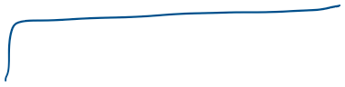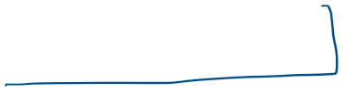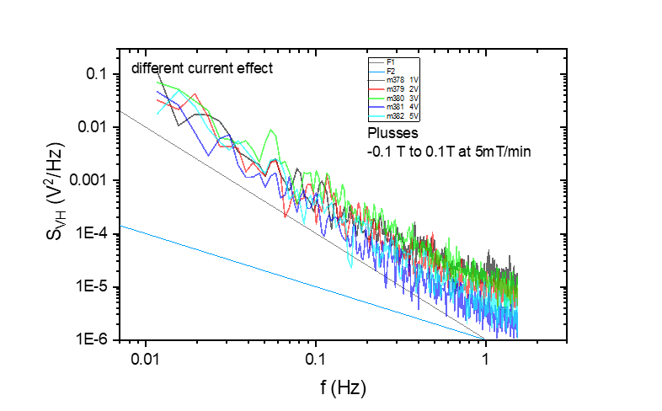

**m378: MFN\_Plusses\_sweep after\_saturation at -1T\_-0.1T to +0.1 T\_5mT.min\_1.5 Hz\_1V\_averages 19\_T=5K**

Samstag, 13. Juli 2019

08:22

|  |  |
| --- | --- |
| Angle of sensor θ | *+90* |
| Temp | 5 K |
|  | **Plusses(1-13)** |
|  | |  |  |  |  | | --- | --- | --- | --- | |  |  |  |  | | ***Gate (0V)*** | ***9 - 4*** |  | ***14 - 7 Preamp.*** | |
|  | **saturation at -1T\_-0.1T to +0.1 T\_5mT.min** |
| Resistance Box | |  |  |  |  |  |  | | --- | --- | --- | --- | --- | --- | |  | *1 MΩ* |  |  |  |  | |  | *1 MΩ* |  |  |  | *10* | |
|  | |  |  |  |  |  |  | | --- | --- | --- | --- | --- | --- | | Sens | 1mV |  | 1 V | *f* | *113 Hz* | | *τ* | *3 ms* | *Input A* | *AC* | *Ground* | *Normal Reserve* | |
| Pre Amplifier (SR560) | |  |  |  |  | | --- | --- | --- | --- | | *Gain Mode* | *Low* | *Gain:* | *2e1* | | *Coupling* | *AC* | *Output (50Ω)* | *LI Input A* | | *Filters:* | *Off* |  |  | |
| Signal Analyzer (SR785) | |  |  |  |  | | --- | --- | --- | --- | | *Ch 1 (A)* |  | *Freq - Span:* | *1.5* | | *Ch 2 (A)* |  | *Averages:* | *10* | |
| Period of measurement (min) | 40min |
| He (l) level consumption |  |
| Data files | <<m378\_MFN Plusses\_T5K\_sweep\_100 mT to -100 mT\_at -1T saturation\_Rate 5mTmin\_SR785\_1.5Hz\_\_aver10\_Vin 1V\_sens 1mV .dat>>    <<Reviewer 1 Review Attachment 1\_Round 2.pdf>> |
| Plot |  |

**m379: MFN\_Plusses\_sweep after\_saturation at -1T\_-0.1T to +0.1 T\_5mT.min\_1.5 Hz\_2V\_averages 19\_T=5K**

Samstag, 13. Juli 2019

10:30

|  |  |
| --- | --- |
| Angle of sensor θ | *+90* |
| Temp | 5 K |
|  | **Plusses(1-13)** |
|  | |  |  |  |  | | --- | --- | --- | --- | |  |  |  |  | | ***Gate (0V)*** | ***9 - 4*** |  | ***14 - 7 Preamp.*** | |
|  | **saturation at -1T\_-0.1T to +0.1 T\_5mT.min** |
| Resistance Box | |  |  |  |  |  |  | | --- | --- | --- | --- | --- | --- | |  | *1 MΩ* |  |  |  |  | |  | *1 MΩ* |  |  |  | *10* | |
|  | |  |  |  |  |  |  | | --- | --- | --- | --- | --- | --- | | Sens | 2mV |  | 2V | *f* | *113 Hz* | | *τ* | *3 ms* | *Input A* | *AC* | *Ground* | *Normal Reserve* | |
| Pre Amplifier (SR560) | |  |  |  |  | | --- | --- | --- | --- | | *Gain Mode* | *Low* | *Gain:* | *2e1* | | *Coupling* | *AC* | *Output (50Ω)* | *LI Input A* | | *Filters:* | *Off* |  |  | |
| Signal Analyzer (SR785) | |  |  |  |  | | --- | --- | --- | --- | | *Ch 1 (A)* |  | *Freq - Span:* | *1.5* | | *Ch 2 (A)* |  | *Averages:* | *10* | |
| Period of measurement (min) | 40min |
| He (l) level consumption |  |
| Data files | <<m379\_MFN Plusses\_T5K\_sweep\_100 mT to -100 mT\_at -1T saturation\_Rate 5mTmin\_SR785\_1.5Hz\_\_aver10\_Vin 2V\_sens 2mV .dat>> |
| Plot |  |

**m380: MFN\_Plusses\_sweep after\_saturation at -1T\_-0.1T to +0.1 T\_5mT.min\_1.5 Hz\_3V\_averages 19\_T=5K**

Samstag, 13. Juli 2019

12:26

|  |  |
| --- | --- |
| Angle of sensor θ | *+90* |
| Temp | 5 K |
|  | **Plusses(1-13)** |
|  | |  |  |  |  | | --- | --- | --- | --- | |  |  |  |  | | ***Gate (0V)*** | ***9 - 4*** |  | ***14 - 7 Preamp.*** | |
|  | **saturation at -1T\_-0.1T to +0.1 T\_5mT.min** |
| Resistance Box | |  |  |  |  |  |  | | --- | --- | --- | --- | --- | --- | |  | *1 MΩ* |  |  |  |  | |  | *1 MΩ* |  |  |  | *10* | |
|  | |  |  |  |  |  |  | | --- | --- | --- | --- | --- | --- | | Sens | 2mV |  | 3V | *f* | *113 Hz* | | *τ* | *3 ms* | *Input A* | *AC* | *Ground* | *Normal Reserve* | |
| Pre Amplifier (SR560) | |  |  |  |  | | --- | --- | --- | --- | | *Gain Mode* | *Low* | *Gain:* | *2e1* | | *Coupling* | *AC* | *Output (50Ω)* | *LI Input A* | | *Filters:* | *Off* |  |  | |
| Signal Analyzer (SR785) | |  |  |  |  | | --- | --- | --- | --- | | *Ch 1 (A)* |  | *Freq - Span:* | *1.5* | | *Ch 2 (A)* |  | *Averages:* | *10* | |
| Period of measurement (min) | 40min |
| He (l) level consumption |  |
| Data files | <<m380\_MFN Plusses\_T5K\_sweep\_100 mT to -100 mT\_at -1T saturation\_Rate 5mTmin\_SR785\_1.5Hz\_\_aver10\_Vin 3V\_sens 2mV .dat>> |
| Plot |  |

**m381: MFN\_Plusses\_sweep after\_saturation at -1T\_-0.1T to +0.1 T\_5mT.min\_1.5 Hz\_4V\_averages 19\_T=5K**

Samstag, 13. Juli 2019

13:30

|  |  |
| --- | --- |
| Angle of sensor θ | *+90* |
| Temp | 5 K |
|  | **Plusses(1-13)** |
|  | |  |  |  |  | | --- | --- | --- | --- | |  |  |  |  | | ***Gate (0V)*** | ***9 - 4*** |  | ***14 - 7 Preamp.*** | |
|  | **saturation at -1T\_-0.1T to +0.1 T\_5mT.min** |
| Resistance Box | |  |  |  |  |  |  | | --- | --- | --- | --- | --- | --- | |  | *1 MΩ* |  |  |  |  | |  | *1 MΩ* |  |  |  | *10* | |
|  | |  |  |  |  |  |  | | --- | --- | --- | --- | --- | --- | | Sens | 5mV |  | 4V | *f* | *113 Hz* | | *τ* | *3 ms* | *Input A* | *AC* | *Ground* | *Normal Reserve* | |
| Pre Amplifier (SR560) | |  |  |  |  | | --- | --- | --- | --- | | *Gain Mode* | *Low* | *Gain:* | *2e1* | | *Coupling* | *AC* | *Output (50Ω)* | *LI Input A* | | *Filters:* | *Off* |  |  | |
| Signal Analyzer (SR785) | |  |  |  |  | | --- | --- | --- | --- | | *Ch 1 (A)* |  | *Freq - Span:* | *1.5* | | *Ch 2 (A)* |  | *Averages:* | *10* | |
| Period of measurement (min) | 40min |
| He (l) level consumption |  |
| Data files | <<m381\_MFN Plusses\_T5K\_sweep\_100 mT to -100 mT\_at -1T saturation\_Rate 5mTmin\_SR785\_1.5Hz\_\_aver10\_Vin 4V\_sens 5mV .dat>> |
| Plot |  |

**m382: MFN\_Plusses\_sweep after\_saturation at -1T\_-0.1T to +0.1 T\_5mT.min\_1.5 Hz\_4V\_averages 19\_T=5K**

Samstag, 13. Juli 2019

15:43

|  |  |
| --- | --- |
| Angle of sensor θ | *+90* |
| Temp | 5 K |
|  | **Plusses(1-13)** |
|  | |  |  |  |  | | --- | --- | --- | --- | |  |  |  |  | | ***Gate (0V)*** | ***9 - 4*** |  | ***14 - 7 Preamp.*** | |
|  | **saturation at -1T\_-0.1T to +0.1 T\_5mT.min** |
| Resistance Box | |  |  |  |  |  |  | | --- | --- | --- | --- | --- | --- | |  | *1 MΩ* |  |  |  |  | |  | *1 MΩ* |  |  |  | *10* | |
|  | |  |  |  |  |  |  | | --- | --- | --- | --- | --- | --- | | Sens | 5mV |  | 5V | *f* | *113 Hz* | | *τ* | *3 ms* | *Input A* | *AC* | *Ground* | *Normal Reserve* | |
| Pre Amplifier (SR560) | |  |  |  |  | | --- | --- | --- | --- | | *Gain Mode* | *Low* | *Gain:* | *2e1* | | *Coupling* | *AC* | *Output (50Ω)* | *LI Input A* | | *Filters:* | *Off* |  |  | |
| Signal Analyzer (SR785) | |  |  |  |  | | --- | --- | --- | --- | | *Ch 1 (A)* |  | *Freq - Span:* | *1.5* | | *Ch 2 (A)* |  | *Averages:* | *10* | |
| Period of measurement (min) | 40min |
| He (l) level consumption |  |
| Data files | <<m382\_MFN Plusses\_T5K\_sweep\_100 mT to -100 mT\_at -1T saturation\_Rate 5mTmin\_SR785\_1.5Hz\_\_aver10\_Vin 5V\_sens 5mV .dat>> |
| Plot |  |

**Filling He(l)**

Dienstag, 16. Juli 2019

17:06

|  |  |
| --- | --- |
| Filling date | 16.07.2019 |
| Before (in) | 17 |
| After (in) | 36.22 |
| consumption | 110-35=75 L |
| Person | MAM |

Notes:



'To do:

**Measurement Plan #12\_plusses\_different regimes (DB = 50mT)**

Donnerstag, 18. Juli 2019

16:10

**different regimes (DB = 50mT)**

|  |  |  |  |  |  |  |  |  |  |  |  |
| --- | --- | --- | --- | --- | --- | --- | --- | --- | --- | --- | --- |
| Nr |  | Struct | Field From | Field To | Saturation at | SR [mT/min] | F-Span | Vin(V)/sens (mV)/gain | Avg | Time [min, Hr] | Date |
| [m383:](onenote:#m383%20MFN_sweep(sat)_25mT%20to%20-25mT_Plusses&section-id={5FAD0518-E349-4A07-93E8-5D105BD4AEB4}&page-id={B8D2D915-FF82-46DA-BEBC-FD952BFB6B0B}&end&base-path=https://goetheuniversitaet.sharepoint.com/sites/Project4/SiteAssets/Project%204%20Notebook/Magnetic%20Flux%20Noise.one) | 1 | Plusses | 25mT | -25mT | +1T | .5 | 1.5 | 5/5/20 | 24 | 100 | 18.07.2019\_Thursday\_ |
| [m384:](onenote:#m384%20MFN_sweep(sat)_-25mT-%20to%20-75mT_Plusses%20without%20saturation&section-id={5FAD0518-E349-4A07-93E8-5D105BD4AEB4}&page-id={2889CF00-04CE-4407-9277-F5197E8CC2CC}&end&base-path=https://goetheuniversitaet.sharepoint.com/sites/Project4/SiteAssets/Project%204%20Notebook/Magnetic%20Flux%20Noise.one) |  | Plusses | -25mT | -75mT | no pre-saturation | .5 | 1.5 | 5/5/20 | 24 | 100 | 19.07.2019\_Friday\_ |
| [m385:](onenote:#m385%20MFN_sweep(sat)_-25mT-%20to%20-75mT_Plusses%20with%20+1Tsaturation&section-id={5FAD0518-E349-4A07-93E8-5D105BD4AEB4}&page-id={C524477E-5C24-44D2-8FF6-7B6FF79C6618}&end&base-path=https://goetheuniversitaet.sharepoint.com/sites/Project4/SiteAssets/Project%204%20Notebook/Magnetic%20Flux%20Noise.one) | 2 | Plusses | -25mT | -75mT | +1T | .5 | 1.5 | 5/5/20 | 24 | 100 | 19.07.2019\_Friday\_ |
| [m386:](onenote:#m386%20MFN_sweep(sat)_-75mT-%20to%20-125mT_Plusses%20with%20+1Tsaturation&section-id={5FAD0518-E349-4A07-93E8-5D105BD4AEB4}&page-id={27C797A5-3480-4491-A81D-4D46C047FA56}&end&base-path=https://goetheuniversitaet.sharepoint.com/sites/Project4/SiteAssets/Project%204%20Notebook/Magnetic%20Flux%20Noise.one) | 3 | Plusses | -75mT | -125mT | +1T | .5 | 1.5 | 5/5/20 | 24 | 100 | 19.07.2019\_Friday\_ |
| [m387](onenote:#m387%20MFN_sweep(sat)_-125mT-%20to%20-175mT&section-id={5FAD0518-E349-4A07-93E8-5D105BD4AEB4}&page-id={4DFD8061-D18B-4729-A7F7-A8B455257A6E}&end&base-path=https://goetheuniversitaet.sharepoint.com/sites/Project4/SiteAssets/Project%204%20Notebook/Magnetic%20Flux%20Noise.one) | 4 |  | -125 | -175 |  |  |  |  |  |  |  |
| [m388](onenote:#m388%20MFN_sweep(sat)_-175mT-%20to%20-225mT&section-id={5FAD0518-E349-4A07-93E8-5D105BD4AEB4}&page-id={C164A19E-41C9-4464-A49A-74AB9D61A2C3}&end&base-path=https://goetheuniversitaet.sharepoint.com/sites/Project4/SiteAssets/Project%204%20Notebook/Magnetic%20Flux%20Noise.one) | 5 |  | -175 | -225 |  |  |  |  |  |  |  |
| [m389](onenote:#m389%20MFN_sweep(sat)_-225mT-%20to%20-275mT&section-id={5FAD0518-E349-4A07-93E8-5D105BD4AEB4}&page-id={D3153175-CA44-41CE-8A7D-3CC30CB26F87}&end&base-path=https://goetheuniversitaet.sharepoint.com/sites/Project4/SiteAssets/Project%204%20Notebook/Magnetic%20Flux%20Noise.one) | 6 |  | -225 | -275 |  |  |  |  |  |  |  |
| [m390](onenote:#m390%20MFN_sweep(sat)_-275mT-%20to%20-325mT&section-id={5FAD0518-E349-4A07-93E8-5D105BD4AEB4}&page-id={10482932-55CA-4215-8230-D30308382C24}&end&base-path=https://goetheuniversitaet.sharepoint.com/sites/Project4/SiteAssets/Project%204%20Notebook/Magnetic%20Flux%20Noise.one) | 7 |  | -275 | -325 |  |  |  |  |  |  |  |
| [m391](onenote:#m391%20MFN_sweep(sat)_-300mT-%20to%20-350mT&section-id={5FAD0518-E349-4A07-93E8-5D105BD4AEB4}&page-id={BA17CCDB-BA58-4983-B070-87B2FC172ADB}&end&base-path=https://goetheuniversitaet.sharepoint.com/sites/Project4/SiteAssets/Project%204%20Notebook/Magnetic%20Flux%20Noise.one) | 8 |  | -300 | -350 |  |  |  |  |  |  |  |
| [m392](onenote:#m392%20MFN_sweep(sat)_-350mT-%20to%20-400mT&section-id={5FAD0518-E349-4A07-93E8-5D105BD4AEB4}&page-id={AA18A14D-1165-4E24-AC91-F643C39E90EC}&end&base-path=https://goetheuniversitaet.sharepoint.com/sites/Project4/SiteAssets/Project%204%20Notebook/Magnetic%20Flux%20Noise.one) | 9 |  | -350 | -400 |  |  |  |  |  |  |  |
| [m393](onenote:#m393%20MFN_sweep(sat)_-400mT-%20to%20-450mT&section-id={5FAD0518-E349-4A07-93E8-5D105BD4AEB4}&page-id={DF5D7711-C4DF-4054-9ACB-21DF4C14B413}&end&base-path=https://goetheuniversitaet.sharepoint.com/sites/Project4/SiteAssets/Project%204%20Notebook/Magnetic%20Flux%20Noise.one) | 10 |  | -400 | -450 |  |  |  |  |  |  |  |
| [m394](onenote:#m394%20MFN_sweep(sat)_-450mT-%20to%20-500mT&section-id={5FAD0518-E349-4A07-93E8-5D105BD4AEB4}&page-id={9A64B0CD-5FC5-47CF-A858-954821BFE748}&end&base-path=https://goetheuniversitaet.sharepoint.com/sites/Project4/SiteAssets/Project%204%20Notebook/Magnetic%20Flux%20Noise.one) | 11 |  | -450 | -500 |  |  |  |  |  |  |  |
| [m395](onenote:#m395%20MFN_sweep(sat)_-500mT-%20to%20-550mT&section-id={5FAD0518-E349-4A07-93E8-5D105BD4AEB4}&page-id={2E37C791-D6F8-4751-A13B-2DE62AFFD97C}&end&base-path=https://goetheuniversitaet.sharepoint.com/sites/Project4/SiteAssets/Project%204%20Notebook/Magnetic%20Flux%20Noise.one) | 12 |  | -500 | -550 |  |  |  |  |  |  |  |
| [m396](onenote:#m396%20MFN_sweep(sat)_50mT-%20to%200mT_Plusses%20with&section-id={5FAD0518-E349-4A07-93E8-5D105BD4AEB4}&page-id={B7135BB2-2AC5-47ED-A085-27D4C59F5F8E}&end&base-path=https://goetheuniversitaet.sharepoint.com/sites/Project4/SiteAssets/Project%204%20Notebook/Magnetic%20Flux%20Noise.one) | 13 |  | -575 | -625 |  |  |  |  |  |  | Filling He (Vx) |
| [m397:](onenote:#m397%20MFN_sweep(sat)_-625mT-%20to%20-575mT_Plusses%20with%20-1Tsaturation&section-id={5FAD0518-E349-4A07-93E8-5D105BD4AEB4}&page-id={5F48DCBC-39A3-4AF6-805F-45CC31F935C0}&end&base-path=https://goetheuniversitaet.sharepoint.com/sites/Project4/SiteAssets/Project%204%20Notebook/Magnetic%20Flux%20Noise.one) | 14 |  | -625 | -575 | -1T |  |  |  |  |  |  |
| [m398:](onenote:#m398%20MFN_sweep(sat)_-50mT-%20to%200mT_Plusses%20with%20-1Tsaturation&section-id={5FAD0518-E349-4A07-93E8-5D105BD4AEB4}&page-id={F393F24F-8D6B-4F2B-9953-DE7F7AE12444}&end&base-path=https://goetheuniversitaet.sharepoint.com/sites/Project4/SiteAssets/Project%204%20Notebook/Magnetic%20Flux%20Noise.one) | 15 |  | -50 | 0 |  |  |  |  |  |  |  |
| [m399:](onenote:#m399%20MFN_sweep(sat)_-575mT-%20to%20-625mT_Plusses%20with%20+1Tsaturation&section-id={5FAD0518-E349-4A07-93E8-5D105BD4AEB4}&page-id={2DE6D288-769B-41FB-8474-86D97AB01795}&end&base-path=https://goetheuniversitaet.sharepoint.com/sites/Project4/SiteAssets/Project%204%20Notebook/Magnetic%20Flux%20Noise.one) | 16 |  | -575 | -625 | +1T |  |  |  |  |  | Repeat |
| [m400:](onenote:#m400%20MFN_sweep(sat)_0mT-%20to%2050mT_Plusses%20with%20-1Tsaturation&section-id={5FAD0518-E349-4A07-93E8-5D105BD4AEB4}&page-id={2370519D-9349-49DF-9377-2E10E7B28A8D}&end&base-path=https://goetheuniversitaet.sharepoint.com/sites/Project4/SiteAssets/Project%204%20Notebook/Magnetic%20Flux%20Noise.one) | 17 |  | 0 | 50 | -1T |  |  |  |  |  |  |
| [m401:](onenote:#m401%20MFN_sweep(sat)_50mT-%20to%200mT_Plusses%20with%20+1Tsaturation&section-id={5FAD0518-E349-4A07-93E8-5D105BD4AEB4}&page-id={7661A5B1-B648-4A07-8575-EDCE10A12724}&end&base-path=https://goetheuniversitaet.sharepoint.com/sites/Project4/SiteAssets/Project%204%20Notebook/Magnetic%20Flux%20Noise.one) | 18 |  | 50 | 0 | +1T |  |  |  |  |  |  |
| [m402:](onenote:#m402%20MFN_sweep(sat)_0mT-%20to%20-50mT_Plusses%20with%20+1Tsaturation&section-id={5FAD0518-E349-4A07-93E8-5D105BD4AEB4}&page-id={660E811D-C6B0-457D-8DE9-5809A90B19D4}&end&base-path=https://goetheuniversitaet.sharepoint.com/sites/Project4/SiteAssets/Project%204%20Notebook/Magnetic%20Flux%20Noise.one) | 19 |  | 0 | -50 |  |  |  |  |  |  |  |
| [M403:](onenote:#M403%20MFN_sweep(sat)_0mT-%20to%2050mT_Plusses%20with%20-1Tsaturation&section-id={5FAD0518-E349-4A07-93E8-5D105BD4AEB4}&page-id={EBFB597F-BEE0-476F-9AE1-E042F5F3B151}&end&base-path=https://goetheuniversitaet.sharepoint.com/sites/Project4/SiteAssets/Project%204%20Notebook/Magnetic%20Flux%20Noise.one) | 20 |  | 25 | -25 |  |  |  |  |  |  |  |
| [M404:](onenote:#M404%20MFN_sweep(sat)_0mT-%20to%2050mT_Plusses%20with%20-1Tsaturation&section-id={5FAD0518-E349-4A07-93E8-5D105BD4AEB4}&page-id={AD452DCE-72DF-4C7F-9189-9AD6D0CDB1FC}&end&base-path=https://goetheuniversitaet.sharepoint.com/sites/Project4/SiteAssets/Project%204%20Notebook/Magnetic%20Flux%20Noise.one) | 21 |  | -25 | -75 |  |  |  |  |  |  |  |
| [M405:](onenote:#M405%20MFN_sweep(sat)_0mT-%20to%2050mT_Plusses%20with%20-1Tsaturation&section-id={5FAD0518-E349-4A07-93E8-5D105BD4AEB4}&page-id={629C0DF3-3923-45BC-9E5D-424016199036}&end&base-path=https://goetheuniversitaet.sharepoint.com/sites/Project4/SiteAssets/Project%204%20Notebook/Magnetic%20Flux%20Noise.one) | 22 |  | -25 | -75 | No saturation |  |  |  |  |  |  |
| [M406:](onenote:#M406%20MFN_sweep(sat)_0mT-%20to%2050mT_Plusses%20with%20-1Tsaturation&section-id={5FAD0518-E349-4A07-93E8-5D105BD4AEB4}&page-id={57BD47EB-210E-47B2-BF28-24AEF6F82B2B}&end&base-path=https://goetheuniversitaet.sharepoint.com/sites/Project4/SiteAssets/Project%204%20Notebook/Magnetic%20Flux%20Noise.one) | 23 |  | 619 | 569 |  |  |  |  |  |  |  |
| [M407:](onenote:#M407%20MFN_sweep(sat)_0mT-%20to%2050mT_Plusses%20with%20-1Tsaturation&section-id={5FAD0518-E349-4A07-93E8-5D105BD4AEB4}&page-id={A63C6532-E5EE-4B2C-A301-552240C08D16}&end&base-path=https://goetheuniversitaet.sharepoint.com/sites/Project4/SiteAssets/Project%204%20Notebook/Magnetic%20Flux%20Noise.one) | 24 |  | 0 | -50 |  |  |  |  |  |  |  |

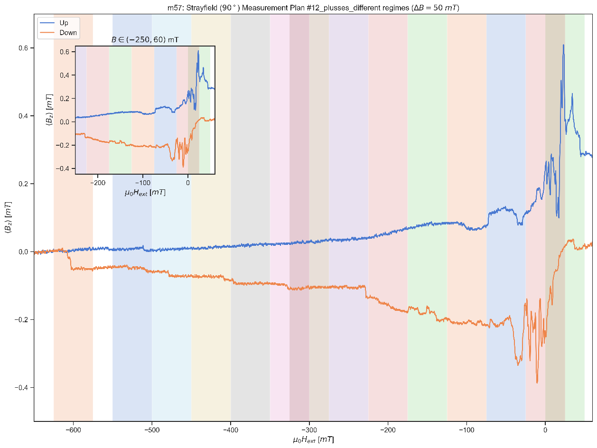

**Plot**

Donnerstag, 15. August 2019

15:09

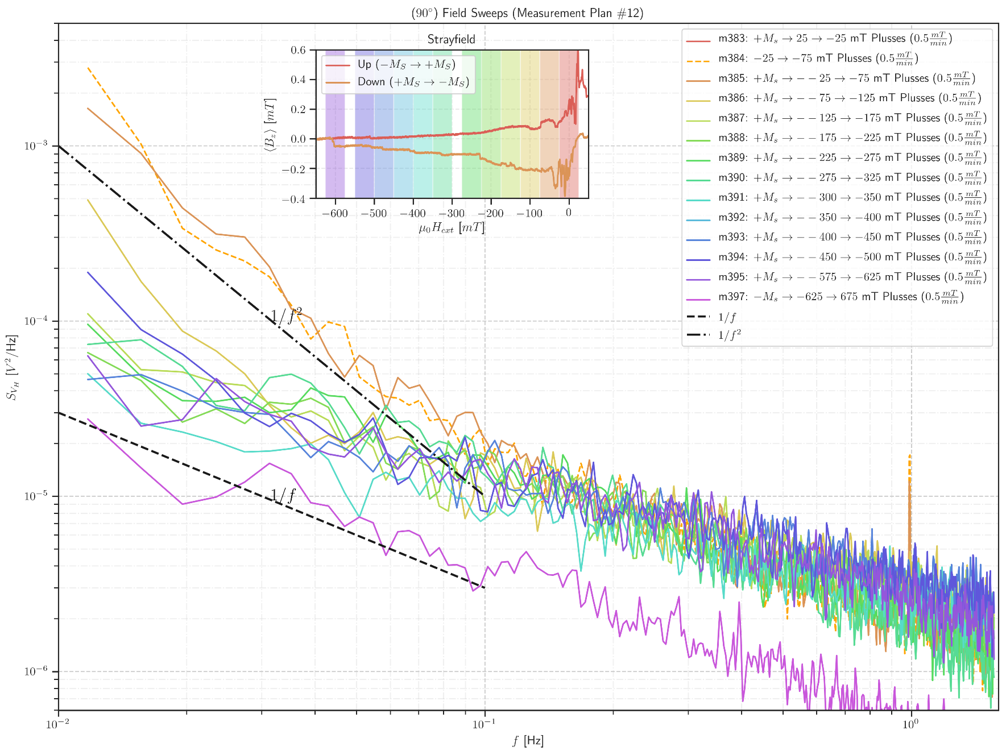

All 0 to -650

<<sweep\_measplan12.pdf>>

<<sweep\_measplan12.png>>

0 to -300

<<sweep\_measplan12\_0-300.pdf>>

-300 to -650

<<sweep\_measplan12-300-650.pdf>>

<<sweep\_measplan12-300-650.png>>

<<sweep\_measplan12\_0-300.png>>

**Data**

Donnerstag, 15. August 2019

14:32

<<m401\_MFN Plusses\_T5K\_sweep\_50 mT to 0 mT\_+1T saturation\_Rate 0.5mTmin\_SR785\_1.5Hz\_\_aver24\_Vin 5V\_sens 5mV\_field\_interval\_effect.dat>>

<<m383\_MFN Plusses\_T5K\_sweep\_25 mT to -25 mT\_at 1T saturation\_Rate 5mTmin\_SR785\_1.5Hz\_\_aver10\_Vin 5V\_sens 5mV .dat>>

<<m383\_MFN Plusses\_T5K\_sweep\_25 mT to -25 mT\_at 1T saturation\_Rate 0.5mTmin\_SR785\_1.5Hz\_\_aver24\_Vin 5V\_sens 5mV\_field\_interval\_effect.dat>>

<<m384\_MFN Plusses\_T5K\_sweep\_-25 mT to -75 mT\_without saturation\_Rate 0.5mTmin\_SR785\_1.5Hz\_\_aver24\_Vin 5V\_sens 5mV\_field\_interval\_effect.dat>>

<<\_m385\_MFN Plusses\_T5K\_sweep\_-25 mT to -75 mT\_+1T saturation\_Rate 0.5mTmin\_SR785\_1.5Hz\_\_aver24\_Vin 5V\_sens 5mV\_field\_interval\_effect.dat>>

<<\_m386\_MFN Plusses\_T5K\_sweep\_-25 mT to -75 mT\_+1T saturation\_Rate 0.5mTmin\_SR785\_1.5Hz\_\_aver24\_Vin 5V\_sens 5mV\_field\_interval\_effect.dat>>

<<m386\_MFN Plusses\_T5K\_sweep\_-75 mT to -125 mT\_+1T saturation\_Rate 0.5mTmin\_SR785\_1.5Hz\_\_aver24\_Vin 5V\_sens 5mV\_field\_interval\_effect.dat>>

<<m386\_Temp.dat>>

<<m387\_MFN Plusses\_T5K\_sweep\_-125 mT to -175 mT\_+1T saturation\_Rate 0.5mTmin\_SR785\_1.5Hz\_\_aver24\_Vin 5V\_sens 5mV\_field\_interval\_effect.dat>>

<<m388\_MFN Plusses\_T5K\_sweep\_-175 mT to -225 mT\_+1T saturation\_Rate 0.5mTmin\_SR785\_1.5Hz\_\_aver24\_Vin 5V\_sens 5mV\_field\_interval\_effect.dat>>

<<m389\_MFN Plusses\_T5K\_sweep\_-225 mT to -275 mT\_+1T saturation\_Rate 0.5mTmin\_SR785\_1.5Hz\_\_aver24\_Vin 5V\_sens 5mV\_field\_interval\_effect.dat>>

<<m390\_MFN Plusses\_T5K\_sweep\_-275 mT to -325 mT\_+1T saturation\_Rate 0.5mTmin\_SR785\_1.5Hz\_\_aver24\_Vin 5V\_sens 5mV\_field\_interval\_effect.dat>>

<<m391\_MFN Plusses\_T5K\_sweep\_-300 mT to -350 mT\_+1T saturation\_Rate 0.5mTmin\_SR785\_1.5Hz\_\_aver24\_Vin 5V\_sens 5mV\_field\_interval\_effect.dat>>

<<m392\_MFN Plusses\_T5K\_sweep\_-350 mT to -400 mT\_+1T saturation\_Rate 0.5mTmin\_SR785\_1.5Hz\_\_aver24\_Vin 5V\_sens 5mV\_field\_interval\_effect.dat>>

<<m388\_Temp.dat>>

<<m393\_MFN Plusses\_T5K\_sweep\_-400 mT to -450 mT\_+1T saturation\_Rate 0.5mTmin\_SR785\_1.5Hz\_\_aver24\_Vin 5V\_sens 5mV\_field\_interval\_effect.dat>>

<<m394\_MFN Plusses\_T5K\_sweep\_-450 mT to -500 mT\_+1T saturation\_Rate 0.5mTmin\_SR785\_1.5Hz\_\_aver24\_Vin 5V\_sens 5mV\_field\_interval\_effect.dat>>

<<m402\_MFN Plusses\_T5K\_sweep\_0 mT to -50 mT\_+1T saturation\_Rate 0.5mTmin\_SR785\_1.5Hz\_\_aver24\_Vin 5V\_sens 5mV\_field\_interval\_effect.dat>><<m403\_MFN Plusses\_T5K\_sweep\_25 mT to 0 mT\_+1T saturation\_Rate 0.5mTmin\_SR785\_1.5Hz\_\_aver24\_Vin 5V\_sens 5mV\_field\_interval\_effect.dat>><<m403\_MFN Plusses\_T5K\_sweep\_25 mT to -25 mT\_+1T saturation\_Rate 0.5mTmin\_SR785\_1.5Hz\_\_aver24\_Vin 5V\_sens 5mV\_field\_interval\_effect.dat>><<m404\_MFN Plusses\_T5K\_sweep\_-25 mT to -75 mT\_NO saturation\_Rate 0.5mTmin\_SR785\_1.5Hz\_\_aver24\_Vin 5V\_sens 5mV\_field\_interval\_effect.dat>><<m405\_MFN Plusses\_T5K\_sweep\_-25 mT to -75 mT\_+1T saturation\_Rate 0.5mTmin\_SR785\_1.5Hz\_\_aver24\_Vin 5V\_sens 5mV\_field\_interval\_effect.dat>><<m396\_MFN Plusses\_T5K\_sweep\_-575 mT to -625 mT\_+1T saturation\_Rate 0.5mTmin\_SR785\_1.5Hz\_\_aver24\_Vin 5V\_sens 5mV\_field\_interval\_effect.dat>><<m400\_MFN Plusses\_T5K\_sweep\_0 mT to 50 mT\_-1T saturation\_Rate 0.5mTmin\_SR785\_1.5Hz\_\_aver24\_Vin 5V\_sens 5mV\_field\_interval\_effect.dat>><<m392\_Temp.dat>><<m399\_MFN Plusses\_T5K\_sweep\_-575 mT to 625 mT\_+1T saturation\_Rate 0.5mTmin\_SR785\_1.5Hz\_\_aver24\_Vin 5V\_sens 5mV\_field\_interval\_effect.dat>><<m397\_MFN Plusses\_T5K\_sweep\_-625 mT to -575 mT\_-1T saturation\_Rate 0.5mTmin\_SR785\_1.5Hz\_\_aver24\_Vin 5V\_sens 5mV\_field\_interval\_effect.dat>><<m397\_Temp.dat>><<m395\_MFN Plusses\_T5K\_sweep\_-500 mT to -550 mT\_+1T saturation\_Rate 0.5mTmin\_SR785\_1.5Hz\_\_aver24\_Vin 5V\_sens 5mV\_field\_interval\_effect.dat>><<m398\_MFN Plusses\_T5K\_sweep\_-50 mT to 0 mT\_-1T saturation\_Rate 0.5mTmin\_SR785\_1.5Hz\_\_aver24\_Vin 5V\_sens 5mV\_field\_interval\_effect.dat>>

**m383: MFN\_sweep(sat)\_25mT to -25mT\_Plusses**

Donnerstag, 18. Juli 2019

16:18

|  |  |
| --- | --- |
| Angle of sensor θ | *+90* |
| Temp | 5 K |
|  | **Plusses** |
|  | |  |  |  |  | | --- | --- | --- | --- | |  | ***1-13*** |  |  | | ***Gate (0V)*** | ***9 - 4*** |  | ***14 - 7 Preamp.*** | |
|  | **saturation at +1T\_25mT to -25mT\_0.5mT.min** |
| Resistance Box | |  |  |  |  |  |  | | --- | --- | --- | --- | --- | --- | |  | *1 MΩ* |  |  |  |  | |  | *1 MΩ* |  |  |  | *10* | |
|  | |  |  |  |  |  |  | | --- | --- | --- | --- | --- | --- | | Sens | 5 mV |  | 5 V | *f* | *113 Hz* | | *τ* | *3 ms* | *Input A* | *AC* | *Ground* | *Normal Reserve* | |
| Pre Amplifier (SR560) | |  |  |  |  | | --- | --- | --- | --- | | *Gain Mode* | *Low* | *Gain:* | *2e1* | | *Coupling* | *AC* | *Output (50Ω)* | *LI Input A* | | *Filters:* | *Off* |  |  | |
| Signal Analyzer (SR785) | |  |  |  |  | | --- | --- | --- | --- | | *Ch 1 (A)* |  | *Freq - Span:* | *1.5625* | | *Ch 2 (A)* |  | *Averages:* | *24* | |
| Period of measurement (min) | *100 min* |
| He (l) level consumption |  |
| Data files | <<m383\_MFN Plusses\_T5K\_sweep\_25 mT to -25 mT\_at 1T saturation\_Rate 0.5mTmin\_SR785\_1.5Hz\_\_aver24\_Vin 5V\_sens 5mV\_field\_interval\_effect.dat>> |
| Plot |  |

**m384: MFN\_sweep(sat)\_-25mT- to -75mT\_Plusses without saturation**

Freitag, 19. Juli 2019

11:04

|  |  |
| --- | --- |
| Angle of sensor θ | *+90* |
| Temp | 5 K |
|  | **Plusses** |
|  | |  |  |  |  | | --- | --- | --- | --- | |  | ***1-13*** |  |  | | ***Gate (0V)*** | ***9 - 4*** |  | ***14 - 7 Preamp.*** | |
|  | **without saturation -25mT to -75mT\_0.5mT.min** |
| Resistance Box | |  |  |  |  |  |  | | --- | --- | --- | --- | --- | --- | |  | *1 MΩ* |  |  |  |  | |  | *1 MΩ* |  |  |  | *10* | |
|  | |  |  |  |  |  |  | | --- | --- | --- | --- | --- | --- | | Sens | 5 mV |  | 5 V | *f* | *113 Hz* | | *τ* | *3 ms* | *Input A* | *AC* | *Ground* | *Normal Reserve* | |
| Pre Amplifier (SR560) | |  |  |  |  | | --- | --- | --- | --- | | *Gain Mode* | *Low* | *Gain:* | *2e1* | | *Coupling* | *AC* | *Output (50Ω)* | *LI Input A* | | *Filters:* | *Off* |  |  | |
| Signal Analyzer (SR785) | |  |  |  |  | | --- | --- | --- | --- | | *Ch 1 (A)* |  | *Freq - Span:* | *1.5625* | | *Ch 2 (A)* |  | *Averages:* | *24* | |
| Period of measurement (min) | *100 min* |
| He (l) level consumption |  |
| Data files | <<m384\_MFN Plusses\_T5K\_sweep\_-25 mT to -75 mT\_without saturation\_Rate 0.5mTmin\_SR785\_1.5Hz\_\_aver24\_Vin 5V\_sens 5mV\_field\_interval\_effect.dat>> |
| Plot |  |

**m385: MFN\_sweep(sat)\_-25mT- to -75mT\_Plusses with +1Tsaturation**

Freitag, 19. Juli 2019

11:04

|  |  |
| --- | --- |
| Angle of sensor θ | *+90* |
| Temp | 5 K |
|  | **Plusses** |
|  | |  |  |  |  | | --- | --- | --- | --- | |  | ***1-13*** |  |  | | ***Gate (0V)*** | ***9 - 4*** |  | ***14 - 7 Preamp.*** | |
|  | **with saturation +1T saturation -25mT to -75mT\_0.5mT.min** |
| Resistance Box | |  |  |  |  |  |  | | --- | --- | --- | --- | --- | --- | |  | *1 MΩ* |  |  |  |  | |  | *1 MΩ* |  |  |  | *10* | |
|  | |  |  |  |  |  |  | | --- | --- | --- | --- | --- | --- | | Sens | 5 mV |  | 5 V | *f* | *113 Hz* | | *τ* | *3 ms* | *Input A* | *AC* | *Ground* | *Normal Reserve* | |
| Pre Amplifier (SR560) | |  |  |  |  | | --- | --- | --- | --- | | *Gain Mode* | *Low* | *Gain:* | *2e1* | | *Coupling* | *AC* | *Output (50Ω)* | *LI Input A* | | *Filters:* | *Off* |  |  | |
| Signal Analyzer (SR785) | |  |  |  |  | | --- | --- | --- | --- | | *Ch 1 (A)* |  | *Freq - Span:* | *1.5625* | | *Ch 2 (A)* |  | *Averages:* | *24* | |
| Period of measurement (min) | *100 min* |
| He (l) level consumption |  |
| Data files | <<\_m385\_MFN Plusses\_T5K\_sweep\_-25 mT to -75 mT\_+1T saturation\_Rate 0.5mTmin\_SR785\_1.5Hz\_\_aver24\_Vin 5V\_sens 5mV\_field\_interval\_effect.dat>> |
| Plot |  |

**Filling He(l)**

Freitag, 19. Juli 2019

17:01

|  |  |
| --- | --- |
| Filling date | 19.07.2019 |
| Before (in) | 28 |
| After (in) | 36.22 |
| consumption | 110-35=75 L |
| Person | MAM |

Notes:



'To do:

**Filling He(l)**

Dienstag, 23. Juli 2019

09:02

|  |  |
| --- | --- |
| Filling date | 23.07.2019 |
| Before (in) | 26 |
| After (in) | 36.22 |
| consumption |  |
| Person | MAM |

Notes:



'To do:

**Filling He(l)**

Freitag, 26. Juli 2019

12:10

|  |  |
| --- | --- |
| Filling date | 26.07.2019 |
| Before (in) | 28 |
| After (in) | 36.22 |
| consumption |  |
| Person | MAM |

Notes:



'To do:

**Filling He(l)**

Dienstag, 30. Juli 2019

12:10

|  |  |
| --- | --- |
| Filling date | 30.07.2019 |
| Before (in) | 26 |
| After (in) | 36.22 |
| consumption |  |
| Person | MAM |

Notes:



'To do:

**Filling He(l)**

Freitag, 2. August 2019

12:10

|  |  |
| --- | --- |
| Filling date | 02.08.2019 |
| Before (in) | 26 |
| After (in) | 36.22 |
| consumption |  |
| Person | MAM |

Notes:



'To do:

**Filling He(l)\_5 in left**

Donnerstag, 8. August 2019

14:11

|  |  |
| --- | --- |
| Filling date | 08.08.2019 |
| Before (in) | 2 |
| After (in) | 32.22 |
| consumption |  |
| Person | MAM |

Notes:



'To do:

**Filling He(l)\_8 in left**

Montag, 12. August 2019

16:17

|  |  |
| --- | --- |
| Filling date | 12.08.2019 |
| Before (in) | 8 |
| After (in) | 36 |
| consumption |  |
| Person | MAM |

Notes:



'To do:

**m386: MFN\_sweep(sat)\_-75mT- to -125mT\_Plusses with +1Tsaturation**

Freitag, 19. Juli 2019

11:04

|  |  |
| --- | --- |
| Angle of sensor θ | *+90* |
| Temp | 5 K |
|  | **Plusses** |
|  | |  |  |  |  | | --- | --- | --- | --- | |  | ***1-13*** |  |  | | ***Gate (0V)*** | ***9 - 4*** |  | ***14 - 7 Preamp.*** | |
|  | **with saturation +1T saturation -75mT to -125mT\_0.5mT.min** |
| Resistance Box | |  |  |  |  |  |  | | --- | --- | --- | --- | --- | --- | |  | *1 MΩ* |  |  |  |  | |  | *1 MΩ* |  |  |  | *10* | |
|  | |  |  |  |  |  |  | | --- | --- | --- | --- | --- | --- | | Sens | 5 mV |  | 5 V | *f* | *113 Hz* | | *τ* | *3 ms* | *Input A* | *AC* | *Ground* | *Normal Reserve* | |
| Pre Amplifier (SR560) | |  |  |  |  | | --- | --- | --- | --- | | *Gain Mode* | *Low* | *Gain:* | *2e1* | | *Coupling* | *AC* | *Output (50Ω)* | *LI Input A* | | *Filters:* | *Off* |  |  | |
| Signal Analyzer (SR785) | |  |  |  |  | | --- | --- | --- | --- | | *Ch 1 (A)* |  | *Freq - Span:* | *1.5625* | | *Ch 2 (A)* |  | *Averages:* | *24* | |
| Period of measurement (min) | *100 min* |
| He (l) level consumption |  |
| Data files |  |
| Plot |  |

**m387: MFN\_sweep(sat)\_-125mT- to -175mT\_Plusses with +1Tsaturation**

Freitag, 19. Juli 2019

11:04

|  |  |
| --- | --- |
| Angle of sensor θ | *+90* |
| Temp | 5 K |
|  | **Plusses** |
|  | |  |  |  |  | | --- | --- | --- | --- | |  | ***1-13*** |  |  | | ***Gate (0V)*** | ***9 - 4*** |  | ***14 - 7 Preamp.*** | |
|  | **with saturation +1T saturation -125mT to -175mT\_0.5mT.min** |
| Resistance Box | |  |  |  |  |  |  | | --- | --- | --- | --- | --- | --- | |  | *1 MΩ* |  |  |  |  | |  | *1 MΩ* |  |  |  | *10* | |
|  | |  |  |  |  |  |  | | --- | --- | --- | --- | --- | --- | | Sens | 5 mV |  | 5 V | *f* | *113 Hz* | | *τ* | *3 ms* | *Input A* | *AC* | *Ground* | *Normal Reserve* | |
| Pre Amplifier (SR560) | |  |  |  |  | | --- | --- | --- | --- | | *Gain Mode* | *Low* | *Gain:* | *2e1* | | *Coupling* | *AC* | *Output (50Ω)* | *LI Input A* | | *Filters:* | *Off* |  |  | |
| Signal Analyzer (SR785) | |  |  |  |  | | --- | --- | --- | --- | | *Ch 1 (A)* |  | *Freq - Span:* | *1.5625* | | *Ch 2 (A)* |  | *Averages:* | *24* | |
| Period of measurement (min) | *100 min* |
| He (l) level consumption |  |
| Data files |  |
| Plot |  |

**m388: MFN\_sweep(sat)\_-175mT- to -225mT\_Plusses with +1Tsaturation**

Dienstag, 13. August 2019

20:57

|  |  |
| --- | --- |
| Angle of sensor θ | *+90* |
| Temp | 5 K |
|  | **Plusses** |
|  | |  |  |  |  | | --- | --- | --- | --- | |  | ***1-13*** |  |  | | ***Gate (0V)*** | ***9 - 4*** |  | ***14 - 7 Preamp.*** | |
|  | **with saturation +1T saturation -175mT to -225mT\_0.5mT.min** |
| Resistance Box | |  |  |  |  |  |  | | --- | --- | --- | --- | --- | --- | |  | *1 MΩ* |  |  |  |  | |  | *1 MΩ* |  |  |  | *10* | |
|  | |  |  |  |  |  |  | | --- | --- | --- | --- | --- | --- | | Sens | 5 mV |  | 5 V | *f* | *113 Hz* | | *τ* | *3 ms* | *Input A* | *AC* | *Ground* | *Normal Reserve* | |
| Pre Amplifier (SR560) | |  |  |  |  | | --- | --- | --- | --- | | *Gain Mode* | *Low* | *Gain:* | *2e1* | | *Coupling* | *AC* | *Output (50Ω)* | *LI Input A* | | *Filters:* | *Off* |  |  | |
| Signal Analyzer (SR785) | |  |  |  |  | | --- | --- | --- | --- | | *Ch 1 (A)* |  | *Freq - Span:* | *1.5625* | | *Ch 2 (A)* |  | *Averages:* | *24* | |
| Period of measurement (min) | *100 min* |
| He (l) level consumption |  |
| Data files |  |
| Plot | Machine generated alternative text: |

**m389: MFN\_sweep(sat)\_-225mT- to -275mT\_Plusses with +1Tsaturation**

Mittwoch, 14. August 2019

10:19

|  |  |
| --- | --- |
| Angle of sensor θ | *+90* |
| Temp | 5 K |
|  | **Plusses** |
|  | |  |  |  |  | | --- | --- | --- | --- | |  | ***1-13*** |  |  | | ***Gate (0V)*** | ***9 - 4*** |  | ***14 - 7 Preamp.*** | |
|  | **with saturation +1T saturation -225mT to -275mT\_0.5mT.min** |
| Resistance Box | |  |  |  |  |  |  | | --- | --- | --- | --- | --- | --- | |  | *1 MΩ* |  |  |  |  | |  | *1 MΩ* |  |  |  | *10* | |
|  | |  |  |  |  |  |  | | --- | --- | --- | --- | --- | --- | | Sens | 5 mV |  | 5 V | *f* | *113 Hz* | | *τ* | *3 ms* | *Input A* | *AC* | *Ground* | *Normal Reserve* | |
| Pre Amplifier (SR560) | |  |  |  |  | | --- | --- | --- | --- | | *Gain Mode* | *Low* | *Gain:* | *2e1* | | *Coupling* | *AC* | *Output (50Ω)* | *LI Input A* | | *Filters:* | *Off* |  |  | |
| Signal Analyzer (SR785) | |  |  |  |  | | --- | --- | --- | --- | | *Ch 1 (A)* |  | *Freq - Span:* | *1.5625* | | *Ch 2 (A)* |  | *Averages:* | *24* | |
| Period of measurement (min) | *100 min* |
| He (l) level consumption |  |
| Data files |  |
| Plot | Machine generated alternative text: |

**m390: MFN\_sweep(sat)\_-275mT- to -325mT\_Plusses with +1Tsaturation**

Donnerstag, 15. August 2019

12:57

|  |  |
| --- | --- |
| Angle of sensor θ | *+90* |
| Temp | 5 K |
|  | **Plusses** |
|  | |  |  |  |  | | --- | --- | --- | --- | |  | ***1-13*** |  |  | | ***Gate (0V)*** | ***9 - 4*** |  | ***14 - 7 Preamp.*** | |
|  | **with saturation +1T saturation -275mT to -325mT\_0.5mT.min** |
| Resistance Box | |  |  |  |  |  |  | | --- | --- | --- | --- | --- | --- | |  | *1 MΩ* |  |  |  |  | |  | *1 MΩ* |  |  |  | *10* | |
|  | |  |  |  |  |  |  | | --- | --- | --- | --- | --- | --- | | Sens | 5 mV |  | 5 V | *f* | *113 Hz* | | *τ* | *3 ms* | *Input A* | *AC* | *Ground* | *Normal Reserve* | |
| Pre Amplifier (SR560) | |  |  |  |  | | --- | --- | --- | --- | | *Gain Mode* | *Low* | *Gain:* | *2e1* | | *Coupling* | *AC* | *Output (50Ω)* | *LI Input A* | | *Filters:* | *Off* |  |  | |
| Signal Analyzer (SR785) | |  |  |  |  | | --- | --- | --- | --- | | *Ch 1 (A)* |  | *Freq - Span:* | *1.5625* | | *Ch 2 (A)* |  | *Averages:* | *24* | |
| Period of measurement (min) | *100 min* |
| He (l) level consumption |  |
| Data files |  |
| Plot |  |

**m391: MFN\_sweep(sat)\_-300mT- to -350mT\_Plusses with +1Tsaturation**

Donnerstag, 15. August 2019

12:58

|  |  |
| --- | --- |
| Angle of sensor θ | *+90* |
| Temp | 5 K |
|  | **Plusses** |
|  | |  |  |  |  | | --- | --- | --- | --- | |  | ***1-13*** |  |  | | ***Gate (0V)*** | ***9 - 4*** |  | ***14 - 7 Preamp.*** | |
|  | **with saturation +1T saturation -300mT to -350mT\_0.5mT.min** |
| Resistance Box | |  |  |  |  |  |  | | --- | --- | --- | --- | --- | --- | |  | *1 MΩ* |  |  |  |  | |  | *1 MΩ* |  |  |  | *10* | |
|  | |  |  |  |  |  |  | | --- | --- | --- | --- | --- | --- | | Sens | 5 mV |  | 5 V | *f* | *113 Hz* | | *τ* | *3 ms* | *Input A* | *AC* | *Ground* | *Normal Reserve* | |
| Pre Amplifier (SR560) | |  |  |  |  | | --- | --- | --- | --- | | *Gain Mode* | *Low* | *Gain:* | *2e1* | | *Coupling* | *AC* | *Output (50Ω)* | *LI Input A* | | *Filters:* | *Off* |  |  | |
| Signal Analyzer (SR785) | |  |  |  |  | | --- | --- | --- | --- | | *Ch 1 (A)* |  | *Freq - Span:* | *1.5625* | | *Ch 2 (A)* |  | *Averages:* | *24* | |
| Period of measurement (min) | *100 min* |
| He (l) level consumption |  |
| Data files | <<m391\_info.dat>> |
| Plot | m391: Temperature  Sample Temp T (3.0)13.4.9900'  4.996  4.901 |

<<m391\_MFN Plusses\_T5K\_sweep\_-300 mT to -350 mT\_+1T saturation\_Rate 0.5mTmin\_SR785\_1.5Hz\_\_aver24\_Vin 5V\_sens 5mV\_field\_interval\_effect.dat>>

**m392: MFN\_sweep(sat)\_-350mT- to -400mT\_Plusses with +1Tsaturation**

Donnerstag, 15. August 2019

12:58

|  |  |
| --- | --- |
| Angle of sensor θ | *+90* |
| Temp | 5 K |
|  | **Plusses** |
|  | |  |  |  |  | | --- | --- | --- | --- | |  | ***1-13*** |  |  | | ***Gate (0V)*** | ***9 - 4*** |  | ***14 - 7 Preamp.*** | |
|  | **with saturation +1T saturation -350mT to -400mT\_0.5mT.min** |
| Resistance Box | |  |  |  |  |  |  | | --- | --- | --- | --- | --- | --- | |  | *1 MΩ* |  |  |  |  | |  | *1 MΩ* |  |  |  | *10* | |
|  | |  |  |  |  |  |  | | --- | --- | --- | --- | --- | --- | | Sens | 5 mV |  | 5 V | *f* | *113 Hz* | | *τ* | *3 ms* | *Input A* | *AC* | *Ground* | *Normal Reserve* | |
| Pre Amplifier (SR560) | |  |  |  |  | | --- | --- | --- | --- | | *Gain Mode* | *Low* | *Gain:* | *2e1* | | *Coupling* | *AC* | *Output (50Ω)* | *LI Input A* | | *Filters:* | *Off* |  |  | |
| Signal Analyzer (SR785) | |  |  |  |  | | --- | --- | --- | --- | | *Ch 1 (A)* |  | *Freq - Span:* | *1.5625* | | *Ch 2 (A)* |  | *Averages:* | *24* | |
| Period of measurement (min) | *100 min* |
| He (l) level consumption |  |
| Data files |  |
| Plot | Machine generated alternative text: |

**m393: MFN\_sweep(sat)\_-400mT- to -450mT\_Plusses with +1Tsaturation**

Donnerstag, 15. August 2019

12:59

|  |  |
| --- | --- |
| Angle of sensor θ | *+90* |
| Temp | 5 K |
|  | **Plusses** |
|  | |  |  |  |  | | --- | --- | --- | --- | |  | ***1-13*** |  |  | | ***Gate (0V)*** | ***9 - 4*** |  | ***14 - 7 Preamp.*** | |
|  | **with saturation +1T saturation -400mT to -450mT\_0.5mT.min** |
| Resistance Box | |  |  |  |  |  |  | | --- | --- | --- | --- | --- | --- | |  | *1 MΩ* |  |  |  |  | |  | *1 MΩ* |  |  |  | *10* | |
|  | |  |  |  |  |  |  | | --- | --- | --- | --- | --- | --- | | Sens | 5 mV |  | 5 V | *f* | *113 Hz* | | *τ* | *3 ms* | *Input A* | *AC* | *Ground* | *Normal Reserve* | |
| Pre Amplifier (SR560) | |  |  |  |  | | --- | --- | --- | --- | | *Gain Mode* | *Low* | *Gain:* | *2e1* | | *Coupling* | *AC* | *Output (50Ω)* | *LI Input A* | | *Filters:* | *Off* |  |  | |
| Signal Analyzer (SR785) | |  |  |  |  | | --- | --- | --- | --- | | *Ch 1 (A)* |  | *Freq - Span:* | *1.5625* | | *Ch 2 (A)* |  | *Averages:* | *24* | |
| Period of measurement (min) | *100 min* |
| He (l) level consumption |  |
| Data files |  |
| Plot |  |

**m395: MFN\_sweep(sat)\_-500mT- to -550mT\_Plusses with +1Tsaturation**

Donnerstag, 15. August 2019

13:00

|  |  |
| --- | --- |
| Angle of sensor θ | *+90* |
| Temp | 5 K |
|  | **Plusses** |
|  | |  |  |  |  | | --- | --- | --- | --- | |  | ***1-13*** |  |  | | ***Gate (0V)*** | ***9 - 4*** |  | ***14 - 7 Preamp.*** | |
|  | **with saturation +1T saturation -500mT to -550mT\_0.5mT.min** |
| Resistance Box | |  |  |  |  |  |  | | --- | --- | --- | --- | --- | --- | |  | *1 MΩ* |  |  |  |  | |  | *1 MΩ* |  |  |  | *10* | |
|  | |  |  |  |  |  |  | | --- | --- | --- | --- | --- | --- | | Sens | 5 mV |  | 5 V | *f* | *113 Hz* | | *τ* | *3 ms* | *Input A* | *AC* | *Ground* | *Normal Reserve* | |
| Pre Amplifier (SR560) | |  |  |  |  | | --- | --- | --- | --- | | *Gain Mode* | *Low* | *Gain:* | *2e1* | | *Coupling* | *AC* | *Output (50Ω)* | *LI Input A* | | *Filters:* | *Off* |  |  | |
| Signal Analyzer (SR785) | |  |  |  |  | | --- | --- | --- | --- | | *Ch 1 (A)* |  | *Freq - Span:* | *1.5625* | | *Ch 2 (A)* |  | *Averages:* | *24* | |
| Period of measurement (min) | *100 min* |
| He (l) level consumption |  |
| Data files |  |
| Plot |  |

**m396: MFN\_sweep(sat)\_-575mT- to -625mT\_Plusses with +1Tsaturation**

Donnerstag, 15. August 2019

13:00

|  |  |
| --- | --- |
| Angle of sensor θ | *+90* |
| Temp | 5 K |
|  | **Plusses** |
|  | |  |  |  |  | | --- | --- | --- | --- | |  | ***1-13*** |  |  | | ***Gate (0V)*** | ***9 - 4*** |  | ***14 - 7 Preamp.*** | |
|  | **with saturation +1T saturation -575mT to -625mT\_0.5mT.min** |
| Resistance Box | |  |  |  |  |  |  | | --- | --- | --- | --- | --- | --- | |  | *1 MΩ* |  |  |  |  | |  | *1 MΩ* |  |  |  | *10* | |
|  | |  |  |  |  |  |  | | --- | --- | --- | --- | --- | --- | | Sens | 5 mV |  | 5 V | *f* | *113 Hz* | | *τ* | *3 ms* | *Input A* | *AC* | *Ground* | *Normal Reserve* | |
| Pre Amplifier (SR560) | |  |  |  |  | | --- | --- | --- | --- | | *Gain Mode* | *Low* | *Gain:* | *2e1* | | *Coupling* | *AC* | *Output (50Ω)* | *LI Input A* | | *Filters:* | *Off* |  |  | |
| Signal Analyzer (SR785) | |  |  |  |  | | --- | --- | --- | --- | | *Ch 1 (A)* |  | *Freq - Span:* | *1.5625* | | *Ch 2 (A)* |  | *Averages:* | *24* | |
| Period of measurement (min) | *100 min* |
| He (l) level consumption |  |
| Data files |  |
| Plot |  |

**Filling He(l)**

Donnerstag, 15. August 2019

17:50

|  |  |
| --- | --- |
| Filling date | 15.08.2019 |
| Before (in) | 27 |
| After (in) | 36 |
| consumption |  |
| Person | JP/MAM |

Notes:



'To do:

**m397: MFN\_sweep(sat)\_-625mT- to -575mT\_Plusses with -1Tsaturation**

Freitag, 16. August 2019

09:53

|  |  |
| --- | --- |
| Angle of sensor θ | *+90* |
| Temp | 5 K |
|  | **Plusses** |
|  | |  |  |  |  | | --- | --- | --- | --- | |  | ***1-13*** |  |  | | ***Gate (0V)*** | ***9 - 4*** |  | ***14 - 7 Preamp.*** | |
|  | **with saturation -1T saturation**  **-625mT to -575mT\_0.5mT.min** |
| Resistance Box | |  |  |  |  |  |  | | --- | --- | --- | --- | --- | --- | |  | *1 MΩ* |  |  |  |  | |  | *1 MΩ* |  |  |  | *10* | |
|  | |  |  |  |  |  |  | | --- | --- | --- | --- | --- | --- | | Sens | 5 mV |  | 5 V | *f* | *113 Hz* | | *τ* | *3 ms* | *Input A* | *AC* | *Ground* | *Normal Reserve* | |
| Pre Amplifier (SR560) | |  |  |  |  | | --- | --- | --- | --- | | *Gain Mode* | *Low* | *Gain:* | *2e1* | | *Coupling* | *AC* | *Output (50Ω)* | *LI Input A* | | *Filters:* | *Off* |  |  | |
| Signal Analyzer (SR785) | |  |  |  |  | | --- | --- | --- | --- | | *Ch 1 (A)* |  | *Freq - Span:* | *1.5625* | | *Ch 2 (A)* |  | *Averages:* | *24* | |
| Period of measurement (min) | *100 min* |
| He (l) level consumption |  |
| Data files |  |
| Plot |  |

**m398: MFN\_sweep(sat)\_-50mT- to 0mT\_Plusses with -1Tsaturation**

Freitag, 16. August 2019

09:54

|  |  |
| --- | --- |
| Angle of sensor θ | *+90* |
| Temp | 5 K |
|  | **Plusses** |
|  | |  |  |  |  | | --- | --- | --- | --- | |  | ***1-13*** |  |  | | ***Gate (0V)*** | ***9 - 4*** |  | ***14 - 7 Preamp.*** | |
|  | **with saturation -1T saturation**  **-50mT to 0mT\_0.5mT.min** |
| Resistance Box | |  |  |  |  |  |  | | --- | --- | --- | --- | --- | --- | |  | *1 MΩ* |  |  |  |  | |  | *1 MΩ* |  |  |  | *10* | |
|  | |  |  |  |  |  |  | | --- | --- | --- | --- | --- | --- | | Sens | 5 mV |  | 5 V | *f* | *113 Hz* | | *τ* | *3 ms* | *Input A* | *AC* | *Ground* | *Normal Reserve* | |
| Pre Amplifier (SR560) | |  |  |  |  | | --- | --- | --- | --- | | *Gain Mode* | *Low* | *Gain:* | *2e1* | | *Coupling* | *AC* | *Output (50Ω)* | *LI Input A* | | *Filters:* | *Off* |  |  | |
| Signal Analyzer (SR785) | |  |  |  |  | | --- | --- | --- | --- | | *Ch 1 (A)* |  | *Freq - Span:* | *1.5625* | | *Ch 2 (A)* |  | *Averages:* | *24* | |
| Period of measurement (min) | *100 min* |
| He (l) level consumption |  |
| Data files |  |
| Plot |  |

**m399: MFN\_sweep(sat)\_-575mT- to -625mT\_Plusses with +1Tsaturation**

Montag, 19. August 2019

15:41

|  |  |
| --- | --- |
| Angle of sensor θ | *+90* |
| Temp | 5 K |
|  | **Plusses** |
|  | |  |  |  |  | | --- | --- | --- | --- | |  | ***1-13*** |  |  | | ***Gate (0V)*** | ***9 - 4*** |  | ***14 - 7 Preamp.*** | |
|  | **with saturation +1T saturation -575mT to -625mT\_0.5mT.min** |
| Resistance Box | |  |  |  |  |  |  | | --- | --- | --- | --- | --- | --- | |  | *1 MΩ* |  |  |  |  | |  | *1 MΩ* |  |  |  | *10* | |
|  | |  |  |  |  |  |  | | --- | --- | --- | --- | --- | --- | | Sens | 5 mV |  | 5 V | *f* | *113 Hz* | | *τ* | *3 ms* | *Input A* | *AC* | *Ground* | *Normal Reserve* | |
| Pre Amplifier (SR560) | |  |  |  |  | | --- | --- | --- | --- | | *Gain Mode* | *Low* | *Gain:* | *2e1* | | *Coupling* | *AC* | *Output (50Ω)* | *LI Input A* | | *Filters:* | *Off* |  |  | |
| Signal Analyzer (SR785) | |  |  |  |  | | --- | --- | --- | --- | | *Ch 1 (A)* |  | *Freq - Span:* | *1.5625* | | *Ch 2 (A)* |  | *Averages:* | *24* | |
| Period of measurement (min) | *100 min* |
| He (l) level consumption | *MEASUREMENT REPEATED* |
| Data files |  |
| Plot |  |

**m400: MFN\_sweep(sat)\_0mT- to 50mT\_Plusses with -1Tsaturation**

Montag, 19. August 2019

15:41

|  |  |
| --- | --- |
| Angle of sensor θ | *+90* |
| Temp | 5 K |
|  | **Plusses** |
|  | |  |  |  |  | | --- | --- | --- | --- | |  | ***1-13*** |  |  | | ***Gate (0V)*** | ***9 - 4*** |  | ***14 - 7 Preamp.*** | |
|  | **with saturation -1T saturation 0mT to 50mT\_0.5mT.min** |
| Resistance Box | |  |  |  |  |  |  | | --- | --- | --- | --- | --- | --- | |  | *1 MΩ* |  |  |  |  | |  | *1 MΩ* |  |  |  | *10* | |
|  | |  |  |  |  |  |  | | --- | --- | --- | --- | --- | --- | | Sens | 5 mV |  | 5 V | *f* | *113 Hz* | | *τ* | *3 ms* | *Input A* | *AC* | *Ground* | *Normal Reserve* | |
| Pre Amplifier (SR560) | |  |  |  |  | | --- | --- | --- | --- | | *Gain Mode* | *Low* | *Gain:* | *2e1* | | *Coupling* | *AC* | *Output (50Ω)* | *LI Input A* | | *Filters:* | *Off* |  |  | |
| Signal Analyzer (SR785) | |  |  |  |  | | --- | --- | --- | --- | | *Ch 1 (A)* |  | *Freq - Span:* | *1.5625* | | *Ch 2 (A)* |  | *Averages:* | *24* | |
| Period of measurement (min) | *100 min* |
| He (l) level consumption |  |
| Data files |  |
| Plot |  |

**m400: MFN\_sweep(sat)\_0mT- to 50mT\_Plusses with -1Tsaturation**

Donnerstag, 13. Februar 2020

13:12

|  |  |
| --- | --- |
| Angle of sensor θ | *+90* |
| Temp | 5 K |
|  | **Plusses** |
|  | |  |  |  |  | | --- | --- | --- | --- | |  | ***1-13*** |  |  | | ***Gate (0V)*** | ***9 - 4*** |  | ***14 - 7 Preamp.*** | |
|  | **with saturation -1T saturation 0mT to 50mT\_0.5mT.min** |
| Resistance Box | |  |  |  |  |  |  | | --- | --- | --- | --- | --- | --- | |  | *1 MΩ* |  |  |  |  | |  | *1 MΩ* |  |  |  | *10* | |
|  | |  |  |  |  |  |  | | --- | --- | --- | --- | --- | --- | | Sens | 5 mV |  | 5 V | *f* | *113 Hz* | | *τ* | *3 ms* | *Input A* | *AC* | *Ground* | *Normal Reserve* | |
| Pre Amplifier (SR560) | |  |  |  |  | | --- | --- | --- | --- | | *Gain Mode* | *Low* | *Gain:* | *2e1* | | *Coupling* | *AC* | *Output (50Ω)* | *LI Input A* | | *Filters:* | *Off* |  |  | |
| Signal Analyzer (SR785) | |  |  |  |  | | --- | --- | --- | --- | | *Ch 1 (A)* |  | *Freq - Span:* | *1.5625* | | *Ch 2 (A)* |  | *Averages:* | *24* | |
| Period of measurement (min) | *100 min* |
| He (l) level consumption |  |
| Data files |  |
| Plot |  |

**m401: MFN\_sweep(sat)\_50mT- to 0mT\_Plusses with +1Tsaturation**

Montag, 19. August 2019

15:42

|  |  |
| --- | --- |
| Angle of sensor θ | *+90* |
| Temp | 5 K |
|  | **Plusses** |
|  | |  |  |  |  | | --- | --- | --- | --- | |  | ***1-13*** |  |  | | ***Gate (0V)*** | ***9 - 4*** |  | ***14 - 7 Preamp.*** | |
|  | **with saturation +1T saturation 50mT to 0mT\_0.5mT.min** |
| Resistance Box | |  |  |  |  |  |  | | --- | --- | --- | --- | --- | --- | |  | *1 MΩ* |  |  |  |  | |  | *1 MΩ* |  |  |  | *10* | |
|  | |  |  |  |  |  |  | | --- | --- | --- | --- | --- | --- | | Sens | 5 mV |  | 5 V | *f* | *113 Hz* | | *τ* | *3 ms* | *Input A* | *AC* | *Ground* | *Normal Reserve* | |
| Pre Amplifier (SR560) | |  |  |  |  | | --- | --- | --- | --- | | *Gain Mode* | *Low* | *Gain:* | *2e1* | | *Coupling* | *AC* | *Output (50Ω)* | *LI Input A* | | *Filters:* | *Off* |  |  | |
| Signal Analyzer (SR785) | |  |  |  |  | | --- | --- | --- | --- | | *Ch 1 (A)* |  | *Freq - Span:* | *1.5625* | | *Ch 2 (A)* |  | *Averages:* | *24* | |
| Period of measurement (min) | *100 min* |
| He (l) level consumption |  |
| Data files |  |
| Plot |  |

**m402: MFN\_sweep(sat)\_0mT- to -50mT\_Plusses with +1Tsaturation**

Montag, 19. August 2019

15:43

|  |  |
| --- | --- |
| Angle of sensor θ | *+90* |
| Temp | 5 K |
|  | **Plusses** |
|  | |  |  |  |  | | --- | --- | --- | --- | |  | ***1-13*** |  |  | | ***Gate (0V)*** | ***9 - 4*** |  | ***14 - 7 Preamp.*** | |
|  | **with saturation +1T saturation 0mT to -50mT\_0.5mT.min** |
| Resistance Box | |  |  |  |  |  |  | | --- | --- | --- | --- | --- | --- | |  | *1 MΩ* |  |  |  |  | |  | *1 MΩ* |  |  |  | *10* | |
|  | |  |  |  |  |  |  | | --- | --- | --- | --- | --- | --- | | Sens | 5 mV |  | 5 V | *f* | *113 Hz* | | *τ* | *3 ms* | *Input A* | *AC* | *Ground* | *Normal Reserve* | |
| Pre Amplifier (SR560) | |  |  |  |  | | --- | --- | --- | --- | | *Gain Mode* | *Low* | *Gain:* | *2e1* | | *Coupling* | *AC* | *Output (50Ω)* | *LI Input A* | | *Filters:* | *Off* |  |  | |
| Signal Analyzer (SR785) | |  |  |  |  | | --- | --- | --- | --- | | *Ch 1 (A)* |  | *Freq - Span:* | *1.5625* | | *Ch 2 (A)* |  | *Averages:* | *24* | |
| Period of measurement (min) | *100 min* |
| He (l) level consumption |  |
| Data files |  |
| Plot |  |

**M403: MFN\_sweep(sat)\_0mT- to 50mT\_Plusses with -1Tsaturation**

09 December 2019

10:51

|  |  |
| --- | --- |
| Angle of sensor θ | *+90* |
| Temp | 5 K |
|  | **Plusses** |
|  | |  |  |  |  | | --- | --- | --- | --- | |  | ***1-13*** |  |  | | ***Gate (0V)*** | ***9 - 4*** |  | ***14 - 7 Preamp.*** | |
|  | **with saturation -1T saturation 0mT to 50mT\_0.5mT.min** |
| Resistance Box | |  |  |  |  |  |  | | --- | --- | --- | --- | --- | --- | |  | *1 MΩ* |  |  |  |  | |  | *1 MΩ* |  |  |  | *10* | |
|  | |  |  |  |  |  |  | | --- | --- | --- | --- | --- | --- | | Sens | 5 mV |  | 5 V | *f* | *113 Hz* | | *τ* | *3 ms* | *Input A* | *AC* | *Ground* | *Normal Reserve* | |
| Pre Amplifier (SR560) | |  |  |  |  | | --- | --- | --- | --- | | *Gain Mode* | *Low* | *Gain:* | *2e1* | | *Coupling* | *AC* | *Output (50Ω)* | *LI Input A* | | *Filters:* | *Off* |  |  | |
| Signal Analyzer (SR785) | |  |  |  |  | | --- | --- | --- | --- | | *Ch 1 (A)* |  | *Freq - Span:* | *1.5625* | | *Ch 2 (A)* |  | *Averages:* | *24* | |
| Period of measurement (min) | *100 min* |
| He (l) level consumption |  |
| Data files |  |
| Plot |  |

**M404: MFN\_sweep(sat)\_0mT- to 50mT\_Plusses with -1Tsaturation**

09 December 2019

10:51

|  |  |
| --- | --- |
| Angle of sensor θ | *+90* |
| Temp | 5 K |
|  | **Plusses** |
|  | |  |  |  |  | | --- | --- | --- | --- | |  | ***1-13*** |  |  | | ***Gate (0V)*** | ***9 - 4*** |  | ***14 - 7 Preamp.*** | |
|  | **with saturation -1T saturation 0mT to 50mT\_0.5mT.min** |
| Resistance Box | |  |  |  |  |  |  | | --- | --- | --- | --- | --- | --- | |  | *1 MΩ* |  |  |  |  | |  | *1 MΩ* |  |  |  | *10* | |
|  | |  |  |  |  |  |  | | --- | --- | --- | --- | --- | --- | | Sens | 5 mV |  | 5 V | *f* | *113 Hz* | | *τ* | *3 ms* | *Input A* | *AC* | *Ground* | *Normal Reserve* | |
| Pre Amplifier (SR560) | |  |  |  |  | | --- | --- | --- | --- | | *Gain Mode* | *Low* | *Gain:* | *2e1* | | *Coupling* | *AC* | *Output (50Ω)* | *LI Input A* | | *Filters:* | *Off* |  |  | |
| Signal Analyzer (SR785) | |  |  |  |  | | --- | --- | --- | --- | | *Ch 1 (A)* |  | *Freq - Span:* | *1.5625* | | *Ch 2 (A)* |  | *Averages:* | *24* | |
| Period of measurement (min) | *100 min* |
| He (l) level consumption |  |
| Data files |  |
| Plot |  |

**M405: MFN\_sweep(sat)\_0mT- to 50mT\_Plusses with -1Tsaturation**

09 December 2019

10:51

|  |  |
| --- | --- |
| Angle of sensor θ | *+90* |
| Temp | 5 K |
|  | **Plusses** |
|  | |  |  |  |  | | --- | --- | --- | --- | |  | ***1-13*** |  |  | | ***Gate (0V)*** | ***9 - 4*** |  | ***14 - 7 Preamp.*** | |
|  | **with saturation -1T saturation 0mT to 50mT\_0.5mT.min** |
| Resistance Box | |  |  |  |  |  |  | | --- | --- | --- | --- | --- | --- | |  | *1 MΩ* |  |  |  |  | |  | *1 MΩ* |  |  |  | *10* | |
|  | |  |  |  |  |  |  | | --- | --- | --- | --- | --- | --- | | Sens | 5 mV |  | 5 V | *f* | *113 Hz* | | *τ* | *3 ms* | *Input A* | *AC* | *Ground* | *Normal Reserve* | |
| Pre Amplifier (SR560) | |  |  |  |  | | --- | --- | --- | --- | | *Gain Mode* | *Low* | *Gain:* | *2e1* | | *Coupling* | *AC* | *Output (50Ω)* | *LI Input A* | | *Filters:* | *Off* |  |  | |
| Signal Analyzer (SR785) | |  |  |  |  | | --- | --- | --- | --- | | *Ch 1 (A)* |  | *Freq - Span:* | *1.5625* | | *Ch 2 (A)* |  | *Averages:* | *24* | |
| Period of measurement (min) | *100 min* |
| He (l) level consumption |  |
| Data files |  |
| Plot |  |

**M406: MFN\_sweep(sat)\_0mT- to 50mT\_Plusses with -1Tsaturation**

09 December 2019

10:51

|  |  |
| --- | --- |
| Angle of sensor θ | *+90* |
| Temp | 5 K |
|  | **Plusses** |
|  | |  |  |  |  | | --- | --- | --- | --- | |  | ***1-13*** |  |  | | ***Gate (0V)*** | ***9 - 4*** |  | ***14 - 7 Preamp.*** | |
|  | **with saturation -1T saturation 0mT to 50mT\_0.5mT.min** |
| Resistance Box | |  |  |  |  |  |  | | --- | --- | --- | --- | --- | --- | |  | *1 MΩ* |  |  |  |  | |  | *1 MΩ* |  |  |  | *10* | |
|  | |  |  |  |  |  |  | | --- | --- | --- | --- | --- | --- | | Sens | 5 mV |  | 5 V | *f* | *113 Hz* | | *τ* | *3 ms* | *Input A* | *AC* | *Ground* | *Normal Reserve* | |
| Pre Amplifier (SR560) | |  |  |  |  | | --- | --- | --- | --- | | *Gain Mode* | *Low* | *Gain:* | *2e1* | | *Coupling* | *AC* | *Output (50Ω)* | *LI Input A* | | *Filters:* | *Off* |  |  | |
| Signal Analyzer (SR785) | |  |  |  |  | | --- | --- | --- | --- | | *Ch 1 (A)* |  | *Freq - Span:* | *1.5625* | | *Ch 2 (A)* |  | *Averages:* | *24* | |
| Period of measurement (min) | *100 min* |
| He (l) level consumption |  |
| Data files |  |
| Plot |  |

**M407: MFN\_sweep(sat)\_0mT- to 50mT\_Plusses with -1Tsaturation**

09 December 2019

10:52

|  |  |
| --- | --- |
| Angle of sensor θ | *+90* |
| Temp | 5 K |
|  | **Plusses** |
|  | |  |  |  |  | | --- | --- | --- | --- | |  | ***1-13*** |  |  | | ***Gate (0V)*** | ***9 - 4*** |  | ***14 - 7 Preamp.*** | |
|  | **with saturation -1T saturation 0mT to 50mT\_0.5mT.min** |
| Resistance Box | |  |  |  |  |  |  | | --- | --- | --- | --- | --- | --- | |  | *1 MΩ* |  |  |  |  | |  | *1 MΩ* |  |  |  | *10* | |
|  | |  |  |  |  |  |  | | --- | --- | --- | --- | --- | --- | | Sens | 5 mV |  | 5 V | *f* | *113 Hz* | | *τ* | *3 ms* | *Input A* | *AC* | *Ground* | *Normal Reserve* | |
| Pre Amplifier (SR560) | |  |  |  |  | | --- | --- | --- | --- | | *Gain Mode* | *Low* | *Gain:* | *2e1* | | *Coupling* | *AC* | *Output (50Ω)* | *LI Input A* | | *Filters:* | *Off* |  |  | |
| Signal Analyzer (SR785) | |  |  |  |  | | --- | --- | --- | --- | | *Ch 1 (A)* |  | *Freq - Span:* | *1.5625* | | *Ch 2 (A)* |  | *Averages:* | *24* | |
| Period of measurement (min) | *100 min* |
| He (l) level consumption |  |
| Data files |  |
| Plot |  |

**Measurements plan 12**

Monday, 9. December 2019

10:01

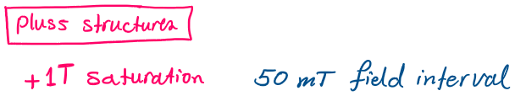

**Measurement Plan #3\_magnetic field effect**

02 June 2019

17:30

Field Sweeps (ΔB = T)

|  |  |  |  |  |  |  |  |  |  |  |
| --- | --- | --- | --- | --- | --- | --- | --- | --- | --- | --- |
| Nr | Struct | Field From | Field To | Hloop\_branch | SR [mT/min] | F-Span | Vin(V)/sens (mV)/gain | Avg | Time [min, Hr] | Date |
| [m342:](onenote:#m342%20MFN_Plusses_sweep%20after%20+%20saturation%20at%201T_0.005T%20to%20-0.005T_mT.min_1.5,%200.78Hz_5V&section-id={5FAD0518-E349-4A07-93E8-5D105BD4AEB4}&page-id={0664508E-5C60-4D50-9F2A-99136D158CE7}&end&base-path=https://goetheuniversitaet.sharepoint.com/sites/Project4/SiteAssets/Project%204%20Notebook/Magnetic%20Flux%20Noise.one) | Plusses | 25 mT | -25 mT | +Saturated | 0.11 | 1.5/0.7 | 5/5/20 | 35 | 448\_7.4 | 02.07.2019 |
| [m343:](onenote:#m343%20MFN_Plusses_sweep%20after%20-%20saturation%20at%201T_0.005T%20to%20-0.005T_mT.min_1.5,%200.78Hz_5V&section-id={5FAD0518-E349-4A07-93E8-5D105BD4AEB4}&page-id={9D1A8DBE-486A-444C-9890-8A4FB60E50D2}&end&base-path=https://goetheuniversitaet.sharepoint.com/sites/Project4/SiteAssets/Project%204%20Notebook/Magnetic%20Flux%20Noise.one) | Plusses | -25 mT | 25 mT | -Saturated | 0.11 | 1.5/0.7 | 5/5/20 | 35 | 448\_7.4 | 03.07.2019 |
| [m344:](onenote:#m344%20MFN_Plusses_sweep%20after_saturation%20at%20+1T_-0.443T%20to%20-0.611T_2.352mT.min_1.5,%200.78Hz_5V&section-id={5FAD0518-E349-4A07-93E8-5D105BD4AEB4}&page-id={C53AAB46-C98F-4039-8C24-F8153D391688}&end&base-path=https://goetheuniversitaet.sharepoint.com/sites/Project4/SiteAssets/Project%204%20Notebook/Magnetic%20Flux%20Noise.one) | Plusses | -443 mT | -611 mT | +Saturated | 2.352 | 1.5/0.7 | 5/5/20 | 35 | 448\_7.4 | 03.07.2019 |
| [m345:](onenote:#m345%20MFN_Plusses_sweep%20after_saturation%20at%20+1T_%20-0.2913%20T%20to%20-0.443%20T_1.638mT.min_1.5,%200.78Hz_5V&section-id={5FAD0518-E349-4A07-93E8-5D105BD4AEB4}&page-id={0BD41550-00B9-4E21-A600-12F3044B3C99}&end&base-path=https://goetheuniversitaet.sharepoint.com/sites/Project4/SiteAssets/Project%204%20Notebook/Magnetic%20Flux%20Noise.one) | Plusses | **-291 mT** | -443 mT | +Saturated | 0.5 | 1.5/0.7 | 5/5/20 | 24 | 303\_5 | 03.07.2019 |
| [m346:](onenote:#m346%20MFN_Plusses_sweep%20after_saturation%20at%20+1T_%20-0.06798%20T%20to%20-0.2913%20T_1.638mT.min_1.5,%200.78Hz_5V&section-id={5FAD0518-E349-4A07-93E8-5D105BD4AEB4}&page-id={5FCA0077-B82E-4798-A046-B161DE856008}&end&base-path=https://goetheuniversitaet.sharepoint.com/sites/Project4/SiteAssets/Project%204%20Notebook/Magnetic%20Flux%20Noise.one) | Plusses | 36.56mT | **-291.13 mT** | +Saturated | 0.5 | 1.5/0.7 | 5/5/20 | 51 | 655\_10.9 | 04.07.2019 |
| [m347:](onenote:#m347%20MFN_Plusses_sweep%20after_saturation%20at%20-1T_%20-0.03656%20T%20to%200.2913%20T_0.5mT.min_1.5%20Hz_5V_averages%20153&section-id={5FAD0518-E349-4A07-93E8-5D105BD4AEB4}&page-id={16C4D18A-3947-458C-ADD2-F4CBD3355863}&end&base-path=https://goetheuniversitaet.sharepoint.com/sites/Project4/SiteAssets/Project%204%20Notebook/Magnetic%20Flux%20Noise.one) | Plusses | -36.56mT | **-291.13 mT** | -Saturated | 0.5 | 1.5 | 5/5/20 | 153 | 652\_10.9 | 04.07.2019\_Thursday night |
| [m348:](onenote:#m348%20MFN_Empty_sweep%20after_saturation%20at%20-1T_%20-0.03656%20T%20to%200.2913%20T_0.5mT.min_1.5%20Hz_5V_averages%20153&section-id={5FAD0518-E349-4A07-93E8-5D105BD4AEB4}&page-id={A8F12604-CEF9-4037-97CE-1E62BF0761C2}&end&base-path=https://goetheuniversitaet.sharepoint.com/sites/Project4/SiteAssets/Project%204%20Notebook/Magnetic%20Flux%20Noise.one) | Empty | 36.56mT | **-291.13 mT** | -Saturated | 0.5 | 1.5 | 5/5/20 | 153 | 652\_10.9 | 05.07.2019\_Friday |
| [m349:](onenote:#m349%20MFN_Empty_sweep%20after_saturation%20at%20-1T_%20-0.025T%20to%200.025%20T_0.5mT.min_1.5%20Hz_5V_averages%2024&section-id={5FAD0518-E349-4A07-93E8-5D105BD4AEB4}&page-id={A1A7C247-1384-40EE-842C-EAC6A278714F}&end&base-path=https://goetheuniversitaet.sharepoint.com/sites/Project4/SiteAssets/Project%204%20Notebook/Magnetic%20Flux%20Noise.one) | Empty | -25 mT | +25 mT | -Saturated | 0.5 | 1.5 | 5/5/20 | 24 | 100 | 06.07.2019\_midnight\_Saturday |
| [m350:](onenote:#m350%20MFN_Plusses_sweep%20after_saturation%20at%20-1T_%20-0.025T%20to%200.025%20T_0.5mT.min_1.5%20Hz_5V_averages%2024&section-id={5FAD0518-E349-4A07-93E8-5D105BD4AEB4}&page-id={1EA829B7-965C-4961-9B23-F96DDD8F9E7F}&end&base-path=https://goetheuniversitaet.sharepoint.com/sites/Project4/SiteAssets/Project%204%20Notebook/Magnetic%20Flux%20Noise.one) | Plusses | -25 mT | +25 mT | -Saturated | 0.5 | 1.5 | 5/5/20 | 24 | 100 | 06.07.2019\_Saturday\_afternoon |
| [m351:](onenote:#m351%20MFN_Plusses_sweep%20after_saturation%20at%20-1T_%20-0.025T%20to%200.025%20T_1mT.min_1.5%20Hz_5V_averages%2012&section-id={5FAD0518-E349-4A07-93E8-5D105BD4AEB4}&page-id={046961AE-ADE6-41BF-B254-AA185E078B79}&end&base-path=https://goetheuniversitaet.sharepoint.com/sites/Project4/SiteAssets/Project%204%20Notebook/Magnetic%20Flux%20Noise.one) | Plusses | -25 mT | 25 mT | -Saturated | 1 | 1.5 | 5/5/20 | 12 | 50 | 06.07.2019\_Saturday\_evening |
| [m352:](onenote:#m352%20MFN_Plusses_sweep%20after_saturation%20at%20-1T_%20-0.025T%20to%200.025%20T_0.1mT.min_1.5%20Hz_5V_averages%20117&section-id={5FAD0518-E349-4A07-93E8-5D105BD4AEB4}&page-id={87401F82-7B5F-4BD6-9B30-CDD5C3F109BF}&end&base-path=https://goetheuniversitaet.sharepoint.com/sites/Project4/SiteAssets/Project%204%20Notebook/Magnetic%20Flux%20Noise.one) | Plusses | -25 mT | 25 mT | -Saturated | 0.1 | 1.5 | 5/5/20 | 117 | 500 | 06.07.2019\_Saturday\_night |
| [m353:](onenote:#m353%20MFN_Plusses_sweep%20after_saturation%20at%20-1T_%20-0.025T%20to%200.025%20T_0.25mT.min_1.5%20Hz_5V_averages%2047&section-id={5FAD0518-E349-4A07-93E8-5D105BD4AEB4}&page-id={FE9092E1-169E-4347-9969-D12D8CB66BD4}&end&base-path=https://goetheuniversitaet.sharepoint.com/sites/Project4/SiteAssets/Project%204%20Notebook/Magnetic%20Flux%20Noise.one) | Plusses | -25 mT | 25 mT | -Saturated | 0.25 | 1.5 | 5/5/20 | 47 | 200 | 07.07.2019\_Sunday\_morning |
| [m354:](onenote:#m354%20MFN_Plusses_sweep%20after_saturation%20at%20-1T_%20-0.025T%20to%200.025%20T_2mT.min_1.5%20Hz_5V_averages%206&section-id={5FAD0518-E349-4A07-93E8-5D105BD4AEB4}&page-id={962BDDFC-8A50-4AB8-A318-6997909CE9D1}&end&base-path=https://goetheuniversitaet.sharepoint.com/sites/Project4/SiteAssets/Project%204%20Notebook/Magnetic%20Flux%20Noise.one) | Plusses | -25 mT | 25 mT | -Saturated | 2 | 1.5 | 5/5/20 | 6 | 25 | 07.07.2019\_Sunday\_lunch time |



